Ωnyx Tutorial

Jan 15, 2019

1. Download Ωnyx at <http://onyx.brandmaier.de/>
2. You will need Java Runtime Environment installed in order to run Ωnyx.
   1. <https://java.com/en/download/manual.jsp>
3. Ωnyx is not installed but is simply opened using Java, so just double click on the .jar file to open the program
4. Ωnyx is almost entirely graphically based and relies on point-and-click methods. Start by opening some data. Open the Ωnyx menu at the top left and navigate to the Simple Regression Data to begin.

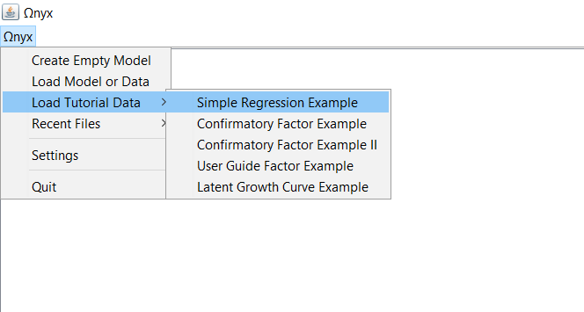

1. You’ll see a hexagon appear. This represents a dataset and includes 3 vectors: ID, X_c, and Y_c, the latter of which are two centered continuous variables.

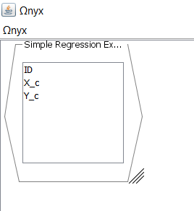

1. Double-click in the blank space or right(ctrl) click and select “Create Empty Model” to create a space for your path diagram.

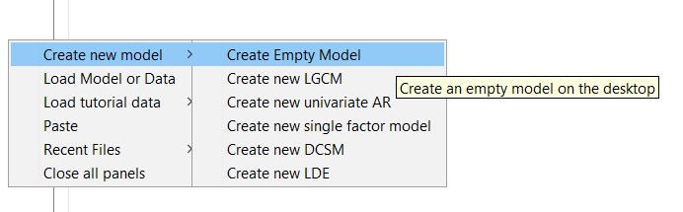

1. By right(ctrl) clicking in the model space, you will open a window from which you can build your model. Try creating two observed variables for your X and Y vectors from the dataset you opened earlier.

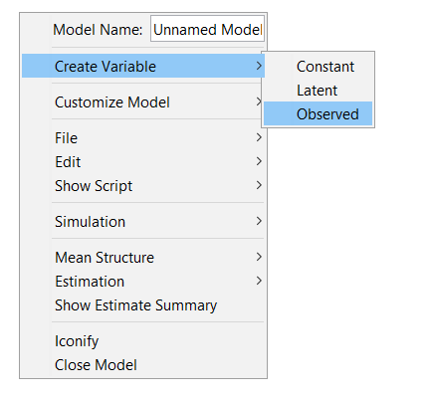

1. Connect these variables with a regression line by right(ctrl) clicking and dragging the arrow that appears from one box to the other.

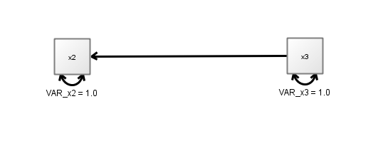

1. You’ve now created the visual representation of your first regression model! Now, add the data to the appropriate boxes by dragging the variables from the data hexagon to the boxes. You’ll notice that the variable names change in the boxes and actual variance estimates are now generated, based on the raw data.

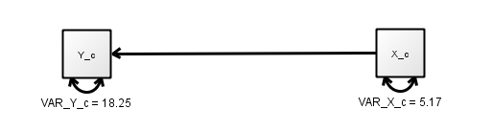

1. Finally, allow the regression path to be freely estimated by right(ctrl) clicking on the regression line and selecting “Free Parameter”.

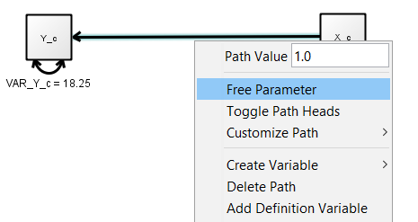

1. You’ll notice there is now an unstandardized *b* weight being estimated for the regression of Y_c onto X_c. You can also add the standardized weights by selecting “Show Standardized Estimates” under the “Customize Path” dialog.

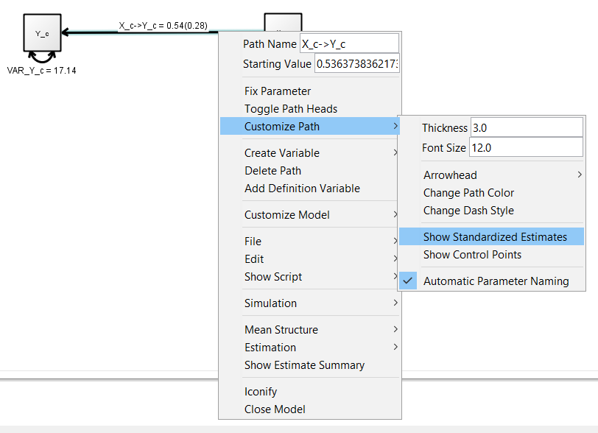

1. We can also clean up the variable names in the boxes or for the paths/variances if we want, change the colors, etc. all in the right(ctrl) click dialog box.

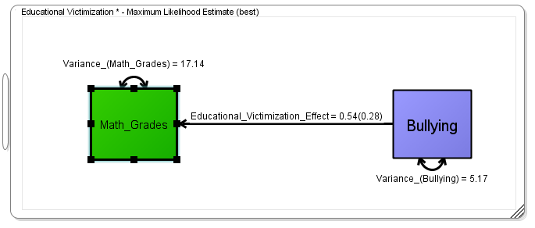

1. One final helpful trick is to pull the underlying code (e.g., lavaan code) and/or the covariance matrix from the model you just developed. Notice Ωnyx generates lavaan code that is used with the lavaan() function (rather than the cfa() function), which requires specifying of all relevant parameters (e.g., variances) and is more useful for learning what’s going on with your code.

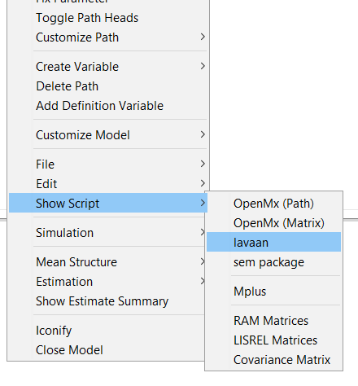

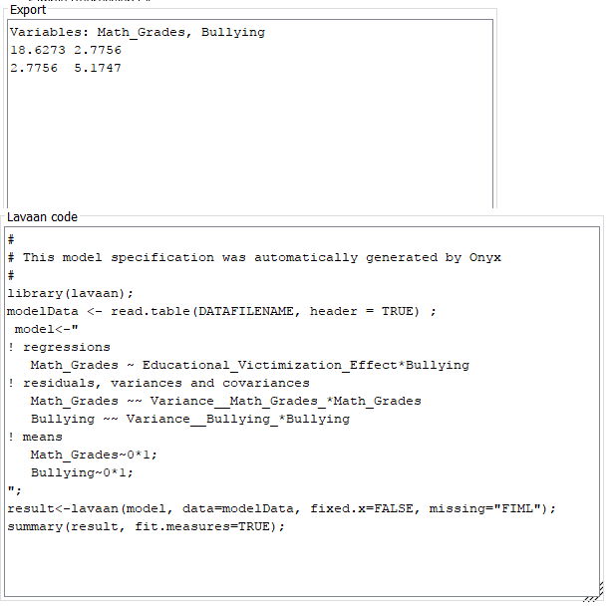

*Here are some other example models in Ωnyx*:

1. Multiple regression (based on Assignment 1, except without filtering by cyl):
   1. Variances/covariances
   2. Confirming in R

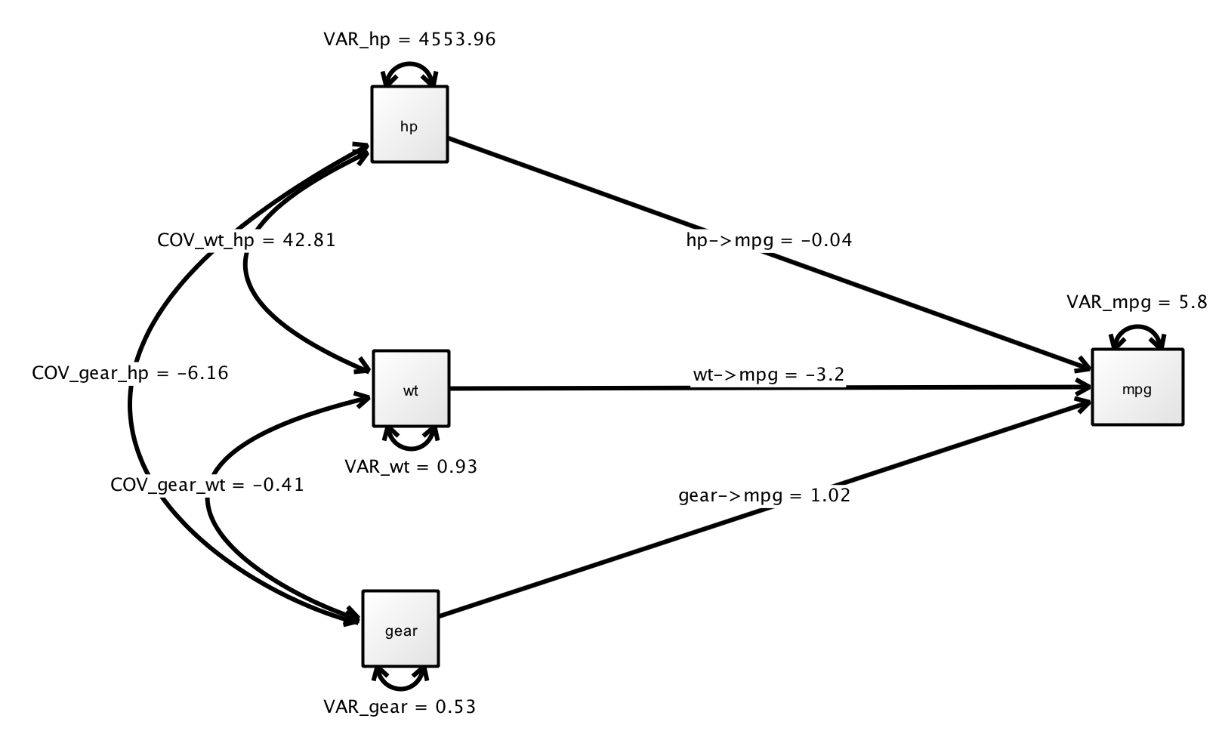

1. Confirmatory 3-factor model
   1. Generating model from dataset in Onyx
   2. Save data to read in from R
   3. Freeing paramters vs fixing

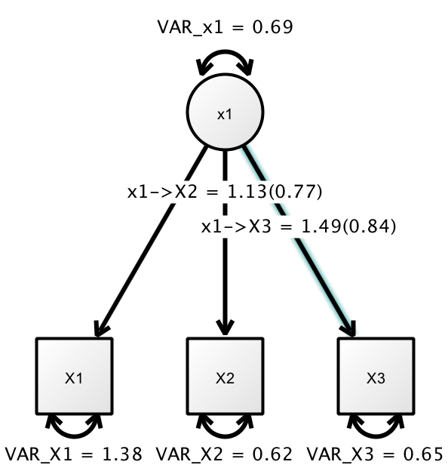

1. Latent Growth Curve Model (will likely not get into this one)

