Exercise 07

Making figures with Python

|  |
| --- |
| Work in progress |
| This page is under construction.  It may change before the assignment is released to class. |

## Dates

We’ll work on this exercise in-class on Thursday, April 10, 2025.

The write-up is due on Thursday, April 17, 2025.

## Goals

1. Create some simple figures in Python using the Pandas library.
2. Gain an appreciation of the costs and benefits of scripting the generation of figures.

## Assignment

## Set-up

For reasons not especially worth explaning here, we have to use R to configure Python for making figures using posit.cloud.

library(reticulate)  
py_require(c("pandas", "matplotlib", "numpy"))

Python calls groups of functions *libraries*. These are analogous to *packages* in R.

import numpy as np  
import matplotlib.pyplot as plt  
import pandas as pd

|  |
| --- |
| Note |
| In Python, we use the import command.  We create ‘nicknames’ for the packages so that we can refer to them using an easy-to-type shorthand. The nicknames are the short names: … import pandas as pd, means import the ‘pandas’ library and give it the shortname of ‘pd’. |

## NFSG data

### Gather

We’ll make plots of some of NSFG data we discussed in class on [2025-04-01](../slides/wk11-04-01-more-ggplot.qmd).

|  |
| --- |
| Note |
| The data file has been saved under csv/ |

The pandas library (shortname in our code pd) handles the creation and manipulation of data frames. That includes importing comma-separated value (CSV) files.

nsfg = pd.read_csv('../include/csv/NSFG_2022_2023_FemPregPUFData.csv')

We confirm that this worked by checking the data types in nsfg:

nsfg.dtypes

CaseID int64  
PREGORDR int64  
FTFMODE int64  
BORNALIV float64  
RECNT5YRPRG float64  
 ...   
CMJAN3YR int64  
CMJAN4YR int64  
CMJAN5YR int64  
YEAR int64  
QUARTER int64  
Length: 111, dtype: object

This is similar to running the str() function on an R data frame.

|  |
| --- |
| Python methods |
| Objects in Python have specialized functions that can be used with them using a simple ‘dot’ syntax. So nsfg.dtypes means ‘run the data types function on the nsfg data frame.’ These specialized functions are called ‘methods.’ |

nsfg.shape

(8247, 111)

The shape method is similar to the dim() function in R. What do the two numbers mean?

### Plot

Since we used the pandas library to import our data frame, we can use one of the built-in methods that apply to data frames to plot a histogram. Here, we create a histogram by calling the hist() method on the nsfg data frame and by specifying the column AGER, the age of the responding participant.

nsfg.hist(column = "AGER")

array([[<Axes: title={'center': 'AGER'}>]], dtype=object)

plt.show()

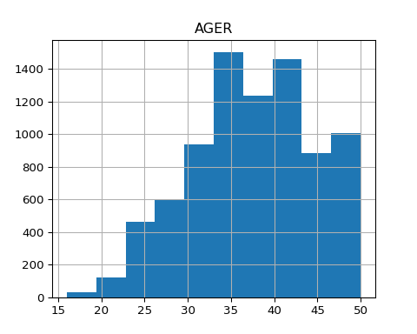

Now, let’s customize the plot by changing some parameters in the hist() method. Add change the number of bins to some larger number like 20, 25, or 30 (the default is 10), by changing LARGE_NUMBER to a number.

LARGE_NUMBER = 35  
nsfg.hist(column = "AGER", bins = LARGE_NUMBER)

array([[<Axes: title={'center': 'AGER'}>]], dtype=object)

plt.show()

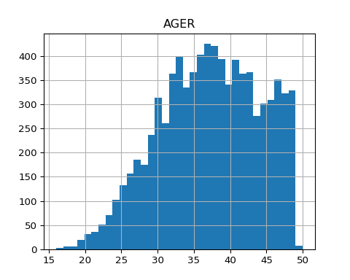

Now, try a smaller value, less than 10. Change the code below to try this.

SMALLER_NUMBER = 5  
nsfg.hist(column = "AGER", bins = SMALLER_NUMBER)

array([[<Axes: title={'center': 'AGER'}>]], dtype=object)

plt.show()

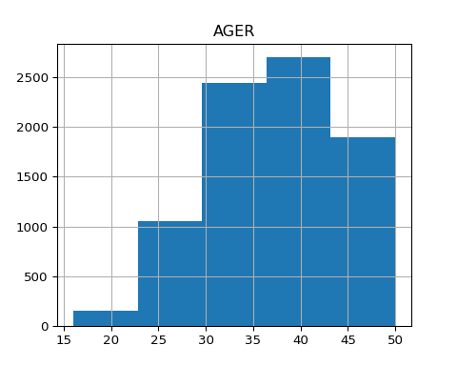

What do you notice?

Let’s look at the histograms by RELIGION, like we did in class on [2025-04-01](https://psu-psychology.github.io/psych-490-data-viz-2025-spring/slides/wk11-2025-04-01-more-ggplot.html).

nsfg.hist(column = 'AGER', by = 'RELIGION')

array([[<Axes: title={'center': '1'}>, <Axes: title={'center': '2'}>],  
 [<Axes: title={'center': '3'}>, <Axes: title={'center': '4'}>]],  
 dtype=object)

plt.show()

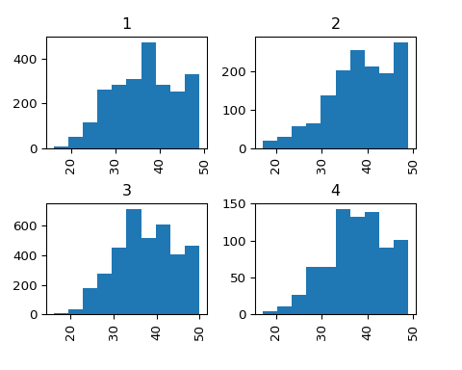

Modify the code below to create a set of histograms by some *other* variable that you choose (change VARIABLE_YOU_CHOOSE in the code below.) Make sure to look at the [codebook](https://psu-psychology.github.io/psych-490-data-viz-2025-spring/include/pdf/2022-2023-NSFG-FemRespPUFCodebook.pdf) to make sure that the variable you choose makes sense.

|  |
| --- |
| Warning |
| Make sure to put the variable you choose in quotations. |

VARIABLE_YOU_CHOOSE = 'BABYSEX'  
nsfg.hist(column = 'AGER', by = VARIABLE_YOU_CHOOSE)

array([[<Axes: title={'center': '1.0'}>, <Axes: title={'center': '2.0'}>],  
 [<Axes: title={'center': '8.0'}>, <Axes: title={'center': '9.0'}>]],  
 dtype=object)

plt.show()

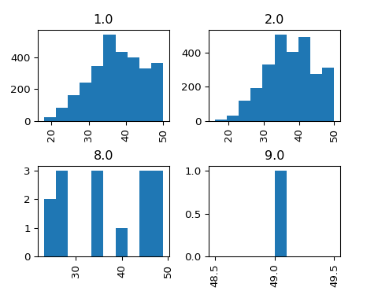

Finally, experiment with changing some of the default parameters like grid (values can be True or False), xrot (rotation of x axis labels) or yrot (rotation of y axis labels).

MY_XROT = 0  
nsfg.hist(column = 'AGER', by = 'RELIGION', xrot = MY_XROT)

array([[<Axes: title={'center': '1'}>, <Axes: title={'center': '2'}>],  
 [<Axes: title={'center': '3'}>, <Axes: title={'center': '4'}>]],  
 dtype=object)

plt.show()

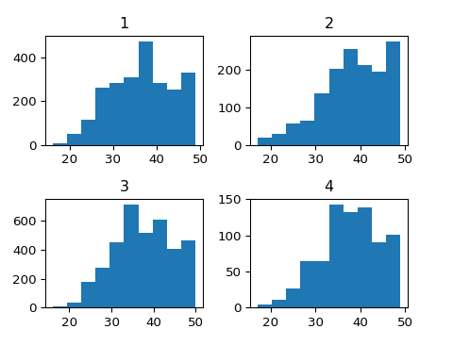

### Plot other

## Submit

1. The code you wrote in following the steps above.
2. The results of running your code.
3. Comments about what you observed.