Installing AND UPDATING R and R studio ON YOUR COMPUTER
For this course you will need BOTH R and R studio.
You have three options and you can jump between them from lab to lab.
- Installing on your own computer (recommended if you normally bring a laptop)
- Lab computers (hopefully!)
- Online at Posit-cloud https://posit.cloud/
Read if you already have R and R-Studio installed
If you already have R and/or R-studio installed on your computer, it’s important you update to the most recent version, because many of the large analysis packages updated recently. You should be running
- R: R 4.5.2 “[Not] Part in a Rumble” released on 2025/10/31
- R-Studio: “Apple Blossom”

If you already have the most recent version, jump down to Activity 2.4 (screenshots)
If your version is out of date, follow the instructions below as though you were installing for the first time. It’s still possible to roll-back if needed. You will not lose your work! It just updates the underlying software. If you have any concerns, please let Dr G know.

Installing R and R-Studio for the first time (or Updating R and R Studio)
To install the lab software onto your own laptop, you need to complete two tasks:
- First you need to teach your computer to ‘speak R’ by downloading/installing the R software.
- Then need to install the software we use for the labs (R-Studio).

INSTALLING R
STEP 1
- Go to this website https://posit.co/download/rstudio-desktop/
- Scroll down and click on “Installing R”.
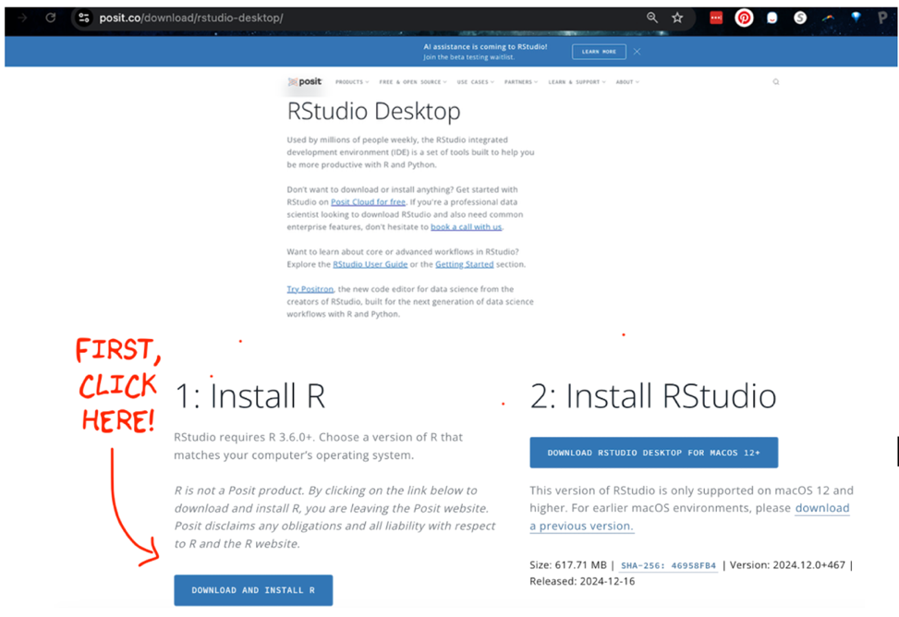
STEP 2
- Clicking the link will take you to a scary looking website called Cran R.
- Click the “INSTALL R” for your computer type.
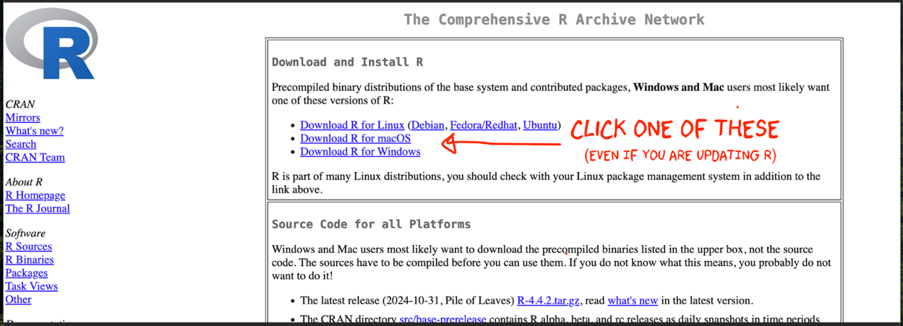
The next part looks a little different depending on whether you are using a Windows computer or a Mac.

STEP 3 FOR WINDOWS PEOPLE
- Click “Installing R for the first time”, EVEN IF YOU ARE UPDATING R-STUDIO
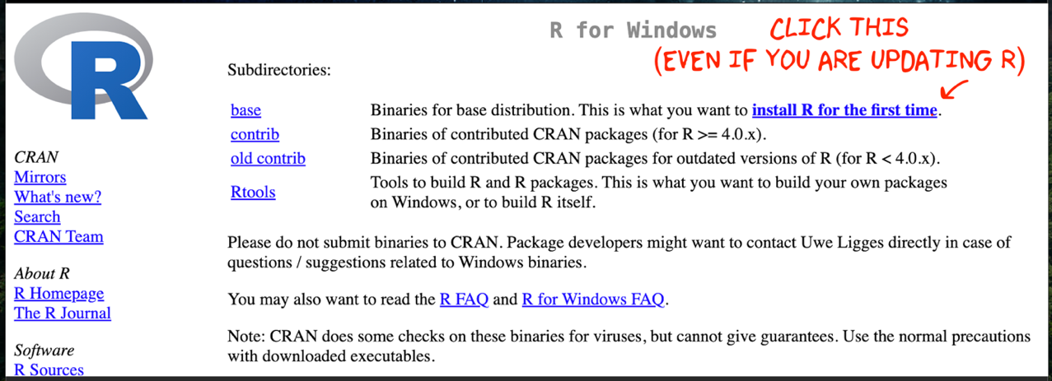
- This will download a file.
- Double click to install.
- You do not need a shortcut on your desktop (because we will use R studio to access it)

STEP 3 FOR PEOPLE USING A MAC
- There are two potential options for you to download - only one will work and neither will hurt your computer, so it’s easy to try both if you’re not sure.
  - If your Mac is pretty new, try the top option.
  - If your Mac is more than a few years old, try the second option.
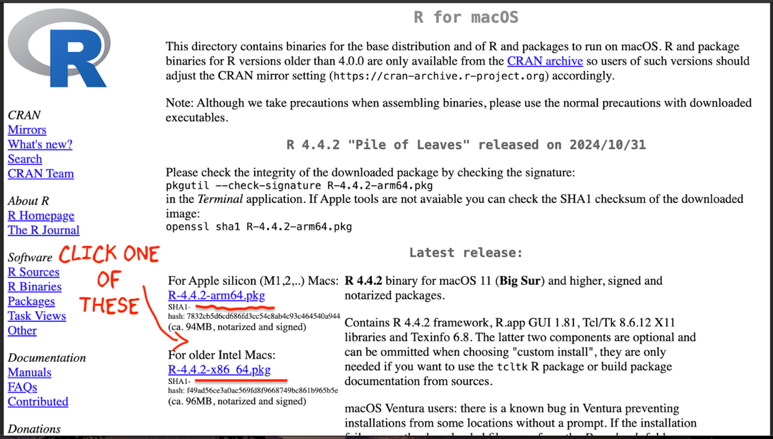
- This will download a file.
- Double click to install.
- It might say that you cannot open the file because of safety concerns. If that’s the case, click the magnifying-glass on the top right of your screen, search for settings, click on the security tab and click that it’s OK to open it. Then try again.

INSTALLING R-STUDIO
You installed R! Your computer can now understand R commands. But we don’t yet have a good way of creating our programs and reports. R-Studio is designed to do this.

STEP 1
- Go back to this website https://posit.co/download/rstudio-desktop/
- Scroll down but this time click the button on the right. It should automatically download a file onto your computer. (if you’re on a mac and not sure which version, keep reading below the screenshot)
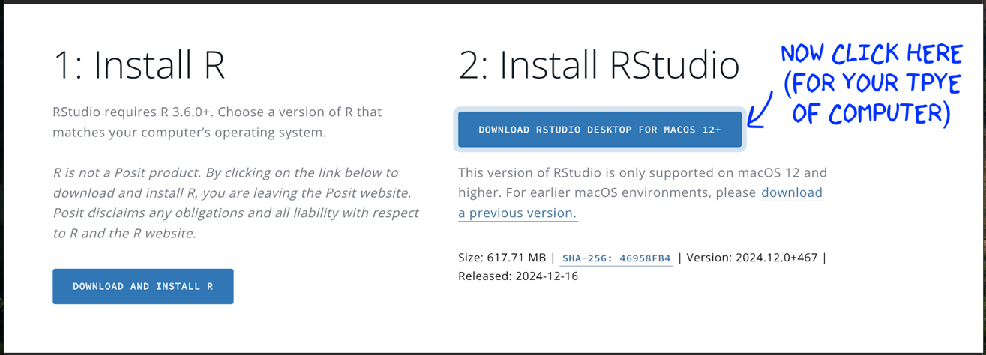
If you’re using a mac and need to check which version of the operating system you’re using, follow these instructions.
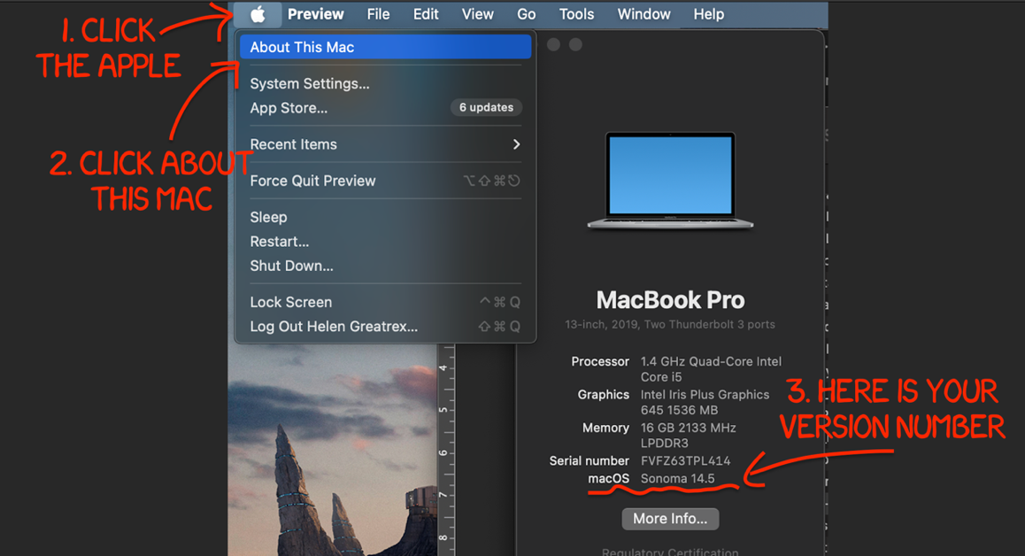

STEP 2
Once you have downloaded the install file from R-Studio.
- IF YOU’RE USING A WINDOWS MACHINE: Double click and install as normal.
- IF YOU’RE USING A MAC, double click, then drag the icon into applications.
Nothing should happen!
If you have a very old mac this might be where the process breaks (Dr G can fix it)
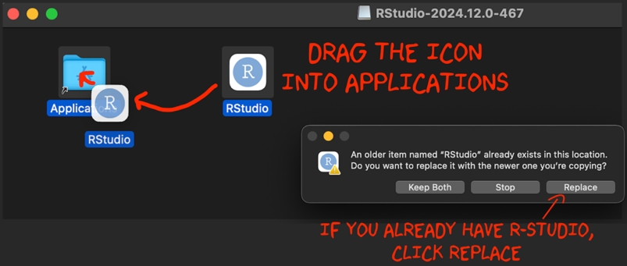
WELCOME TO R!
Now everything is installed, open R-studio (NOT R!).
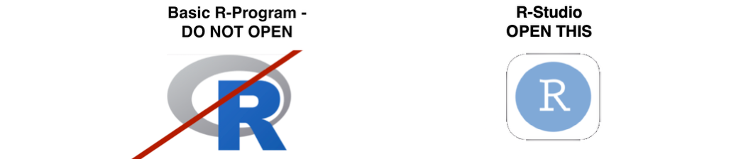
Or if you are on posit cloud, just start a new workspace. You should be running at least
  - R: R 4.5.2 “[Not] Part in a Rumble” released on 2025/10/31
  - R-Studio: “Apple Blossom”
  - If you tried updating and it didn’t work, reach out to Dr G.
