Peter Subacz – RBE550 – Path Planning, Coding Assignment 2

A* algorithm is used to compute lowest cost pathing in graph-based environments. The advantages of A* is that it avoids expanding paths that are already expensive and converges to optimal path, if and only if heuristic is admissible. A* works by adding heuristics of the L2 norm cost between two points and the past cost to reach a goal state. The advantages of A* is that it avoids expanding paths that are already expensive and converges to optimal path, if and only if heuristic is admissible.

This can be seen in the equation [1] below

𝑓(𝑥) = 𝑔(𝑥) + ℎ(𝑥)

Where:

*g(x) is the past cost*

*h(x) is the heuristic cost*

ANA* is an expanded A* adding a weighting factor similar to the Weighted A* algorithm. The cost in the Weghted A* algorithm is show below. ANA* changes the scaling factor, 𝜖𝑛𝑒𝑤, iteratively until the optimal solution has been found

𝑓(𝑠) = 𝑔(𝑠) + 𝜖 ⋅ ℎ(𝑠)

𝜖𝑛𝑒𝑤 = 𝜖𝑜𝑙𝑑 − Δ𝜖

Where:

*g(x) is the past cost*

*h(x) is the heuristic cost*

𝜖𝑛𝑒𝑤 *is a scaling factor*

The A*, Wieghted A*, and ANA* algothims were coded and ran on the trivial, medium, and hard mazes. The computation time and cost of the final solutions were recorded and can be found in the Table 1 below.

Table 1 - Time and Cost of A* Algorithms

|  |  |  |  |
| --- | --- | --- | --- |
| Trivial Maze | A* Solution | Wieghted A* | ANA* |
| Time (s) | 1.58 | 1.55 | 1.57 |
| Cost | 112.0 | 112.0 | 112.0 |
| Medium Maze | A* Solution | Wieghted A* | ANA* |
| Time (s) | 600.40 | 1770.83 | 1414. 38 |
| Cost | 2992.0 | 2992.0 | 2992.0 |
| Hard Maze | A* Solution | Wieghted A* | ANA* |
| Time (s) | 4729.62 | 6472.58 | 6645.60 |
| Cost | 7907.0 | 7907.0 | 7907.0 |

Figures 1, 2, and 3 shown below are solved illustrations of the maps with the three different algorithms. The biggest difference between the A*, Wieghted A*, and ANA* is the time it takes to solve each maze and the open nodes left to explore. The Wieghted A* and ANA* algorthms had more nodes left in the open list, meaning that these nodes were not explored and computation was saved. This effect is especailly noticable in the medium and hard difficulty maps where entire sections of the maze was left unexplored.



Figure 1 - Solved Trivial Maze – Left, A*, Middle Wieghted A*, Right ANA*

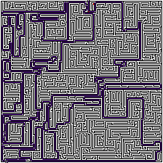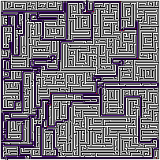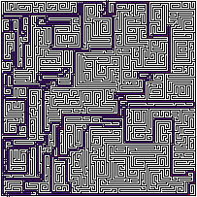

Figure 2- Solved Medium Maize – Left A*, Middle Wieghted A*, Right ANA*

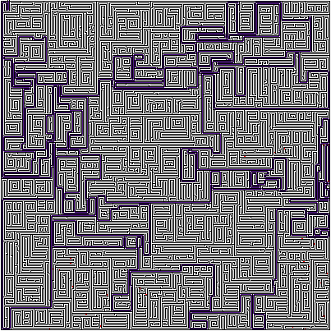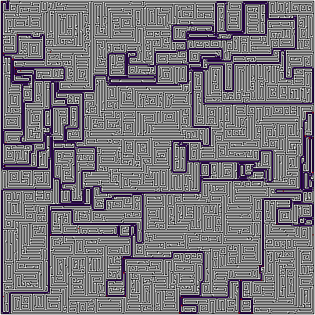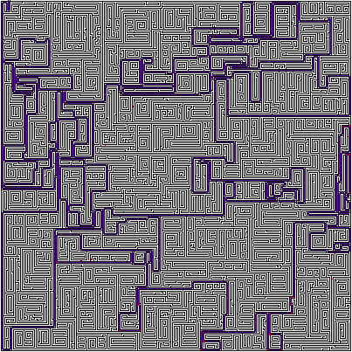

Figure 3- Solved Hard Maze– Left A*, Middle Wieghted A*, Right ANA*