Google assistant by rpi
step-1:Configure a Developer Project and Account Settings
A Google Cloud Platform project, managed by the Actions Console, gives your device access to the Google Assistant API. The project tracks quota usage and gives you valuable metrics for the requests made from your device.
Step-2:
- Open the Actions Console.
Go to the Actions Console
- Click on Add/import project.
- To create a new project, type a name in the Project name box and click CREATE PROJECT.
If you already have an existing Google Cloud Platform project, you can select that project and import it instead.

- If you created a new project, click the Device registration box near the bottom of the page. If you imported a previously-created project, this box will not be displayed; select the Device registration tab (under ADVANCED OPTIONS) from the left navbar.
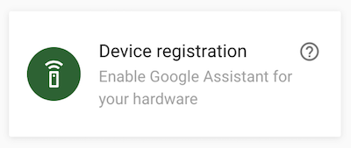
Keep this browser tab open. You will use it to register a device model in a later step.
- Enable the Google Assistant API on the project you selected (see the Terms of Service). You need to do this in the Cloud Platform Console.
Enable the API
Click Enable.
- You must configure the OAuth consent screen for your project in the Cloud Platform Console. Note that most fields on this page are optional.

Set activity controls for your account
In order to use the Google Assistant, you must share certain activity data with Google. The Google Assistant needs this data to function properly; this is not specific to the SDK.
Open the Activity Controls page for the Google account that you want to use with the Assistant. You can use any Google account, it does not need to be your developer account.
Ensure the following toggle switches are enabled (blue):
- Web & App Activity
  - In addition, be sure to select the Include Chrome history and activity from sites, apps, and devices that use Google services checkbox.
- Device Information
- Voice & Audio Activity
step 3

Register the Device Model
In order for the Google Assistant to respond to commands appropriate to your device and the given context, the Assistant needs information about your particular device. You provide this information, which includes fields like device type and manufacturer, as a device model. You can think of this model as a general class of device - like a light, speaker, or toy robot.
This information is then accessible to the Google Assistant and is associated with your Actions Console project. No other projects have access to your model and device information.
Step 4:Download credentials
The client_secret_<client-id>.json file must be located on the device. This file contains a client ID and client secret, but no access token. Later, you will run an authorization tool and reference this file in order to authorize the Google Assistant SDK sample to make Google Assistant queries (see the OAuth 2.0 documentation for more information). Do not rename this file.
Step 5:

Install the SDK and Sample Code
Follow these instructions to install the SDK and sample code on your device. Run all of the commands on this page in a terminal on the device (either directly or via an SSH connection).

Configure a new Python virtual environment
Use a Python virtual environment to isolate the SDK and its dependencies from the system Python packages.
sudo apt-get update
sudo apt-get install python3-dev python3-venv
python3 -m venv env
env/bin/python -m pip install --upgrade pip setuptools wheel
source env/bin/activate
step 6:Get the package
The Google Assistant SDK package contains all the code required to get the Google Assistant running on the device, including the sample code.
Install the package's system dependencies:
sudo apt-get install portaudio19-dev libffi-dev libssl-dev libmpg123-dev
Use pip to install the latest version of the Python package in the virtual environment:
python -m pip install --upgrade google-assistant-library==1.0.0
step 7:Generate credentials
- Install or update the authorization tool:
python -m pip install --upgrade google-auth-oauthlib[tool]
- Generate credentials to be able to run the sample code and tools. Reference the JSON file you downloaded in a previous step; you may need to copy it the device. Do not rename this file.
google-oauthlib-tool --scope https://www.googleapis.com/auth/assistant-sdk-prototype \
--scope https://www.googleapis.com/auth/gcm \
--save --headless --client-secrets /path/to/client_secret_client-id.json
step 8:After you approve the permission request from the API, a code will appear in your browser, such as "4/XXXX". Copy and paste this code into the terminal:
Enter the authorization code:
If authorization was successful, you will see a response similar to the following:
credentials saved: /path/to/.config/google-oauthlib-tool/credentials.json
If instead you see InvalidGrantError, then an invalid code was entered. Try again, taking care to copy and paste the entire code.
Step 9:
Run the Sample Code
At this point, you are ready to run the sample and make a query.
In the following command:
- Replace my-dev-project with the Google Cloud Platform project ID for the Actions Console project you created. To find the project ID in the Actions Console, select the project, click the gear icon, and select Project settings.
- Replace my-model with the name of the model you created in the previous step.
googlesamples-assistant-hotword --project-id my-dev-project --device-model-id my-model
Say Ok Google or Hey Google, followed by your query. You can try some of the following:
- Who am I?
- Listen to This American Life podcast.
- What is the weather in San Francisco?
If the Assistant does not respond, follow the troubleshooting instructions.
To change the language for the Google Assistant or to enable personal results, use the Google Assistant app.
If you have a Cast-enabled device on the same network and configured with the same user account, you can control it remotely:
- Ok Google, play Spotify on the Kitchen Speaker.
To broadcast a voice message, make sure to first set the device location in the Google Assistant app. Then try the following:
- Ok Google, broadcast Come to dinner.

Step 10:

Find the device instance ID
When you run the sample the first time, it will generate a device instance for your particular device. This device instance will be associated with the device model that you specified to run the sample. You can also create the instance yourself using the registration tool.
The sample saves the device instance ID. If you run the sample with the same model ID, it defaults to using the saved device instance ID.
Find the device instance ID in the console for the sample.
device_model_id: my-model
device_id: 1C3E1558B0023E49F71CA0D241DA03CF # Device instance ID
Registering...Done.
ON_MUTED_CHANGED:
{'is_muted': False}
ON_START_FINISHED
step 11:

Next Steps
Once you have the Google Assistant running on your prototype, give these a try:
- Customize how your device interacts with the Assistant. For example, trigger the Assistant with the push of a button or blink an LED when playing back audio. You can even show a speech recognition transcript from the Assistant on a display.
- Control your device with Device Actions. For example, ask your lamp, with the Assistant built-in, to turn on and change its brightness.
- If you're looking to ship a commercial device with the Google Assistant, please contact us.

Customize how your device interacts with the Assistant

Trigger the Assistant
With the Google Assistant Library, you trigger an Assistant request by speaking a hotword like Ok Google. You can mute the microphone to stop the Assistant from listening for the hotword. Use the set_mic_mute() to control this. Trigger the start_conversation() method based on your own custom event.

Get the transcript of the user request
The Google Assistant SDK gives you a text transcript of the user request. Use this to provide feedback to the user by rendering the text to a display, or even for something more creative such as performing some local actions on the device.
The transcript is located in a Python string object in the ON_RECOGNIZING_SPEECH_FINISHED event.

Control your device with Device Actions
You can add Device Actions to the Assistant that allow you to control your device via voice. Extend the Google Assistant Library sample to include Device Actions.

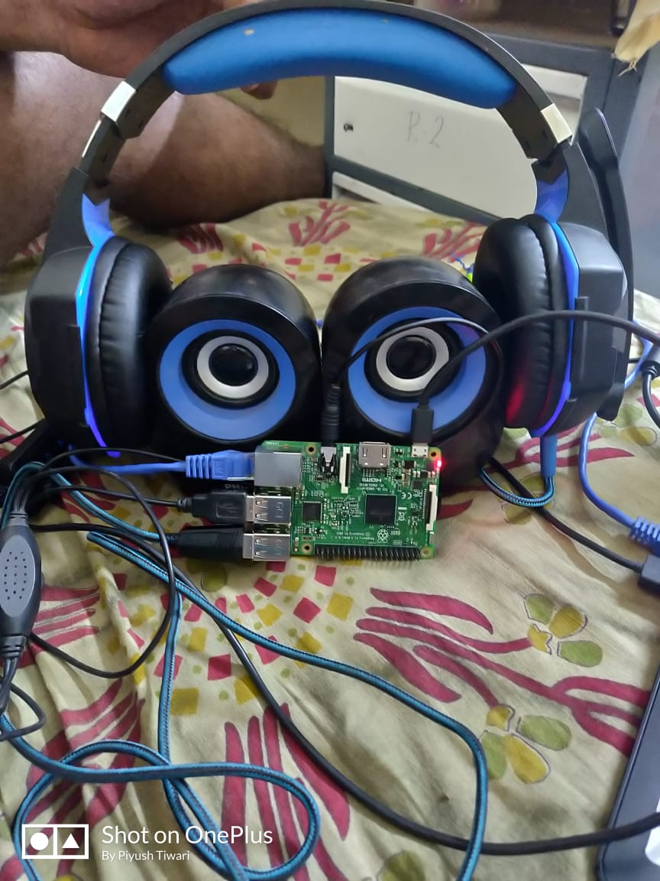
try yourself!

