HEAD COMPONENTS USED AND SOFTWARE USED FOR IT

Processes to be done by Humanoid Robot (Flowchart):
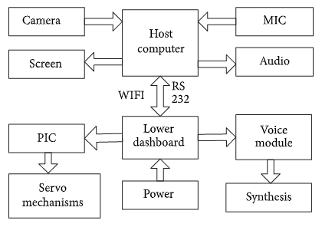
Face Recognition
A facial recognition system is a technology capable of identifying or verifying a person from a digital image or a video frame from a video source.
There are multiple methods in which facial recognition systems work, but in general, they work by comparing selected facial features from given image with faces within a database.
The process of face recognition is performed in two steps. The first involves feature extraction and selection and, the second is the classification of objects. Later developments introduced varying technologies to the procedure.
Some face recognition algorithm identify facial features by extracting landmarks, or features, from an image of the subject's face. For example, an algorithm may analyze the relative position, size, and/or shape of the eyes, nose, cheekbones, and jaw. These features are then used to search for other images with matching features.
Popular recognition algorithms include principal component analysis using eigenfaces, linear discriminant analysis, elastic bunch graph matching using the Fisherface algorithm, the hidden Markov model, the multilinear subspace learning using tensor representation, and the neuronal motivated dynamic link matching.

Camera used for Face Recognition:
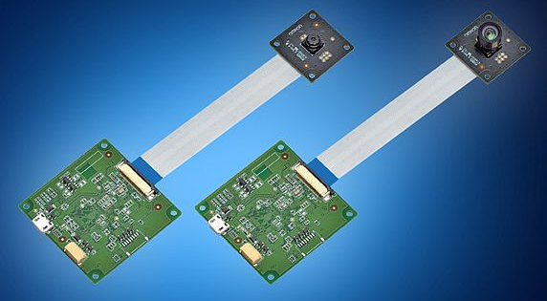
The Omron B5T HVC-P2 face detection sensor modules, available from Mouser Electronics, each consist of a camera and a separate main board, connected via a flexible flat cable, allowing it to be installed on the edge of a flat display unit. The modules’ new package size improves upon previously available all-in-one units. The boards feature UART and USB interfaces, which control the module and send the data output (as no image output, 160×120 pixels, or 320×240 pixels) to an external system. The range of the camera is 30-40mtrs.

3-Dimensional recognition
Three-dimensional face recognition technique uses 3D sensors to capture information about the shape of a face. This information is then used to identify distinctive features on the surface of a face, such as the contour of the eye sockets, nose, and chin.
Three-dimensional data points from a face vastly improve the precision of face recognition. The sensors work by projecting structured light onto the face. Up to a dozen or more of these image sensors can be placed on the same CMOS chip—each sensor captures a different part of the spectrum.
Thermal cameras
A different form of taking input data for face recognition is by using thermal cameras, by this procedure the cameras will only detect the shape of the head and it will ignore the subject accessories such as glasses, hats, or makeup. Unlike conventional cameras, thermal cameras can capture facial imagery even in low-light and nighttime conditions without using a flash and exposing the position of the camera.

Basic components required in H.R.
Minimal device requirements for creating a Humanoid are HD Cameras, which will help collect data for Image processing, RFID, which will help give us instructions remotely, IR Sensors, to detect obstacle, humans, and distance from them, Rotors, for their movement, Accelerometer, Magnetometer, Gyroscope and Ethernet connection for controlling the movement if needed, A CPU, a Battery Unit, a PLC is must for regulated outputs and designing the logic.

Controllers that can be used in H.R.:
- Atmel AVR microcontrollers (ATmega, ATtiny, etc.)
- Microchip Technology PIC microcontrollers (PIC16, PIC24, etc.)
- Microcontrollers based on ARM technology.

Software for synchronization of task:
Robot Operating System (ROS) is robotics middleware (i.e. collection of software frameworks for robot software development).
Systems and tools
- Actionlib provides a standardized interface for interfacing with preemptable tasks.
- Nodelet provides a way to run multiple algorithms in a single process.
- Rosbridge provides a JSON API to ROS functionalities for non-ROS programs.
Mapping and localization
- Gmapping provides a wrapper for OpenSlam's Gmapping algorithm for simultaneous localization and mapping.
- Cartographer provides real time 2D and 3D SLAM algorithms developed at Google.
- Amcl provides an implementation of adaptive Monte-Carlo localization.
Navigation
- nav2d provides the capability of navigating a mobile robot in a planar environment.
Perception
- Vision_opency is a meta-package which provides packages for integrating ROS with OpenCV.

Coordinate frame representation
- tf provided a system for representing, tracking and transforming coordinate frames until ROS Hydro, when it was deprecated in favor of tf2.
- tf2 is the second generation of the tf library and provides the same capabilities for ROS versions after Hydro.
Simulation
- Gazebo_ros_pkgs is a meta-package which provides packages for integrating ROS with the Gazebo simulator.
- stage provides an interface for the 2D Stage simulator.
Programming language to be used : Python for implementing algorithms and Embedded C for programming microcontrollers like PIC for performing Embed Tasks.

speech recognition
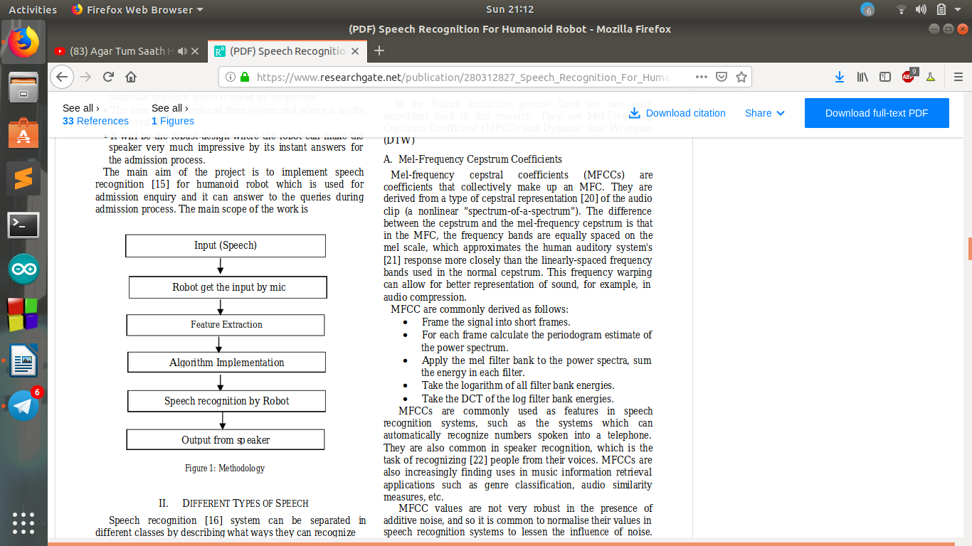
FLOW CHART

HOW IS SPEECH RECOGNITION IS DONE BY HUMANOID BOT

STT conversion is the process of converting spoken words into written texts. This process is also often called speech recognition. Although these terms are almost synonymous, Speech recognition is sometimes used to describe the wider process of extracting meaning from speech
HOW STT WORKS
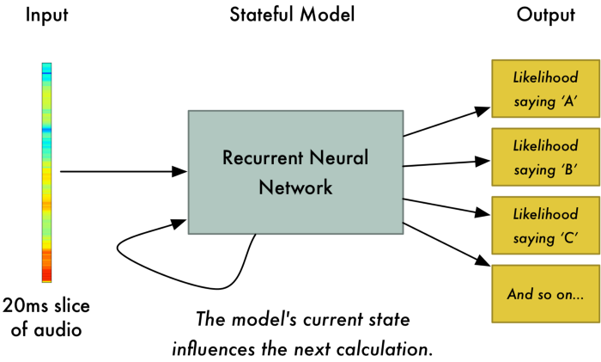
Now that we have our audio in a format that’s easy to process, we will feed it into a deep neural network. The input to the neural network will be 20 millisecond audio chunks. For each little audio slice, it will try to figure out the letter that corresponds the sound currently being spoken.

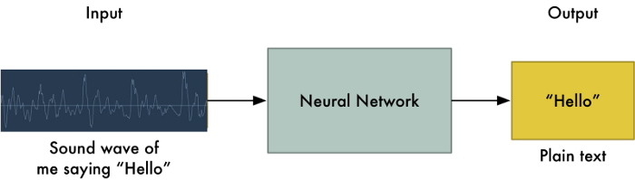

DIFFERENT TYPE OF SOFTWARE'S ARE USED FOR STT
1.google docs voice typing
2.Dragon professional individual
3.braina pro
4.Speechnotes
5.e-speaking
6.Voice finger
7.Apple Dictation
8.Windows speech recognition
ALGORITHM OF SPEECH RECOGNITION
There are 3 main algorithm of speech recognition
1.Hidden Markov Model(HMM)
2.Dynamic Time Warping(DTW)
3.Artificial Neural Networks(ANN)
best programming language for speech recognition.
1.C#
2.JAVA
3.PHP
4.PERL

