A
Project Report on
WEBSITE BLOCKER
Submitted by

Mr.P Subham Biswal
Roll No : 11031016

for the partial fulfillment of the requirements for the degree of
Bachelor of Computer Science (BscCS)



LAKSHYA INSTITUTE OF TECHNOLOGY
LAKSHAY INSTITUTE, Acharya Vihar, Bhubaneswar – 768019
May, 2022
CERTIFICATE
I hereby declare that the work which is being presented in the project report entitled “<WEBSITE BLOCKER>”, in partial fulfillment of the requirements for the award of Degree of Master of Computer Applications (BCA) submitted to the Department of Bachelor in Computer Applications, LIT, Bhubaneswar is an authentic record of my own work. The content presented in this project report has not been submitted for the award of any other degree of this or any other University.

P Subham Biswal
(Regd. No : )

It is certified that the above statement made by the student is correct to the best of my knowledge and belief.

Prof. (Mr.) Sujit Kumar Pradhan
Assistant Professor, Department of CSE&A
Countersigned by:

Faculty In-Charge, BCA Head, Department of

External Examiner

ACKNOWLEDGEMENT

I would like to thank Mr. Sujit Kumar Pradhan, Assistant Professor, Department of Bachelor Computer Applications (BCA) for the opportunity to work with him, for his invaluable guidance, encouragement, suggestions and untiring support. He has been an advisor in true sense both academically and morally though out this project work.
I am highly grateful to Mr. Chandrakanta Rout for providing all the necessary infrastructure to complete my BscCS Project Work.
I extend my sincere thanks to Smruti Rout for their continuous inspiration and intellectual support during this project work.
Special thanks to my family members especially to my parents and friends whose uninterrupted love, inspiration and blessings helped me to complete my Industrial Project Work.
I thank and owe my deepest regards to all who have helped me directly or indirectly.

P Subham Biswal
(Roll No: 11031016)

ABSTRACT

Website Blocker is a tool that denies access to websites permanently or by schedule. To use the internet safely we can block all websites from unwanted categories.

While creating Python Website Blocker Application, we are going to use only one module – Tkinter Module to make easy GUI using Python. We will be making two functions Block() and Unblock(). As the names suggest these functions will perform blocking and unblocking of websites respectively. These websites are added to the host file of the system.

LIST OF TABLES

Table 1.1. | <Table Title in chapter 1> | <Page no>
Table 2.1: | <Table Title in chapter 2> | <15>
Table 2.2: | <Table Title in chapter 2> | <16>

:

:

LIST OF FIGURES

Figure 1.1: | < A sample figure with figure title placed appropriately. This title is very long and is single-spaced. Notice how the text is aligned. > | <1>
Figure 1.2: | <Figure Caption in Chapter 1> | <5>

ABBREVIATIONS

(If Required write otherwise Delete this Page)

SUIIT | Sambalpur University Institute of Information Technology
SBP | Sambalpur

:
:

TABLE OF CONTENTS

CERTIFICATE |  |  | II
DECLARATION |  |  | III
ACKNOWLEDGEMENTS |  |  | IV
ABSTRACT |  |  | V
LIST OF TABLES |  |  | VI
LIST OF FIGURES |  |  | VII
ABBREVIATIONS |  |  | VIII
1 | <CHAPTER-1 TITLE IN UPPER CASE> |  | 1-9
 | 1.1 | <Title-1.1> | 1
 | 1.2 | <Title-1.2> | 3
 | 1.3 | <Title-1.3> | 8
2 | <CHAPTER-2 TITLE IN UPPER CASE> |  | 10-12
3 | <CHAPTER-3 TITLE IN UPPER CASE> |  | 13-14
4 | <CHAPTER-4 TITLE IN UPPER CASE> |  | 15-20
 | 4.1 <Title-4.1> |  | 15
 | 4.2 <Title-4.2> |  | 16
 | 4.3 <Title-4.3> |  | 17

:
:
:
 | References |  | 30-34

Website Blocker Python Project

The objective of Website Blocker python project is to block the given websites from any device. This project will help the user to stay away from their distraction by blocking websites from their device so that they can not open them.

In this Python Website Blocker Project, the user can enter multiple websites to block, and then clicking on the block button will check the condition that if the website already blocked then print ‘already blocked’ else blocked all that websites and print ‘blocked’.

Python Website Blocker Project Prerequisites:
This project requires basic understanding of Python like defining functions, creating loops etc. To use Tkinter Module we need to install it using the following command:
pip install tk

Project File Structure

Let us have a look at the steps we will be performing to create the Python Website Blocker project

Importing the required library
Creating GUI window
Hostpath and IP address.
Creating Block function to block websites
Creating Unblock function to unblock websites
Creating labels and buttons
Main command

Code:
project/blocker.py
#import module
from tkinter import*

host_path='C:\Windows\System32\drivers\etc\hosts'
ip_address='127.0.0.1'

def block():
website_lists = enter_Website.get(1.0,END)
Website=list(website_lists.split(","))
with open(host_path,'r+')as host_file:
file_content = host_file.read()
for web in Website:
if web in file_content:
display=Label(window,text='Already Blocked',font='arial')
display.place(x=200,y=200)
else:
host_file.write(ip_address+" "+web+'\n')
Label(window,text="Blocked",font='arial').place(x=230,y=200)
def unblock():
website_lists = enter_Website.get(1.0,END)
Website=list(website_lists.split(","))
with open(host_path,'r+')as host_file:
file_content = host_file.readlines()
for web in Website:
if web in website_lists:
with open(host_path,'r+') as f:
for line in file_content:
if line.strip(',')!= website_lists:
f.write(line)
Label(window,text="UnBlocked",font='arial').place(x=350,y=200)
else:
display=Label(window,text='Already UnBlocked',font='arial')
display.place(x=350,y=200)
def close():
window.destroy()

#to make a window
window=Tk()

#set size of window
window.geometry('650x400')
window.maxsize(750,600)
window.minsize(550,300)

#set title of window
window.title('WEBSITE BLOCKER')

#set Header
l1=Label(window,text='WEBSITE BLOCKER',font=('bold',15),fg='purple')
l1.pack()
l2=Label(window,text='Developed By @ODR_MUNA',font=('bold',12),fg='purple')
l2.pack(side=BOTTOM)

l3=Label(window,text='Enter website :')
l3.place(x=100,y=50)
enter_Website=Text(window,font=(10),width=30,height=1)
enter_Website.place(x=200,y=48)

b1=Button(window,text='Block',font=('bold',10),bg='red',fg='white',command=block)
b1.place(x=150,y=100)
b2=Button(window,text='Un Block',font=('bold',10),bg='green',fg='white',command=unblock)
b2.place(x=270,y=100)
b3=Button(window,text='Exit',font=('bold',10),bg='pink',fg='white',command=close)
b3.place(x=400,y=100)
window.mainloop()

How to run:
Open window command prompt in Admin mode and set path
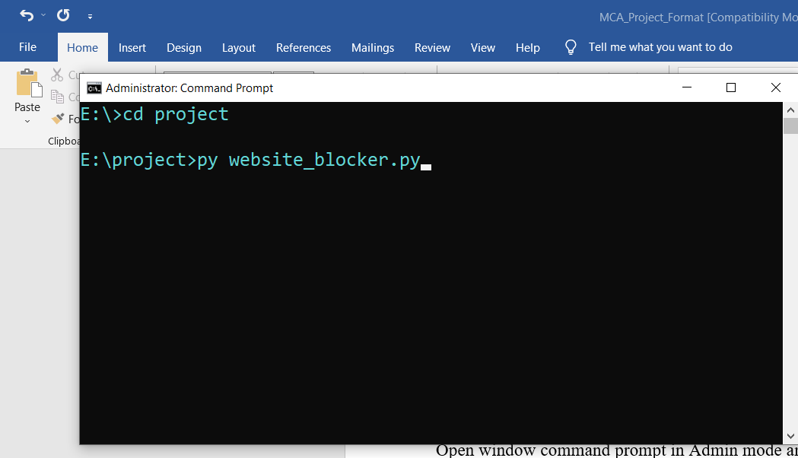
Output Screen

Summary:
We successfully created a Website Blocker Project using Python. Using this application we can block and unblock any websites that we want. We made our GUI using the Tkinter Module and its inbuilt methods.

