Successfully loaded drift data from drift_reports/test_data_drift_report.pkl

==================================================

DRIFT ANALYSIS SUMMARY

==================================================

Analysis Timestamp: 2025-10-11T15:18:49.610602

Test Data Size: 55

Total Chunks Analyzed: 120

DATA DRIFT RESULTS:

Model Chunk_ID Data_Drift_Score KS_Score Cosine_Distance Has_Drift

logistic_regression 9 0.096949 0.104822 0.089077 True

logistic_regression 4 0.098724 0.111394 0.086054 True

logistic_regression 5 0.089037 0.101246 0.076828 True

logistic_regression 3 0.097298 0.101643 0.092952 True

logistic_regression 8 0.106193 0.113758 0.098628 True

logistic_regression 2 0.107243 0.114266 0.100221 True

logistic_regression 10 0.095826 0.101778 0.089875 True

logistic_regression 1 0.090885 0.099279 0.082490 True

logistic_regression 6 0.097465 0.111650 0.083280 True

logistic_regression 7 0.091341 0.103253 0.079428 True

decision_tree 9 0.095457 0.101838 0.089077 True

decision_tree 4 0.094596 0.103138 0.086054 True

decision_tree 5 0.089720 0.102613 0.076828 True

decision_tree 3 0.102473 0.111993 0.092952 True

decision_tree 8 0.096903 0.095178 0.098628 True

decision_tree 2 0.108179 0.116136 0.100221 True

decision_tree 10 0.097065 0.104256 0.089875 True

decision_tree 1 0.095661 0.108831 0.082490 True

decision_tree 6 0.092997 0.102714 0.083280 True

decision_tree 7 0.092364 0.105300 0.079428 True

neural_network 9 0.094585 0.100094 0.089077 True

neural_network 4 0.097667 0.109279 0.086054 True

neural_network 5 0.087340 0.097852 0.076828 True

neural_network 3 0.103557 0.114162 0.092952 True

neural_network 8 0.107193 0.115758 0.098628 True

neural_network 2 0.110640 0.121058 0.100221 True

neural_network 10 0.093278 0.096680 0.089875 True

neural_network 1 0.090807 0.099123 0.082490 True

neural_network 6 0.095132 0.106983 0.083280 True

neural_network 7 0.090734 0.102040 0.079428 True

svm 9 0.094319 0.099562 0.089077 True

svm 4 0.091704 0.097354 0.086054 True

svm 5 0.086491 0.096155 0.076828 True

svm 3 0.100850 0.108747 0.092952 True

svm 8 0.100728 0.102828 0.098628 True

svm 2 0.102182 0.104143 0.100221 True

svm 10 0.095584 0.101293 0.089875 True

svm 1 0.096700 0.110909 0.082490 True

svm 6 0.091556 0.099832 0.083280 True

svm 7 0.095044 0.110660 0.079428 True

lasso_regression 9 0.093929 0.098781 0.089077 True

lasso_regression 4 0.098845 0.111636 0.086054 True

lasso_regression 5 0.089690 0.102552 0.076828 True

lasso_regression 3 0.100227 0.107502 0.092952 True

lasso_regression 8 0.107502 0.116377 0.098628 True

lasso_regression 2 0.108276 0.116331 0.100221 True

lasso_regression 10 0.091611 0.093347 0.089875 True

lasso_regression 1 0.091784 0.101078 0.082490 True

lasso_regression 6 0.095539 0.107798 0.083280 True

lasso_regression 7 0.090829 0.102229 0.079428 True

CONCEPT DRIFT RESULTS:

Model Chunk_ID Concept_Drift_Score Accuracy_Drop Train_Accuracy Test_Accuracy Has_Drift

logistic_regression 9 0.581818 0.581818 1.000000 0.418182 True

logistic_regression 4 0.654545 0.654545 1.000000 0.345455 True

logistic_regression 5 0.600000 0.600000 1.000000 0.400000 True

logistic_regression 3 0.727273 0.727273 1.000000 0.272727 True

logistic_regression 8 0.618182 0.618182 1.000000 0.381818 True

logistic_regression 2 0.727273 0.727273 1.000000 0.272727 True

logistic_regression 10 0.709091 0.709091 1.000000 0.290909 True

logistic_regression 1 0.581818 0.581818 1.000000 0.418182 True

logistic_regression 6 0.636364 0.636364 1.000000 0.363636 True

logistic_regression 7 0.672727 0.672727 1.000000 0.327273 True

decision_tree 9 0.466667 0.466667 0.666667 0.200000 True

decision_tree 4 0.522559 0.522559 0.740741 0.218182 True

decision_tree 5 0.597306 0.597306 0.851852 0.254545 True

decision_tree 3 0.781818 0.781818 1.000000 0.218182 True

decision_tree 8 0.522559 0.522559 0.740741 0.218182 True

decision_tree 2 0.727273 0.727273 1.000000 0.272727 True

decision_tree 10 0.818182 0.818182 1.000000 0.181818 True

decision_tree 1 0.657143 0.657143 0.857143 0.200000 True

decision_tree 6 0.541414 0.541414 0.777778 0.236364 True

decision_tree 7 0.688889 0.688889 0.888889 0.200000 True

neural_network 9 0.000000 -0.035690 0.037037 0.072727 False

neural_network 4 0.019529 0.019529 0.074074 0.054545 True

neural_network 5 0.056566 0.056566 0.111111 0.054545 True

neural_network 3 0.001347 0.001347 0.074074 0.072727 False

neural_network 8 0.056566 0.056566 0.111111 0.054545 True

neural_network 2 0.000000 -0.018831 0.035714 0.054545 False

neural_network 10 0.020202 0.020202 0.111111 0.090909 True

neural_network 1 0.016883 0.016883 0.071429 0.054545 True

neural_network 6 0.038384 0.038384 0.111111 0.072727 True

neural_network 7 0.001347 0.001347 0.074074 0.072727 False

svm 9 0.636364 0.636364 1.000000 0.363636 True

svm 4 0.634343 0.634343 0.888889 0.254545 True

svm 5 0.671380 0.671380 0.925926 0.254545 True

svm 3 0.690909 0.690909 1.000000 0.309091 True

svm 8 0.709091 0.709091 1.000000 0.290909 True

svm 2 0.745455 0.745455 1.000000 0.254545 True

svm 10 0.727273 0.727273 1.000000 0.272727 True

svm 1 0.654545 0.654545 1.000000 0.345455 True

svm 6 0.727273 0.727273 1.000000 0.272727 True

svm 7 0.708418 0.708418 0.962963 0.254545 True

lasso_regression 9 0.000000 -0.017508 0.037037 0.054545 False

lasso_regression 4 0.020202 0.020202 0.111111 0.090909 True

lasso_regression 5 0.038384 0.038384 0.111111 0.072727 True

lasso_regression 3 0.000000 -0.017508 0.037037 0.054545 False

lasso_regression 8 0.038384 0.038384 0.111111 0.072727 True

lasso_regression 2 0.052597 0.052597 0.107143 0.054545 True

lasso_regression 10 0.038384 0.038384 0.111111 0.072727 True

lasso_regression 1 0.000000 -0.037013 0.035714 0.072727 False

lasso_regression 6 0.000000 -0.017508 0.037037 0.054545 False

lasso_regression 7 0.000000 -0.016835 0.074074 0.090909 False

Generating visualizations...

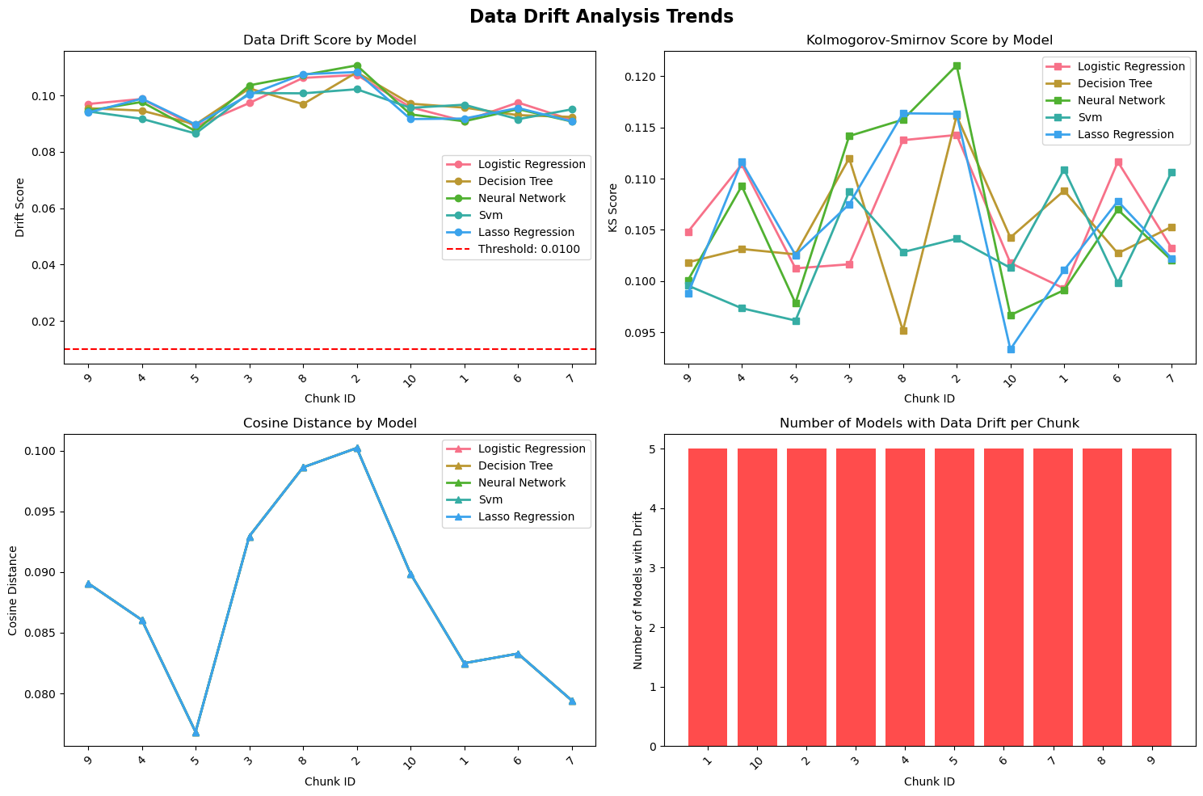

Analysis complete! Check the generated plots for insights.