Loading config from: config.yaml

Successfully loaded drift data from drift_reports/test_data_drift_report.pkl

==================================================

DRIFT ANALYSIS SUMMARY

==================================================

Analysis Timestamp: 2025-10-11T15:31:22.180893

Test Data Size: 55

Total Chunks Analyzed: 50

DATA DRIFT RESULTS:

Model Chunk_ID Data_Drift_Score KS_Score Cosine_Distance Has_Drift

logistic_regression 3 0.104217 0.115461 0.092973 True

logistic_regression 10 0.096196 0.102485 0.089907 True

logistic_regression 1 0.090906 0.099331 0.082482 True

logistic_regression 6 0.092649 0.102007 0.083291 True

logistic_regression 7 0.091913 0.104370 0.079456 True

logistic_regression 5 0.090440 0.104094 0.076786 True

logistic_regression 4 0.099472 0.112889 0.086055 True

logistic_regression 2 0.111251 0.122169 0.100333 True

logistic_regression 9 0.092478 0.095798 0.089157 True

logistic_regression 8 0.104009 0.109475 0.098543 True

decision_tree 9 0.099168 0.109178 0.089157 True

decision_tree 8 0.100126 0.101710 0.098543 True

decision_tree 3 0.099109 0.105246 0.092973 True

decision_tree 4 0.100132 0.114209 0.086055 True

decision_tree 7 0.094317 0.109178 0.079456 True

decision_tree 5 0.087040 0.097293 0.076786 True

decision_tree 6 0.090639 0.097987 0.083291 True

decision_tree 10 0.094475 0.099044 0.089907 True

decision_tree 2 0.107777 0.115221 0.100333 True

decision_tree 1 0.090575 0.098669 0.082482 True

neural_network 5 0.086679 0.096572 0.076786 True

neural_network 4 0.100004 0.113953 0.086055 True

neural_network 3 0.097210 0.101448 0.092973 True

neural_network 2 0.112163 0.123994 0.100333 True

neural_network 1 0.094156 0.105831 0.082482 True

neural_network 10 0.098138 0.106370 0.089907 True

neural_network 6 0.094036 0.104781 0.083291 True

neural_network 9 0.094229 0.099300 0.089157 True

neural_network 7 0.091186 0.102916 0.079456 True

neural_network 8 0.102362 0.106182 0.098543 True

svm 10 0.094728 0.099549 0.089907 True

svm 7 0.091934 0.104411 0.079456 True

svm 5 0.088838 0.100889 0.076786 True

svm 9 0.094340 0.099522 0.089157 True

svm 3 0.097685 0.102397 0.092973 True

svm 2 0.109277 0.118221 0.100333 True

svm 1 0.094413 0.106344 0.082482 True

svm 4 0.100916 0.115778 0.086055 True

svm 8 0.100079 0.101616 0.098543 True

svm 6 0.092443 0.101596 0.083291 True

lasso_regression 6 0.093053 0.102815 0.083291 True

lasso_regression 8 0.103362 0.108182 0.098543 True

lasso_regression 9 0.090394 0.091630 0.089157 True

lasso_regression 3 0.097439 0.101906 0.092973 True

lasso_regression 1 0.092218 0.101955 0.082482 True

lasso_regression 5 0.088780 0.100774 0.076786 True

lasso_regression 4 0.090216 0.094377 0.086055 True

lasso_regression 7 0.087913 0.096370 0.079456 True

lasso_regression 10 0.097425 0.104943 0.089907 True

lasso_regression 2 0.106812 0.113292 0.100333 True

CONCEPT DRIFT RESULTS:

Model Chunk_ID Concept_Drift_Score Accuracy_Drop Train_Accuracy Test_Accuracy Has_Drift

logistic_regression 3 0.727273 0.727273 1.000000 0.272727 True

logistic_regression 10 0.709091 0.709091 1.000000 0.290909 True

logistic_regression 1 0.581818 0.581818 1.000000 0.418182 True

logistic_regression 6 0.636364 0.636364 1.000000 0.363636 True

logistic_regression 7 0.672727 0.672727 1.000000 0.327273 True

logistic_regression 5 0.600000 0.600000 1.000000 0.400000 True

logistic_regression 4 0.654545 0.654545 1.000000 0.345455 True

logistic_regression 2 0.727273 0.727273 1.000000 0.272727 True

logistic_regression 9 0.581818 0.581818 1.000000 0.418182 True

logistic_regression 8 0.618182 0.618182 1.000000 0.381818 True

decision_tree 9 0.523232 0.523232 0.777778 0.254545 True

decision_tree 8 0.540067 0.540067 0.703704 0.163636 True

decision_tree 3 0.725253 0.725253 0.888889 0.163636 True

decision_tree 4 0.486195 0.486195 0.740741 0.254545 True

decision_tree 7 0.540741 0.540741 0.740741 0.200000 True

decision_tree 5 0.709091 0.709091 1.000000 0.290909 True

decision_tree 6 0.743434 0.743434 0.888889 0.145455 True

decision_tree 10 0.633670 0.633670 0.851852 0.218182 True

decision_tree 2 0.727273 0.727273 1.000000 0.272727 True

decision_tree 1 0.533117 0.533117 0.678571 0.145455 True

neural_network 5 0.056566 0.056566 0.111111 0.054545 True

neural_network 4 0.000000 -0.017508 0.037037 0.054545 False

neural_network 3 0.019529 0.019529 0.074074 0.054545 True

neural_network 2 0.000000 -0.018831 0.035714 0.054545 False

neural_network 1 0.016883 0.016883 0.071429 0.054545 True

neural_network 10 0.000000 -0.017508 0.037037 0.054545 False

neural_network 6 0.038384 0.038384 0.111111 0.072727 True

neural_network 9 0.000000 -0.035690 0.037037 0.072727 False

neural_network 7 0.019529 0.019529 0.074074 0.054545 True

neural_network 8 0.056566 0.056566 0.111111 0.054545 True

svm 10 0.727273 0.727273 1.000000 0.272727 True

svm 7 0.726599 0.726599 0.962963 0.236364 True

svm 5 0.671380 0.671380 0.925926 0.254545 True

svm 9 0.618182 0.618182 1.000000 0.381818 True

svm 3 0.690909 0.690909 1.000000 0.309091 True

svm 2 0.745455 0.745455 1.000000 0.254545 True

svm 1 0.654545 0.654545 1.000000 0.345455 True

svm 4 0.634343 0.634343 0.888889 0.254545 True

svm 8 0.709091 0.709091 1.000000 0.290909 True

svm 6 0.727273 0.727273 1.000000 0.272727 True

lasso_regression 6 0.000000 -0.017508 0.037037 0.054545 False

lasso_regression 8 0.038384 0.038384 0.111111 0.072727 True

lasso_regression 9 0.000000 -0.017508 0.037037 0.054545 False

lasso_regression 3 0.000000 -0.017508 0.037037 0.054545 False

lasso_regression 1 0.000000 -0.037013 0.035714 0.072727 False

lasso_regression 5 0.038384 0.038384 0.111111 0.072727 True

lasso_regression 4 0.020202 0.020202 0.111111 0.090909 True

lasso_regression 7 0.000000 -0.016835 0.074074 0.090909 False

lasso_regression 10 0.038384 0.038384 0.111111 0.072727 True

lasso_regression 2 0.052597 0.052597 0.107143 0.054545 True

Generating visualizations...

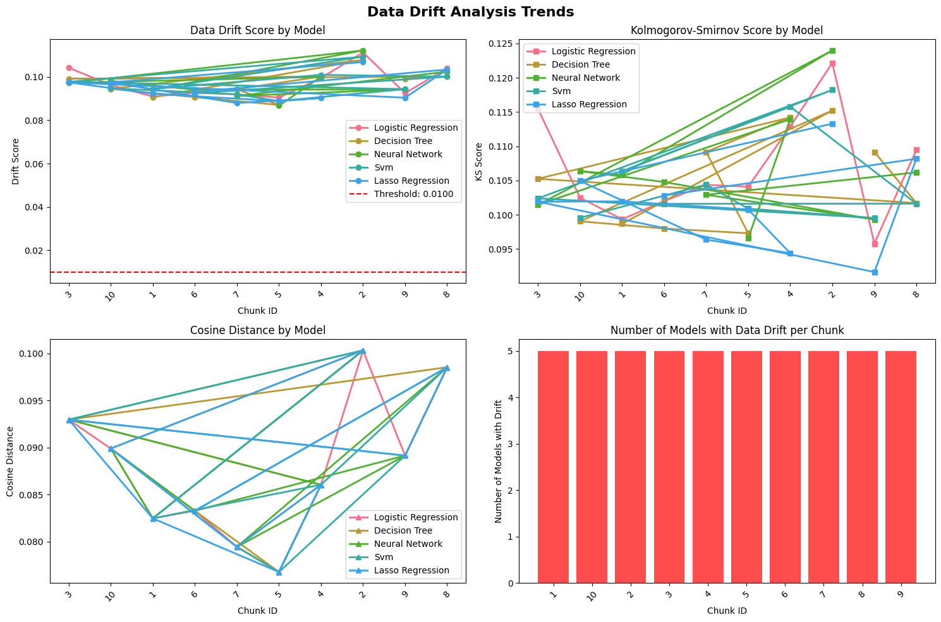

Analysis complete! Check the generated plots for insights.