BioAmp EXG Pill

Introduction
BioAmp EXG Pill is a small, powerful analog-front-end (AFE) biopotential signal-acquisition board that can be paired with any microcontroller unit (MCU) or single-board computer (SBC) with an analog-to-digital converter (ADC) such as Arduino UNO & Nano, Espressif ESP32, Adafruit QtPy, STM32 Blue Pill, BeagleBone Black, and Raspberry Pi Pico, to name just a few. It also works with any dedicated ADC, like the Texas Instruments ADS1115 and ADS131M0x, among others.
Specification | Details
Operating Voltage | 5V / 3.3 v with a voltage divider
Input Impedance | 10¹² Ω
Compatible Hardware | Any development board with an ADC (Arduino UNO & Nano, Espressif ESP32, Adafruit QtPy, STM32 Blue Pill, BeagleBone Black, Raspberry Pi Pico, etc.) or any standalone ADC of your choice
Biopotentials | EMG, ECG, EOG, EEG (configurable band-pass; by default configured for EEG & EOG)
No. of Channels | 1
Electrodes | 2 or 3 (by default configured for 3 electrodes)
Dimensions | 25.4 × 10 mm
Open Source | Hardware + Software

You can:
- Increase the gain of the instrumentation amplifier by using a 0603 resistor at R6. Decrease gain and configure the bandpass filter by using 0603 parts at R12 and C5. Band limiting is very useful for EOG and EEG recording. Also, the signal sometimes clips while recording ECG with electrodes very close to the heart. Creating a solder jumper for a band-pass filter helps with that. By default, BioAmp EXG Pill is configured to record EEG and EOG but you can bridge the pads (below bandpass) with solder to make it configurable for EMG and ECG.
- The normal method of operation for best-quality signal amplification is to use 3 electrodes by default but you can bridge the pads (below electrodes) to make it configurable for 2 electrodes. The 2-electrode mode is specifically included for projects like heart (ECG) patches for HRV. It’s only supposed to be used with a battery-operated setup and is quite prone to high interference noise due to a lack of proper reference on the body (This option is not recommended for most operations)

Note:
BioAmp EXG Pill is by default configured for recording EEG or EOG but if you want to record good quality ECG or EMG, then it is recommended to configure it by making a solder joint. Even without making the solder joint the BioAmp EXG Pill is capable of recording ECG or EMG as well but the signals would be more accurate if you configure it. (optional): Configure to operate at 3.3V It is by default compatible with 5V but you can make it compatible with 3.3V as well using a voltage divider.

Tests

EEG
- O1 – Reference
- O2 – Reference
- O1 – O2
- Fp1 – Reference
- Fp2 – Reference
- Fp1 – Fp2
- C3 – Reference
- C4 – Reference
- C3 – C4
- P3 – Reference
- P4 – Reference
- P3 – P4
- F3 – Reference
- F4 – Reference
- F3 – F4

ECG
- Lead I: RA – LA
- Lead II: RA – LL
- Lead III: LA – LL
- V1 – Reference
- V2 – Reference
- V3 – Reference
- V4 – Reference
- V5 – Reference
- V6 – Reference

EMG
- Biceps
- Triceps
- Forearm flexor
- Forearm extensor
- Masseter
- Deltoid
- Pectoralis major
- Trapezius
- Rectus abdominis
- Quadriceps
- Hamstring
- Gastrocnemius
- Tibialis anterior
For each muscle: two electrodes along the muscle fiber + reference electrode.

EOG
- Horizontal EOG: left canthus – right canthus
- Vertical EOG: above eye – below eye
- Left-eye EOG: electrodes around left eye
- Right-eye EOG: electrodes around right eye
- Diagonal EOG: upper-left – lower-right
- Blink recording: above/below eye

Additional characterization recordings
- EEG – different electrode separations
- ECG – different electrode separations
- EMG – different inter-electrode distances
- EOG – different distances from eye
- Same electrode placement – repeated recordings
- Resting baseline / no intentional movement
- Recording with intentional physiological movement
Recommended core dataset: If you don't want 50 configurations, use O1–O2, Fp1–Fp2, C3–C4, ECG Lead II, biceps EMG, forearm EMG, quadriceps EMG, horizontal EOG, vertical EOG, and blink EOG as the primary collection set.
Safety note: For human recordings, use a battery-powered/isolation-safe setup and appropriate biopotential electrodes; don't connect a person to mains-referenced equipment.

Bit Resolution
The ideal ADC voltage resolution is: LSB = V_reference / 2^N, where N is the ADC bit depth. These are ideal values; real usable resolution depends on noise and effective number of bits (ENOB).
Bits | 5 V range | 3.3 V range
4 | 312.500 mV | 206.250 mV
5 | 156.250 mV | 103.125 mV
6 | 78.125 mV | 51.563 mV
7 | 39.063 mV | 25.781 mV
8 | 19.531 mV | 12.891 mV
9 | 9.766 mV | 6.445 mV
10 | 4.883 mV | 3.223 mV
11 | 2.441 mV | 1.611 mV
12 | 1.221 mV | 805.664 µV
13 | 610.352 µV | 402.832 µV
14 | 305.176 µV | 201.416 µV
15 | 152.588 µV | 100.708 µV
16 | 76.294 µV | 50.354 µV
17 | 38.147 µV | 25.177 µV
18 | 19.073 µV | 12.589 µV
19 | 9.537 µV | 6.294 µV
20 | 4.768 µV | 3.147 µV
21 | 2.384 µV | 1.573 µV
22 | 1.192 µV | 786.850 nV
23 | 596.046 nV | 393.425 nV
24 | 298.023 nV | 196.695 nV
25 | 149.012 nV | 98.347 nV
26 | 74.506 nV | 49.174 nV
27 | 37.253 nV | 24.587 nV
28 | 18.626 nV | 12.293 nV
29 | 9.313 nV | 6.147 nV
30 | 4.657 nV | 3.073 nV
31 | 2.328 nV | 1.537 nV
32 | 1.164 nV | 0.768 nV

For example, a 24-bit ADC with a 3.3 V input range has an ideal step size of: 3.3 / 2^24 ≈ 0.197 µV
However, a nominal 24-bit ADC may have only 16–21 effective bits after noise, giving approximately 1.6–50 µV of practical resolution depending on the device and circuit design.
The nRF boards, such as the nRF52811, nRF52840, and nRF54L15, support ADC resolutions of up to 12 bits or more, depending on the specific model and configuration. For example, the nRF52811 can achieve effective resolution (ENOB) of around 10.5 bits with oversampling, while the nRF54L15 can read voltages with a resolution of 10 to 14 bits based on the settings used.
- ADS1115 — 16-bit → best inexpensive general-purpose choice.
- MCP3424 — 18-bit → excellent for slow, low-level sensor measurements.
- ADS1256 — 24-bit → much more serious precision data acquisition.
- NAU7802 — 24-bit → particularly good if your application involves a load cell/strain gauge.
- 10 bit 9.77mV (Arduino Uno R3)
- 12 bit 1.2mV (ESP32)
- 14 bit 0.061 mV (61 µV) (Arduino Uno R4)
- 16 bit (15 µV)
- 24 bit (244nV) (ADS129X series)

Planned Sections (TODO)
- Mains and Filtering
- FFT
- Multiple GPIO configuration
- Self hosted AP Dashboard
- Recordings of tests
- Post collection analysis
- interface with wristband
- FAQ

Links
- EEGAnalyzer - main project
- BioSignal-Recorder
- Upside Down Labs Instructables - list of projects to implement with a bioamp-microcontroller setup
- BackyardBrains Spike-Recorder
- YouTube video
- YouTube playlist
- BioAmp-EXG-Pill repo
- BioAmp-EXG-Pill docs
- BioAmp-EXG-Pill schematic.pdf
- BioAmp-EXG-Pill software

Additional References
- Brain-Computer-Interface
- OpenBCI-ESP32
- BioAmp EXG Pill v1.0 on Hackaday
- ESP32 + BioAmp EXG Pill (Crowd Supply update)
- MDPI Sensors paper
- Upside Down Labs research papers

Results
Recorded EEG sessions and reference notes, embedded here as-collected for now (raw results, pending write-up).
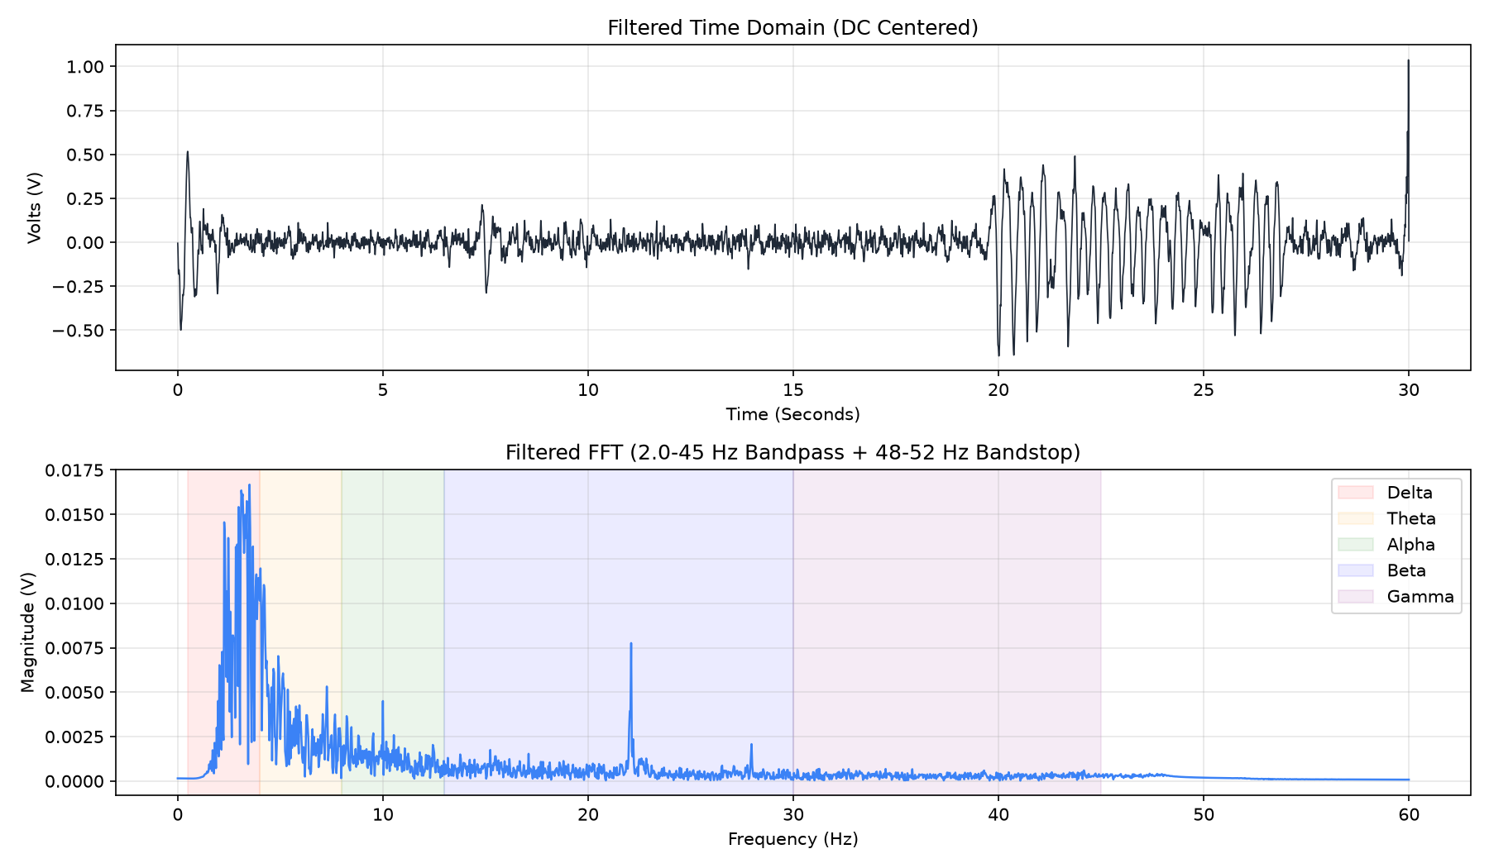
EEG session — 2026-09-08 15:47:51

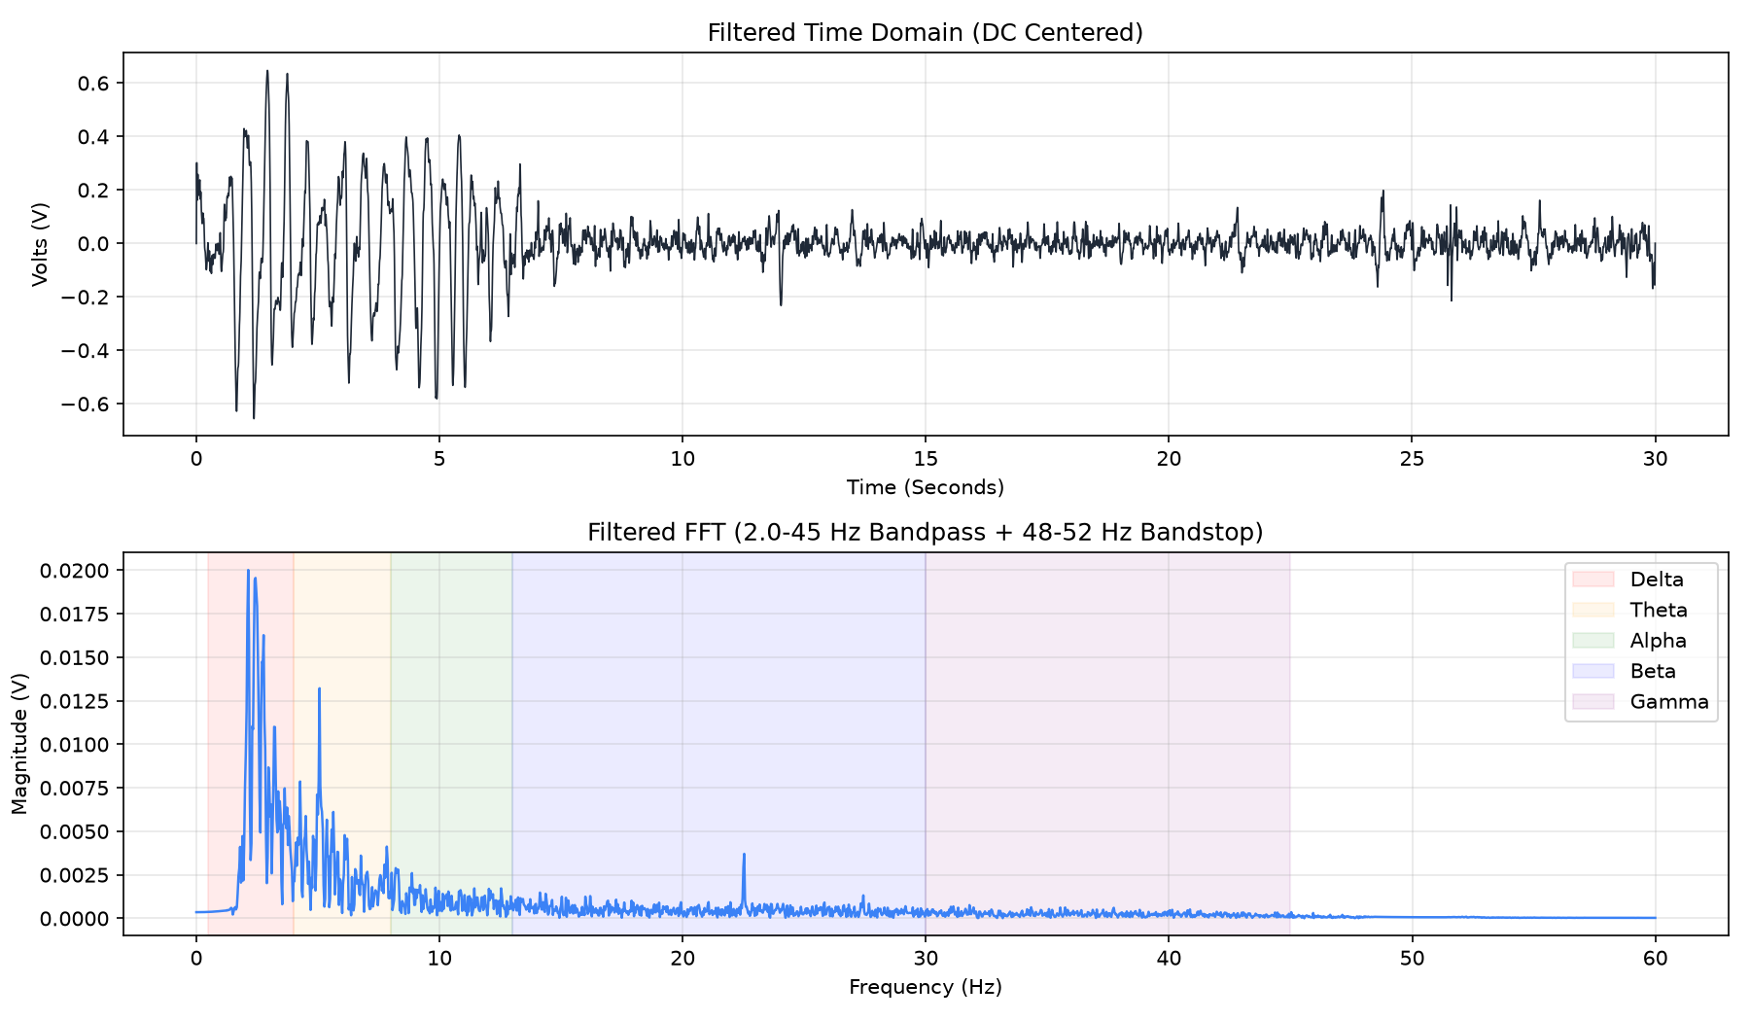
EEG session — 2026-09-08 16:27:31

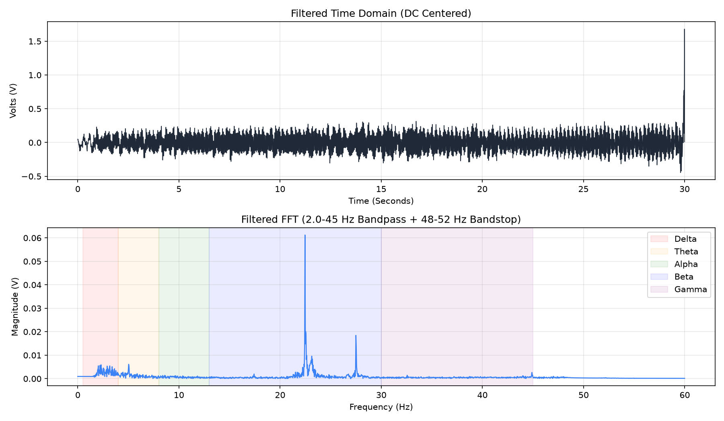
EEG session — 2026-09-08 16:29:21
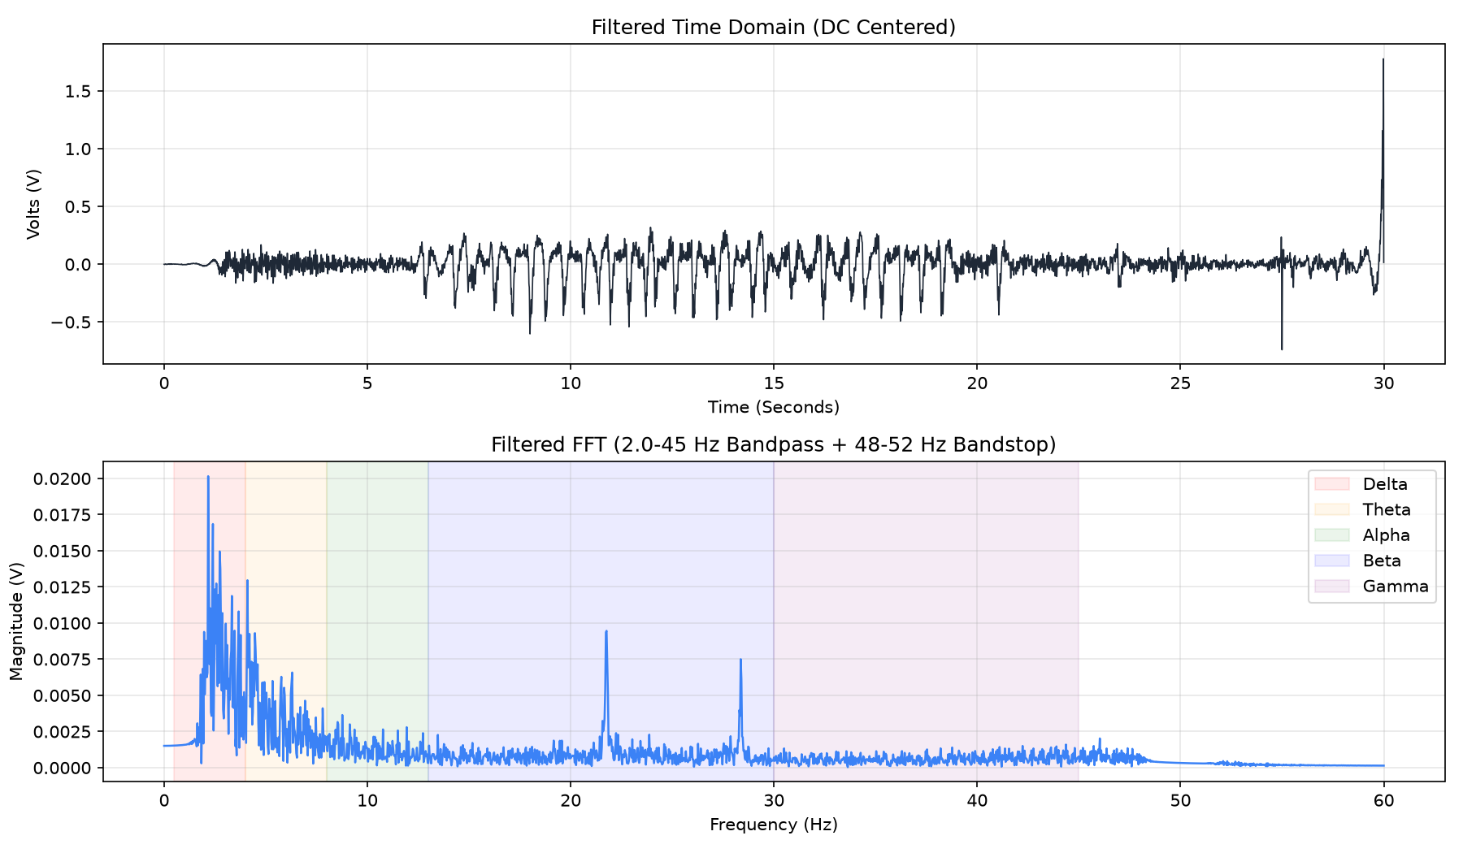
EEG session — 2026-09-08 18:04:37

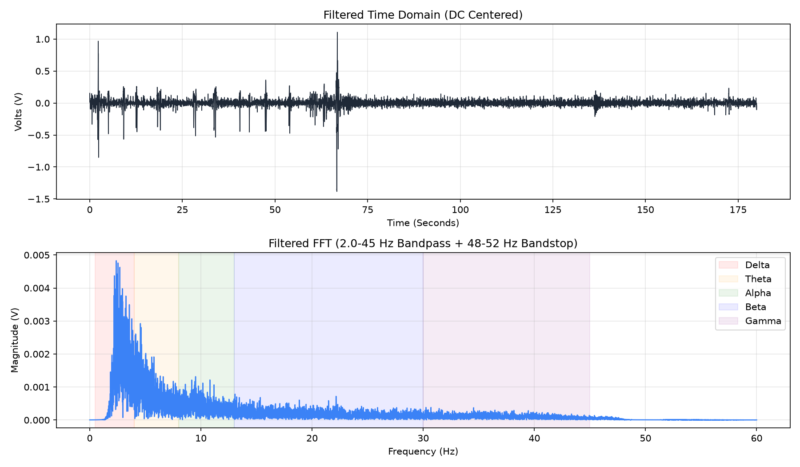
EEG session — 2026-09-08 19:32:52

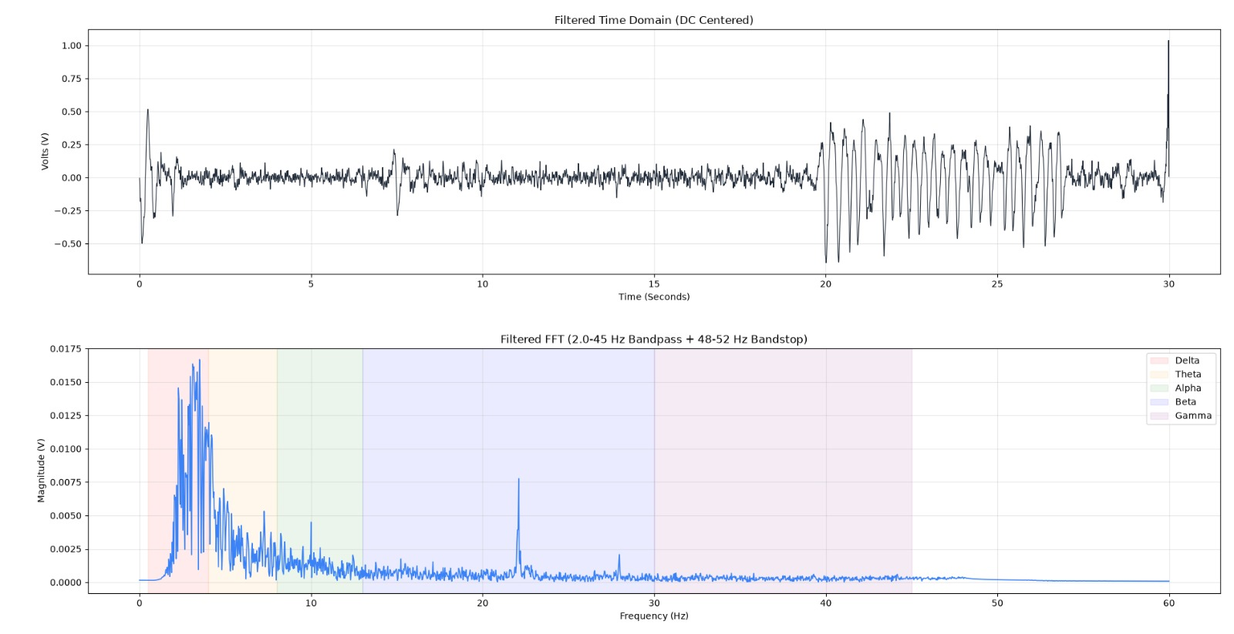
Session capture — shared 2026-09-08 15:49

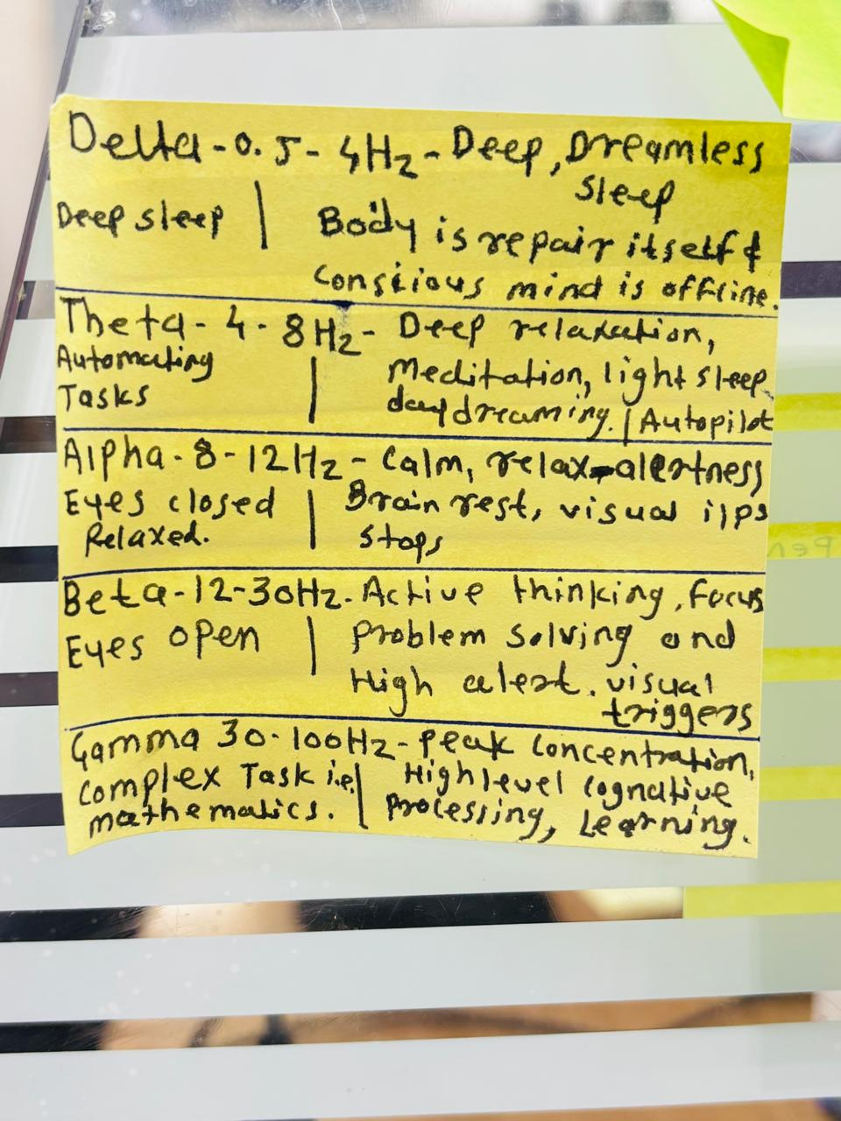
Reference notes: EEG frequency bands

Hands-on Experiments Possible with BioAmp EXG Pill

Documentation
- Controlling LEDs of Arduino Uno R4 With Your Mind (EEG)
- Control Dino Game Using Eye Blinks (EOG)
- Control the Flame of a Candle Using Your Focus (EEG)
- Playing Games With Your Mind Using Arduino Uno R4
- Control Car Racing Game Using Muscle Signals (EMG)
- Play Tug of War Game With Your Mind Using EEG
- Drowsiness Detector by Detecting EOG Signals Using BioAmp EXG Pill
- Eye Blink Detection by Recording EOG Using BioAmp EXG Pill

Hands-on Experiments Possible with DIY Neuroscience Kit - Pro

Documentation

- Control Dino Game Using Eye Blinks (EOG)
- Controlling Video Games Using Muscle Signals (EMG)
- Scroll YouTube Shorts Using 2 Channel EMG Signals
- The Ultimate "Servo Claw Game"
- Record, Visualize & Listen to Muscle Signals Using Muscle BioAmp Shield
- Controlling Prosthetic Hand (cardboard Version) Using EMG Sensor
- Control a Servo Claw Using Your Eye Blinks (EOG)

Hands-on Experiments Possible with Neuro Playground Lite (NPG Lite) Kit

Documentation
- Brain-Controlled Car: EEG + EMG Robotic Control
- Create a Hands-Free Computer Mouse With Your Eyes & Muscle
- CortEX: a Neurofeedback Meditation Journey
- Pop Bubbles With Your Mind (EEG) | Neuro PlayGround (NPG) Lite
- Muscle Melody: Play Music With Your Muscle Movements (EMG)
- EEG Controlled Drone
- Speak With Your Eyes: Build a Mind-to-Words (M2W) Interface
- Play Dino Game Using Eye Blinks
- Monitor ECG and Heart Rate on Your Mobile Phone
- Your First Steps to HCI/BCI Projects
- Monitor ECG Anywhere
- Control a Wheelchair With Your Eyes and Jaw
- Toggle any AC appliance ON or OFF through mind-generated EEG signals.
- Manage devices like TVs or fans using EEG combined with infrared signaling.
- Multi-channel EMG-based gesture recognition interface for AR, games, and prosthetics control.

