1. Download GIT
   1. Go to <https://git-scm.com/downloads>

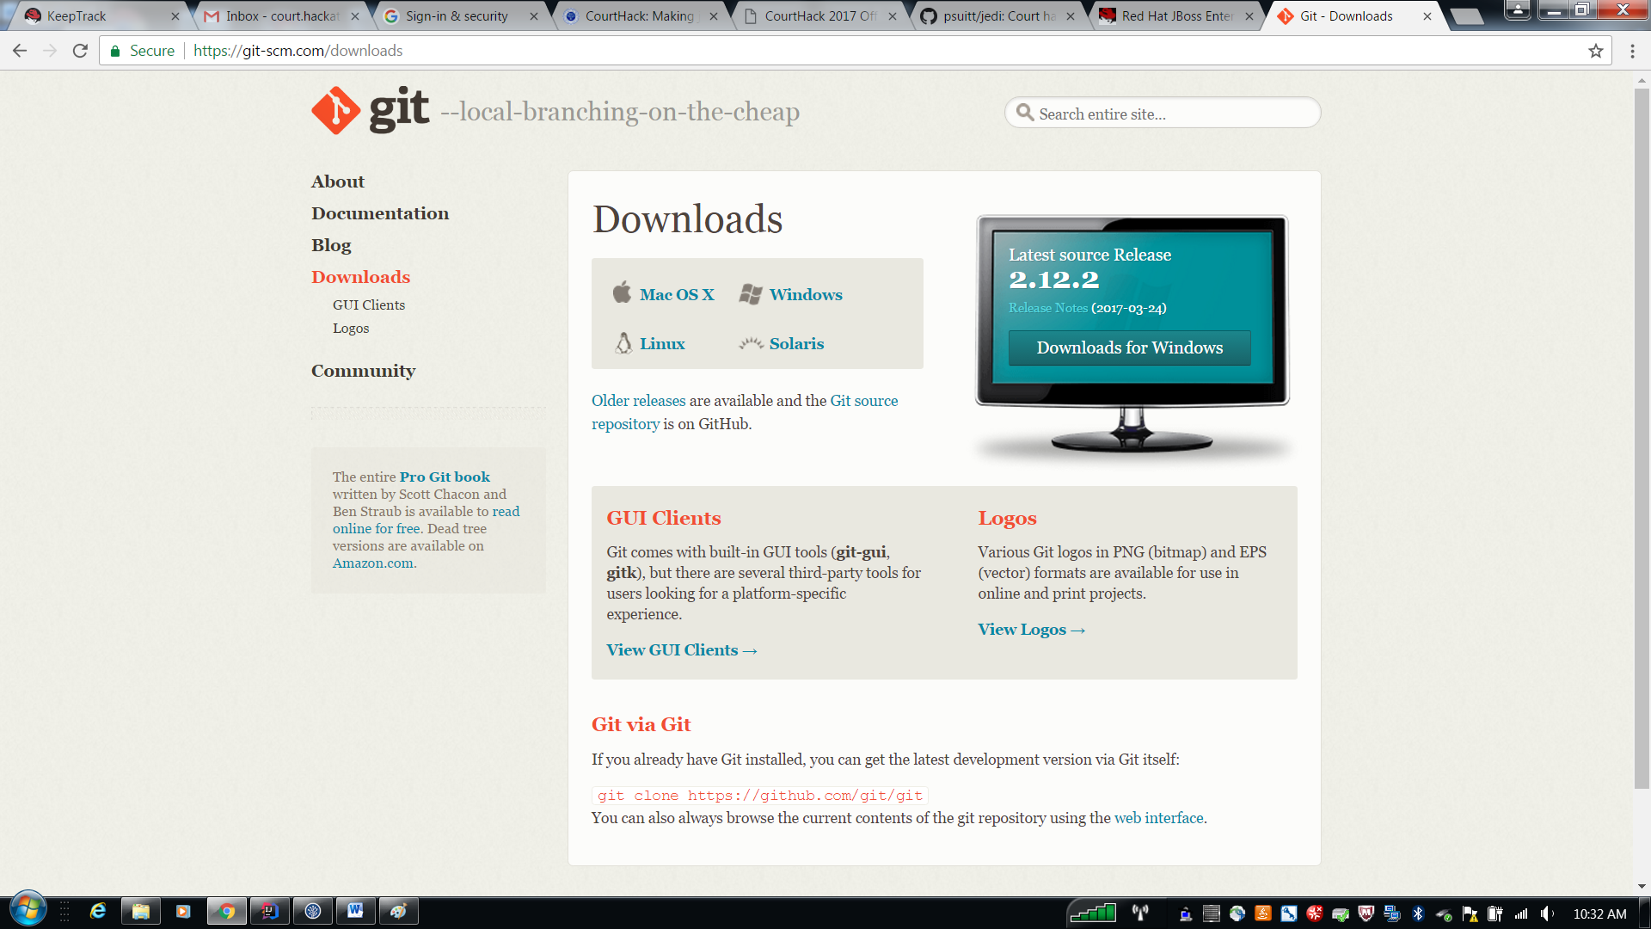

* 1. Check out the project from <https://github.com/psuitt/jedi>

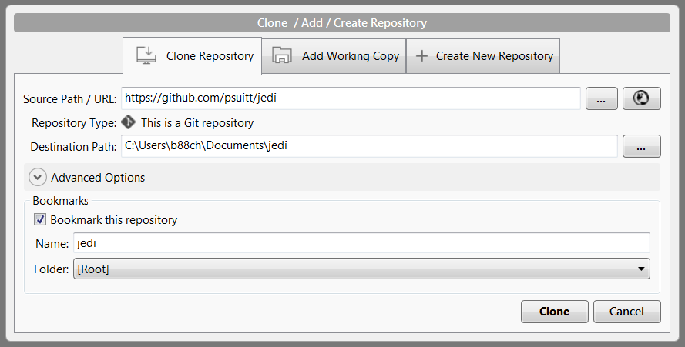

1. Get DB2 or your favorite Relational Database
   1. Run the Database scripts to create the Tables
   2. Manually insert an Admin account so you can login
2. Download JBOSS 7.x Server
   1. <https://developers.redhat.com/products/eap/download/>
   2. Configure your standalone.xml to connect to the database
      1. <JBOSS_HOME>/standalone/configuration/standalone.xml
      2. If you are using DB2, please insert the following and change the username and password

<datasources>

<datasource jta="false" jndi-name="java:/jdbc/jedi" pool-name="jediDS" enabled="true" use-ccm="false">

<connection-url>jdbc:as400://itest.judicial.local;cursor hold=false;libraries=jedi;naming=sql;translate binary=true;date format=usa</connection-url>

<driver-class>com.ibm.as400.access.AS400JDBCDriver</driver-class>

<driver>jt400</driver>

<pool>

<min-pool-size>1</min-pool-size>

<max-pool-size>40</max-pool-size>

<prefill>true</prefill>

</pool>

<security>

<user-name>username</user-name>

<password>password</password>

</security>

<validation>

<valid-connection-checker class-name="org.jboss.jca.adapters.jdbc.extensions.db2.DB2ValidConnectionChecker"/>

<validate-on-match>false</validate-on-match>

<background-validation>false</background-validation>

<exception-sorter class-name="org.jboss.jca.adapters.jdbc.extensions.db2.DB2ExceptionSorter"/>

</validation>

<statement>

<track-statements>true</track-statements>

<share-prepared-statements>false</share-prepared-statements>

</statement>

</datasource>

<drivers>

<driver name="jt400" module="com.ibm.as400">

<xa-datasource-class>com.ibm.as400.access.AS400JDBCDriver</xa-datasource-class>

</driver>

<driver name="as400" module="com.ibm.as400">

<datasource-class>com.ibm.as400.access.AS400JDBCConnectionPoolDataSource</datasource-class>

</driver>

</drivers>

</datasources>

1. Download your favorite IDE
   1. Import or install your plugin for JBOSS
   2. Import Existing Maven Project
      1. Navigate to the location of where you checked out the project

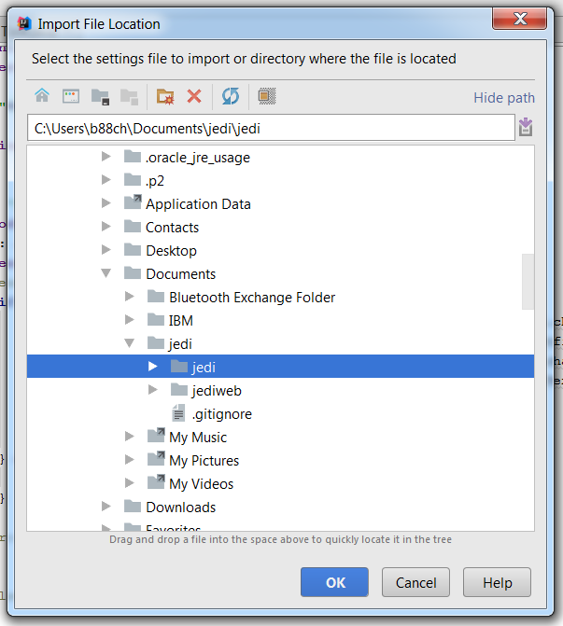

* 1. Add the project’s artifact to the Server

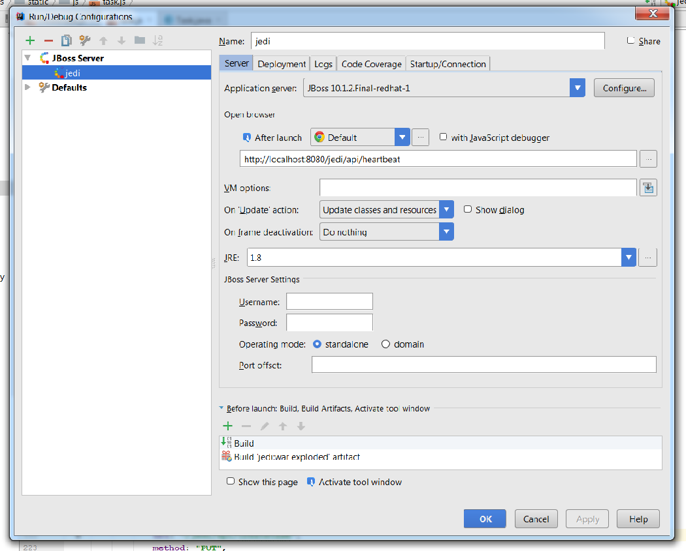

1. Run the application



1. Go to <http://localhost:8080/jedi/api/login>
   1. Login and have a blast.