Remote Vs On-site Job Posting

import pandas as pd  
import matplotlib.pyplot as plt  
import seaborn as sns  
  
# Load dataset (correct path syntax)  
data = pd.read_csv(r"C:\Users\pooja\Desktop\Repositories\ad688-employability-sp25A1-pooja\lightcast_job_postings.csv")  
  
# Drop any missing values just in case  
pdf = data[["NAICS2_NAME", "SALARY_FROM"]].dropna()  
  
# Plot  
plt.figure(figsize=(10, 6))  
sns.boxplot(data=pdf, x="NAICS2_NAME", y="SALARY_FROM", color="#636EFA")  
  
# Add labels and title  
plt.title("Salary Distribution by Industry", fontsize=16, fontname="Arial")  
plt.xlabel("Industry", fontsize=12)  
plt.ylabel("Starting Salary", fontsize=12)  
plt.xticks(rotation=45)  
plt.tight_layout()  
  
# Show plot  
plt.show()

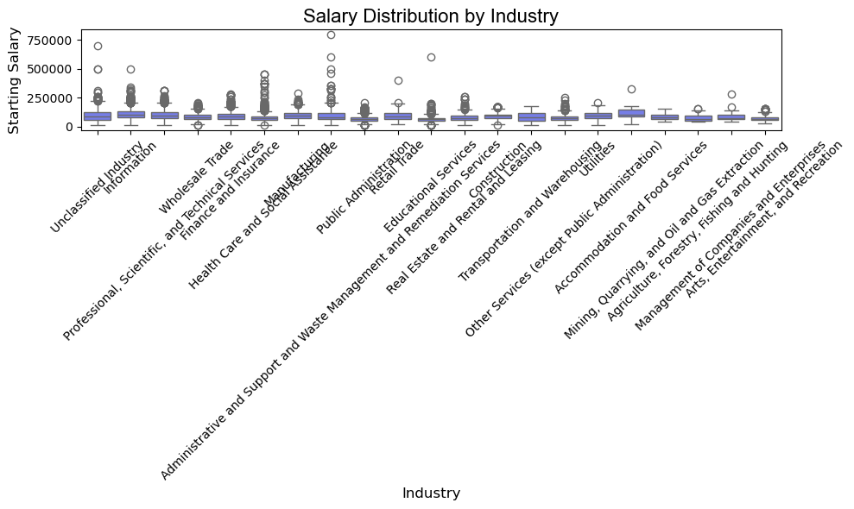

import pandas as pd  
import matplotlib.pyplot as plt  
import seaborn as sns  
  
# Load dataset (correct path syntax)  
data = pd.read_csv(r"C:\Users\pooja\Desktop\Repositories\ad688-employability-sp25A1-pooja\lightcast_job_postings.csv")  
  
# Drop missing values  
pdf = data[["NAICS2_NAME", "SALARY_FROM"]].dropna()  
  
# Group by industry and calculate average salary  
avg_salary = pdf.groupby("NAICS2_NAME", as_index=False)["SALARY_FROM"].mean()  
  
# Sort industries by average salary (optional)  
avg_salary = avg_salary.sort_values(by="SALARY_FROM", ascending=False)  
  
# Plot  
plt.figure(figsize=(12, 6))  
sns.barplot(data=avg_salary, x="NAICS2_NAME", y="SALARY_FROM", color="#636EFA")  
  
# Customize  
plt.title("Average Starting Salary by Industry", fontsize=16, fontname="Arial")  
plt.xlabel("Industry", fontsize=12)  
plt.ylabel("Average Starting Salary", fontsize=12)  
plt.xticks(rotation=45, ha='right')  
plt.tight_layout()  
  
# Show plot  
plt.show()

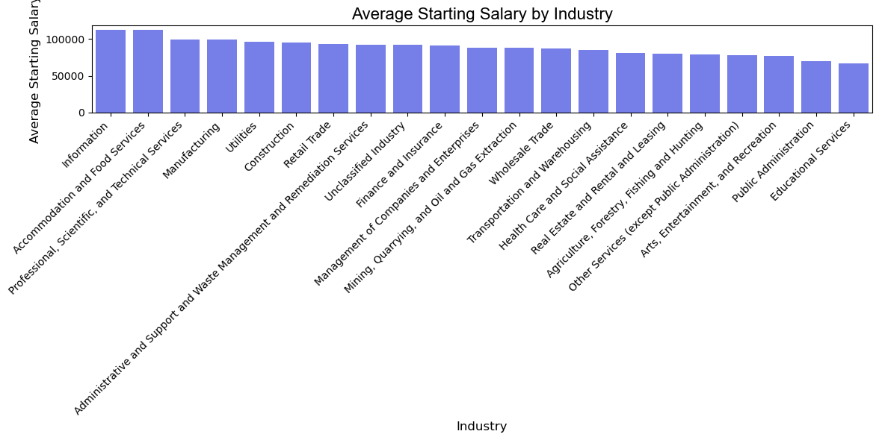

import pandas as pd  
import matplotlib.pyplot as plt  
  
# Step 1: Load the dataset (update path as needed)  
df = pd.read_csv(r"C:\Users\pooja\Desktop\Repositories\ad688-employability-sp25A1-pooja\lightcast_job_postings.csv")  
  
# Step 2: Select and clean the relevant column  
pdf = df[["REMOTE_TYPE_NAME"]].dropna()  
  
# Step 3: Count occurrences of each remote type  
remote_type_counts = pdf["REMOTE_TYPE_NAME"].value_counts().reset_index()  
remote_type_counts.columns = ["REMOTE_TYPE_NAME", "Job Count"]  
  
# Step 4: Create pie chart using matplotlib  
plt.figure(figsize=(8, 8))  
plt.pie(  
 remote_type_counts["Job Count"],  
 labels=remote_type_counts["REMOTE_TYPE_NAME"],  
 autopct='%1.1f%%',  
 startangle=140,  
 colors=plt.cm.Set2.colors # Optional color palette  
)  
  
# Step 5: Add title and format  
plt.title("Remote vs On-Site Job Postings", fontsize=16, fontname="Arial")  
plt.axis("equal") # Ensures the pie chart is circular  
  
# Step 6: Show plot  
plt.show()

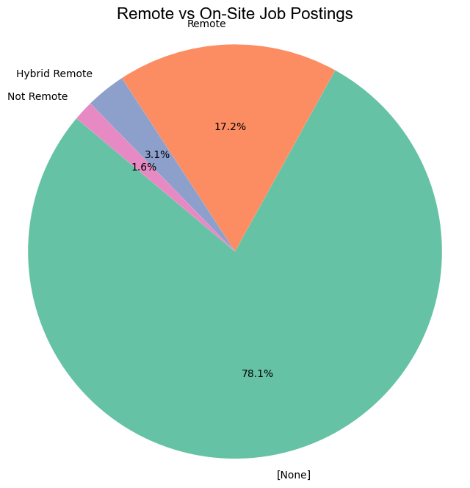

df.columns

Index(['ID', 'LAST_UPDATED_DATE', 'LAST_UPDATED_TIMESTAMP', 'DUPLICATES',  
 'POSTED', 'EXPIRED', 'DURATION', 'SOURCE_TYPES', 'SOURCES', 'URL',  
 ...  
 'NAICS_2022_2', 'NAICS_2022_2_NAME', 'NAICS_2022_3',  
 'NAICS_2022_3_NAME', 'NAICS_2022_4', 'NAICS_2022_4_NAME',  
 'NAICS_2022_5', 'NAICS_2022_5_NAME', 'NAICS_2022_6',  
 'NAICS_2022_6_NAME'],  
 dtype='object', length=131)

column_list = df.columns.tolist()  
print(column_list)

['ID', 'LAST_UPDATED_DATE', 'LAST_UPDATED_TIMESTAMP', 'DUPLICATES', 'POSTED', 'EXPIRED', 'DURATION', 'SOURCE_TYPES', 'SOURCES', 'URL', 'ACTIVE_URLS', 'ACTIVE_SOURCES_INFO', 'TITLE_RAW', 'BODY', 'MODELED_EXPIRED', 'MODELED_DURATION', 'COMPANY', 'COMPANY_NAME', 'COMPANY_RAW', 'COMPANY_IS_STAFFING', 'EDUCATION_LEVELS', 'EDUCATION_LEVELS_NAME', 'MIN_EDULEVELS', 'MIN_EDULEVELS_NAME', 'MAX_EDULEVELS', 'MAX_EDULEVELS_NAME', 'EMPLOYMENT_TYPE', 'EMPLOYMENT_TYPE_NAME', 'MIN_YEARS_EXPERIENCE', 'MAX_YEARS_EXPERIENCE', 'IS_INTERNSHIP', 'SALARY', 'REMOTE_TYPE', 'REMOTE_TYPE_NAME', 'ORIGINAL_PAY_PERIOD', 'SALARY_TO', 'SALARY_FROM', 'LOCATION', 'CITY', 'CITY_NAME', 'COUNTY', 'COUNTY_NAME', 'MSA', 'MSA_NAME', 'STATE', 'STATE_NAME', 'COUNTY_OUTGOING', 'COUNTY_NAME_OUTGOING', 'COUNTY_INCOMING', 'COUNTY_NAME_INCOMING', 'MSA_OUTGOING', 'MSA_NAME_OUTGOING', 'MSA_INCOMING', 'MSA_NAME_INCOMING', 'NAICS2', 'NAICS2_NAME', 'NAICS3', 'NAICS3_NAME', 'NAICS4', 'NAICS4_NAME', 'NAICS5', 'NAICS5_NAME', 'NAICS6', 'NAICS6_NAME', 'TITLE', 'TITLE_NAME', 'TITLE_CLEAN', 'SKILLS', 'SKILLS_NAME', 'SPECIALIZED_SKILLS', 'SPECIALIZED_SKILLS_NAME', 'CERTIFICATIONS', 'CERTIFICATIONS_NAME', 'COMMON_SKILLS', 'COMMON_SKILLS_NAME', 'SOFTWARE_SKILLS', 'SOFTWARE_SKILLS_NAME', 'ONET', 'ONET_NAME', 'ONET_2019', 'ONET_2019_NAME', 'CIP6', 'CIP6_NAME', 'CIP4', 'CIP4_NAME', 'CIP2', 'CIP2_NAME', 'SOC_2021_2', 'SOC_2021_2_NAME', 'SOC_2021_3', 'SOC_2021_3_NAME', 'SOC_2021_4', 'SOC_2021_4_NAME', 'SOC_2021_5', 'SOC_2021_5_NAME', 'LOT_CAREER_AREA', 'LOT_CAREER_AREA_NAME', 'LOT_OCCUPATION', 'LOT_OCCUPATION_NAME', 'LOT_SPECIALIZED_OCCUPATION', 'LOT_SPECIALIZED_OCCUPATION_NAME', 'LOT_OCCUPATION_GROUP', 'LOT_OCCUPATION_GROUP_NAME', 'LOT_V6_SPECIALIZED_OCCUPATION', 'LOT_V6_SPECIALIZED_OCCUPATION_NAME', 'LOT_V6_OCCUPATION', 'LOT_V6_OCCUPATION_NAME', 'LOT_V6_OCCUPATION_GROUP', 'LOT_V6_OCCUPATION_GROUP_NAME', 'LOT_V6_CAREER_AREA', 'LOT_V6_CAREER_AREA_NAME', 'SOC_2', 'SOC_2_NAME', 'SOC_3', 'SOC_3_NAME', 'SOC_4', 'SOC_4_NAME', 'SOC_5', 'SOC_5_NAME', 'LIGHTCAST_SECTORS', 'LIGHTCAST_SECTORS_NAME', 'NAICS_2022_2', 'NAICS_2022_2_NAME', 'NAICS_2022_3', 'NAICS_2022_3_NAME', 'NAICS_2022_4', 'NAICS_2022_4_NAME', 'NAICS_2022_5', 'NAICS_2022_5_NAME', 'NAICS_2022_6', 'NAICS_2022_6_NAME']

# Bar Plot – Average Salary: AI vs. Non-AI Career

import pandas as pd  
import matplotlib.pyplot as plt  
import seaborn as sns  
  
df = pd.read_csv(r"C:\Users\pooja\Desktop\Repositories\ad688-employability-sp25A1-pooja\lightcast_job_postings.csv")  
  
# Filter AI-related jobs  
df['IS_AI_JOB'] = df['TITLE_NAME'].str.contains("AI|Artificial Intelligence|Machine Learning|Data Scientist", case=False, na=False)  
  
# Group by AI vs. Non-AI and calculate average salary  
salary_compare = df[df["SALARY_FROM"].notna()].groupby("IS_AI_JOB")["SALARY_FROM"].mean().reset_index()  
salary_compare["Category"] = salary_compare["IS_AI_JOB"].map({True: "AI Careers", False: "Non-AI Careers"})  
  
# Plot  
plt.figure(figsize=(8, 6))  
barplot = sns.barplot(data=salary_compare, x="Category", y="SALARY_FROM", palette=["#cdb4db", "#fcbf49"])  
  
# Add numbers on top of bars  
for i, row in salary_compare.iterrows():  
 barplot.text(  
 i,   
 row["SALARY_FROM"] + 1000, # Slightly above the bar  
 f"${row['SALARY_FROM']:.0f}",   
 ha='center',   
 va='bottom',   
 fontsize=12,   
 fontweight='bold'  
 )  
  
# Customize plot  
plt.title("Average Salary: AI vs. Non-AI Careers", fontsize=16)  
plt.ylabel("Average Salary")  
plt.xlabel("")  
plt.tight_layout()  
plt.show()

C:\Users\pooja\AppData\Local\Temp\ipykernel_61152\3999385079.py:16: FutureWarning:   
  
Passing `palette` without assigning `hue` is deprecated and will be removed in v0.14.0. Assign the `x` variable to `hue` and set `legend=False` for the same effect.  
  
 barplot = sns.barplot(data=salary_compare, x="Category", y="SALARY_FROM", palette=["#cdb4db", "#fcbf49"])

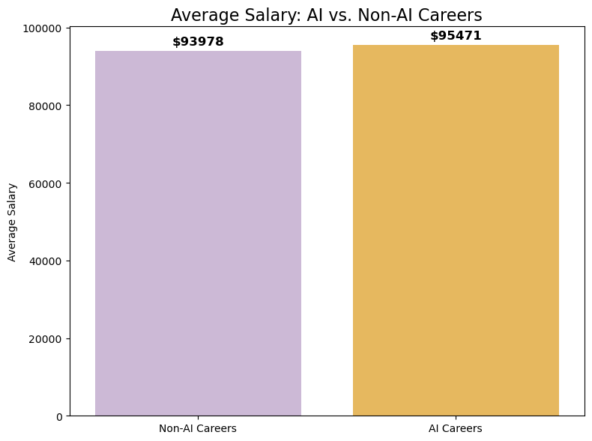

# Bar Plot – Top Regions by AI Salary

# Filter AI jobs and drop missing salary/state  
ai_jobs = df[df["IS_AI_JOB"] & df["SALARY_FROM"].notna() & df["STATE_NAME"].notna()]  
  
# Group and get top 10 states by average salary  
top_states = ai_jobs.groupby("STATE_NAME")["SALARY_FROM"].mean().sort_values(ascending=False).head(10).reset_index()  
  
# Plot  
sns.barplot(data=top_states, x="SALARY_FROM", y="STATE_NAME", palette="viridis")  
plt.title("Top 10 States by Average AI Job Salary")  
plt.xlabel("Average Salary")  
plt.ylabel("State")  
plt.tight_layout()  
plt.show()

C:\Users\pooja\AppData\Local\Temp\ipykernel_61152\1523654589.py:8: FutureWarning:   
  
Passing `palette` without assigning `hue` is deprecated and will be removed in v0.14.0. Assign the `y` variable to `hue` and set `legend=False` for the same effect.  
  
 sns.barplot(data=top_states, x="SALARY_FROM", y="STATE_NAME", palette="viridis")

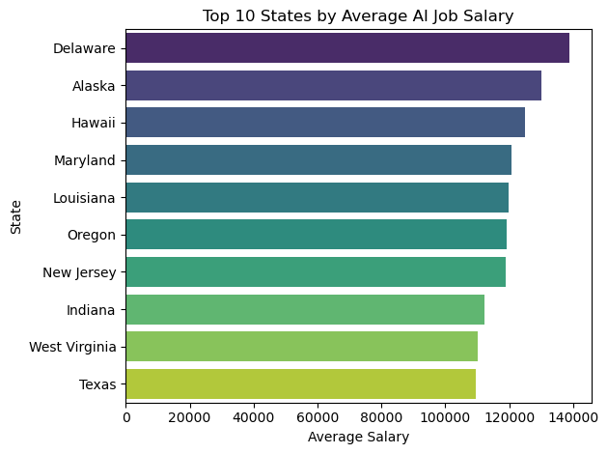

# Box Plot – Salary Distribution by Region (AI vs. Non-AI)

df_filtered = df[df["SALARY_FROM"].notna() & df["STATE_NAME"].notna()]  
df_filtered["Job Type"] = df_filtered["IS_AI_JOB"].map({True: "AI", False: "Non-AI"})  
  
plt.figure(figsize=(12, 6))  
sns.boxplot(data=df_filtered, x="STATE_NAME", y="SALARY_FROM", hue="Job Type")  
plt.xticks(rotation=45)  
plt.title("Salary Distribution by State (AI vs. Non-AI Careers)")  
plt.tight_layout()  
plt.show()

C:\Users\pooja\AppData\Local\Temp\ipykernel_61152\4042802457.py:2: SettingWithCopyWarning:   
A value is trying to be set on a copy of a slice from a DataFrame.  
Try using .loc[row_indexer,col_indexer] = value instead  
  
See the caveats in the documentation: https://pandas.pydata.org/pandas-docs/stable/user_guide/indexing.html#returning-a-view-versus-a-copy  
 df_filtered["Job Type"] = df_filtered["IS_AI_JOB"].map({True: "AI", False: "Non-AI"})

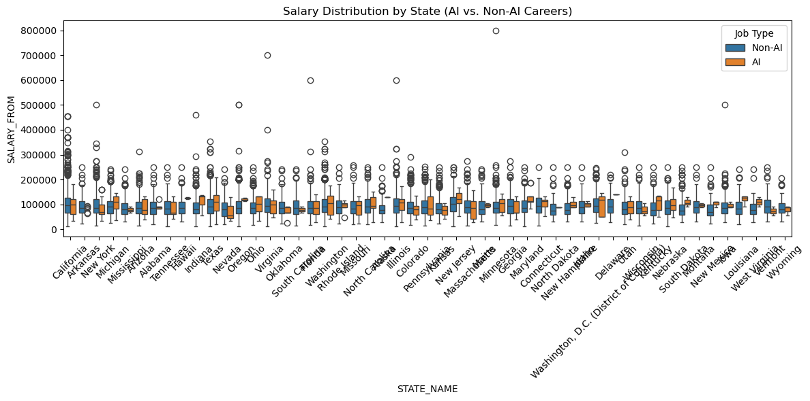

# Histogram – Salary Range Distribution (AI vs. Non-AI)

plt.figure(figsize=(10, 6))  
sns.histplot(data=df_filtered, x="SALARY_FROM", hue="Job Type", bins=30, kde=True, element="step")  
plt.title("Salary Distribution: AI vs. Non-AI Careers")  
plt.xlabel("Starting Salary")  
plt.tight_layout()  
plt.show()

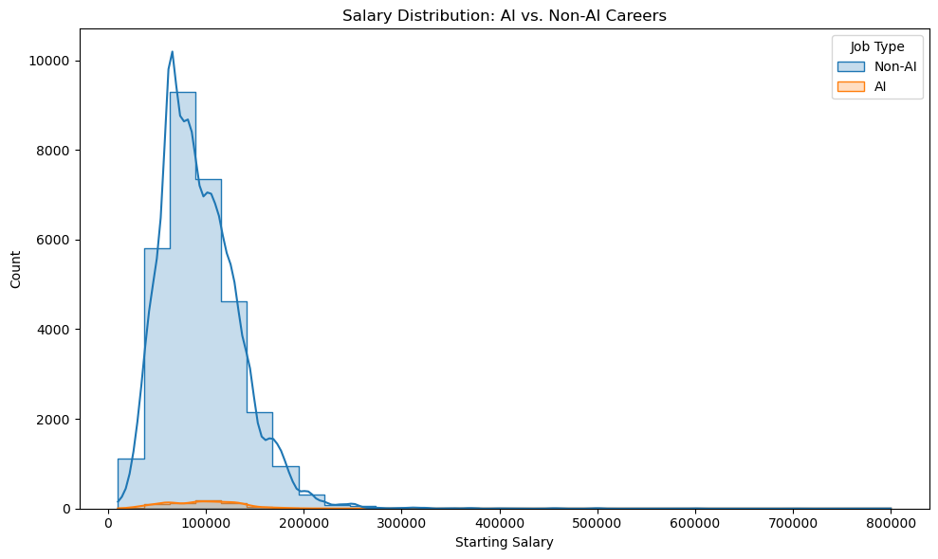

# Pie Chart – Proportion of AI vs. Non-AI Jobs in Dataset

job_counts = df["IS_AI_JOB"].value_counts().reset_index()  
job_counts.columns = ["IS_AI_JOB", "Count"]  
job_counts["Category"] = job_counts["IS_AI_JOB"].map({True: "AI Careers", False: "Non-AI Careers"})  
  
plt.pie(job_counts["Count"], labels=job_counts["Category"], autopct='%1.1f%%', startangle=140, colors=plt.cm.Set2.colors)  
plt.axis("equal")  
plt.title("AI vs. Non-AI Job Proportion")  
plt.show()

