Technical Design: Databricks DAG-Based Orchestration with Airflow
Version 1.0 | 5 November 2026 | Status: implemented and tested
Item | Value
Pipeline | medallion_pipeline (Airflow DAG)
Orchestrator | Apache Airflow 2.10.5 (local Docker)
Execution platform | Azure Databricks, serverless compute, Unity Catalog
Target | dev.airflow_medallion (7 Delta tables)
Schedule | Daily at 06:00 IST

1. Summary
We built a working Bronze → Silver → Gold pipeline in which an Airflow DAG orchestrates Databricks. It runs every day at 06:00 IST, and a full run takes about 4–5 minutes. Every test run between 4 and 5 Nov 2026 succeeded.
- Airflow owns the order of steps, the schedule, retries and timeouts. It never processes data.
- Databricks runs every step as a notebook on serverless compute. It reads samples.tpch and writes 7 Delta tables to dev.airflow_medallion.
- Data quality is a gate. If the Silver checks fail, Gold does not run, so bad data never reaches the business tables.
- Parallel runs: the 3 Bronze runs, and the 2 Gold runs, run at the same time in Databricks.

2. Architecture
Airflow and Databricks talk only through the Databricks Jobs REST API. Airflow sends a run request and then polls for its status. All compute and storage stay in Databricks.
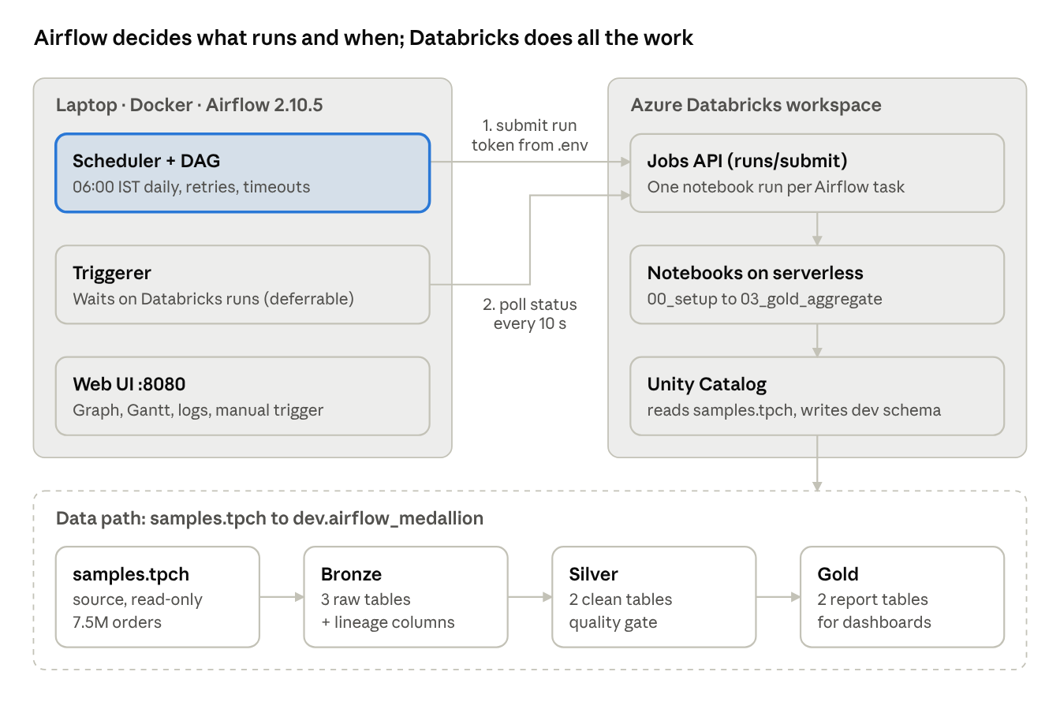
Figure 1. System architecture: Airflow, Databricks and the data path
Airflow holds no data. It holds the token, the task order and the run history. Databricks reads the source samples.tpch and writes all 7 tables to dev.airflow_medallion.

3. Pipeline design
The DAG medallion_pipeline has 9 tasks in 3 task groups. Each Databricks task runs one notebook. The same notebook is reused with different parameters where the logic is shared.
Step | Airflow task(s) | Notebook | Output tables | Logic
Setup | create_schema | 00_setup | schema dev.airflow_medallion | CREATE SCHEMA IF NOT EXISTS; runs once, before the parallel Bronze tasks
Bronze | bronze.orders, bronze.customers, bronze.nation (parallel) | 01_bronze_ingest (source parameter) | bronze_orders, bronze_customers, bronze_nation | Full copy of samples.tpch plus lineage columns; fails if a table is empty
Silver | silver.transform | 02_silver_transform | silver_customers, silver_orders | Renames and types columns, joins customers to nation, maps status codes, removes duplicates, then runs the quality checks
Gold | gold.revenue_by_country, gold.top_customers (parallel) | 03_gold_aggregate (report parameter) | gold_revenue_by_country, gold_top_customers | Revenue, orders and average order value by country and year; top 100 customers by lifetime revenue

Data-quality gate (Silver)
The Silver notebook raises an error, which fails the Airflow task, if any check fails:
- silver_orders is empty
- any order_id appears more than once
- any customer has no country
- more than 1% of Bronze orders were dropped
A failed check stops the pipeline before Gold, so the business tables always hold the last good data.
The Airflow Graph view of the run on 5 Nov 2026 shows all 9 tasks green, with Bronze and Gold fanning out in parallel:
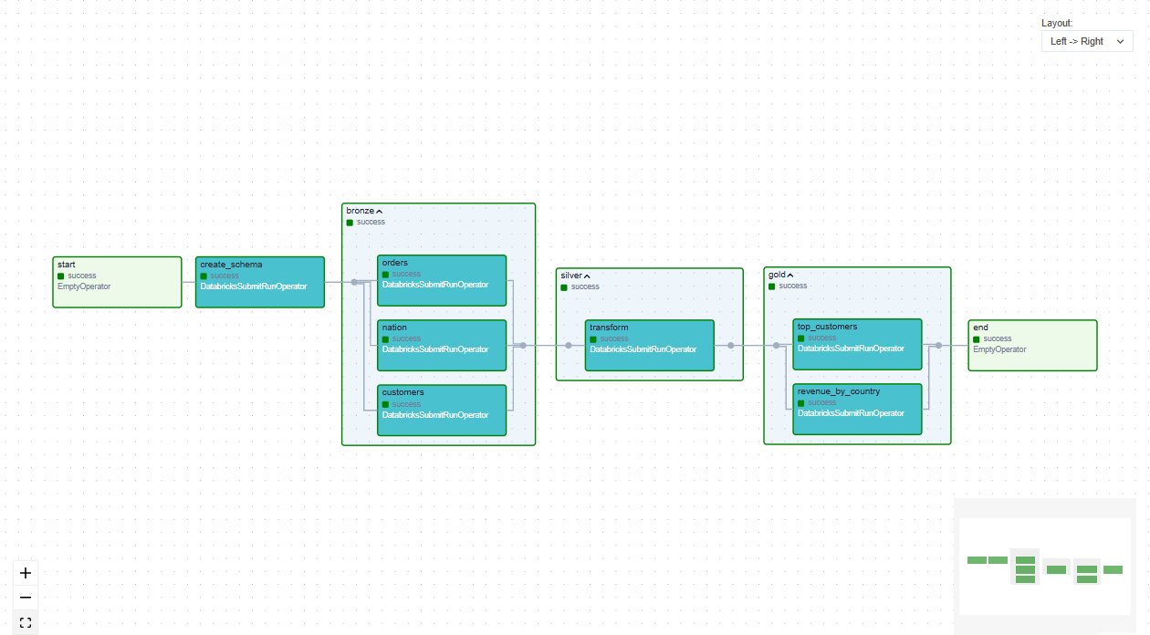
Figure 2. Airflow Graph view of medallion_pipeline (run of 5 Nov 2026)

4. Orchestration features
All orchestration behaviour lives in one DAG file, dags/medallion_pipeline_dag.py, as code.
Feature | Setting | Effect
Dependencies | start >> create_schema >> bronze >> silver >> gold >> end | A step starts only after the steps before it succeed. If a step fails, everything after it is skipped.
Schedule | 0 6 * * *, Asia/Kolkata | Runs daily at 06:00 IST
Catch-up | catchup=False | After downtime, only the latest missed run is executed
Concurrency | max_active_runs=1 | Two pipeline runs never overlap
Task retries | 3, exponential backoff (1, 2, 4 min, max 10) | Recovers from temporary failures without manual action
API retries | databricks_retry_limit=5, 10 s apart | Recovers from Databricks API errors and rate limits
Timeouts | 30 min per task (Airflow and Databricks), 1 h per run | A hung step cannot block the pipeline
Parallel Databricks runs | deferrable=True | Each task submits its run and hands the waiting to Airflow's triggerer, so tasks in a group run at the same time
Parameters | catalog, schema, run_date, airflow_run_id | Each notebook knows which run it belongs to
Lineage | _run_date, _airflow_run_id, _ingested_at | Every row can be traced back to the Airflow run that loaded it
Compute | Serverless by default; cluster if CLUSTER_ID is set | No cluster to manage

One Python function, databricks_notebook(), builds all 7 Databricks tasks. Each task is a DatabricksSubmitRunOperator that submits a one-time notebook run through the Databricks Jobs API (runs/submit).

5. Components and configuration
The project has 5 working parts. No secret is stored in code.
Component | Technology | Role
dags/medallion_pipeline_dag.py | Airflow 2.10.5, Databricks provider | Defines the tasks, their order, the schedule, retries and timeouts
notebooks/00–03_*.py | Databricks notebooks (PySpark + SQL) | Do all the data processing; imported to /Workspace/Users/jayashree7762@gmail.com/Airflow
docker-compose.yml | Docker, airflow standalone | Runs the Airflow webserver, scheduler and triggerer in one container; UI on port 8080
.env | Environment file (git-ignored) | Holds the Databricks host and token, notebook folder, catalog, schema and Airflow login
Databricks workspace | Azure Databricks, Unity Catalog, serverless | Runs the notebooks, stores the Delta tables

Configuration (.env)
Variable | Value | Purpose
DATABRICKS_HOST | https://adb-7405611928404553.13.azuredatabricks.net | Workspace URL
DATABRICKS_TOKEN | (secret) | Personal access token Airflow uses to call Databricks
NOTEBOOK_DIR | /Workspace/Users/jayashree7762@gmail.com/Airflow | Where the notebooks live
CLUSTER_ID | empty | Empty = serverless compute
CATALOG / SCHEMA | dev / airflow_medallion | Where the tables are written

Security
- Airflow builds its databricks_default connection from .env when it starts, so the token never appears in the DAG code.
- .env is listed in .gitignore, so it is never committed.
- The token's user needs only USE CATALOG and CREATE SCHEMA on dev, plus read access to samples.

6. Test runs and evidence
Every full pipeline run succeeded, and moving to deferrable tasks cut the run time from about 8.5 to about 4.5 minutes. The times below come from the Databricks Jobs API run history.
Date (IST) | Run | Result | Duration | Note
5 Nov, 12:33–12:37 | scheduled__2026-11-04 | Success, 9/9 tasks | 4 min 23 s | Catch-up of the 06:00 run after Docker restarted
5 Nov, 12:11–12:13 | scheduled__2026-11-04 | Interrupted after 2 tasks | — | Docker Desktop stopped; led to the restart policy and unpaused-DAG fixes
5 Nov, 00:10–00:14 | scheduled__2026-11-03 | Success, 9/9 tasks | ~4 min | Final design: single container, deferrable tasks
4 Nov, 23:45–23:49 | scheduled__2026-11-03 | Success, 9/9 tasks | 4 min 17 s | Parallel test (later simplified)
4 Nov, 21:46–21:52 | manual__2026-11-04 | Success, all tasks | ~6 min | First version; tasks ran one after another
4 Nov, 21:37–21:46 | scheduled__2026-11-03 | Success, all tasks | ~8.5 min | First version; tasks ran one after another

Tables produced
Row counts in dev.airflow_medallion after the 5 Nov run:
Table | Rows
bronze_orders | 7,500,000
bronze_customers | 750,000
bronze_nation | 25
silver_orders | 7,500,000
silver_customers | 750,000
gold_revenue_by_country | 175 (25 countries × 7 years)
gold_top_customers | 100

No order was dropped between Bronze and Silver, and all quality checks passed. Every Bronze row carries _airflow_run_id = scheduled__2026-11-04T00:30:00+00:00, linking it to the Airflow run that loaded it.

Gold sample: top 5 countries by revenue (all years)
Country | Revenue (USD bn) | Orders
Iraq | 45.97 | 304,044
Indonesia | 45.92 | 304,068
Germany | 45.73 | 302,582
Iran | 45.71 | 302,722
France | 45.71 | 301,561

Screenshots
Airflow UI, run of 5 Nov 2026. The DAG list shows the DAG active, on its 06:00 schedule, with the last run green:
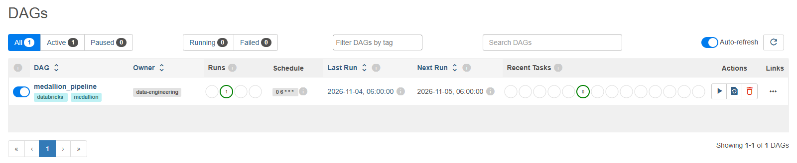
Figure 3. Airflow DAG list
The Gantt chart proves the parallel design: the 3 Bronze bars overlap, and so do the 2 Gold bars. Silver starts only after the last Bronze run ends.
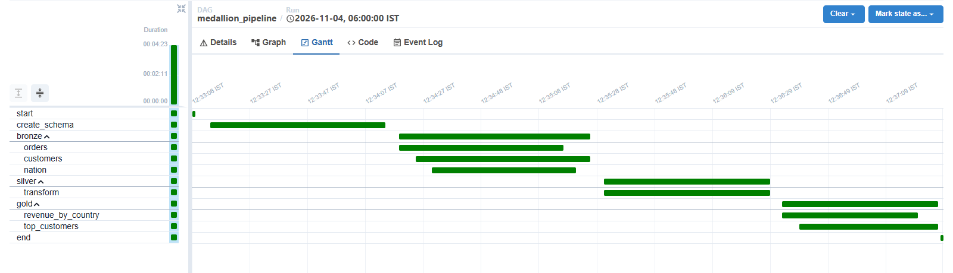
Figure 4. Airflow Gantt chart, 12:33 to 12:37 IST
Run details: a scheduled run, status success, 4 min 23 s.
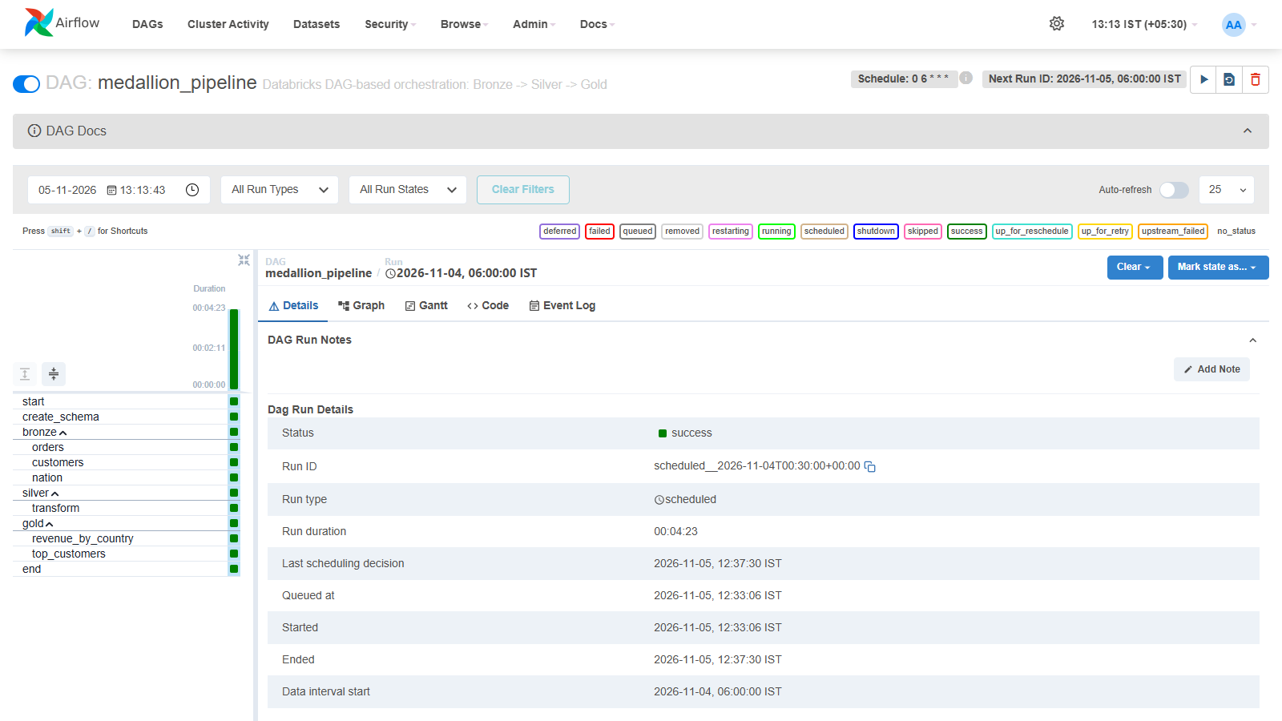
Figure 5. Airflow run details
The task log shows the hand-off to Databricks: the run is submitted, the task is deferred while Databricks runs it, and it completes successfully. The Databricks run URL is in the log.
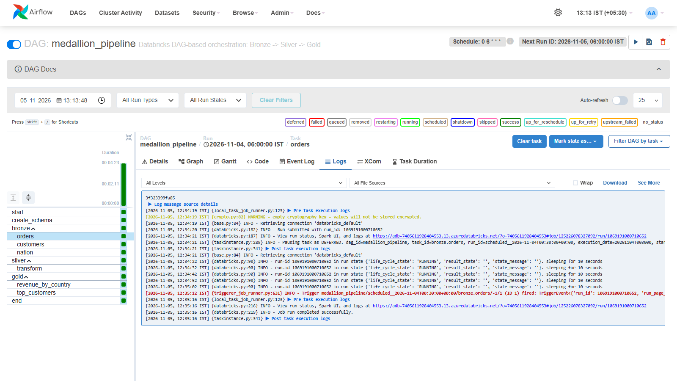
Figure 6. Airflow task log for bronze.orders

7. Operations
The pipeline runs by itself at 06:00 IST once Docker Desktop is running. A manual run is one click: Trigger DAG in the Airflow UI.
Task | How
Start Airflow | docker compose up -d, then open http://localhost:8080 (login from .env)
Stop Airflow | docker compose down (clears Airflow's run history; Databricks tables are unaffected)
Run now | Airflow UI → medallion_pipeline → Trigger DAG
Watch progress | Airflow Graph tab: green = success, purple = waiting on Databricks, orange = retrying, red = failed
Open the Databricks run | Airflow task → Logs → Databricks run URL
Check results | Databricks Catalog → dev.airflow_medallion

When a step fails
- Airflow retries it after 1, 2 and then 4 minutes.
- If it still fails, the task turns red and every later step is marked upstream_failed and does not run.
- Tables from the layers that succeeded keep their previous good data.
- The fix is made in the notebook or configuration. The run is then cleared in the Airflow UI and resumes from the failed step.
Resilience: the Airflow container has restart: unless-stopped, so it starts again whenever Docker starts. The DAG is created unpaused (DAGS_ARE_PAUSED_AT_CREATION=false), so the schedule keeps working after a restart.

8. Limitations and next steps
The design is complete for a demo. Four items stand between it and production.
Limitation | Impact | Recommended next step
Airflow runs on a laptop | The 06:00 run happens only if the laptop and Docker are on (seen on 5 Nov: the run started at 12:33 instead) | Host Airflow on a server or a managed service (Azure Managed Airflow, AWS MWAA, Astronomer)
Notebooks are imported by hand | A code change needs a manual re-import | Use git_source so Databricks reads notebooks from Git, or Databricks Asset Bundles with CI/CD
Full refresh on every run | Fine for sample data; slow and costly for large sources | Incremental loads with MERGE or Auto Loader, keyed on run_date
No alerts | Failures are seen only in the Airflow UI | Add an on_failure_callback that posts to email or Teams

The Airflow metadata database is SQLite inside the container, so run history resets when the container is recreated. A hosted Airflow (first row) removes this too.

