# Project Milestone 01

1. **Submit your project title, project description, team name, team member names, client, and team logo.**

**Project Title:** Food Quality Control Management

**Project Description:** Quality control is a must in any business, but it is especially important in the food industry. Food quality control is to guarantee that food items are safe and appropriate for human consumption, that they meet consumer or regulatory criteria, and that they are consistently high in quality.

Given that food items have a direct influence on customers' health and wellness, firms must examine and document product quality throughout all phases of manufacturing.

Quality assurance is not a single stage in the manufacturing process. Instead, it is integrated across the whole process, including creation, manufacturing, and dissemination.

**Team Name:** SPGNRVC

**Team Member Names:** Pooja Sura, Pravallika Kakanoori, Gomathi Gade, Neerazsai

Veeranki, Rajasekhara Reddy Madire, Vedha Sri Gaddam, Nagadesi Danica Thanmai

Charita.

**Client:** Sodexo

**Logo:**

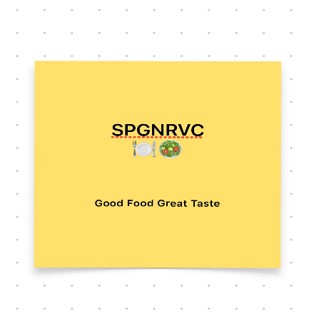

1. **Create an initial page.**

Project Charter

Date

|  |  |  |  |
| --- | --- | --- | --- |
| **Project Title**: Food Quality Control Management | | | |
| **Project Start Date: 02/02/23 Projected Finish Date:** **05/08/23** | | | |
| **Budget Information: 420000 $** | | | |
| **Project Manager:**  Name: Pravallika Kakanoori  Phone: +1 660 541 2424  e-mail: Pravallika.af686@gmail.com | | | |
| **Project Objectives:** The major function of quality assurance in food processing is to guarantee that all elements of quality - portion size, product qualities, customer expectations, and value for money - fulfill different internal and external standards and laws. | | | |
| **Success Criteria:** Generally, the phrase food quality refers to the total of all the characteristics of a food product that really are satisfactory to the client. These food quality features include size, shape, gloss, color, and consistency, texture, flavor, and nutritional value. | | | |
| **Approach:** Food Quality Control Management involves implementing a range of measures to ensure that food products meet specific standards for safety, nutrition, taste, and consistency. Here are some approaches for food quality control management: Establish quality control procedures, conduct regular inspections, Train staff on quality control, Implement a HACCP (Hazard Analysis and Critical Control Points) plan, Use food Quality testing equipment, Establish supplier partnerships, Continuously monitor and evaluate. | | | |
| **Roles and Responsibilities** | | | |
| ***Name and Signature*** | ***Role*** | ***Position*** | ***Contact Information*** |
| Pooja Sura | **Team Lead** | Guiding, Monitoring and Leading an entire group | S555254@nwmissouri.edu |
| Gomathi Gade | **Stakeholder** | Shareholder | S555491@nwmissouri.edu |
| Neerazsai Veeranki | **User** | Food Technologist | S549929@nwmissouri.edu |
| Rajasekhara Reddy Madire | **Food Inspector** | Quality Control Technician | S555824@nwmissouri.edu |
| Vedha Sri Gaddam | **Chef** | Baker, Broiler Cook | S555686@nwmissouri.edu |
| Nagadesi Danica Thanmai Charita | **Maintenance** | Server, Bartender, Packer. | S550593@nwmissouri.edu |
|  | | | |
| **Comments:** (Handwritten or typed comments from above stakeholders, if applicable) | | | |

1. **Include an initial in your Project Charter.**

Stakeholder Register for Project Name

**Prepared by:** **Date:**

|  |  |  |  |  |
| --- | --- | --- | --- | --- |
| **Name** | **Position** | **Internal/External** | **Project Role** | **Contact Information** |
| Pooja Sura | **Team Lead** | Internal | Guiding, Monitoring and Leading an entire group. | S555254@nwmissouri.edu |
| Pravallika Kakanoori | **Project Manager** | Internal | Deliver the Project. | S555344@nwmissouri.edu |
| Gomathi Gade | **Stakeholder** | Internal/External | Shareholder | S555491@nwmissouri.edu |
| Neerazsai Veeranki | **User** | External | Food Technologist | S549929@nwmissouri.edu |
| Rajasekhara Reddy Madire | **Food Inspector** | External | Quality Control Technician | S555824@nwmissouri.edu |
| Vedha Sri Gaddam | **Chef** | Internal | Baker, Broiler Cook. | S555686@nwmissouri.edu |
| Nagadesi Danica Thanmai Charita | **Maintenance** | Internal | Server,Bartender, Packer. | S550593@nwmissouri.edu |

1. **Explain how you will work together as a team (Where and when you will meet, how you will share contact information, and what will you do to do a non-participating team member work in the project)**

We will meet in our organizations and our team will contact through emails and using team meets. We as a team will work through assigning tasks using GitHub. And will meet targets with the deadlines. As a team lead, we will try to give one more change, if it repeats, we no longer encourage such sort of things.

1. **Roles: Describe what each team member will contribute to the team project.**

Project Manager - Pravallika Kakanoori (Deliver the Project)

Team Lead – Pooja Sura (Guiding, Monitoring and Leading an entire group)

Stakeholder – Gomathi Gade (Shareholder)

User – Neerazsai Veeranki (Food Technologist)

Food Inspector – Rajasekhara Reddy Madire (Quality Control Technician)

Chef – Vedha Sri Gaddam (Baker, Broiler Cook)

Maintenance – Nagadesi Danica Thanmai Charita (Server, Bartender, Packer)

1. **Include names of all the team members at the bottom of the document**

Pooja Sura, Pravallika Kakanoori, Gomathi Gade, Neerazsai Veeranki,

Rajasekhara Reddy Madire, Vedha Sri Gaddam, Nagadesi Danica Thanmai Charita.

1. **One person from the team should submit.**
2. **Provide a link to your GitHub Project Management sheet related to your project and which is similar to what was shown in the class.**

<https://github.com/users/psura06/projects/2/views/1>