Scale: Sabotage belief

**Non-social**:

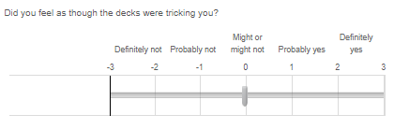

**Social**:

