Rural Health Unit Management System
Menard Dane Macabulos Marie Del Rosario

ABSTRACT
Elective 1 (Web Systems and Technologies 2)

This study endeavors to develop a comprehensive Rural Health Unit Management System is modified to meet the specific needs and challenges faced by healthcare facilities in rural areas. The focus lies on database design, derived directly from the requirements analysis phase, aiming to automate various administrative and clinical processes within the rural health unit. The study adopts Rapid Application Development (RAD) as the system's development life cycle methodology to ensure efficient and iterative development. The system aims to streamline operations, enhance patient care, and optimize resource management within rural health units.

General Terms
Governance, Expenditure, Records, Configuration, Dependability

Keywords
Healthcare Allocation, Rural Health Resource Allocation, Health Service Management, Rural Health Management System

BACKGROUND OF THE STUDY
Rural areas often struggle to provide quality healthcare due to their remote locations, lack of infrastructure, and limited resources. In these places, Rural Health Units (RHUs) step in as primary healthcare providers, vital for addressing local health needs.
However, managing RHUs efficiently is tough. They face challenges like complex paperwork, stretched resources, and delivering quality care with limited means.

Many RHUs still rely on old-fashioned paper systems, leading to mistakes and data management headaches. This calls for modern solutions to streamline operations, make better use of resources, and improve healthcare quality.

Technology offers a ray of hope. By creating tailored digital systems using databases and fast development methods, we can greatly improve how RHUs operate. This study aims to design and build a robust Rural Health Unit Management System. This system will automate tasks, help with decision-making, and make RHUs work better overall.

Statement of the Objectives
This study aims to develop a Rural Health Unit Management System (RHUMS), with the following specific objectives:
    - To identify the system's essential business rules, including:
      - Rules governing patient management within the
RHU
      - Procedures for inventory and resource management
      - Protocols for appointment scheduling and tracking

    - To design the database architecture of the RHUMS, which involves:
      - Creating Entity Relationship Diagrams (ERDs) for each functional module of the system
      - Establishing an Integrated Entity Relationship Diagram (IERD) illustrating the interconnectedness of system components
      - Compiling comprehensive data dictionaries outlining the attributes and relationships of database entities
      - Configuring database instances to support real- time data processing and storage
    - To describe the features and functionalities of the RHUMS, highlighting its capabilities in addressing the specific needs of rural healthcare settings. This includes:
      - Patient record management and tracking
      - Inventory and resource management for medical supplies and equipment
      - Appointment scheduling and reminder functionalities
      - Reporting and analytics tools for monitoring RHU performance and resource utilization.

Conceptual Framework
The conceptual framework for the Rural Health Unit Management System (RHUMS) is depicted in Figure 1.2, employing the Input- Process-Output (IPO) framework. The framework is structured as follows:

Figure 1.2

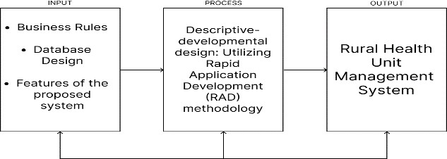

Discuss the conceptual framework, and use the INPUT, PROCESS, OUTPUT framework.

Scope and Limitation
The Rural Health Unit Management System (RHUMS) is designed to streamline administrative and clinical processes, optimize resource allocation, and improve data management practices within Rural Health Units (RHUs). While RHUMS does not directly handle financial aspects, it aims to enhance operational efficiency and patient care delivery through automation of tasks such as patient registration, appointment scheduling, and medical records management. The system also offers reporting and analytics features to provide insights into RHU performance and resource utilization, enabling informed decision-making by healthcare administrators. However, RHUMS may not fully address all aspects of financial tracking, budgeting, and expense management within RHUs, and users seeking comprehensive financial management functionalities may need to integrate RHUMS with dedicated financial management software.
Additionally, its effectiveness may be limited by factors such as user adoption rates, training needs, and the availability of necessary infrastructure and resources in rural healthcare settings.

Significance of the Study
This study is beneficial to the following.
Users:
The Rural Health Unit Management System (RHUMS) greatly improves patient experiences in rural areas by streamlining administrative processes and enhancing access to healthcare services. Through features like automated appointment scheduling and efficient medical records management, RHUMS reduces waiting times and improves communication between patients and healthcare providers. Ultimately, RHUMS enhances healthcare outcomes and promotes the well-being of individuals and communities in rural areas.

Local Government Unit:
The implementation of the Rural Health Unit Management System (RHUMS) is a significant step towards improving healthcare delivery in rural areas. By optimizing resource allocation and enhancing operational efficiency within Rural Health Units (RHUs), RHUMS enables the government to maximize healthcare investments and address the needs of rural populations more effectively. Additionally, RHUMS provides valuable insights into RHU performance, enabling informed decision-making and better allocation of resources to improve healthcare access and outcomes for rural communities.

Definition of Terms
The following terms are defined operationally for the common understanding.

- Rural Health Unit (RHU): A healthcare facility situated in rural areas, primarily tasked with providing essential healthcare services to underserved communities. RHUs typically offer a range of medical services, including consultations, preventive care, and basic diagnostic procedures.

- Rural Health Unit Management System (RHUMS): A software solution designed to streamline administrative and clinical processes within RHUs. RHUMS facilitates tasks such as patient registration, appointment scheduling, medical records management, and resource allocation, aiming to enhance operational efficiency and improve patient care delivery in rural healthcare settings.

- Operational Efficiency: The ability of a healthcare facility to utilize resources effectively and achieve desired outcomes with minimal waste. Operational efficiency in RHUs involves optimizing processes, reducing wait times, and improving overall service delivery while utilizing available resources efficiently.

- Resource Allocation: The process of distributing available resources, such as personnel, equipment, and funding, to different areas or activities within a healthcare facility. Effective resource allocation in RHUs ensures that resources are directed towards priority areas to meet the healthcare needs of the community.

- Reporting and Analytics: The process of collecting, analyzing, and presenting data to gain insights into the performance and operations of a healthcare facility. Reporting and analytics tools in RHUMS provide valuable information on RHU performance, resource utilization, and patient outcomes, enabling informed decision-making by healthcare administrators.

- Healthcare Outcomes: The results or effects of healthcare interventions on patients' health status and well-being. Positive healthcare outcomes in RHUs include improvements in patient health, satisfaction with healthcare services, and adherence to treatment plans. RHUMS aims to improve healthcare outcomes by enhancing access to care, promoting preventive measures, and facilitating efficient healthcare delivery.

METHODOLOGY

Research Design
The research design employed in this study blends elements of descriptive and developmental research methodologies to guide the development process of the Rural Health Unit Management System (RHUMS). Descriptive research involves systematically observing and portraying phenomena without influencing them, providing an in-depth understanding of the subject matter. In contrast, developmental research focuses on creating, refining, and evaluating programs or products to achieve specific goals.

The decision to utilize a descriptive-developmental approach stems from the necessity to derive business rules for RHUMS through diverse data collection methods such as observation, interviews, surveys, and analysis of operational manuals. By integrating descriptive and developmental research methodologies, the study aims to create an automated budget management system tailored to the unique requirements and challenges faced by rural healthcare units.

To expedite the development process and ensure responsiveness to evolving needs, an agile-driven methodology was adopted, with Rapid Application Development (RAD) as the primary system development life cycle model. RAD emphasizes iterative development, rapid prototyping, and user involvement to accelerate the delivery of functional solutions. The RAD model comprises iterative stages of requirements analysis, prototyping, refinement, and deployment, enabling the efficient creation and implementation of RHUMS. This iterative approach allows for flexibility and adaptation to changing requirements during the development

process.
Figure 2.1: RAD Model
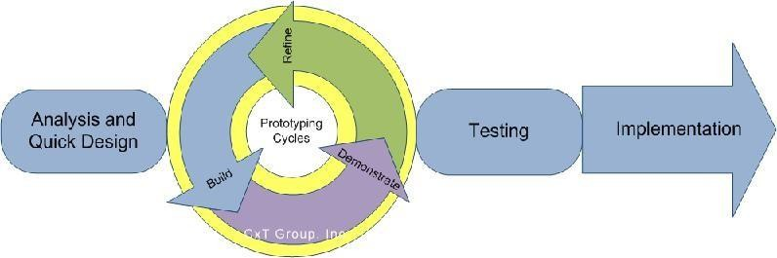

Sources of Data
Primary data for the Rural Health Unit Management System (RHUMS) was collected primarily through research and interviews. A series of interviews were conducted to gather essential information regarding administrative processes, patient care, resource allocation, and other pertinent aspects of healthcare management in rural settings. Additionally, observations were made to understand users' experiences, challenges, and the impact of the RHUMS on the overall management processes within rural health units.

Secondary data sources were obtained through extensive internet research and analysis. Relevant articles, journals, and resources related to RHUMS and rural healthcare management were explored to supplement the primary data collected. This secondary data served to enrich the understanding of the subject matter, provide context, and support the findings derived from primary research methods. By combining primary and secondary data sources, a comprehensive understanding of RHUMS and its implications for rural healthcare management was achieved.

Instrumentation and Data Collection
Interviews: A series of interviews with stakeholders was conducted as a primary data collection method. According to Smith (2015), interviews involve system analysts engaging with individuals or groups of users, offering an effective means to grasp business functions and rules. This method was employed to complement information gathered from various literature sources and to gain an in-depth understanding of the existing system.

Observation: Observation played a crucial role in the study's development process. It is a method wherein system analysts observe business functions to visualize the new systems associated with the business process (Jones, 2012). This method aided in understanding the intricacies of the business functions and processes, contributing to the development of the Rural Health Unit Management System (RHUMS).

Tools for Data Analysis
ER Diagrams: The study employed ER diagrams to visualize the database structure effectively. An entity-relationship (ER) diagram is a graphical representation illustrating the relationships between entities in a database. In this diagram, entities are depicted using boxes, relationships using diamonds, and attributes using ovals. This tool served as a blueprint for accurately reflecting the organization's operations within the database, ensuring the adequacy of entities, attributes, and relationships. ER diagrams also facilitated the validation of proposed data dictionary entries, ensuring consistency and completeness in database design.

PRESENTATION AND FINDINGS OF THE STUDY
This section of the research paper presents the findings of the study. It presents the data, their analysis and the interpretation of findings to the specific objectives. The main objective of this study is to develop a Rural Health Unit Management System.

Business Rules
The business rules of the Budget Management System are presented in table 3.1
Table 3.1
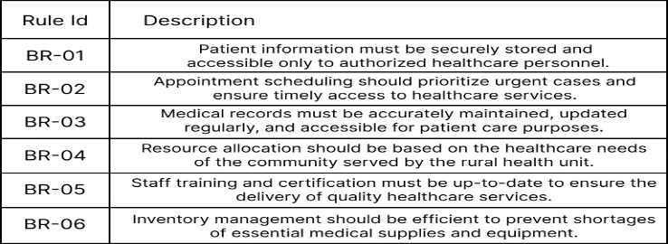

Database Design
This section presents the database design of the Rural Health Unit Management System.
- Appointment Table:
This section handles the logs for the inserted appointments. id (Primary Key)
firstname middlename lastname
email phonenumber sex
service date message

- ContactUs Table:
This section handles the messages inserted from the user page. id (Primary Key)
fullname emailaddress message

- Events Table:
This section handles the events inserted from the admin page. id (Primary Key)
eventTitle eventDescription eventDate

- Medicine Table:
This section handles the medicines inserted from the admin page. id (Primary Key)
medicinename desciption quantity manufacturingdate expirationdate

- UserLogin Table:
This section handles the accounts. id (Primary Key)
email password

Features of the System
This section presented the features of the Rural Health Unit Management System.
    - Patient Management: RHUMS facilitates efficient patient management, including registration, and appointment scheduling.
    - Resource Allocation: The system assists in allocating resources such as medical equipment, and medications based on patient needs and availability.
    - Appointment Scheduling: RHUMS streamlines appointment scheduling processes, ensuring timely access to healthcare services while optimizing healthcare provider schedules.
    - Inventory Management: The system enables effective management of medical supplies and equipment, tracking inventory levels, expiration dates, and restocking needs.
    - Communication: RHUMS facilitates communication within the rural health unit, including internal messaging systems and notifications for appointments, events, and medication refills.

SUMMARY, CONCLUSIONS, AND RECOMMENDATIONS

Summary
Healthcare management, requires a nuanced approach that balances precision with flexibility. The Rural Health Unit Management System (RHUMS) seeks to embody this equilibrium by providing a user-friendly platform designed to enhance healthcare delivery and administration within rural health units. Serving as a multifaceted tool, RHUMS facilitates efficient patient management, resource allocation, and communication among stakeholders.

As a patient management system, RHUMS enables healthcare providers to efficiently schedule appointments, maintain medical records, and input available medicines for patients. This
functionality streamlines administrative processes and ensures the timely delivery of healthcare services to patients in rural areas.

In terms of resource allocation, RHUMS assists healthcare administrators in managing medical supplies and equipment effectively. Through features such as inventory management, RHUMS optimizes resource utilization and ensures that rural health units are adequately equipped to meet patient needs.

Moreover, RHUMS serves as a communication platform, facilitating internal communication among healthcare staff and external communication with patients and other stakeholders. Features such as messaging systems and appointment notifications enhance communication efficiency and contribute to improved patient engagement and satisfaction.

Overall, RHUMS plays a pivotal role in enhancing the operational efficiency, resource management, and communication within rural health units, ultimately leading to improved healthcare outcomes for underserved populations.

Conclusion
In conclusion, the Rural Health Unit Management System (RHUMS) plays a vital role in optimizing healthcare delivery in rural areas despite encountering challenges. The system's functions are geared towards enhancing patient care, streamlining administrative processes, and improving resource allocation within rural health units.

Despite its significance, RHUMS faces obstacles such as inadequate communication among stakeholders, excessive involvement of personnel, and difficulties in managing external factors. To overcome these challenges, it is essential to align RHUMS functions with strategic planning objectives. This involves integrating the system's features with the overarching goals of healthcare provision in rural communities.

Furthermore, RHUMS should prioritize adaptability to changes in healthcare policies, patient demographics, and technological advancements. Flexibility in system design and processes will enable RHUMS to respond effectively to evolving needs and challenges in rural healthcare delivery.

Moreover, RHUMS should facilitate seamless collaboration among healthcare professionals, ensuring efficient communication and coordination of patient care. By fostering a collaborative environment, RHUMS can enhance the quality and continuity of healthcare services provided in rural health units.

Ultimately, RHUMS should be perceived as a dynamic and integral component of healthcare management in rural areas. By continuously refining its functions and processes to meet the evolving needs of rural communities, RHUMS can contribute significantly to improving healthcare outcomes and access in underserved regions.

Recommendations

Managing health records and forecasting healthcare needs have historically been perceived as daunting tasks in healthcare. The

excitement and passion felt in providing quality healthcare can diminish when healthcare providers are faced with the challenge of managing patient data and predicting future healthcare demands. However, despite the complexity, efficient management of health records and accurate forecasting of healthcare needs are crucial for ensuring the well-being of patients and the effectiveness of healthcare delivery in rural areas.

Recommendations for Improved Health Outcomes:

- Prioritize Preventive Care: Regular check-ups, screenings, and vaccinations are essential for maintaining good health and preventing the onset of diseases. Individuals should prioritize preventive care by scheduling routine appointments with healthcare providers and following recommended guidelines for screenings and immunizations based on their age, gender, and medical history.

- Adopt Healthy Lifestyle Behaviors: Healthy lifestyle choices, including regular exercise, balanced nutrition, adequate sleep, stress management, and avoidance of harmful substances like tobacco and excessive alcohol, play a significant role in promoting overall health and well-being. Individuals should strive to adopt and maintain healthy habits to reduce the risk of chronic diseases and improve their quality of life.

- Stay Informed and Educated: Health literacy is crucial for making informed decisions about healthcare and managing chronic conditions effectively. Individuals should actively seek out reliable sources of health information, ask questions, and engage in health education programs to enhance their understanding of medical conditions, treatment options, and preventive measures.

- Build Strong Relationships with Healthcare Providers: Establishing a trusting and collaborative relationship with healthcare providers is essential for receiving personalized care and support. Individuals should communicate openly with their healthcare team, share relevant health information, and actively participate in shared decision-making processes regarding their treatment plans and goals.

- Monitor Health Metrics and Track Progress: Regular monitoring of health metrics such as blood pressure, blood sugar levels, cholesterol levels, and weight can help individuals track their progress towards health goals and identify any potential health concerns early on. Utilizing tools such as health apps, wearable devices, or health diaries can facilitate self-monitoring and empower individuals to take proactive steps towards better health.

- Seek Timely Medical Attention: Prompt evaluation and treatment of symptoms or health concerns can prevent minor issues from escalating into more serious conditions. Individuals should seek timely medical attention from healthcare providers when experiencing symptoms of illness or injury and adhere to recommended treatment plans to optimize recovery and prevent complications.
- Engage in Community Support Networks: Building connections with peers, support groups, and community resources can provide individuals with valuable social support, encouragement, and practical assistance in managing health challenges. Engaging in community-based activities, joining support groups, or participating in online forums can help individuals feel connected and supported on their health journey.

- In conclusion, by prioritizing preventive care, adopting healthy lifestyle behaviors, staying informed and educated, building strong relationships with healthcare providers, monitoring health metrics, seeking timely medical attention, and engaging in community support networks, individuals can take proactive steps towards achieving better health outcomes and enhancing their overall well-being and quality of life.

ACKNOWLEDGMENTS

I extend my heartfelt thanks to Marie Del Rosario and Menard Dane Macabulos for their invaluable support and assistance during the course of this project. Their dedication, insights, and contributions have played a significant role in shaping the outcomes of this endeavor. Their willingness to offer guidance, share expertise, and provide feedback have been instrumental in navigating the challenges encountered along the way. I am truly grateful for their unwavering support and encouragement, which have greatly contributed to the successful completion of this project.

REFERENCES
[1] https://lgustamaria-pangasinan.com/health/

