Laboratory reportof Nanjing University of Information Science and TechnologyExperiment
Title Lab 1 Date 2025.4.1 Class 24AC
Name ZhuangZhong ID 202483910032

1. Objectives
The primary objective of this lab is to install Docker Desktop , deploy a Gitea instance using containerization technology, and verify the platform's support for Git Large File Storage (LFS) by managing files exceeding 1GB.

2. Environment Preparation
2.1 Docker Desktop Installation
The first step of the experiment is to build a complete Docker operating environment.
Installation: Windows users need to enable the WSL 2 backend by running the wsl --install command, and then install Docker Desktop. Mac users can install Docker via Homebrew with the command brew install --cask docker.
Registration: After the installation is finished, users must register and log in to a Docker account, because authentication is necessary to pull images and use related services normally.

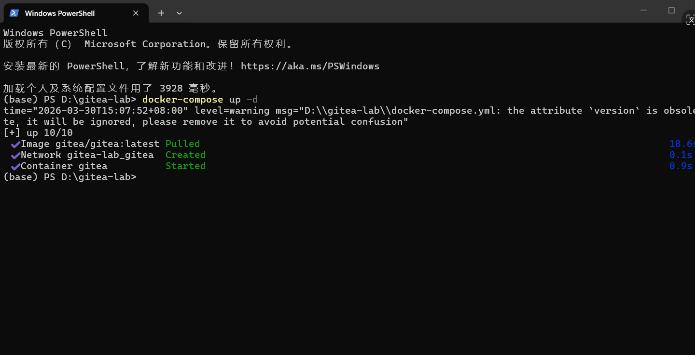

3. Implementation: Gitea Deployment
3.1 Docker-based Installation
Gitea was deployed using the official Docker image to ensure environment isolation and ease of management.
Procedure: A docker-compose.yml file was created to define the Gitea service and its persistent storage volumes.
Initialization: The service was started, and the initial configuration was completed via the web interface at http://localhost:3000, using SQLite3 as the lightweight database backend.

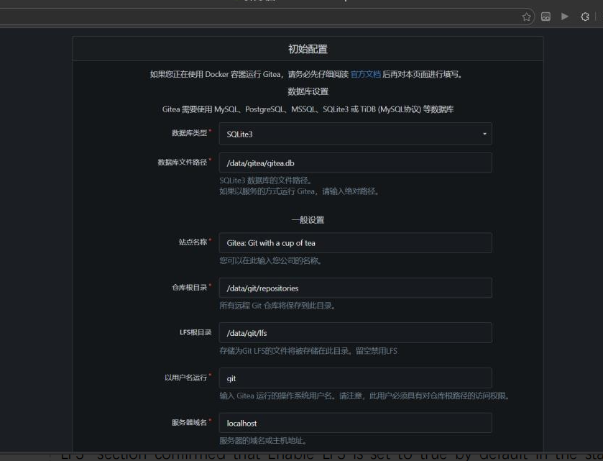
4. Verification of LFS Support
The experiment needs to confirm whether Gitea supports Git Large File Storage (LFS) and provide valid proof.
Verification Evidence: In the Site Administration > Configuration panel, the LFS module is enabled by default in the standard Docker deployment.
Function Confirmation: The repository settings page contains an independent LFS management tab, proving that the server can process large file binary pointers normally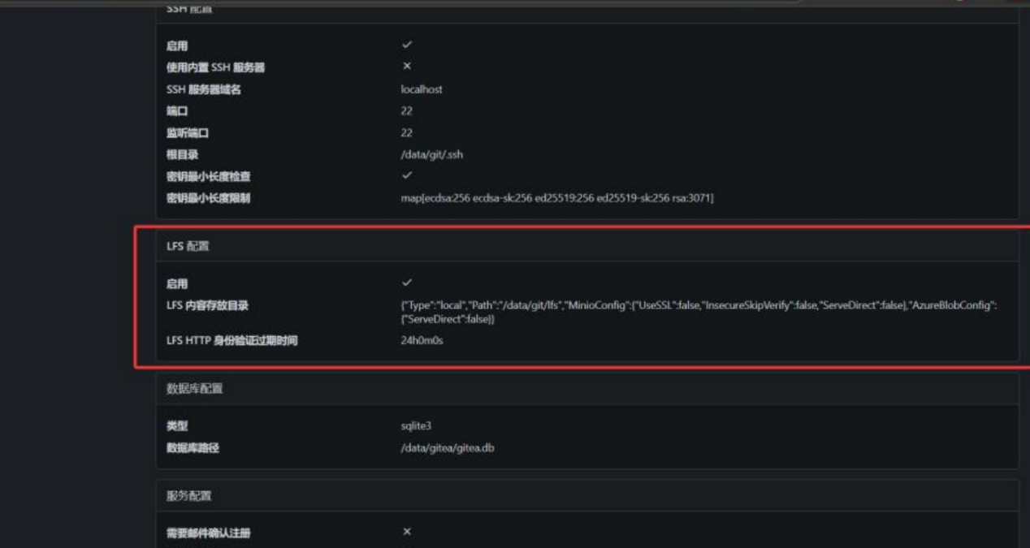
5. Large File Management (1GB+)
5.1 Repository Creation and Data Push
To test the LFS functionality, a new repository was created to host a file exceeding 1GB in size.
Step 1: Created a repository named lfs-test-repo on the Gitea web UI.
Step 2: Generated a 1GB dummy file locally using the command:
fsutil file createnew large_data.dat 1073741824
Step 3: Initialized LFS in the local git directory:
git lfs install
git lfs track "*.dat"
git add .gitattributes large_data.dat
git commit -m "Add 1GB large file via LFS"git push origin main
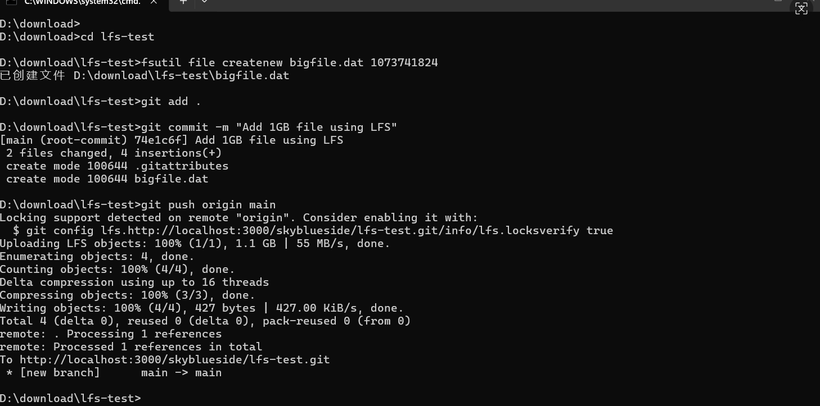
Results: The push was successful, and the Gitea web interface correctly displayed
the file with an "LFS" badge, indicating it is stored outside the main git object
database.
6. Conclusion
This experiment successfully deploys a code hosting platform based on Docker. By verifying the LFS support and completing the upload of a 1GB large file, it is confirmed that Gitea has stable performance in managing large‑scale AI datasets and binary files

