Laboratory reportof Nanjing University of Information Science and TechnologyExperiment
Title Lab 2 Date 2025.4.28 Class 24AC
Name ZhuangZhong ID 202483910032

1. Objectives
The main objective of this lab is to understand and practice fundamental Docker container operations, including running containers with persistent storage (volumes), publishing container ports to the host, interacting with containers, sharing local files between the host and containers, overriding default container commands, and verifying container behavior and data persistence.

2. Environment Preparation
Docker Desktop was installed on Windows 11 with WSL 2 backend enabled, and Docker Hub login was completed to allow image pulling.
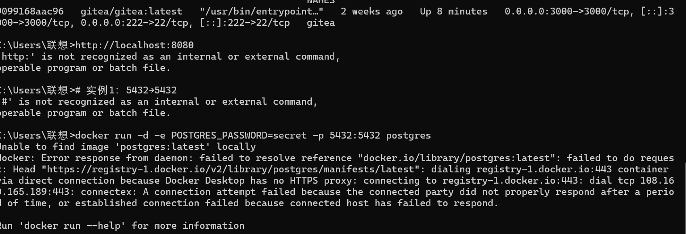
3. Experiment Implementation and Results
3.1 Creating and Running a Container with a Volume
The command docker run -d --name my-test-container -v my-volume:/data busybox sleep 3600 was executed, and the output container ID was 175d41e1b302dea0a2ec5b036fbb7b2e86028ebd645fd2ddde3476afe93d613.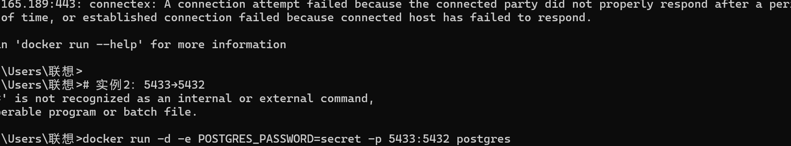 The command docker inspect my-test-container was then used to view detailed container information. The -v my-volume:/data option creates or uses an existing Docker volume named my-volume and mounts it to the /data directory inside the container, ensuring that data written to /data persists even if the container is removed.

3.2 Port Publishing Experiment
The first example executed docker run -d -e POSTGRES_PASSWORD=secret -p 5432:5432 postgres, which failed due to network proxy issues.
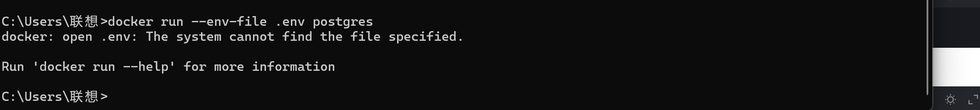
The second example executed docker run -d -e POSTGRES_PASSWORD=secret -p 5433:5432 postgres, where -p 5433:5432 maps host port 5433 to container port 5432, allowing multiple containers to use the same internal container port as long as different host ports are assigned. 

3.3 Running the Welcome to Docker Container
The command docker run -d -p 8080:80 docker/welcome-to-docker was executed to start the container, and docker ps was used to view the running containers, showing both the welcome-to-docker container and the previously deployed gitea container. Opening http://localhost:8080 in a browser displays the welcome page. 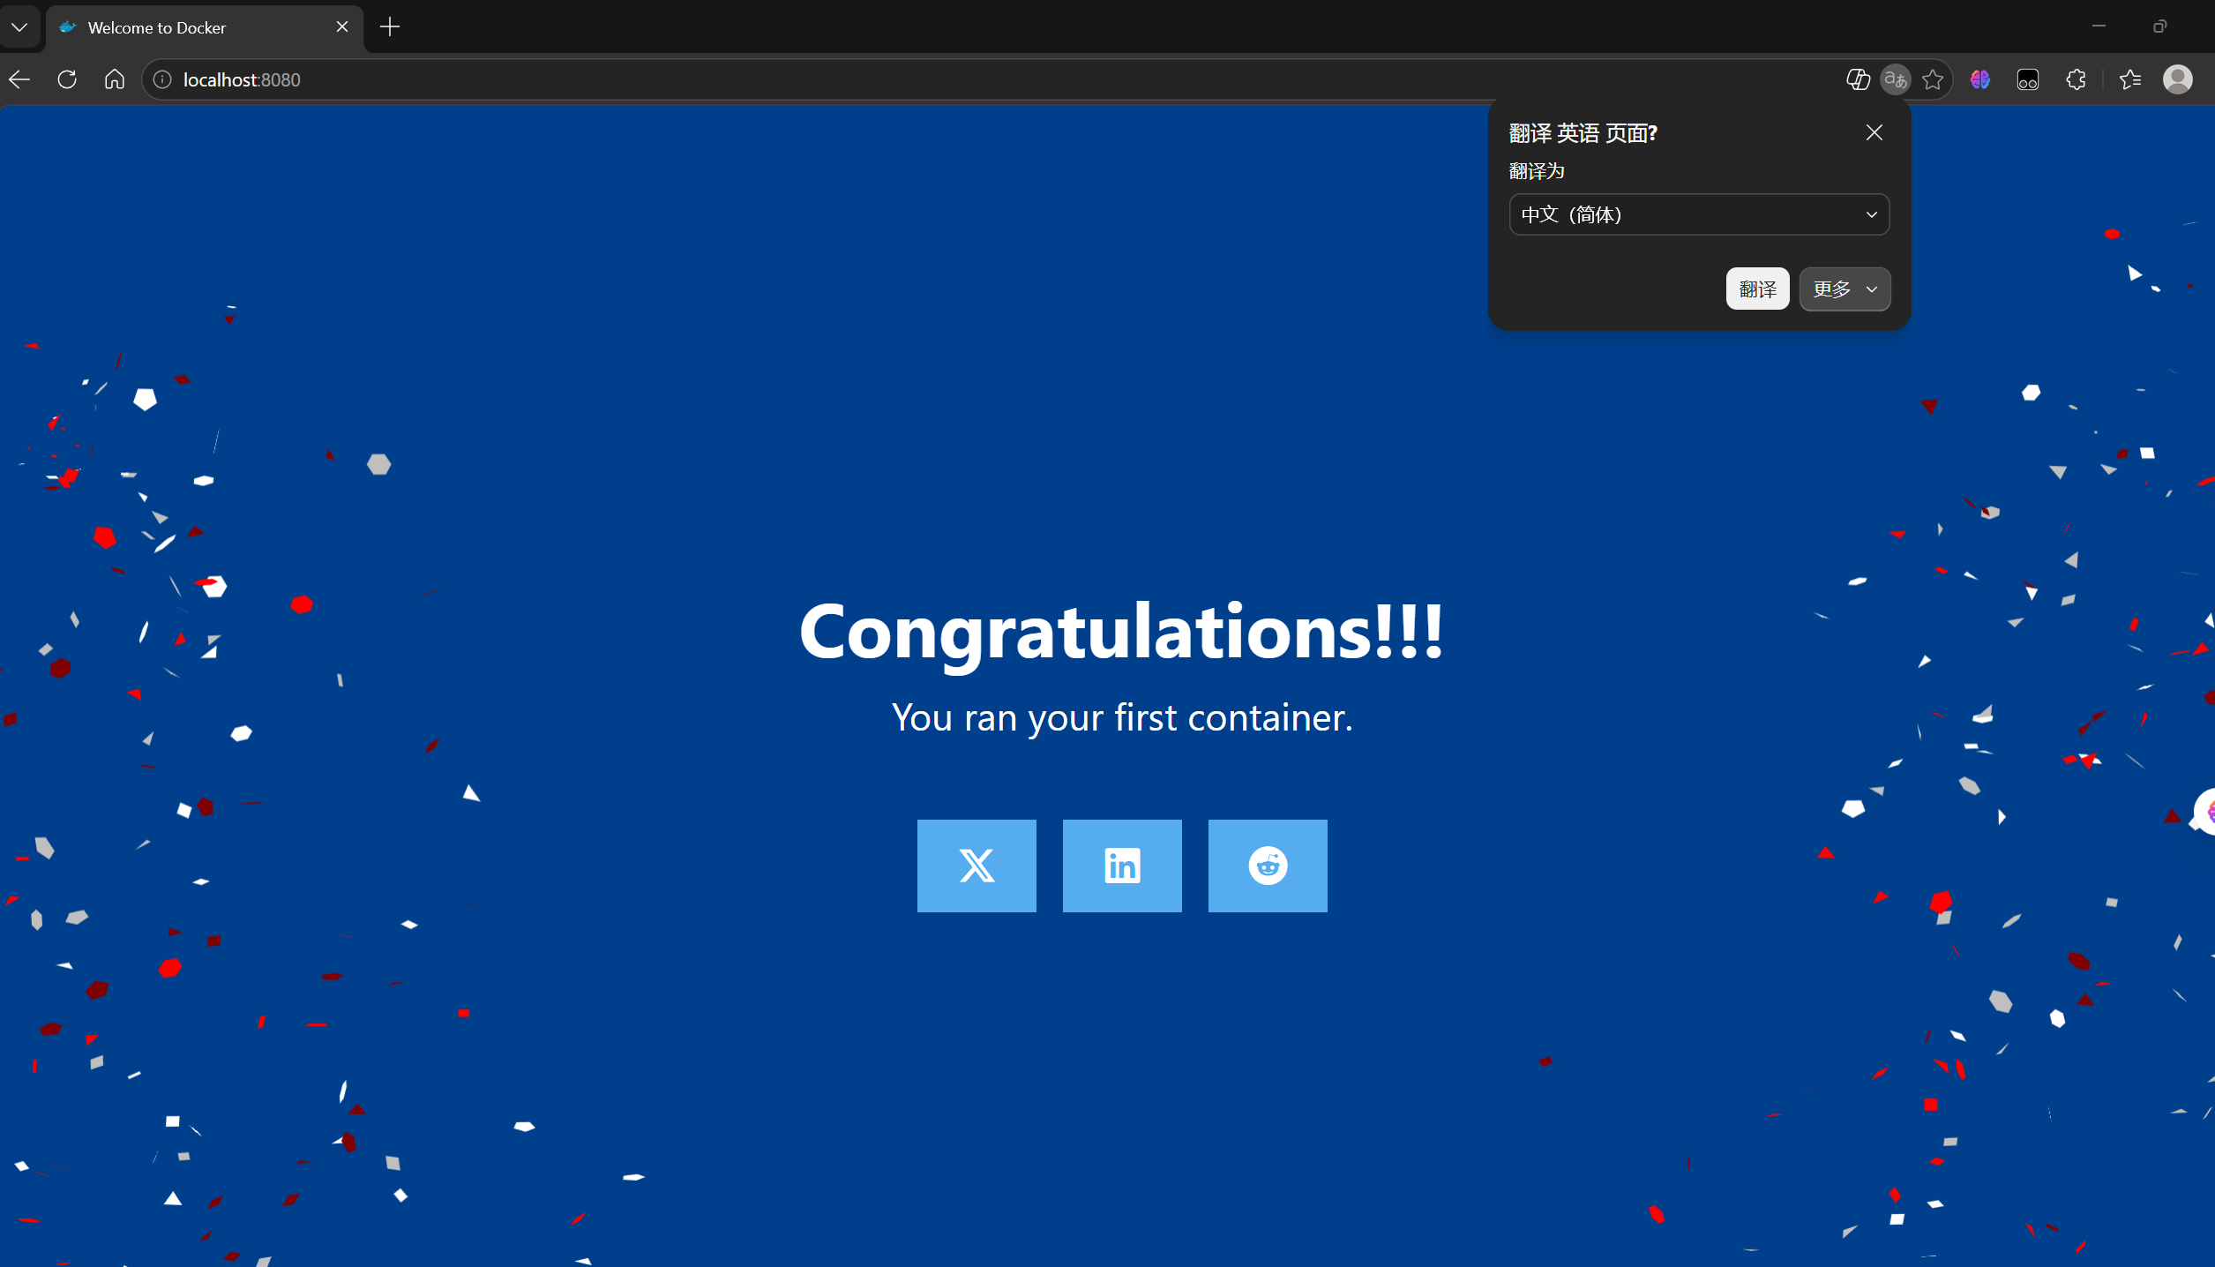

3.4 Running an Interactive Busybox Container
The command docker run --rm -it busybox sh was executed to enter the container, where --rm automatically deletes the container after exit, -it allocates an interactive terminal, and busybox sh overrides the default command to start a shell. Inside the container, running ls shows the directories under the root path, and running echo "Hello from Docker container!" outputs the corresponding string
.
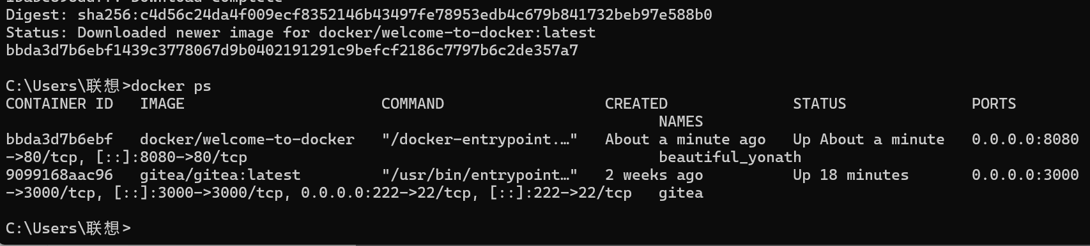
3.5 Sharing Local Files Between Host and Container
The command docker run -d -p 8082:80 -v "%cd%":/usr/local/apache2/htdocs httpd:2.4 was executed to start an Apache container, where -v "%cd%":/usr/local/apache2/htdocs mounts the current host directory to Apache's web root directory, so any file changes in the host directory take effect immediately in the container, which is very suitable for development and debugging.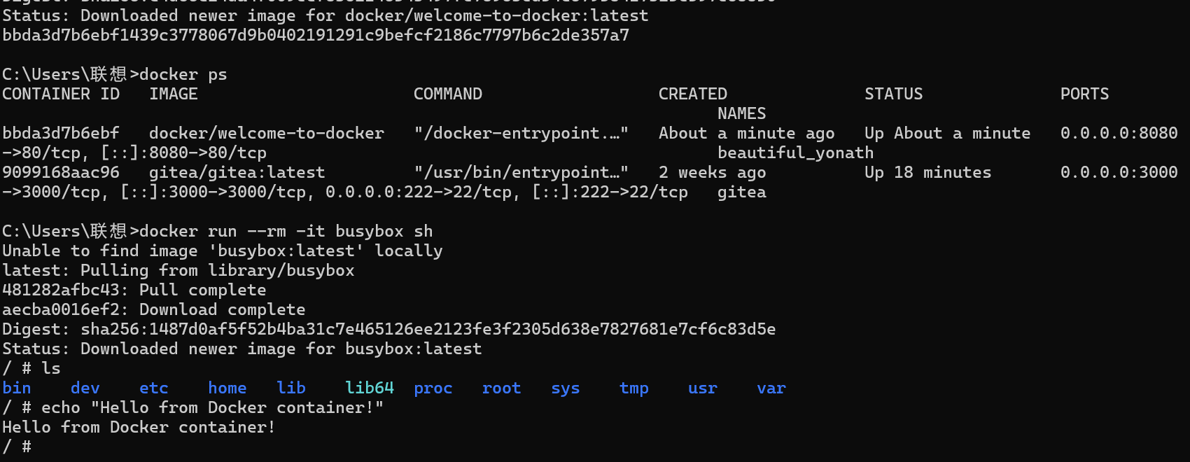
3.6 Creating and Managing Docker Volumes
The command docker volume create my-volume was executed on the host to create a volume named my-volume. It should be noted that if a docker command is mistakenly executed inside a busybox container, an error sh: docker: not found will appear, which is normal because the busybox container does not include the Docker client.
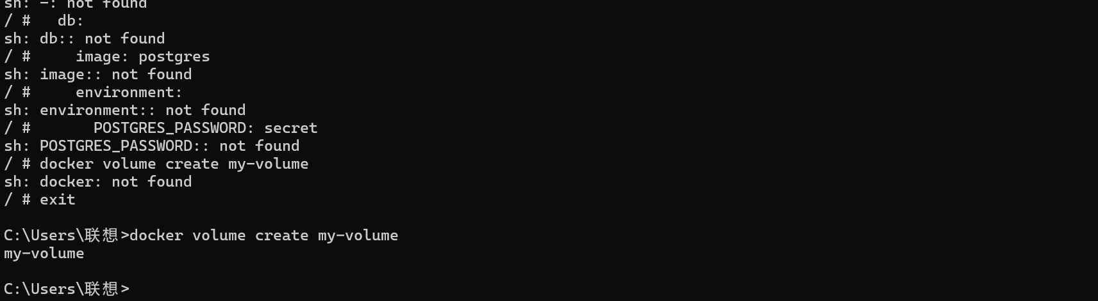
4. Issues and Solutions
Three main issues were encountered during the experiment. First, docker pull failed with a connection attempt failed message, which was resolved by configuring an HTTPS proxy in Docker Desktop. Second, directly entering http://localhost:8080 in CMD did not work and needed to be opened in a browser instead. Third, the error sh: docker: not found inside a container is normal because the Docker client must be installed on the host and cannot be called directly inside a container.

5. Key Concepts Summary
The core operations covered in this lab include running a container with a volume using docker run -v my-volume:/data busybox, publishing ports using -p 8080:80, overriding default commands using busybox sleep 3600, starting an interactive container using docker run -it busybox sh, sharing local files using -v "%cd%":/container/path, managing volumes using docker volume create, and viewing running containers and container details using docker ps and docker inspect.

6. Conclusion
This lab successfully demonstrated the core Docker operations of data persistence, port publishing, file sharing, and interactive container use. Data persistence through Docker volumes allows data to exist independently of the container lifecycle. Port publishing enables external access to services running inside containers. File sharing allows bidirectional file synchronization between the host and containers, facilitating development and configuration. Interactive operations allow entering containers to execute commands for debugging and testing. These operations form the foundation of containerized deployment and lay a solid practical foundation for advanced topics such as Docker Compose multi-container orchestration and microservices architecture.

