创建Student和Score表：

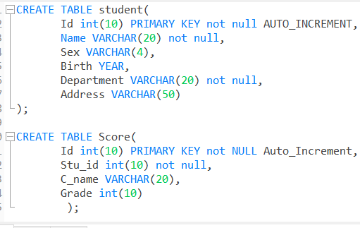

为两个表插数据：

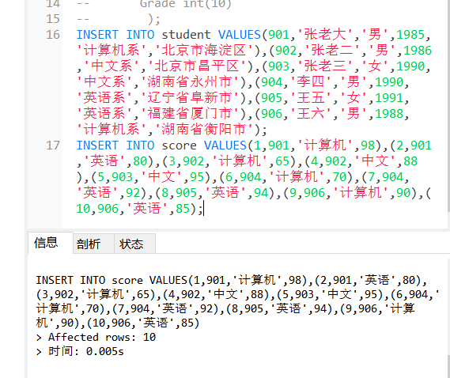

修改score表906的英语成绩为68分：

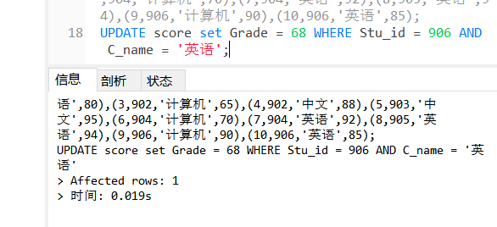

删除计算机成绩为65分的数据：

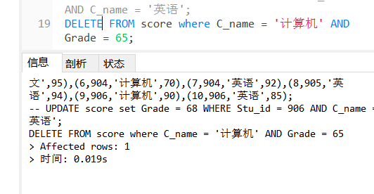

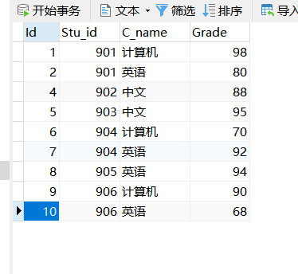

从Student表中查询计算机系和英语系的学生的信息

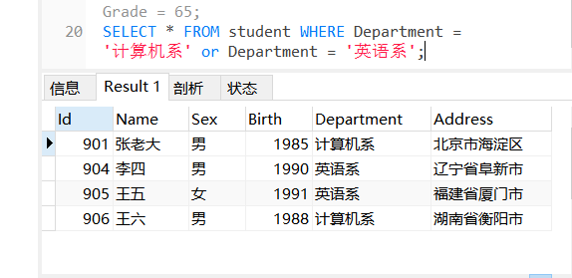

从student表中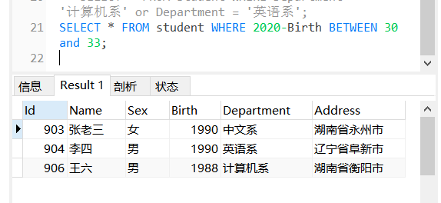查询年龄30~33岁之间的学生信息

完整代码：

CREATE TABLE student(

Id int(10) PRIMARY KEY not null AUTO_INCREMENT,

Name VARCHAR(20) not null,

Sex VARCHAR(4),

Birth YEAR,

Department VARCHAR(20) not null,

Address VARCHAR(50)

);

CREATE TABLE Score(

Id int(10) PRIMARY KEY not NULL Auto_Increment,

Stu_id int(10) not null,

C_name VARCHAR(20),

Grade int(10)

);

INSERT INTO student VALUES(901,'张老大','男',1985,'计算机系','北京市海淀区'),(902,'张老二','男',1986,'中文系','北京市昌平区'),(903,'张老三','女',1990,'中文系','湖南省永州市'),(904,'李四','男',1990,'英语系','辽宁省阜新市'),(905,'王五','女',1991,'英语系','福建省厦门市'),(906,'王六','男',1988,'计算机系','湖南省衡阳市');

INSERT INTO score VALUES(1,901,'计算机',98),(2,901,'英语',80),(3,902,'计算机',65),(4,902,'中文',88),(5,903,'中文',95),(6,904,'计算机',70),(7,904,'英语',92),(8,905,'英语',94),(9,906,'计算机',90),(10,906,'英语',85);

UPDATE score set Grade = 68 WHERE Stu_id = 906 AND C_name = '英语';

DELETE FROM score where C_name = '计算机' AND Grade = 65;

SELECT * FROM student WHERE Department = '计算机系' or Department = '英语系';

SELECT * FROM student WHERE 2020-Birth BETWEEN 30 and 33;