# 1.创建student和score表

## 创建student

CREATE TABLE Student (

Id INT ( 10 ) PRIMARY KEY NOT NULL AUTO_INCREMENT,

Name VARCHAR ( 20 ) NOT NULL,

Sex VARCHAR ( 4 ),

Birth YEAR,

Department VARCHAR ( 20 ) NOT NULL,

Address VARCHAR ( 50 )

) ENGINE = INNODB DEFAULT CHARSET = utf8;

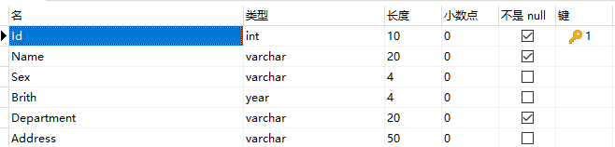

## 创建score表

CREATE TABLE Score(

Id INT(10) PRIMARY KEY NOT NULL AUTO_INCREMENT,

Stu_id INT(10) NOT NULL,

C_name VARCHAR(20),

Grade INT(10)

)ENGINE = INNODB DEFAULT CHARSET = utf8;

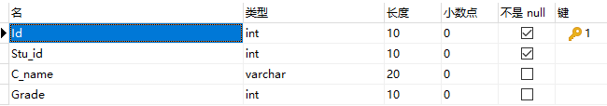

# 2.为student表和score表增加记录

## student表添加

INSERT INTO Student ( id, NAME, sex, birth, department, address )

VALUES

( 901, '张老大', '男', 1985, '计算机系', '北京市海淀区' ),

( 902, '张老二', '男', 1986, '中文系', '北京市昌平区' ),

( 903, '张三', '女', 1990, '中文系', '湖南省永州市' ),

( 904, '李四', '男', 1990, '英语系', '辽宁省阜新市' ),

( 905, '王五', '女', 1991, '英语系', '福建省厦门市' ),

( 906, '王六', '男', 1988, '计算机系', '湖南省衡阳市' );

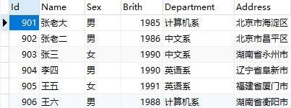

## score表添加

INSERT INTO score(Stu_id,C_name,Grade)

VALUES

(901, '计算机',98),

(901, '英语', 80),

(902, '计算机',65),

(902, '中文',88),

(903, '中文',95),

(904, '计算机',70),

(904, '英语',92),

(905, '英语',94),

(906, '计算机',90),

(906, '英语',85);

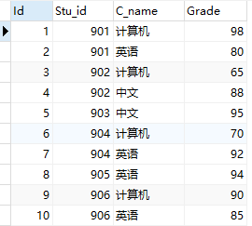

# 3.修改score表906的英语成绩为68分

UPDATE score

SET Grade = 68

WHERE

Stu_id = 906;

SELECT

id,

Stu_id,

C_name,

Grade

FROM

score

WHERE

Stu_id = 906;

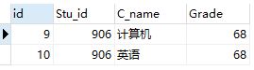

# 4.删除计算机成绩为65分的数据

DELETE

FROM

score

WHERE

C_name = '计算机'

AND Grade = 65;

SELECT

*

FROM

score

WHERE

C_name = '计算机';

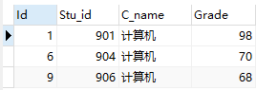

# 5.从student表中查询计算机系和英语系的学生的信息

SELECT

id AS '学号',

NAME AS '姓名',

sex AS '性别',

birth AS '出生年份',

department AS '院系',

address AS '家庭住址'

FROM

student

WHERE

department = '计算机系'

OR department = '英语系';

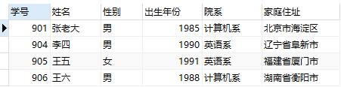

# 6.从student表中查询年龄18~22岁的学生信息

INSERT INTO Student ( id, NAME, sex, birth, department, address )

VALUES

( 901, '伍貌腥', '男', 2002, '飞行技术系', '汕头市金平区' ),

( 902, '成巢韬', '男', 1998, '挖掘机系', '揭阳市普宁市' ); #先插入符合要求的数据

#查询方式1，无临时表

SELECT

id AS '学号',

NAME AS '姓名',

sex AS '性别',

birth AS '出生年份',

department AS '院系',

address AS '家庭住址',

YEAR ( CURDATE( ) ) - birth AS '年龄'

FROM

student

WHERE

YEAR ( CURDATE( ) ) - birth >= 18

AND YEAR ( CURDATE( ) ) - birth <= 22;

#YEAR(DATE)获取日期中的年份，CURDATE()获取当前日期

#查询方式2，有临时表

SELECT

stu.Id AS '学号',

stu.`Name` AS '姓名',

stu.Sex AS '性别',

stu.Birth AS '出生年份',

stu.Department AS '院系',

stu.Address AS '家庭住址',

tb_age.age AS '年龄'

FROM

( SELECT id, YEAR ( CURDATE( ) ) - birth AS age FROM student ) AS tb_age,

student AS stu

WHERE

tb_age.id = stu.Id AND tb_age.age >=18 AND tb_age.age <=22;

