1. 创建student和score表

CREATE TABLE Student (

id INT(10) NOT NULL AUTO_INCREMENT ,

NAME VARCHAR(20) NOT NULL,

Sex VARCHAR(4),

birth YEAR,

Department VARCHAR(20) NOT NULL,

Address VARCHAR(50),

PRIMARY KEY (id)

);

CREATE TABLE Score (

id INT(10) NOT NULL AUTO_INCREMENT COMMENT '编号',

Stu_id INT(10) NOT NULL COMMENT '学号',

C_name VARCHAR(20) COMMENT '课程名',

Grade INT(10) COMMENT '分数',

PRIMARY KEY (id)

);

1. 为student表和score表增加记录

INSERT INTO Student VALUE(901,'张老大','男',1985,'计算机系','北京市海淀区'),

(902,'张老二','男',1986,'中文系','北京市昌平区'),

(903,'张三','女',1990,'中文系','湖南省永州市'),

(904,'李四','男',1990,'英语系','辽宁省阜新市'),

(905,'王五','女',1991,'英语系','福建省厦门市'),

(906,'王六','男',1988,'计算机系','湖南省衡阳市');

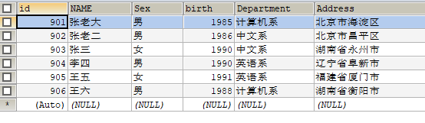

INSERT INTO score (id, Stu_id, C_name, Grade) VALUE (1, 901, '计算机', 98),

(2, 901, '英语', 80),

(3, 902, '计算机', 65),

(4, 902, '中文', 88),

(5, 903, '中文', 95),

(6, 904, '计算机', 70),

(7, 904, '英语', 92),

(8, 905, '英语', 94),

(9, 906, '计算机', 90),

(10, 906, '英语', 85) ;

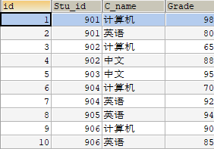

1. 修改score表906的英语成绩为68分

UPDATE score SET Grade = 68 WHERE Stu_id = 906 AND C_name = '英语';



1. 删除计算机成绩为65分的数据

DELETE FROM score WHERE Grade = 65 AND C_name = '计算机';

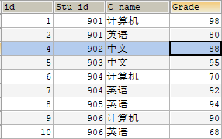

1. 从student表中查询计算机系和英语系的学生的信息

SELECT * FROM Student WHERE Department IN('计算机系','英语系');

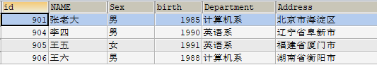

1. 从student表中查询年龄18~22岁的学生信息

SELECT * FROM Student WHERE (2020 - birth) BETWEEN 18 AND 22;