Part 1

* “What should the solved maze look like when I’m done?”
  + Something like this:  
     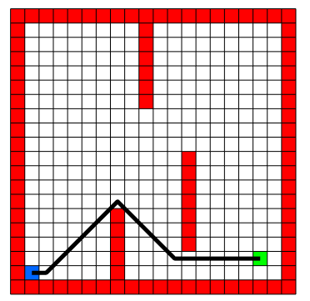
* “I’m getting very weird paths. What’s wrong?”
  + Check your calculation of path cost. Depending on how you’re calculating things, it may be useful to create a separate “path_cost_array” to store these values

1.1:

1.2:

1.3:

* Why is the from_array 3 dimensional?
  + that is so that the from_array can hold the x,y coordinates of the node that expanded it. Let’s say that node (Nx,Ny) was expanded from node (Ox, Oy). To get the coordinates of the node that expanded node (Nx,Ny), you would find Ox = from_array(Nx, Ny, 1) and Oy = from_array(Nx, Ny, 2)

1.4:

1.5: