**CHAPTER III**

**RESEARCH METHODOLOGY AND DESIGN**

This chapter presents theories associated with obtaining necessary to be used in this study, software methodology, research design, and system development phases which include the planning, design, development, testing, deployment, and review.

**Environment**

The study took place at the Muslim Affairs Office, Municipal Compound, Tupi, South Cotabato.

**Software Methodology**

The System Agile Development Life Cycle will be used in the software development for the completion of MAO Infosys. The said model comprises six (6) phases, which include;

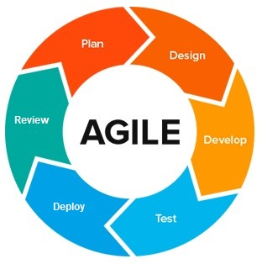

*Figure 3.0 Software Model: SDLC Model for MAO Infosys that illustrates the System Development Process.*

**System Development Phases**

**Planning**

**Planning for S.O.1** (Provide module for posting/delivering information, news reports, and current events to the Muslim Community.)

To simplify Muslim Affairs Office information, the researchers strategized to create an easy-to-use method of posting/delivering information, news reports, and current events to the Muslim Community.

**Planning for S.O.2** (Easily find the records so that it is accurate, complete, accessible, and usable.)

To enhance the documentation process, the researchers have strategized to associate the Muslim Affairs staff with an automated system, ensuring the correct process.

**Planning for S.O.3** (Provide received reports.)

To enhance the information accuracy and efficiency, the researchers have strategized for the system to receive and automatically record all information and reports that have been submitted.

**Planning for S.O.4** (Generate a module for a messaging forum where the Muslim community can interact and report any problems/cases that need help or assistance immediately.)

To ensure that the moderator stays informed about reliable information or messages, the researchers have strategized to include a message bot with a notification in the system on every message sent.

**Planning for S.O.5** (Generate information and statistical reports.)

To simplify data management, the researchers have strategized to automatically generate information, and statistical reports, to evaluate for making it easy for the moderator to analyze data and make informed decisions.

**Design**

**Design for S.O.1** (Provide module for posting/delivering information, news reports, and current events to the Muslim Community.)

In the design phase, the researchers conceptualize an easy-to-use effective method of posting/delivering detailed information to the Muslim Community.

**Design for S.O.2** (Easily find the records so that it is accurate, complete, accessible, and usable.)

In the design phase, the researchers aim to design an automated information system for everyday clients' activities, and events. This design is intended to enhance the accuracy and efficiency of easy access records.

**Design for S.O.3** (Provide receive reports)

In the design phase, the researchers have planned for the system to automatically provide and keep detailed information for the community to easily identify.

**Design for S.O.4** (Generate a module for a messaging forum where the Muslim community can interact and report any problems/cases that need help or assistance immediately.)

In the design phase, the researchers aim to provide a message booth or messenger for easy access to send/reply important information anytime anywhere.

**Design for S.O.5** (Generate information and statistical reports.)

In the design phase, the researchers aim to design a system to automatically generate information, and statistical reports, to evaluate and analyze data and make informed decisions.

**Development**

**Development for S.O.1** (Provide module for posting/delivering information, news reports, and current events to the Muslim Community.)

In the development phase, the researchers work on creating an easy-to-use information system that has an effective method of posting/delivering detailed information to the Muslim Community.

**Development for S.O.2** (Easily find the records so that it is accurate, complete, accessible, and usable.)

In the development phase, the researchers work on building an automated system to associate each Muslim Affairs staff with an automated system, enhancing accuracy and efficiency.

**Development for S.O.3** (Provide received reports.)

In the development phase, the researchers focus on building a system that automatically record all submitted detailed information.

**Development for S.O.4** (Generate module for messaging forum where the Muslim community can interact and report any problems/cases that need help or assistance immediately.)

In the development phase, the researchers implement message booth in the system. This feature ensures that the moderator can interact, send/reply about any problems/cases reported that need help or assistance immediately.

**Development for S.O.5** (Generate information and statistical reports.)

In the development phase, the researchers work on implementing a system that automatically generate information, and statistical reports, to evaluate for making it easy for the moderator to analyze data and make informed decisions.

**Testing**

**Testing for S.O.1** (Provide module for posting/delivering information, news reports, and current events to the Muslim Community.)

In the testing phase, the researchers evaluate the easy-to-use information system functionality that has an effective method of posting/delivering information to the Muslim Community.

**Testing for S.O.2** (Easily find the records so that it is accurate, complete, accessible, and usable.)

In the testing phase, the researchers validate the automated system’s functionality, enhancing accuracy and efficiency.

**Testing for S.O.3** (Provide received reports.)

In the testing phase, the researchers validate the information system that receives and automatically records all information and reports that have been submitted.

**Testing for S.O.4** (Generate module for messaging forum where the Muslim community can interact and report any problems/cases that need help or assistance immediately.)

In the testing phase, the researchers assess the message booth features performance in the system on every message sent/information reported. They verified that the feature can send/reply immediately about any problems/cases reported that need help or assistance immediately.

**Testing for S.O.5** (Generate information and statistical reports.)

In the testing phase, the researchers evaluate the functionality of the implemented system that automatically generate information, and statistical reports, to evaluate for making it easy for the moderator to analyze data and make informed decisions.

**Deployment**

**Deployment for S.O.1** (Provide module for posting/delivering information, news reports, and current events to the Muslim Community.)

In the deployment phase, the researchers introduced to the intended users, ensuring that the easy-to-use information system has an effective method of posting/delivering information to the Muslim Community.

**Deployment for S.O.2** (Easily find the records so that it is accurate, complete, accessible, and usable.)

In the deployment phase, the automated information system is made accessible to the users. This deployment aims to ensure to easily find the records so that it is accurate, complete, accessible, and usable.

**Deployment for S.O.3** (Provide received reports.)

In the deployment phase, the researchers make the information system available to the users, ensuring that can receive and automatically records all information and reports that have been submitted.

**Deployment for S.O.4** (Generate module for messaging forum where the Muslim community can interact and report any problems/cases that need help or assistance immediately.)

In the deployment phase, the message booth feature is activated and accessible to the users. This deployment makes sure that the moderator can send/reply immediately to any problems/cases reported that need help or assistance immediately.

**Deployment for S.O.5** (Generate information and statistical reports.)

In the deployment phase, the researchers activated the functionality of the implemented system that automatically generate information, and statistical reports, to evaluate for making it easy for the moderator to analyze data and make informed decisions.

**Review**

**Review for S.O.1** Provide module for posting/delivering information, news reports, and current events to the Muslim Community.)

In the review phase, the researchers ensure the functionality of the easy-to-use information system has an effective method of posting/delivering information to the Muslim Community. This ongoing review ensures the system's accuracy and efficiency in posting/delivering detailed information to the public.

**Review for S.O.2** (Easily find the records so that it is accurate, complete, accessible, and usable.)

In the review phase, the automated information system is monitored and updated. This review aims to enhance record accuracy, complete, accessible, and usable.

**Review for S.O.3** (Provide received reports.)

In the review phase, the researchers continue to monitor the information system, ensuring it to receives and automatically records all information and reports that have been submitted.

**Review for S.O.4** (Generate module for messaging forum where the Muslim community can interact and report any problems/cases that need help or assistance immediately.)

In the review phase, the message booth feature is always monitored and maintained. This review regularly updates and supports to make sure that the moderator can send/reply messages immediately about any problems/cases reported that need help or assistance immediately.

**Review for S.O.5** (Generate information and statistical reports.)

In the review phase, the researchers reviewed the functionality of the implemented system that automatically generate information, and statistical reports, to evaluate for making it easy for the moderator to analyze data and make informed decisions. This review ongoing support and updates are provided.

|  |  |  |  |  |  |
| --- | --- | --- | --- | --- | --- |
| **Key Partners** | **Key Activities** | **Value Proposition** | | **Customer Relationships** | **Customer Segments** |
| Muslim Affairs Office | System Development  Research and Development  **Key Resources**  Technology Infrastructure  Human Resources  Financial | Provide received reports.  Provide module easily finding records.  Provide posting/delivering information, news reports, and current events.  Generate module messaging forum.  Generate information and statistical reports | | AUTOMATED SERVICES  **Channels**  PERSONAL COMPUTER | Client  Admin |
| **Cost Structure**  System Development Cost  Professional Services  Transportation Expense  Research and Development Expenses | | | **Revenue Streams**  Maintenance fee  System fee  Upgrade fee | | |

**Business Model Canvas**

*Figure 3.1: MAO Infosys Business Model Canvas*

*This is the strategic management and lean startup template for the development of the Muslim Affairs Office Information System (MAO Infosys). This is the overview that lays out both what is the system for and how it will run.*

**Gantt Chart**

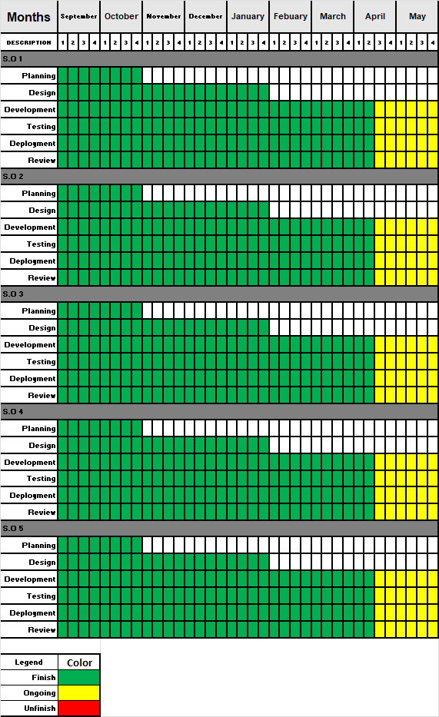

*Figure 3.2: Gantt chart*

*This chart illustrates this capstone project’s schedule. This illustrates the start and ending week of the terminal elements and summary elements of the project. Terminal elements and summary elements comprise the work breakdown structure of the development of the system.*

**FUNCTIONAL DECOMPOSITION DIAGRAM**

*Figure 3.2: Functional Decomposition Diagram*

*\*This figure shows the flow of the Muslim Affairs Office Information System (MAO Infosys)*

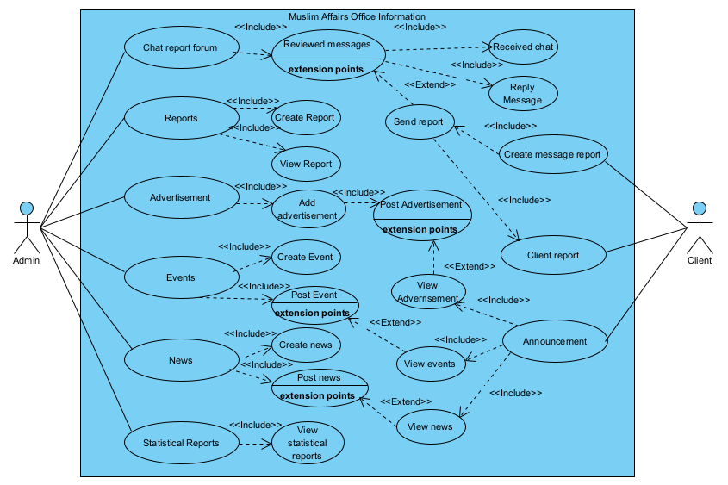**USE CASE DESIGN PHASE**

*Figure 3.3 MAO Information System Use Case Design*

*A use case diagram is a graphical depiction of a user's possible interactions with a system.*

**Use Case Matrix**

|  |  |
| --- | --- |
| **GENERAL CHARACTERISTICS** | |
| **Intent** | To identify the purpose of the features that Muslim Affairs Office Information System has. |
| **Scope** | The scope of this Use Case is Admin and Client only |
| **Level** | 2nd Level |
| **Author** | Marzon, Jorefe D., Sacandal, Sulayman A., and Zolina, Arzel John R. |
| **Last Update** | March 15, 2024 |
| **Status** | Ongoing |
| **Primary Actor** | Admin, it is the one who will use the system |
| **Secondary Actor** | Client, it is the one who is responsible to use for viewing the announcement and sending report |
| **Precondition** | The developer must assist the admin for using this system especially on Muslim Affairs Office Information System |
| **<Dynamic Precondition>** | The admin must explore the system for them to memorize all the functions that run without having a problem. |
| **Assumptions** | All the Dynamic Preconditions are already running successfully |
| **Trigger** | When the admin login their accounts and when the client starts to sending message as a source of reports. |
| **Success Post Condition** | After the admin login their account, all the function and features that based on the current problem was running successfully without any preconditions. |
| **Failed Post Condition** | Other modules are still on progress. |
| **<Model>** | Use Case Matrix |
| **Operation Concepts** | In implementing this system, the system must run according to the features that the developers gathered in observing the current problem in the respondent. Those function will be going to help the Muslim Affairs Office to reach the goals in recording the client reports. |
| **Overview** | All Characteristics are still in progress, analyzing all those common errors will make this system flow smoothly before implementing it. |

*Table 3.1*  *Muslim Affairs Office Information System Use Case Matrix*

**STORYBOARD**

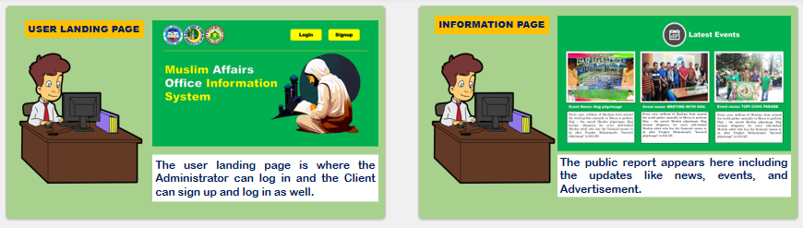

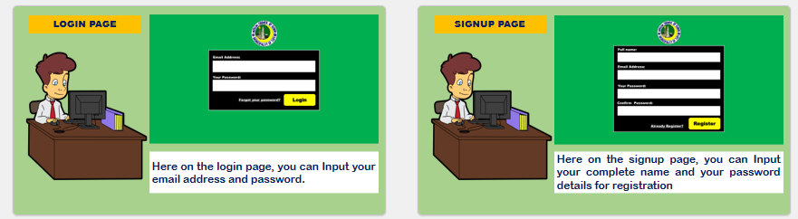

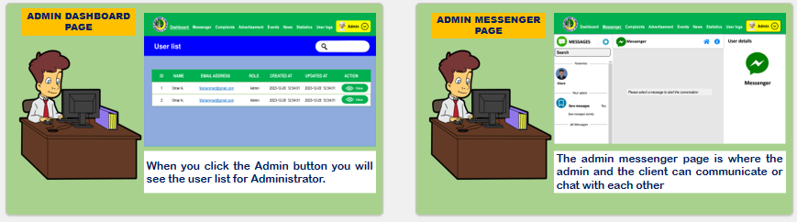

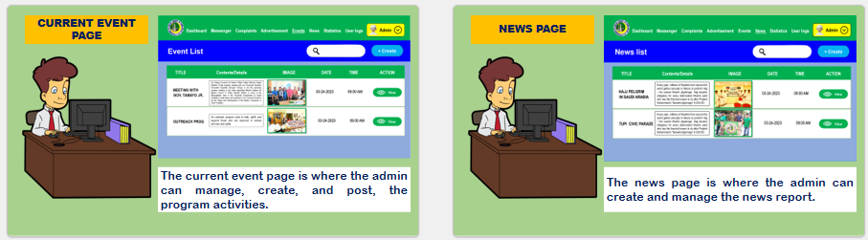

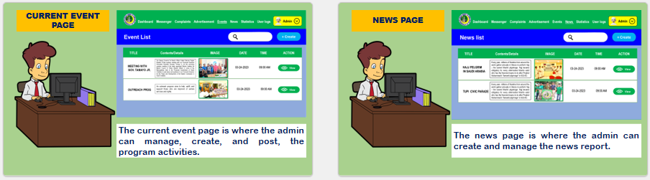

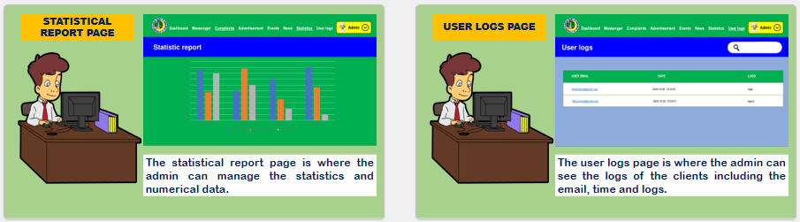

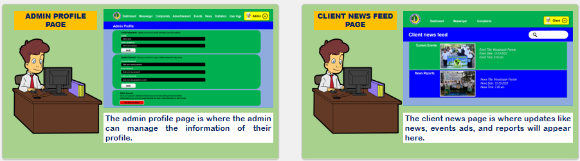

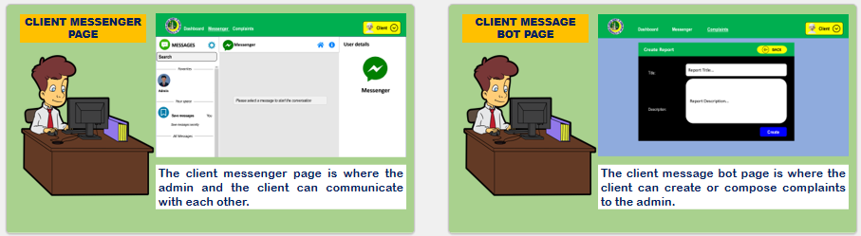

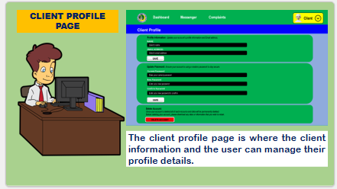

*Figure: 3.7.0 Muslim Affairs Office Information System Story boarding in to the system.*

**Forms**

**Login Page**

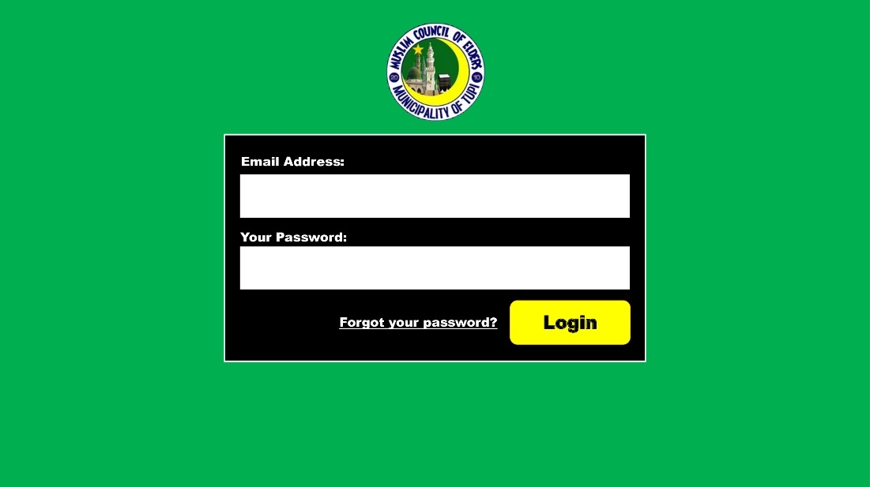

**Signup Page**

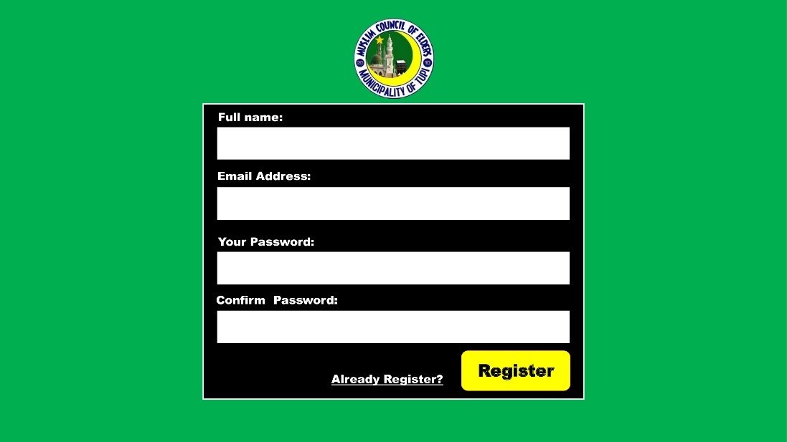

*Figure 3.7.1 this signup page is where the client registers to the system.*

**Reports**

**Admin Reports Page**

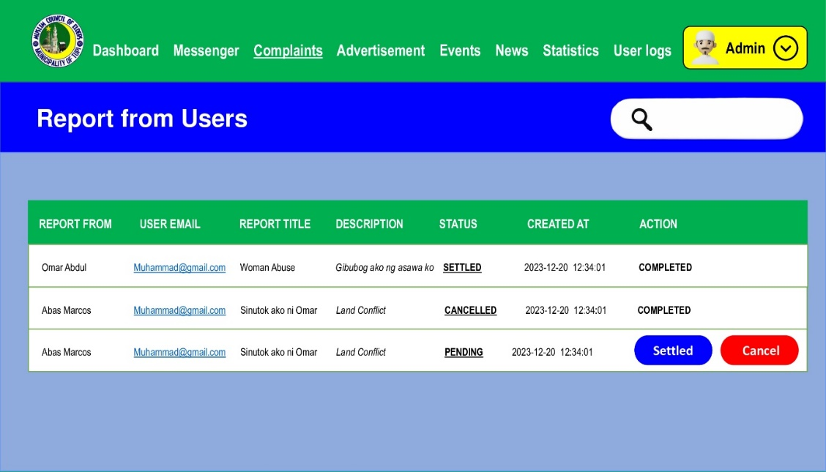

*.*

**Statistical Report Page**

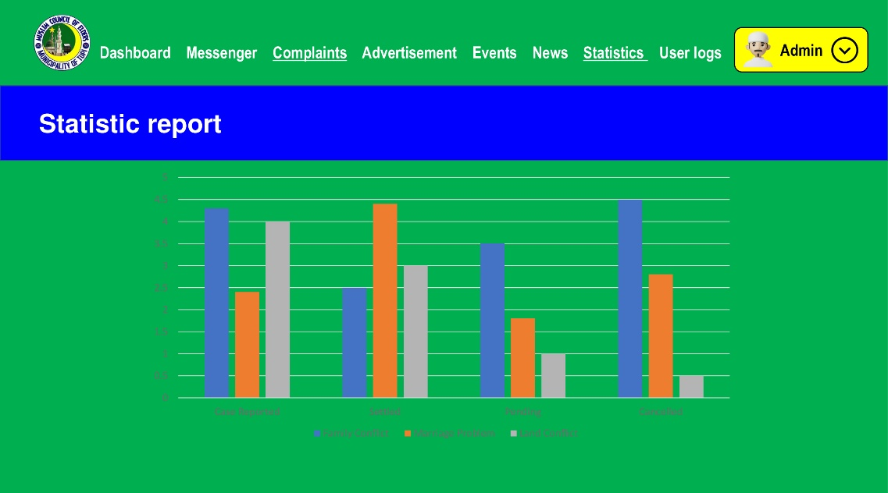

*Figure 3.7.2 this statistical report page where you can see the number of cases that have been solved or settled.*

**Database Design**

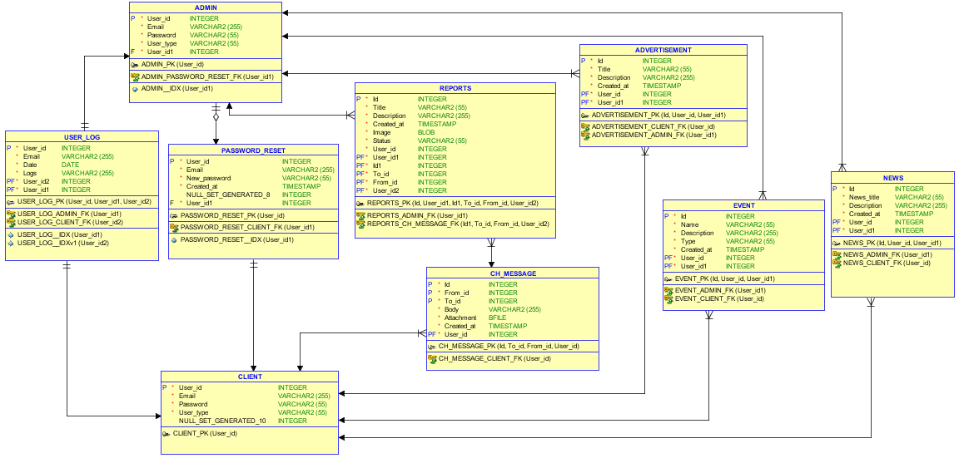

*Figure 3.8.0 MAO Infosys Database Design*

*\*This figure will determine what MAO Infosys data must be stored and how the data will be managed accordingly.*

**Entity Relationship Diagram**

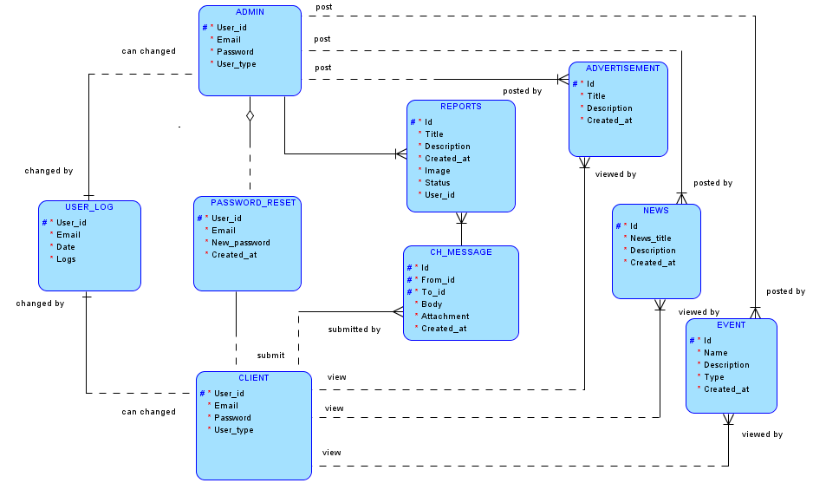

*Figure 3.7.1 MAO Infosys Entity Relationship Diagram to depict relationships among the user’s, object, concepts, or events within the MAO Infosys.*

**Data Dictionary**

|  |  |  |  |  |
| --- | --- | --- | --- | --- |
| **Table name** | **Admin** | | | |
| **Attribute** | **Type** | **Null** | **Default** | **Description** |
| User_id | int (11) | No | PK | Indicates the ID of the user |
| Email | varchar (255) | No |  | User’s email |
| Password | varchar (55) | No |  | User’s password |
| User_type | varchar (55) | No |  | Type of a user’s being login to the system |

*Table 3.2.0* *Data Dictionary User Table of the MAO Infosys*

|  |  |  |  |  |
| --- | --- | --- | --- | --- |
| **Table name** | **Reports** | | | |
| **Attribute** | **Type** | **Null** | **Default** | **Description** |
| id | int (11) | No | PK | Indicates the ID of the reports table |
| Title | varchar (55) | No |  | Title of a report |
| Description | varchar (255) | No |  | Reports description |
| Created_at | timestamp | No |  | Created report timestamp |
| Image | imagge (55) | No |  | Reported image |
| Status | varchar (55) | No |  | Report status (settled/unsettled) |
| User_id | int (11) | No | FK | User’s id |

*Table 3.2.1 Data Dictionary Report Table of the MAO Infosys*

|  |  |  |  |  |
| --- | --- | --- | --- | --- |
| **Table name** | **Password_reset** | | | |
| **Attribute** | **Type** | **Null** | **Default** | **Description** |
| User_id | int (11) | No | PK | Indicates the ID of the user |
| Email | Varchar (255) | No |  | Email of a user |
| New_password | Varchar (55) | No |  | Created new password |
| Created_at | Time_stamp | No |  | Password created at timestamp |

*Table 3.2.2 Data Dictionary Password Reset Table of the MAO Infosys*

|  |  |  |  |  |
| --- | --- | --- | --- | --- |
| **Table name** | **Event** | | | |
| **Attribute** | **Type** | **Null** | **Default** | **Description** |
| Id | int (11) | No | PK | Event id |
| Name | varchar (55) | No |  | Event name |
| Description | varchar (255) | No |  | Event description |
| Type | varchar (55) | No |  | Type of event |
| Created_at | timestamp | No |  | Event created timestamp |

*Table 3.2.3 Data Dictionary Event Table of the MAO Infosys*

|  |  |  |  |  |
| --- | --- | --- | --- | --- |
| **Table name** | **Ch_message** | | | |
| **Attribute** | **Type** | **Null** | **Default** | **Description** |
| Id | int (11) | No | PK | Indicates the ID of the reports table |
| From_id | int (11) | No | FK | Indicates the PF ID of the event table |
| To_id | int (11) | No | FK | Indicates the PF ID of the event table |
| Body | Varchar (255) | No |  | Body of messages |
| Attachment | bfile | No |  | Attachment of the file |
| Created_at | timestamp | No |  | Created message timestamp |

*Table 3.2.4 Data Dictionary Chat Message Table of the MAO Infosys.*

|  |  |  |  |  |
| --- | --- | --- | --- | --- |
| **Table name** | **Advertisement** | | | |
| **Attribute** | **Type** | **Null** | **Default** | **Description** |
| Id | int (11) | No | PK | Advertisement id |
| Title | varchar (55) | No |  | Title of advertisement |
| Description | varchar (255) | No |  | Description of advertisement |
| Created_at | timestamp | No |  | Advertisement creation timestamp |

*Table 3.2.5 Data Dictionary Advertisement Table of the MAO Infosys*

|  |  |  |  |  |
| --- | --- | --- | --- | --- |
| **Table name** | **News** | | | |
| **Attribute** | **Type** | **Null** | **Default** | **Description** |
| Id | int (11) | No | PK | Id of news |
| Title | varchar (55) | No |  | News title |
| Description | varchar (255) | No |  | News description |
| Created_at | timestamp | No |  | News created at |

*Table 3.2.6 Data Dictionary News Table of the MAO Infosys*

|  |  |  |  |  |
| --- | --- | --- | --- | --- |
| **Table name** | **User_log** | | | |
| **Attribute** | **Type** | **Null** | **Default** | **Description** |
| id | int (11) | No | PK | Id of user |
| Email | varchar (255) | No |  | Email of user |
| Date | date | No |  | Date of user who logs |
| Logs | timestamp | No |  | Logs of user login/logout |

*Table 3.2.7 Data Dictionary User Logs Table of the MAO Infosys*

|  |  |  |  |  |
| --- | --- | --- | --- | --- |
| **Table name** | **Users** | | | |
| **Attribute** | **Type** | **Null** | **Default** | **Description** |
| User_id | int (11) | No | PK | Indicates the ID of the user |
| Email | varchar (255) | No |  | User’s email |
| Password | varchar (55) | No |  | User’s password |
| User_type | varchar (55) | No |  | Type of a user’s being login to the system |

*Table 3.2.8 Data Dictionary User Table of the MAO Infosys*

**Network design**

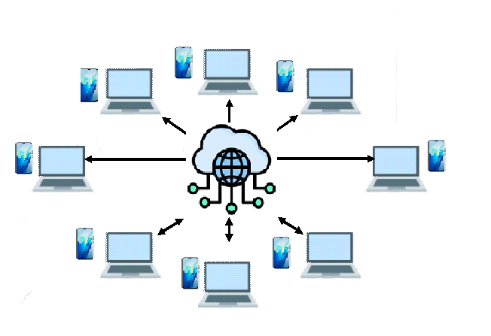Network design is the integration of different network devices to achieve end-to-end communication between network hosts, and to identify what type of topology is going to be used in the Muslim Affairs Office Information System (MAO Infosys).



*Figure 3.9.0 MAO Infosys Networking design*

**Network topology**

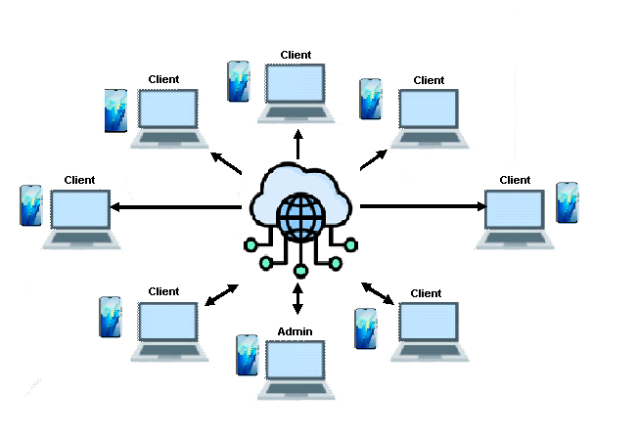The network model that will be used is the star topology model, in a star topology, the messages and each component are directly connected to the central hub that acts as a server and the connecting nodes as a client.



*Figure 3.9.1 MAO Infosys Networking Topology*

**Development/Construction/Build Phase**

**Technological Stack**

***Figure 3.10:*** *MAO Infosys Technology Stack*

**Software Specification**

Language : PHP

Technology : HTML, CSS FRAMEWORK, JS, AND PHP

Database : MySQL WAMP Server

IDE : Sublime Text

Operating System : Microsoft Windows 10

**Hardware Specification**

1. Processor : Inter® Core™ i3-6006U
2. Hard Disk : 464GB
3. RAM : 8192MB

**Program Specification**

Language : PHP

Database : MySQL Wamp

IDE : Sublime Text

**List of modules**

**Managed chat forum Module**

The chat forum module enables clients to have text-based, real-time synchronous discussions about reports. The Chat module contains several features for managing and reviewing chat discussions of the admin. The Messenger Management Module allows the moderator and the client to interact with each other to send and reply to messages.

**Managed Reports Module**

Reports module can be generated through a list from client reports provided in the system data can be mined from any easily accessible field in the system to ensure efficient storage and organization of document report records.

**Managed Advertisement Module**

Advertising module users are allowed to access all the information to view advertisements. The information or messages conveyed through advertising are essential to the decision-making public.

**Managed Events Module**

The events module allows a client to come alive and the admin provides or posts about current events for information.

**Managed News Module**

Under the news module, the client can see the list of all news about the admin on the news section.

**Managed Statistical Reports Module**

The statistical report management module keeps the moderator informed manages the detailed report submitted and makes decisions.

**References (30 sources)**

Adi P., Permana G.; Dewanti, P. (2019) Resident Information Systems. https://ieeexplore.ieee.org/abstract/document/8874930

Baballe, M. A. and Bello M., (2021) Impact and Challenges of Implementing Management Information System. https://www.researchgate.net/publication/357368016_Impact_and_Challenges_of_Implementing_Management_Information_System

Carpio, C. (2020) - Barangay Management System. ‖ International Journal of Multidisciplinary Research and Publications (IJMRAP), 3(2), 26–32. http://ijmrap.com/wp-content/uploads/2020/07/IJMRAP-V3N1P78Y20.pdf

Dela Merced J. and Pagtaconan W. C. (2022, August 8) Development of an Information Systems for the Municipality of Nueva Era, Ilocos Norte. IJISRT22AUG220 (1)_(1).pdf

Jamis, M. N., Coloma, C. R., Cabanlit, P. J. Q., Balanay, R. V., Menor, S. R. N., Yabut, E. R., & Caluya, S. S. (2022, December 1). One Barangay: A Mobile And Web Barangay Management System. IEEE Xplore. https://doi.org/10.1109/iCORE58172.2022.00055

Hendriyati, P., Agustin, F., Rahardja, U., & Ramadhan, T. (2021). Management Information Systems on Integrated Student and Lecturer Data. Aptisi Transactions on Management (ATM), 6(1), 1–9. https://doi.org/10.33050/atm.v6i1.1527

Gallera J., (2023 July 2) Resident Information Management System for Local Barangay in Surigao City. https://ijarsct.co.in/Paper12173.pdf

Gcora N. and Chigona W., (2019 Feb. 11) Evaluation and challenges of Integrated Financial Management Information Systems for municipalities in South Africa. https://hdl.handle.net/10520/EJC-1d06b61038

Mabanta M. J., (2022 October 15), Development of Village Management Information System for Brgy. Matungao, Bulakan, Bulacan. https://papers.ssrn.com/sol3/papers.cfm?abstract_id=4232209

Macapeges H., (2019) Management Information System in the Medical Service of a Provincial Hospital. Madayaw. https://ejournals.ph/article.php?id=17848

Mukhtar, M., Sudarmi, S., Wahyudi, M., & Burmansah, B. (2020). The Information System Development Based on Knowledge Management in Higher Education Institution. International Journal of Higher Education, 9(3), 98. https://doi.org/10.5430/ijhe.v9n3p98

Tolulope, E., and Haliso, Y. (2019). Role of Government in the Provision of Information System and Services in Nigeria (p.2421). https://digitalcommons.unl.edu/cgi/viewcontent.cgi?article=5909&context=libphilprac

**CURRICULUM VITAE**



**Jorefe D. Marzon**

Barangay Liberty, Tampakan South Cotabato jorefmarzon28@gmail.com

+63 9056225679

**PERSONAL INFORMATION**

Name : Jorefe D. Marzon

Birthdate : November 28, 2001

Sex : Female

Civil Status : Single

Citizenship : Filipino

Religion : Catholic

Ethnicity : Cebuano

Father’s Name : Joemarie M. Marzon

Mother’s Name : Fe D. Marzon

**Educational Background**

Tertiary: Bachelor of Science Information Technology

South East Asian Institute of Technology- SEAIT

2020 – Present

Senior High: Liberty National High School

Junior High: Liberty National High School

Barangay Liberty, Tampakan South Cotabato

2019 - 2020

Primary: Liberty Elementary School

Barangay Liberty Tampakan, South Cotabato

2013-2014

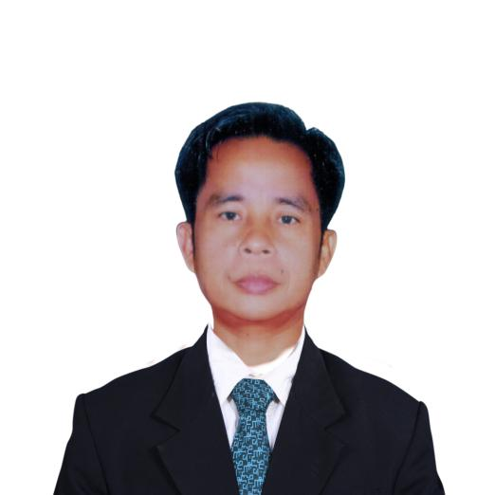

**Sulayman A. Sacandal**

Sitio Dahal, Palian, Tupi, South Cotabato

tengsacandal@gmail.com

+639159234799

**Personal Information**

Civil Status : Single

Date of Birth : May 5, 1973

Sex : Male

Nationality : Filipino

Dialect Spoken : Tagalog, Bisaya, Ilonggo, Maguindanaon

Religion : Islam

Father : Daud P. Sacandal

Mother : Maysara S. Andag-Sacandal

**Educational Background**

Tertiary : Bachelor of Science in Information Technology

(Associate in Information Technology)

South East Asian Institute of Technology, Incorporated

2020 – Present

College : Mindanao State University – General Santos City

Undergraduate – 1995-1996

Secondary : Tupi National High School,

1993 -1994

Elementary : Palian Elementary School,

1985 -1986

**Arzel John R. Zolina**

Purok Masagana,Brgy. Pagalungan, Polomolok South Cotabato

[Arzeljrz17@gmail.com](mailto:Arzeljrz17@gmail.com)

+639090937257

+639159234799

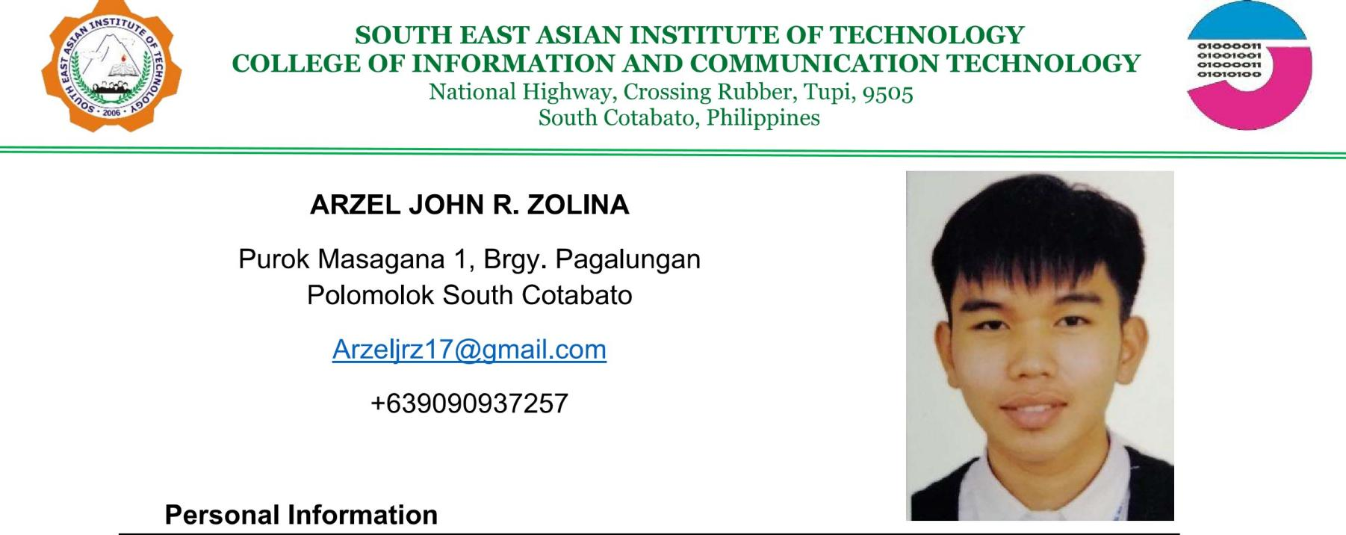**Personal Information**

Civil Status : Single

Date of Birth : September 10, 2001

Dialect Spoken : Filipino, Bisaya, Hiligaynon

Religion : Born Again

Father : Bernel S. Zolina

Mother : Rhodora S. Zolina

**Educational Background**

Tertiary : Bachelor of Science in Information Technology

South East Asian Institute of Technology, Incorporated

2020 – Present

Secondary : Southern Institute of Technical Education, Inc. Corner De Pedro, Balmores street, Koronadal City

　　 2019 - 2020

Elementary : Pagalungan Elementary School

　 Brgy. Pagalungan, Polomolok South Cotabato

　　 2013-2014

**APPENDICES**

**APPENDIX A**

**(Permission Letter)**

September 19, 2023

Muslim Council of Elders (MUSLIM AFFAIRS)

Local Government of Tupi (LGU)

Municipal Compound, Tupi, South Cotabato

Greetings of Peace!

We, the students of Bachelor of Science in Information Technology of South East Asian Institute of Technology, Inc. Are currently developing a PROJECT system as a requirement for our subject, IT 411: Capstone Project and Research 1.

In this connection, we would like to seek approval from your good office to allow us to conduct the project entitled Muslim Affairs Office Information System.

Furthermore, we would like to ask your permission to allow us to conduct the following:

1. Interview authorized personnel concerned with the information needed for this Project.
2. Take pictures to be used in the said system.

Any information that we may gather will be kept confidential and will be used for educational purposes only.

Your approval of our request is very much appreciated. Thank you and God bless!

Respectfully Yours,

**JOREFE D. MARZON SULAYMAN A. SACANDAL ARZEL JOHN R. ZOLINA**

Researcher (Hipster) Researcher (Hustler) Researcher (Hacker)

Noted by: Approved by:

**HERNIE B. DEDURO, LPT SULTAN RAHMAN P. EBRAHIM AL-HAJJ**

Project Adviser Deputy Governor for Muslim Affairs

**APPENDIX B**

**(Project Proposal)**

**Project Proposal**

**Name of Proponents:** Arzel John R. Zolina

Sulayman A. Sacandal

Jorefe D. Marzon

**1.0 Proposed Case Study Title**

**MAO Infosys**

(Muslim Affairs Office Information System)

**2.0 Area of Investigation**

Muslim Affairs Office, LGU - Tupi, South Cotabato

**3.0 Function of the Proposed System**

* Manage client input and secure/store clients' collected information
* Contact/send messages to report issues and concerns.
* Recording/storing of the information about the issues and concerns in the system.
* Show the news reports, updates, and information about the Muslim Affairs Office.
* Provide statistical reports
* Printing of (Memorandum of Agreement, Muslim Certificates, and Settlements reports.
* Saving Muslim ordinances, Muslim Community leader's information, and Muslim Community blotter reports.

**4.0 Cited Problems**

This study sought to answer the following problems false information and current events of the Muslim Affairs Office.

* Due to the difficulties of the Muslim Affairs Office to deliver Information to the community. In some instances, the Muslim community receives false information.
* Manual writing reports which are prone to human errors
* Due to the Muslim community not being able to easily contact or reach out to the Muslim Affairs Office.
* The Muslim community has difficulties giving information and reporting a problem/case to the Muslim Affairs Office immediately because of the distant places in South Cotabato
* No proper document storage.

**5.0 Features of the Proposed System**

* To provide a system that has an effective method of posting/delivering information that will lessen the difficulties of the Muslim Affairs Office in delivering information to the community.
* To provide a system that is automated to reduce human errors in manual written reports.
* To provide a system that receives and records all information and reports that have been submitted.
* To provide a system that has a message bot where the Muslim community can report any problems/cases that need help or assistance immediately.
* To provide a system that will automatically generate information, and statistical reports for the Muslim Affairs Office.

1. **Programming Language and Database**

Front End:

HTML, CSS, JavaScript

Back End:

PHP, MySQL

**7.0 Reason for the Choice**

To provide an efficient and reliable Information System to provide news reports, current events, and legal actions for the Muslim Affairs Office as it is accessible to the Muslim community.

**8.0 Importance of the Study**

**Organization**

To provide a suitable system to handle accurate reports, news, and current events in the Muslim Affairs Office.

**Community**

It would pose an advantage for the community since the system will ensure that information and current events of the Muslim Affairs Office are accessible online.

**Researcher**

The study will be used to provide training to the proponents to improve their insight and knowledge while designing a system. The researchers will improve their abilities, knowledge, and academic achievement as a result of their research.

**Future Researcher**

This Muslim Affairs Office Information System may serve as a reference for future researchers for the improvement of the system.

**9.0 Target User/Beneficiaries**

**Admin** – giving reliable information to the Muslim Community.

**Clients/Community** – for them to be able to easily access and be updatedabout the Muslim Affairs Office

**APPENDIX D**

**(Questioner)**

**APPENDIX E**

**(Map of Research Environment)**

**Map of Research Environment**

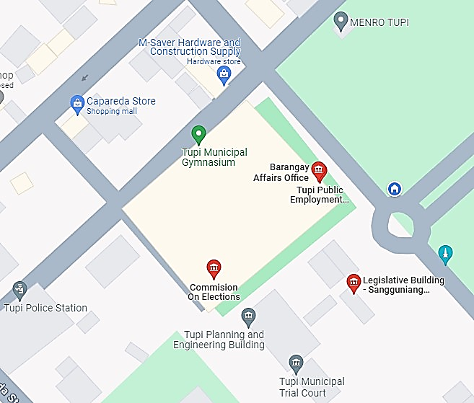



**Muslim Council of Elders – Muslim Affairs,**

Municipal Compound, Purok 8, Poblacion,Tupi, South Cotabato, 9505