

Fuzzy Logic and Fuzzy Systems -CW1  
***Designing and Tuning Fuzzy Inference Systems***

Dongchen Yao

psxdy2 - 20349894

CONTENT

1.Introduction 2

2. Language terms 2

3. Initial Model 2

3.1 Affiliation functions 3

3.2 Rules 3

3.3 Control surface 4

3.4 Change 4

3.4.1 Rules 4

3.4.2 Weights 5

3.4.3 Fuzzy method 5

4. Final model and details 5

4.1 Visualization of results 6

4.2 System explanation 7

5. Discussion of the final model 7

6. System interface diagram 8

7.Reference: 9

# 1.Introduction

This thesis is based on designing a hypothetical fuzzy inference system, in which the patient's temperature and the severity of the headache, are input into the system so as to determine whether the patient should be transferred to the hospital for an emergency examination.

In this paper, I have built a model by giving three terms of trapezoidal affiliation functions, specifying different rules and giving a rule table, and analyzing the initial part of the model by changing the rules, warrants, and performing fuzzification methods. How to go about changing the affiliation function is analyzed and the final model is determined. Images of the final affiliation function and control surfaces are given, and the system is explained. The last part of the article is a brief discussion of the system, describing the strengths and weaknesses, as well as giving the data metrics of the model graph, showing the system interface diagram, and determining the feasibility of the system.

# 2. Language terms

**Headache:** The title provides a discourse range of [0, 10] for the definition of the severity of headache.

**Temperature:** In an article by Cosinuss on body temperature it is mentioned that, the lower limit of body temperature is 27°C and the upper limit is 42°C, *(Cosinuss,2022)* so the discourse range of temperature is [27, 42].

**Tightness:** The title provides the discourse range of the definition of tightness as [0, 100].

# 3. Initial Model

A simple model is first created that not only roughly outlines the system and the significant pros and cons of the system, but also ensures that the final system is interpretable. When the system is introduced into a real medical situation, professionals verify the safety of the system's decision process and if it passes safety verification, the system is approved for application.

All linguistic terms are composed of simple shapes (trapezoid, Gaussian) with linear intersections for the overlaps. This helps to create a reasonable control interface.

Some ranges of temperature have no practical meaning according to a fixed and equal change of temperature units, and therefore cannot be divided into temperature intervals by equal division. We use the terms normal, two ranges above normal and two ranges below normal to describe temperature terms. In other words, five terms, high fever, low fever, normal, low temperature, and dangerously low temperature, are used to describe temperature.

Headache was divided into 3 linguistic terms in an equal division, because 5 terms are too many and have crossover and are not useful. Since headache is discrete, the 3 categories have a crossover at each boundary, allowing the creation of a fuzzy affiliation function. For emergencies, 5 terms were chosen and we divided 0 to 100 equally into 5 terms.

## 3.1 Affiliation functions

The initial affiliation functions of the three terms are selected as trapezoidal, trapezoidal and Gaussian affiliation functions (shown below), and later different affiliation functions are selected for iteration according to the performance of the affiliation functions, and then the final model is obtained.

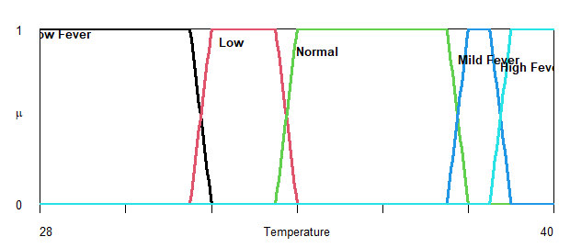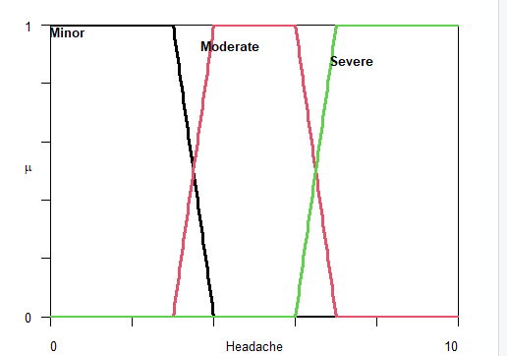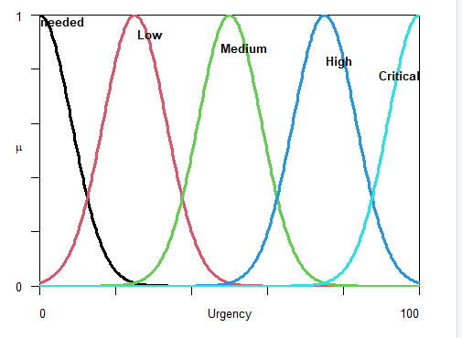

## 3.2 Rules

Based on the 5 temperature terms and 3 headache terms divided, there are then 15 different possibilities for rule combinations, with only a few rules in practice. In order to reduce the number of rule combinations, one rule was developed for each linguistic term, containing no other linguistic variables. This resulted in 8 simple relations. These 8 rules can be combined with a defuzzification approach to create a control surface that spans the entire domain of discourse. Control surfaces can be generated using the following rule list.

Table 1: Table of rules

|  |  |  |
| --- | --- | --- |
| linguistic variable | terminology | urgency |
| **Temperature** | Low risk | High |
|  | low temperature | Medium |
|  | normal | Unneeded |
|  | low fever | High |
|  | high fever | Critical |
| **Headache** | Minor | Low |
|  | Moderate | Medium |
|  | Severe | High |

## 3.3 Control surface

The final control surface is quite good, but there is still a problematic area. The red circle in the figure below is the problematic area, where the temperature rises to a more dangerous level, but the urgency is reduced; the headache rises to a dangerous level, but the urgency does not change significantly. In the other regions, the control surface follows the general idea initially proposed. There are several ways to try and improve the problem region, such as adjusting the range of regions for temperature (as we know from the previous affiliation function for temperature, the range is too wide for the low temperature case), changing/adding rules, changing the weight of the current rules, or changing the defuzzification method.

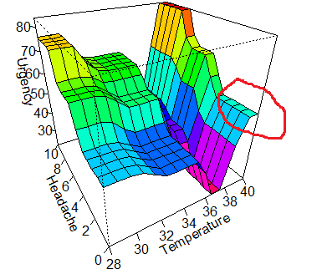

## 3.4 Change

### 3.4.1 Rules

There are a total of 15 possible combinations of temperature and headache rules for language terms. It is not practical to create rules for a certain combination.

so the initial 8 rules were retained.

### 3.4.2 Weights

Adjusting the weight of each rule is a good way to change the control surface. Temperature changes are more severe than changes in headache in terms of urgency, so the importance of the headache rule was reduced and the weight of the headache rule was set to 0.1, while the temperature rule was kept at 1. This produced a control surface that better reflected the importance of temperature extremes.

### 3.4.3 Fuzzy method

There are 5 different defuzzification methods in the FuzzyR package, center of mass, parity, middle of maximum, maximum of maximum, and a minimum of maximum. The default option is the center of mass, which produces the most sensible control surface compared to the other methods. Many other defuzzification methods produce odd control surfaces that are not appropriate, so the center of mass is ultimately retained.

Affiliation function：Changing the affiliation function can help provide a less steep edge valley shape. Therefore, choose a Gaussian affiliation function. One problem with changing the affiliation functions is that we want them to cover the same range of values while defining them by different parameters.

The 2 parameters of the Gaussian function are the mean and the standard deviation. Since we want to keep a similar range to the previous affiliation function, we need to calculate these parameters. Calculating the mean is easy because the trapezoidal affiliation function used is symmetric and the midpoint of the trapezoidal base will be the mean of the Gaussian function, and for trigonometric functions, the midpoint is the mean. The standard deviation is a more difficult value to define, and ultimately we want the affiliation function to cover a similar range as the previous affiliation function. I was greatly inspired by three-sigma rule that the similarity range of the affiliation function can be calculated using the well-known Gaussian distribution rule, namely, the 68-95-99.7 rule sometimes called the 3-sigma rule. (Huber, Franz ,2018) This rule states that 99.7% of the Gaussian distribution is contained within μ ± 3σ. (where μ is the mean and σ is the standard deviation) Using this rule, (Erik W ,2006) we can take the range of the original affiliation function and divide it by 3 to obtain the standard deviation.

# 4. Final model and details

The problems and improvements in the initial part of the model are described in the previous section, and since the model is constructed through an iterative process, the final visualization results after the iterations are directly presented and illustrated here, along with the interpretation of the model.

## 4.1 Visualization of results

The final plots of the affiliation functions and control surfaces are shown below. The control surface presented appears to follow the pattern shown in the design of the fuzzy system, and it addresses the key issues described in the initial model.

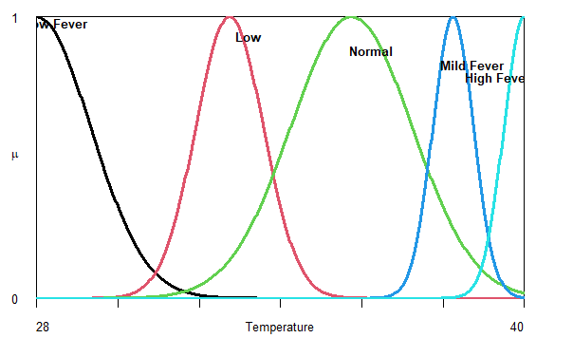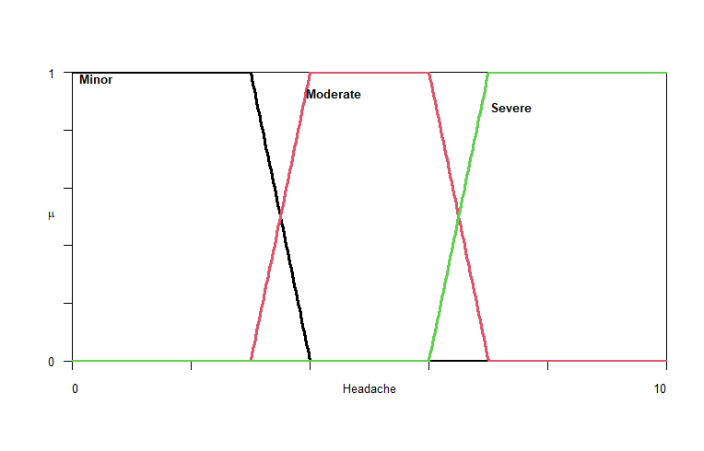

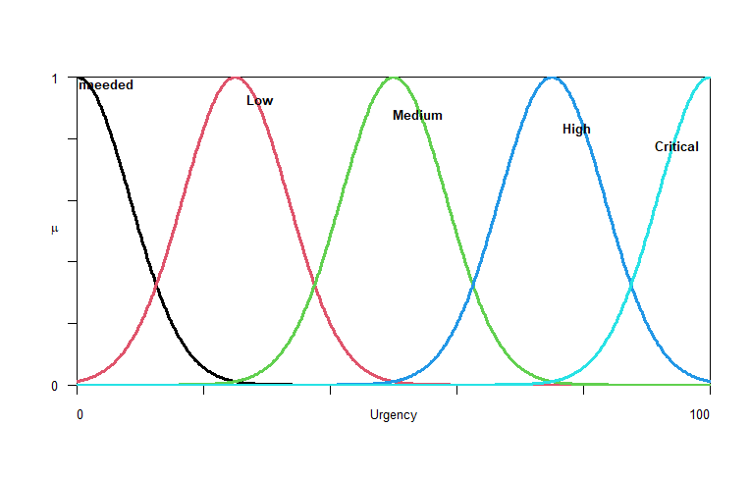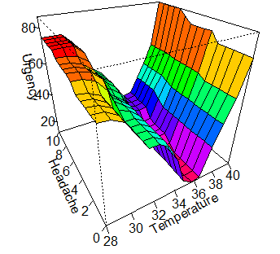

## 4.2 System explanation

When the system is explained to medical professionals, the affiliation function and rules are explained to them, as well as the control surfaces for combinations of these rules. It can be seen that as the temperature increases or decreases to either extreme, the urgency increases, and as the severity of the headache increases, so does the urgency.

It would certainly be groundbreaking if the system were to be considered reliable by medical professionals, gaining approval from medical institutions to use the model in it.

# 5. Discussion of the final model

The control interface of this system is how the control surface behaves when the input variables are changed. We can test if it is correct. The figure below shows which values do not follow these properties and how many control surfaces do not follow these properties. It allows testing if the system meets the requirements. This is done by generating a series of values to pass to Evalfis and then analyzing the results. As you can see from the graph, most of these metrics are on a single line with few other outliers, proving that the model performs relatively well and can be used as an application. However, the model also has some drawbacks, being that some values do not comply with the attribute conventions, such as increasing headache, which does not correspond to all body temperatures and results in severity, which often deviates somewhat from medical perception, but on the whole, the model performs well.

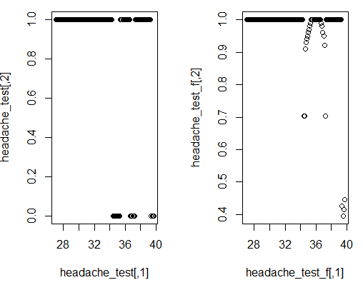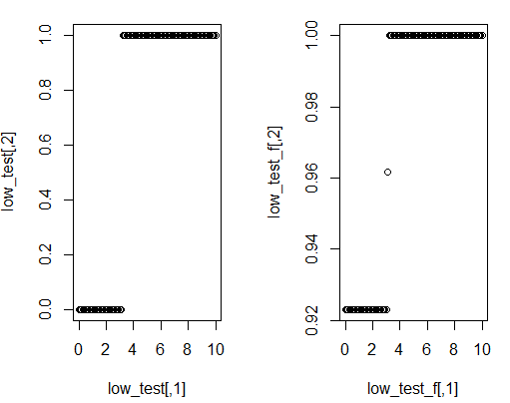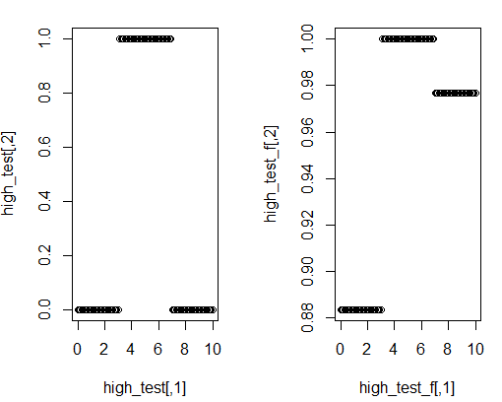

# 6. System interface diagram

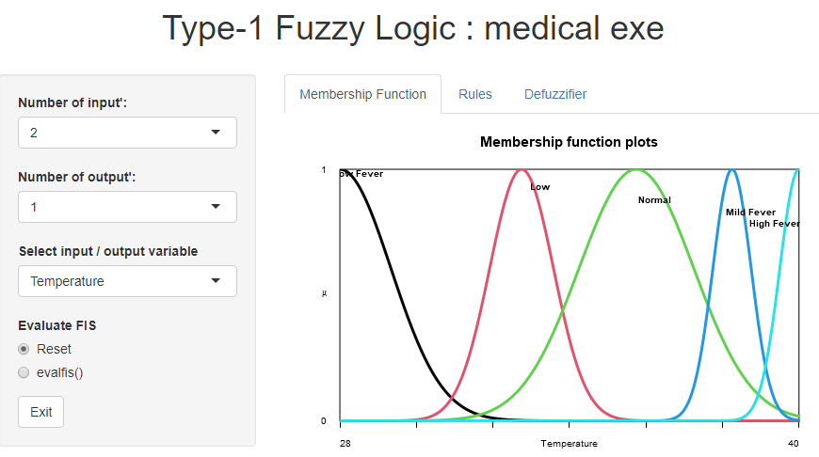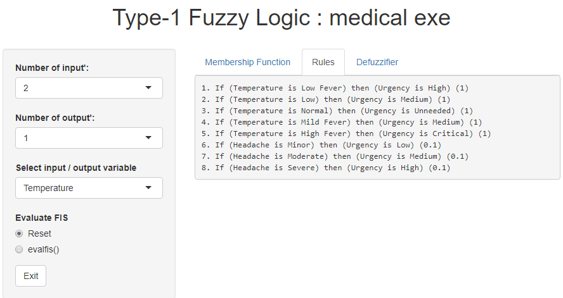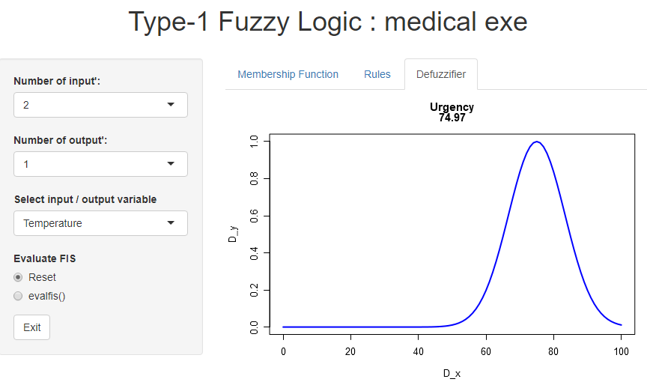

# 7.Reference:

1. Cosinuss,2022-VITAL SIGNS-Body temperature

<https://www.cosinuss.com/en/measured-data/vital-signs/body-temperature/>

2.Huber, Franz (2018). [*A Logical Introduction to Probability and Induction*](https://www.google.com/books/edition/A_Logical_Introduction_to_Probability_an/Z2J7DwAAQBAJ?hl=en&gbpv=1&pg=PA80&printsec=frontcover). New York, N.Y.: [*Oxford University Press*](https://en.wikipedia.org/wiki/Oxford_University_Press). p. 80. [*ISBN*](https://en.wikipedia.org/wiki/ISBN_(identifier)) [*9780190845414*](https://en.wikipedia.org/wiki/Special:BookSources/9780190845414).

**3.** this usage of "three-sigma rule" entered common usage in the 2000s, e.g. cited in *[Schaum's Outline of Business Statistics](https://archive.org/details/businessstatisti0000unse)*. McGraw Hill Professional. 2003. p. 359, and in Grafarend, Erik W. (2006). [*Linear and Nonlinear Models: Fixed Effects, Random Effects, and Mixed Models*](https://archive.org/details/linearnonlinearm00wgra). Walter de Gruyter. p. [*553*](https://archive.org/details/linearnonlinearm00wgra/page/n573).