COMP4003 / COMP4031 / COMP4026 Project Plan
Student: Omkar Mainkar
Student ID: 20550557
Course: M.Sc. Data Science

“Deep Learning-enabled Steel Defect Identification and Classification”

Introduction

Steel is a crucial building material known for its durability and resistance to wear, making it essential in construction and infrastructure projects globally. Ensuring high-quality steel is critical, yet current quality control techniques rely predominantly on human visual inspection. This process is inherently subjective, time-consuming, and often inconsistent.

Severstal, a leader in steel production, emphasizes the importance of innovation in quality control. With a commitment to economic, environmental, and social responsibility, Severstal has developed the largest industrial data lake and is leveraging machine learning to enhance automation and efficiency while maintaining high-quality standards. This project aims to improve the defect detection algorithm in the steel manufacturing process by localizing and classifying surface flaws on flat sheet steel.

We propose to develop a robust machine learning model that accurately identifies and classifies defects using high-frequency camera images. This advancement will uphold high manufacturing standards, promote innovation, and contribute to a more efficient industry.

Project Aims and Objectives
The primary aim of this project is to develop an automated visual inspection system for steel manufacturing to improve quality control.
The system will identify and classify defects in steel samples using deep learning techniques, thereby reducing the reliance on human inspectors and increasing the reliability and efficiency of the inspection process.
The specific objectives are:
- Develop a deep learning-based classifier to detect the presence of defects in steel images.
- Implement a semantic segmentation model to accurately locate and identify various types of defects.
- Optimize the models for high precision and recall, ensuring robust defect detection and classification.

Related Work:
Table 1. Literature Review
Ref | Dataset | Models Implemented | Results
[1] | Severstal Steel Defect Dataset | ResNet34 for classifier  Ensembles (Unet + FPN) for segmentation  Combination of Unet and FPN with powerful encoders (ResNet, SE-ResNeXt, EfficientNet) | Models achieve dice coefficients over 0.915 and 0.905 at a speed of over 1.5 images per second on the public test set and private test set
[2] | Severstal Steel Defect Dataset | Base Model (Convolutional layers, Dense layers)  Transfer learning, Pre-trained on ImageNet, Finetuning(MobileNet-v2, Xception, DenseNet121, ViT, ResNet-50)  DenseNet121 (Weighted Loss) | F1 score Micro: 0.84, Macro: 0.65, Weighted: 0.83  ViT and DenseNet121 achieved the highest value of the weighted F1 Score, which was 0.91  The weighted F1 score achieved 0.92%
[3] | Severstal Steel Defect Dataset | In this work, we propose to use the transfer learning framework for steel defect classification and segmentation.  We use a U-Net architecture as a base architecture and explore two kinds of encoders: ResNet and Dense Net. We compare these nets’ performance using random initialization and the pre-trained networks trained using ImageNet data set. | Classification: Transfer learning improves MLA by 5% (absolute) with full training data and by 8% (absolute) with reduced training data.  Segmentation: Transfer learning with ResNet shows a 26% (relative) improvement in DICE and IoU with full data, and DenseNet shows a 60% (relative) improvement with reduced data.
[4] | Severstal Steel Defect Detection | Baseline (DeepLabV3+ without encoder module. Input image fed into pretrained ResNet101 model followed by decoder module)  Experimented (DeepLabV3+ with encoder-decoder structure. Encoder uses normal and atrous convolution modules. Explored backbones: ResNet101, DenseNet201, EfficientNet B1.) | Mean IoU  Baseline: 0.29  DenseNet201: 0.325, ResNet101: 0.57, EfficientNet B1: 0.57

Methodology
To achieve the project aims and objectives, the following methodology will be employed:
We will complete the task in two stages:
1. Classification (check if a defect is present or not)
2. Semantic Segmentation (identify and locate the defect if present)
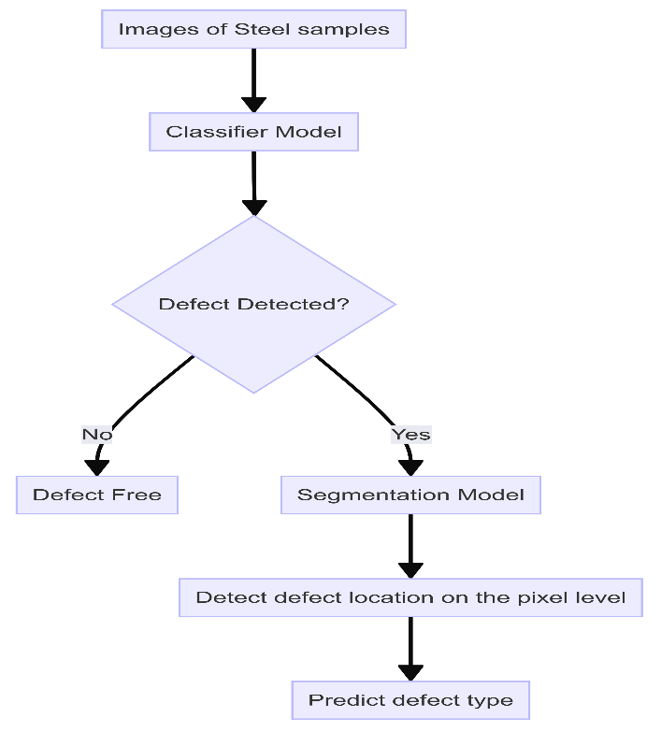
Figure 1. Methodology of the Project
- Data Collection and Preparation:
We are provided with images of sample steel. Each image may have no defects, a defect of a single class, or defects of multiple classes.
For each image we must segment defects of each class.
Images of steel sheets with annotations for different defect types. Each defect is labelled with a ClassId (1, 2, 3, or 4) and encoded using run-length encoding (RLE).
Collect and preprocess the dataset provided, including images and their corresponding defect annotations.
Perform exploratory data analysis (EDA) to understand the distribution and types of defects in the dataset.
Split the data into training, validation, and test sets, ensuring a balanced representation of defect types.
- Model Development:
We will approach this segmentation task in two steps.
Build a classifier model to detect the presence of defects.
In the above section, we have learnt that we want to segment images for different defect types. However, there are images without defects as well. Therefore, it will be useful if we first filter data with defects from the one without defects. For this purpose, we will build a classifier whose job will be to classify sample images as defect (1) or without defect(0).
For defective samples-
In the next stage, we will pass only those samples which are classified as defective by our classifier to the segmentation model.
Generate masks for defective samples using the encoded pixels for respective images.
Implement the U-Net architecture with various pre-trained backbones (Eg: ResNet34, ResNet50, EfficientNetB4).
Train the segmentation model to identify and locate defects, using metrics for evaluation.
- Model Optimization and Validation:
Conduct extensive experiments to compare different model architectures.
Select the best-performing model based on validation results and fine-tune it on the entire training dataset.
Evaluate the model using the Dice coefficient, which measures the pixel-wise agreement between predicted segmentation and ground truth masks.
Evaluate the final model on the test dataset to assess its generalization capability.
Conclusion:
This project aims to revolutionize the quality control process in steel manufacturing by leveraging the power of deep learning. By automating defect detection, we can ensure higher standards of quality, increase efficiency, and reduce the reliance on subjective human inspections. The successful implementation of this project will set a precedent for further innovations in the industry.
Tools and Software
- Programming Language: Python
- Deep Learning Framework: TensorFlow/ Keras/ PyTorch
- Pre-trained Models: UNet (eg: ResNet, VGG, EfficientNet)
- Model Evaluation: scikit-learn
- Image Processing: OpenCV
- Data Visualization: Matplotlib, Seaborn, Tensorboard
- Development Environment: Google Colab Notebook, Jupyter Notebook
Project TimeLine:
Week | Task Description | Mon | Tue | Wed | Thu | Fri | Sat | Sun
Week 1 | Project Planning and Setup
 | Define project goals and milestones | x | x
 | Set up development environment |  |  | x | x
 | Collect and organize dataset |  |  |  | x | x | x
 | Perform exploratory data analysis (EDA) |  |  |  |  |  | x | x
Week 2 | Data Preprocessing
 | Clean and preprocess the dataset | x | x | x | x
 | Split the dataset |  |  |  | x | x
 | Generate masks for defective samples |  |  |  |  | x | x | x
Week 3 | Classification Model Development
 | Design and implement a binary classifier | x | x | x | x
 | Train the classifier |  |  |  | x | x | x
 | Evaluate and optimize the classifier |  |  |  |  |  | x | x
Week 4 | Segmentation Model Preparation
 | Implement U-Net architecture | x | x | x | x
 | Train the segmentation model |  |  |  | x | x | x
 | Evaluate the segmentation model |  |  |  |  |  | x | x
Week 5 | Model Optimization
 | Perform hyperparameter tuning | x | x | x
 | Conduct extensive experiments |  |  | x | x | x | x
 | Validate models using precision, recall, etc. |  |  |  |  |  | x | x
Week 6 | Combined Model Integration
 | Integrate classification and segmentation models | x | x | x | x
 | Test integrated system |  |  |  | x | x | x
 | Optimize combined model |  |  |  |  |  | x | x
Week 7 | Final Model Training and Evaluation
 | Train the best-performing model | x | x | x | x
 | Fine-tune the model |  |  |  | x | x | x
 | Evaluate final model on test dataset |  |  |  |  |  | x | x
Week 8 | Dissertation and Report Preparation
 | Document project process | x | x
 | Write dissertation chapters |  |  | x | x | x | x | x
Week 9 | Dissertation and Report Preparation
 | Write dissertation chapters | x | x | x | x | x | x | x
 | Review and revise content |  |  |  |  |  | x | x
Week 10 | Preparation and Final Review
 | Create PowerPoint presentation | x | x | x
 | Review and finalize PPT |  |  |  | x | x
 | Final review of dissertation and report |  |  |  |  | x | x | x
References:
[1] Kun Qian. 2019. Automated Detection of Steel Defects via Machine Learning based on Real-Time Semantic Segmentation. In Proceedings of the 2019 International Conference on Visual Informatics and Pattern Recognition (ICVIP 2019), December 20–23, 2019, Shanghai, China. ACM, New York, NY, USA. https://doi.org/10.1145/3376067.3376113
[2] A. Komijani, F. Vafaeinezhad, J. Khoramdel, Y. Borhani, and E. Najafi, "Multi-label Classification of Steel Surface Defects Using Transfer Learning and Vision Transformer," in Proc. 2022 13th International Conference on Information and Knowledge Technology (IKT), Tehran, Iran, 2022.
[3] P. Damacharla, A. Rao M. V., J. Ringenberg, and A. Y. Javaid, "TLU-Net: A Deep Learning Approach for Automatic Steel Surface Defect Detection," in Proc. 2021 International Conference on Applied Artificial Intelligence (ICAPAI), Toledo, OH, USA, 2021, doi: 10.1109/ICAPAI49758.2021.9462060
[4] Z. Nie, J. Xu, and S. Zhang, "Analysis on DeepLabV3+ Performance for Automatic Steel Defects Detection," arXiv:2004.04822v2 [cs.CV], Apr. 2020.
[5] E. Güçlü, İ. Aydın, and E. Akın, "Improved Deeplabv3+ Based Steel Surface Defect Segmentation," 2024 ASU International Conference in Emerging Technologies for Sustainability and Intelligent Systems (ICETSIS), Elazığ, Turkey, 2024, doi: 10.1109/ICETSIS61505.2024.10459666.
[6] M. Liu, Y. Huang, and Y. Xie, "Design of Steel Surface Defect Detection System Based on Deep Learning," 2022 IEEE International Conference on Artificial Intelligence and Computer Applications (ICAICA), Kuala Lumpur, Malaysia, 2022,. doi: 10.1109/ICAICA54878.2022.9844624
[7] C. Li, J. Cai, S. Qiu, and H. Liang, "Defects detection of steel based on YOLOv4," 2021 China Automation Congress (CAC), Jiangmen, China, 2021, doi: 10.1109/CAC53003.2021.9728621
[8] D. Bai, G. Li, D. Jiang, B. Tao, J. Yun, Z. Hao, D. Zhou, Z. Ju, "Depth feature fusion based surface defect region identification method for steel plate manufacturing," Computers and Electrical Engineering, vol. 116, p. 109166, March 2024. Available online: https://doi.org/10.1016/j.compeleceng.2024.109166.

