Weather Forecasting System

III Semester Project

# B.Tech In

**Computer Engineering**

## Submitted to: Submitted By:

### Ms. Garima Sharma Prakash Singh Yadav

(CC-CE-III-Sem) Roll No. : 2015532

Guided By: Dr. Sachin Sharma Section: C.E. (Resource Person) Session: 2020-2021

**Department of Computer Science and Engineering Graphic Era Deemed to be University**

# Dehradun, Uttarakhand

**ACKNOWLEDGEMENT**

##### I would like to thank Dr. Sachin Sharma sir and Mr. Jay Kishan sir without whose guidance, I might not have known about this technology.

I would like to thank my mentor Mr. Sachin Sharma sir, for providing the resources and believing in me until completion of this project and having faith in me.

Also I would like to thank my parents for their support and encouragement, and allowing me to reach this far.

Prakash Singh Yadav Roll No.: 2015532

Section: C.E. Session: 2020-2021 GEU, Dehradun

**INTRODUCTION**

1.0 About Project :

* This project just needs a power supply through a simple micro type mobile charger and a Wi-Fi Connection.
* The system makes use of NodeMCU.
* It provides City real time working of Weather forcastingSystem.
* This project is connected to openweathermap.org through which user is notified about the climatic conditions of a particular city.
* It host all the data on the local server on my wifi that I have created.
* It all prints all the data on the serial monitor.
  1. Requirements for the Project:
  2. Hardware Requirements:
* NodeMCU - ESP8266
* USB-cable
  1. Software Requirements:
* Arduino IDE
* Web Browser
* Openweathermap.org

**CIRCUIT DIAGRAM**

**WiFi Server**

**NodeMcu**

USB POWER

**SOFTWARE INTERFACE**

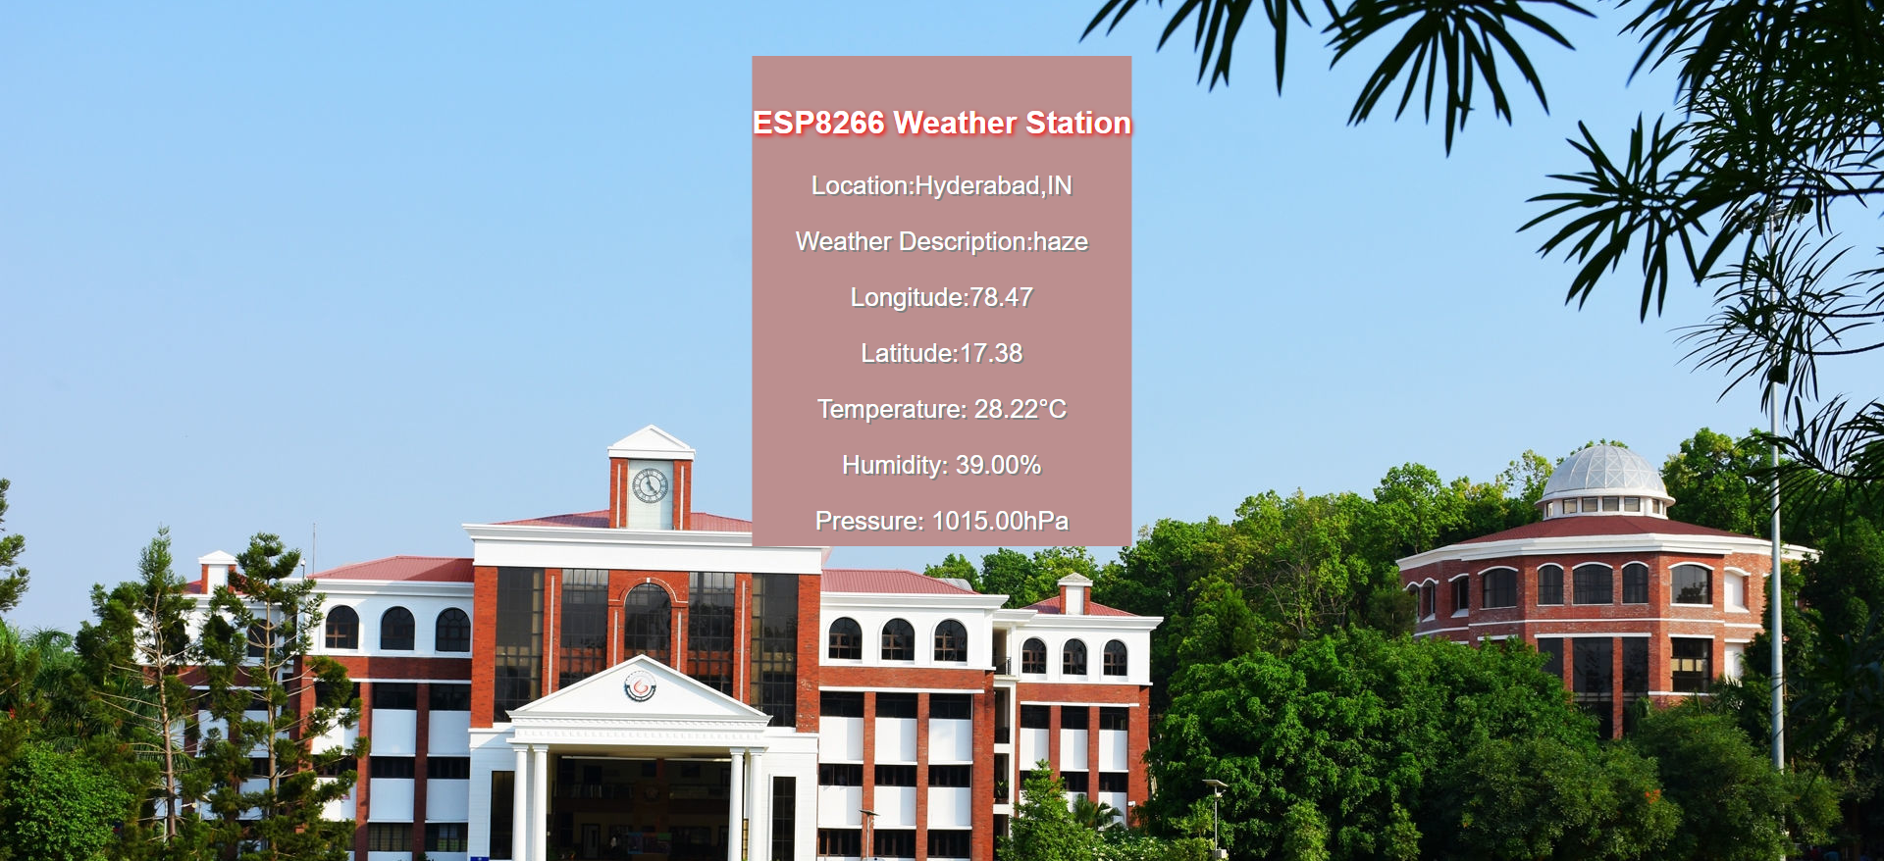

**What is API?**

API is an application programming interface(API) which is set of functions written by software developers to enable anyone to use their data or enable anyone to use their data or services. The open weather map project has an api that enables users to requests weather data.

In this project I have used the api to request the days weather forecast for a particular location, using cityid.

I have used open weather map’s free plans, which provides me everything that I need to complete this project.

**INTRODUCTION**

The Weather forcasting is because of having all the things at your figure tips.

This project can be helpful in our lives, we can get all the weather conditons at the computer screen by just a click.

* 1. NodeMCU – ESP8266 and 12E

The NodeMCU development board comes with the ESP-12E module containing ESP8266 chip having Tensilica Xtensa 32-bit LX106 RISC microprocessor. This microprocessor supports RTOS and operates at 80MHz to 160 MHz adjustable clock frequency. NodeMCU has 128 KB RAM and 4MB of Flash memory to store data and programs. Its high processing power with in-built Wi-Fi / Bluetooth and Deep Sleep Operating features make it ideal for IoT projects.

NodeMCU can be powered using Micro USB jack and VIN pin (External Supply Pin). It supports UART, SPI, and I2C interface.

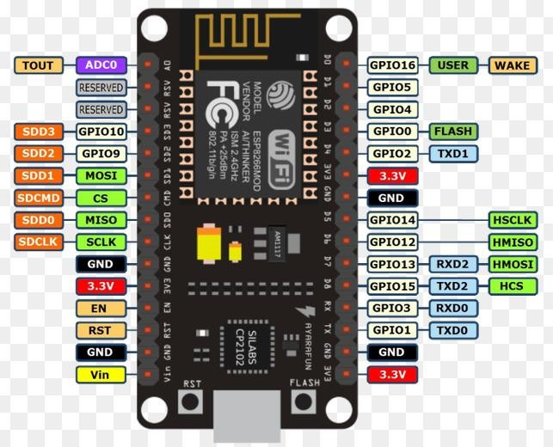

**What is Weather Station ?**

A weather station is a device that collects data related to the weather and environment using many different sensors. Weather stations are also called weather centers, personal weather stations, professional weather stations, home weather station, weather forecaster and forecasters.

#### ****Getting API Key****

1. Go to <http://openweathermap.org/> and create an account if you do not have one.  
2. Login to your account you will find **API Key**in the HOME>SETUP tab.  
3. Copy and paste this key to your code.  
  
 **Getting City Code from OpenWeather**

http://bulk.openweathermap.org/sample/city.list.json.gz

Download list of city codes from the above file.

**The link to the source code is:( please login to ever note using your google id for the code):**

<https://www.evernote.com/shard/s451/sh/99983dc1-7239-5ae8-c4bd-cb82c1fb0877/>

#### REFERENCES

1. https://openweathermap.org/api
2. <https://roboindia.com/tutorials/nodemcu-weather-station-arduino/>
3. <https://circuits4you.com/2019/03/22/esp8266-weather-station-arduino/>
4. Data Sheet of NodeMCU

https://components101.com/development-boards/nodemcu-esp8266-pinout-features-and- datasheet#:~:text=The%20NodeMCU%20ESP8266%20development%20board%20comes%20with% 20the,of%20Flash%20memory%20to%20store%20data%20and%20programs.

1. <https://www.engineersgarage.com/contributions/designing-esp8266-weather-station-using-openweathermap/>
2. <https://randomnerdtutorials.com/esp8266-nodemcu-http-get-open-weather-map-thingspeak-arduino/>
3. <https://lastminuteengineers.com/bme280-esp8266-weather-station/>
4. <https://www.hackster.io/ericBcreator/nodemcu-and-nextion-weather-forecast-station-daf5bd>
5. Geeksforgeeks.com