RMarkdown Manuscript Template

|  |
| --- |
| su1 |
| 1 University of Toronto |
|  |

# Author note

Correspondence concerning this article should be addressed to su, Postal address. E-mail: [my@email.com](mailto:my@email.com)

Abstract

One or two sentences providing a **basic introduction** to the field, comprehensible to a scientist in any discipline.

Two to three sentences of **more detailed background**, comprehensible to scientists in related disciplines.

One sentence clearly stating the **general problem** being addressed by this particular study.

One sentence summarizing the main result (with the words “**here we show**” or their equivalent).

Two or three sentences explaining what the **main result** reveals in direct comparison to what was thought to be the case previously, or how the main result adds to previous knowledge.

One or two sentences to put the results into a more **general context**.

Two or three sentences to provide a **broader perspective**, readily comprehensible to a scientist in any discipline.

*Keywords:* rmarkdown

Word count: x

RMarkdown Manuscript Template

Introduction intro…(Aaker & Lee, 2001)  
blah balh (2000)  
yay (Anusic, Schimmack, Pinkus, & Lockwood, 2009; Apfelbaum, Stephens, & Reagans, 2016)

# Methods

## Participants

We excluded 50 participants who were deemed careless and consistent in their responses.

As shown in Table 1, 2 female participants were 34.94 and NA years old in average (SD = 11.53 and NA).

## Material

### *Regulatory Focus*.

Promotion and prevention focus was collected using a 15-item measure (Higgins, 2005)…

## Procedure

Data was collected throgh Amazon’s MTurk…

## Data analysis

We used R [Version 3.5.1; @] and the R-packages *}base* [@}R-base], *bindrcpp* (Version 0.2.2; Müller, 2018), *broom* (Version 0.5.0; Robinson & Hayes, 2018), *corrplot2017* (Wei & Simko, 2017), *dplyr* (Version 0.7.7; Wickham et al., 2018), *forcats* (Version 0.3.0; Wickham, 2018a), *ggplot2* (Version 3.1.0; Wickham, 2016), *here* (Version 0.1; Müller, 2017), *knitr* (Version 1.20; Xie, 2015), *papaja* (Version 0.1.0.9842; Aust & Barth, 2018), *purrr* (Version 0.2.5; Henry & Wickham, 2018), *readr* (Version 1.1.1; Wickham, Hester, & Francois, 2017), *shiny* (Version 1.2.0; Chang, Cheng, Allaire, Xie, & McPherson, 2018), *stringr* (Version 1.3.1; Wickham, 2018b), *tibble* (Version 1.4.2; Müller & Wickham, 2018), *tidyr* (Version 0.8.2; Wickham & Henry, 2018), and *tidyverse* (Version 1.2.1.9000; Wickham, n.d.) for all our analyses.

# Results

Consistent with our hypothesis, promotion focus negatively predicted the number of profiles viewed, $β$ = , $p$ < …

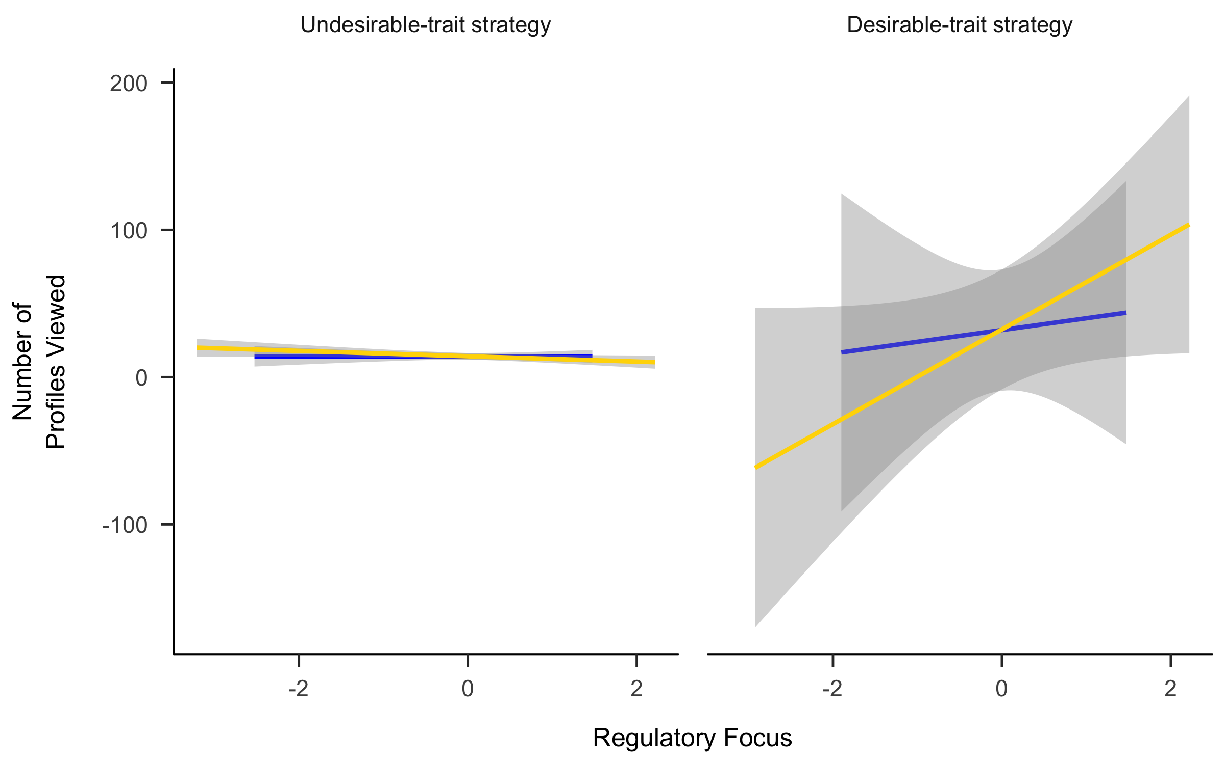 As shown in Figure 1, neither promotion nor prevention focus had an impact on the number of profiles viewed in the undesirable condition, whereas promotion focus but not prevention focus predicted positively the number of profiles viewed in desirable condition.

# Discussion

My study is important. Please believe me.

# References

Aaker, J. L., & Lee, A. Y. (2001). “I” Seek Pleasures and “We” Avoid Pains: The Role of Self-Regulatory Goals in Information Processing and Persuasion. *Journal of Consumer Research*, *28*(1), 33–49. doi:[10.1086/321946](https://doi.org/10.1086/321946)

Adema, P. (2000). Vicarious Consumption: Food, Television and the Ambiguity of Modernity. *Journal of American & Comparative Cultures*, *23*(3), 113–123. doi:[10.1111/j.1537-4726.2000.2303_113.x](https://doi.org/10.1111/j.1537-4726.2000.2303_113.x)

Anusic, I., Schimmack, U., Pinkus, R. T., & Lockwood, P. (2009). The Nature and Structure of Correlations Among Big Five Ratings : The Halo-Alpha-Beta Model, *97*(6), 1142–1156. doi:[10.1037/a0017159](https://doi.org/10.1037/a0017159)

Apfelbaum, E. P., Stephens, N. M., & Reagans, R. E. (2016). Journal of Personality and Social Psychology Beyond One-Size-Fits-All : Tailoring Diversity Approaches to the Representation of Social Groups Beyond One-Size-Fits-All : Tailoring Diversity Approaches to the Representation of Social Groups. *Journal of Personality and Social Psychology*, *111*(4), 547–566.

Aust, F., & Barth, M. (2018). *papaja: Create APA manuscripts with R Markdown*. Retrieved from <https://github.com/crsh/papaja>

Chang, W., Cheng, J., Allaire, J., Xie, Y., & McPherson, J. (2018). *Shiny: Web application framework for r*. Retrieved from <https://CRAN.R-project.org/package=shiny>

Henry, L., & Wickham, H. (2018). *Purrr: Functional programming tools*. Retrieved from <https://CRAN.R-project.org/package=purrr>

Higgins, E. T. (2005). Value from regulatory fit. *Current Directions in Psychological Science*, *14*(4), 209–213.

Müller, K. (2017). *Here: A simpler way to find your files*. Retrieved from <https://CRAN.R-project.org/package=here>

Müller, K. (2018). *Bindrcpp: An ’rcpp’ interface to active bindings*. Retrieved from <https://CRAN.R-project.org/package=bindrcpp>

Müller, K., & Wickham, H. (2018). *Tibble: Simple data frames*. Retrieved from <https://CRAN.R-project.org/package=tibble>

Robinson, D., & Hayes, A. (2018). *Broom: Convert statistical analysis objects into tidy tibbles*. Retrieved from <https://CRAN.R-project.org/package=broom>

Wei, T., & Simko, V. (2017). *R package "corrplot": Visualization of a correlation matrix*. Retrieved from <https://github.com/taiyun/corrplot>

Wickham, H. (2016). *Ggplot2: Elegant graphics for data analysis*. Springer-Verlag New York. Retrieved from <http://ggplot2.org>

Wickham, H. (2018a). *Forcats: Tools for working with categorical variables (factors)*. Retrieved from <https://CRAN.R-project.org/package=forcats>

Wickham, H. (2018b). *Stringr: Simple, consistent wrappers for common string operations*. Retrieved from <https://CRAN.R-project.org/package=stringr>

Wickham, H. (n.d.). *Tidyverse: Easily install and load the ’tidyverse’*.

Wickham, H., François, R., Henry, L., & Müller, K. (2018). *Dplyr: A grammar of data manipulation*. Retrieved from <https://CRAN.R-project.org/package=dplyr>

Wickham, H., & Henry, L. (2018). *Tidyr: Easily tidy data with ’spread()’ and ’gather()’ functions*. Retrieved from <https://CRAN.R-project.org/package=tidyr>

Wickham, H., Hester, J., & Francois, R. (2017). *Readr: Read rectangular text data*. Retrieved from <https://CRAN.R-project.org/package=readr>

Xie, Y. (2015). *Dynamic documents with R and knitr* (2nd ed.). Boca Raton, Florida: Chapman; Hall/CRC. Retrieved from <https://yihui.name/knitr/>