MetaKV: Fault-Resilient Structured Metadata for Low-Precision LLM KV Caches
Ziyang Yi
Independent Researcher, Room 326, Sanhe Apartment, No. 87 Jinpen Road, Tianxin District, Changsha 410000, Hunan Province, P. R. China
Corresponding author: eayon.yi@qq.com
ORCID: https://orcid.org/0009-0002-5534-0494

Abstract
Low-precision large language model inference depends on compressed KV caches, where one scale controls a group of quantized values. A corrupted metadata bit can therefore cause disproportionate numerical amplification. MetaKV addresses this control point through HA-FBMS, a structured 32-bit log-scale representation, and characterization-weighted logical metadata-bit mapping. The representation preserves metadata width while keeping tested logical single-bit amplification below 2×; Binary32-Z reaches 256× or 512×. Evaluation spans more than 1.1 million real scale groups across Llama-3.1-8B, Qwen3-14B, and Qwen3-32B, full-cache replay, and packed INT4 execution on NVIDIA and AMD. In 32-step Qwen3-32B replay, HA-FBMS reduces divergent cases from 8/24 to 5/24 and teacher-forced maximum KL from 9.692 to 0.00778 relative to Binary32-Z. Deployment measurements show backend-dependent implementation cost. HBM2 observations are repeatable in the evaluated corpus, whereas DDR position-specific weights do not generalize reliably. These results support reliable low-precision LLM inference across heterogeneous computing systems.
Keywords: KV cache; low-precision LLM inference; metadata reliability; fault resilience; heterogeneous computing; GPU computing

1. Introduction
Low-precision inference reduces the memory traffic and capacity pressure created by the key-value (KV) cache, a large and performance-critical state retained for every active sequence [1, 2]. Existing work has developed asymmetric, mixed-precision, sparse, and streamed KV-cache representations [3-10, 16]. These methods primarily optimize payload size, model quality, or serving throughput. Group-wise quantization also introduces scale metadata: for a group of 32 INT4 values, one scale controls every reconstructed value in that group.
$\log_{2}(s)$This metadata is small in capacity but reliability-sensitive in effect. A logical bit fault can move a decoded scale slightly, by a large multiplicative factor, or outside the valid numerical domain. Equal metadata width does not imply equal fault response because IEEE-754 scale bits, a uniform integer code for log₂(scale), and a structured log-scale code distribute significance differently across their 32 bits.
MetaKV addresses this control point through HA-FBMS, a structured 32-bit $B_{c}/B_{f}$ log-scale representation. The engineering intuition behind HA-FBMS is simple: a single metadata bit flip should not be allowed to simultaneously alter the scale category and fine-grained value. By separating coarse magnitude information from local refinement, the representation limits the numerical jump caused by isolated metadata corruption. The primary design objective is not a lower average error under an assumed random process. It is to preserve valid scale behavior and bound the tail of tested logical single-bit amplification. Across audited Llama-3.1-8B, Qwen3-14B, and Qwen3-32B configurations, HA-FBMS remains below 2× amplification with no GE2 events. The corrected equal-width Binary32-Z baseline reaches approximately 256× on the 8B and 14B configurations and 512.000× on Qwen3-32B. The 32B evaluation covers 507,904 real scale groups.
Representation geometry is the first layer. Using empirical failure observations, the software-level logical mapping adjusts bit exposure according to the stability of the observed fault patterns in the DDR and HBM2 experiments. DDR and HBM2 corpora show non-uniform logical-position observations, but transferable benefit requires both stable exposure structure and an observable, recalibratable, or explicitly controlled characterization-to-deployment correspondence. The mapping remains a fixed software layout over metadata-bit indices. It is not a physical DRAM/HBM lane-placement mechanism and is not claimed to be globally optimal.
Reliability and deployment cost must be considered together because heterogeneous accelerators implement metadata handling differently. The evaluation combines the true codec, large-scale logical fault screens, real-model scale populations, full-cache one-step and 32-step replay, packed INT4 kernels, and timing across NVIDIA, AMD, and Intel CPU environments. The measurements separate representation-level resilience from backend-specific implementation cost.
The contributions are:
- HA-FBMS restructures the 32-bit metadata word while constraining tested logical single-bit amplification and maintaining small clean reconstruction error.
- $B_{c}/B_{f}$Characterization-weighted logical mapping. Empirical DDR and HBM2 observations guide software-level bit allocation, with transfer interpreted only under the measured positional stability and mapping assumptions.
- Large-scale logical fault characterization and the analytical bound relate representation geometry to validity and multiplicative amplification without treating corpus observations as hardware fault probabilities.
- Real-model validation spans the scale populations of Llama-3.1-8B, Qwen3-14B, and Qwen3-32B together with full-cache semantic replay.
- Packed-kernel deployment measurements cover RTX 4060 Ti, RTX 5080, NVIDIA H800, AMD gfx942-class, and Intel x86-64 environments, including same-GPU Windows/Linux sensitivity; runtime conclusions remain platform specific.

2. Background and Related Work

2.1 Low-Precision and Quantized LLM Inference
Group-wise quantization stores a small integer payload and a scale per group. In the evaluated G32 configuration, each group contains 32 signed INT4 payload values. For a group with maximum absolute value $m$, the scale is $s=\frac{m}{7}$, and reconstructed values multiply the signed INT4 code by $s$. This design concentrates the dynamic range of the group in one metadata value. Prior KV-cache studies motivate low-precision payloads for memory efficiency [3, 4], but the reliability of the accompanying scale representation is a separate question.

2.2 KV-Cache Compression and Quantization
Let $s$ be the clean decoded scale and $s^{′}$ the decoded scale after one logical metadata-bit flip. We study validity and multiplicative amplification $A=max(\frac{s^{′}}{s},\frac{s}{s^{′}})$ when both scales are finite and positive. Invalid, nonfinite, or nonpositive decoded values are counted separately. This metric isolates a mechanism: a single metadata error affects all 32 reconstructed payload values in its group. It does not estimate how often a hardware fault occurs.

2.3 Fault Resilience and Metadata Vulnerability
FP32 stores the scale directly as IEEE-754 Binary32. Its exponent and special-value structure permit selected bit flips to produce invalid scales. Binary32-Z is a conventional equal-width comparison: it uniformly quantizes $z=\log_{2}(s)$ into an unsigned 32-bit integer over a calibrated interval. Binary32-Z is not an IEEE floating-point representation of $z$. Its uniform index geometry avoids FP special values but leaves high-significance integer bits capable of large interval jumps. Only the corrected Binary32-Z implementation used for the reported replay analyses is used in this paper.

2.4 Heterogeneous Accelerator Deployment
MetaKV targets five bounded objectives: preserve 32-bit metadata width; maintain small clean scale reconstruction error; keep tested logical single-bit amplification below a controlled threshold; adapt logical bit placement to empirical non-uniformity; and validate the design in packed kernels and real-model full-cache contexts. It does not target ECC allocation, physical memory-lane control, measured device fault rates, or implementation-independent runtime behavior.

2.5 Literature Positioning
Low-precision KV-cache methods reduce memory pressure through asymmetric, non-uniform, salient-token, sparse, mixed-precision, residual-corrected, or streamed representations [3, 4, 5, 7, 8, 6, 9, 10]. Their main objective is payload compression, quality, or serving efficiency rather than fault-resilient scale metadata. Token-selection approaches also address cache capacity [11].
Numerical reliability studies establish that bit positions have unequal consequences [12]. Flip-S is the closest problem-level precursor found: it exploits grouped quantization scale factors in an adversarial attack on vision-transformer weights [13]. It does not redesign KV-cache metadata or provide the HA-FBMS construction. DRAM and HBM2 studies further show non-uniform vulnerability and error patterns [14, 15, 16]. MetaKV uses these observations only to motivate characterization-weighted logical metadata-bit permutation, without claiming physical placement, BER, or a global optimum.

3. MetaKV and HA-FBMS

3.1 Group-Wise INT4 KV Metadata
MetaKV operates on the scale metadata attached to G32 INT4 groups. The payload format and group definition remain fixed while the scale representation changes. Keeping the comparison at 32 metadata bits separates storage width from representation geometry. Runtime cost is measured independently because equal width does not make encode, decode, or permutation operations free. Figure 1 illustrates the logical data flow.

3.2 HA-FBMS Structured Representation
For a positive group scale $s>0$, define
$z=\log_{2}s.$ (1)
Fix a calibrated interval $\left[z_{min} , z_{max}\right]$ of width $W=z_{max}−z_{min}>0$, and choose $B_{c}$ coarse bits and $B_{f}$ fine bits such that
$B_{c}+B_{f}=32,F_{max}=2^{B_{f}}−1.$ (2)
The audited deployment codecs use $B_{c}=19$ and $B_{f}=13$. HA-FBMS first maps $z$ to a clipped normalized coordinate
$u=clip\left(\frac{\left(z−z_{min})(B_{c}+1\right)}{W},0,B_{c}+1\right).$ (3)
For non-endpoint values, let $c=⌊u⌋$ and $f=rint((u−c)F_{max})$, where the frozen NumPy implementation uses round-to-nearest with ties to even. At $u=B_{c}+1$, the encoder sets $c=B_{c}$ and $f=F_{max}$. Both fields are then clipped to their declared ranges. The coarse field is the $B_{c}$-bit thermometer word
$T(c)=\left\{\begin{matrix}0, & c=0, \\ 2^{c}−1, & 1≤c≤B_{c},\end{matrix}\right.$ (4)
stored in bits $0,…,B_{c}−1$. The fine integer $f∈[0,F_{max}]$ is stored in bits $B_{c},…,31$. The encoded word is
$E_{HA}(z)=T(c)∨(f≪B_{c}).$ (5)

3.3 HA-FBMS Decoding and Clean Reconstruction
For a 32-bit word $w$, the decoder does not require the coarse bits to remain a valid thermometer prefix. It computes
$\hat{c}=popcount\left(w \& (2^{B_{c}}−1)\right),\hat{f}=(w≫B_{c}) \& F_{max},$ (6)
then reconstructs
$\hat{u}=\hat{c}+\frac{\hat{f}}{F_{max}},\hat{z}=z_{min}+\frac{W}{B_{c}+1}\hat{u},\hat{s}=2^{\hat{z}}.$ (7)
For $z$ inside the calibrated interval, round-to-nearest of the fine coordinate gives the analytic clean-log error bound
$|\hat{z}−z|≤ϵ_{z}=\frac{W}{2(B_{c}+1)F_{max}}.$ (8)
The scale-relative reconstruction error used in the frozen scripts is
$e_{rel}=\frac{\left|\hat{s} − s\right|}{max(s,{tiny}_{64})}.$ (9)

3.4 Logical Single-Bit Amplification and Bounded Construction Property
Let $w^{′}=w⊕2^{j}$ be a one-hot logical mutation of the 32-bit metadata word, let ${\hat{s}}^{′}$ be its decoded scale, and require both reference and faulty scales to be finite and positive. The evaluated amplification is
$A(s,{\hat{s}}^{′})=max\left(\frac{{\hat{s}}^{′}}{s} , \frac{s}{{\hat{s}}^{′}}\right)=2^{\left|{\hat{z}}^{′} − z\right|}.$ (10)
Proposition 1 (configuration-specific single-bit construction bound). For the encoder and decoder in Eqs. (3)–(7), a fixed interval, $B_{c}+B_{f}=32$, and an input $z∈[z_{min},z_{max}]$, one logical bit flip changes the decoded log scale by at most $W/(B_{c}+1)$. Relative to the unquantized input scale,
$A(s,{\hat{s}}^{′})≤2^{\frac{W}{B_{c}+1}+ϵ_{z}}.$ (11)
Proof sketch. Flipping one coarse bit changes the popcount in Eq. (6) by exactly one, hence changes $\hat{u}$ by one. Flipping fine bit $k$ changes $\hat{u}$ by $2^{k}/F_{max}≤2^{B_{f}−1}/(2^{B_{f}}−1)<1$. Therefore $|{\hat{z}}^{′}−\hat{z}|≤W/(B_{c}+1)$. Combining this result with Eq. (8) and the triangle inequality gives Eq. (11). Endpoint handling is explicit in the encoder, and the popcount decoder remains defined for any mutated coarse word.
This proposition is an analytic property of the frozen construction, conditional on the calibrated interval and codec configuration. It is distinct from the exhaustive logical screens over the available scale arrays. This parameter-specific bound characterizes single-bit codec geometry within the calibrated range; hardware fault incidence, multi-bit corruption, and other calibration regimes are outside its scope. The observed Qwen3-32B maximum, $A=1.866$, is an empirical result, not a universal theorem constant.
For comparison, corrected Binary32-Z uses
$E_{BZ}(z) = uint32\left(clip\left(rint\left(\frac{z − z_{min}}{W}\left(2^{32} − 1\right)\right), 0, 2^{32} − 1\right)\right)$ (12)
$D_{BZ}(q)=z_{min}+\frac{q}{2^{32}−1}W.$ (13)
Binary32-Z is a uniform unsigned 32-bit code for $\log_{2}(s)$; it is not IEEE floating-point $z$.

3.5 Characterization-Weighted Logical Metadata-Bit Mapping
Empirical corpora show that logical positions do not contribute uniformly to observed fault patterns. MetaKV combines position-dependent exposure weights with representation-dependent consequences. A mapping associates each logical codec bit with a fixed software layout index used by the packed implementation. We write this software-index convention as mapping[logical] = layout-index. The index is physical-like only inside the software layout; no claim is made about a controller-visible lane.

3.6 Pairwise-Swap Multistart Local Search
Mappings are selected by local search. Multiple starts initialize candidate permutations. Each trajectory considers pairwise swaps, accepts objective-improving moves, and stops at a local condition. Deep confirmation covers eight representative configurations. This procedure gives reproducible, objective-specific mappings but no global-optimality certificate.

3.7 Deployment Codec Bridge
The deployment bridge checks that the kernel codec implements the same mathematical family and mapping semantics used by the risk analysis. Separate provenance establishes the frozen mapping inputs. This distinction prevents two common errors: treating all calibrated model instances as exact historical mapping representations, and treating the software layout as physical memory placement.
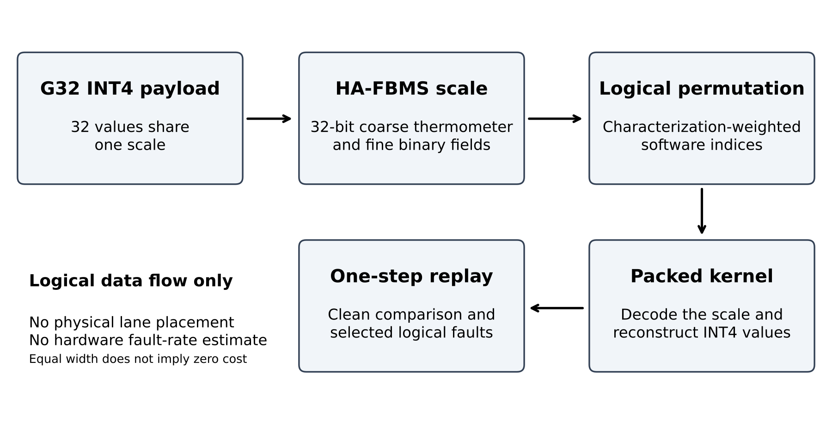
Figure 1. MetaKV treats the 32-bit scale as a reliability control point. HA-FBMS changes logical single-bit geometry, and an empirical-weighted software permutation adapts bit positions without implying physical lane placement.

4. Experimental Methodology

4.1 DDR Scenario Construction
The DDR path begins with 128 JSON sources that yield 1,067,712 strict word-fault rows, 1,384,512 runs, and 71,858,832 observed flip positions. Thirty-two unpooled scenarios retain source-specific structure. The empirical subset model summarizes Hamming depth and within-byte/halfword structure without converting corpus counts into a device fault rate.

4.2 HBM2 Characterization Corpus
The HBM2 path analyzes a six-chip characterization corpus. The primary aggregate is union presence over logical 32-bit positions, accompanied by descriptive concentration, entropy, and cross-chip rank statistics. Union observations do not reveal whether positions flipped simultaneously. We use these data for empirical weighting, not as direct deployed-system HBM fault injections.

4.3 Mapping Evaluation
Mapping evaluation separates native-domain improvement from transfer. Because DDR and HBM2 objectives arise from different empirical constructions, their absolute values are not placed on a shared scale. Cross-technology results are ratios to the relevant native-domain reference. The robust selection minimizes the worst domain-relative reference ratio within the evaluated local-search candidates.

4.4 Mapping Scrambling and DDR Generalization

Controller-scrambling sensitivity applies frozen permutations only to the exposure-position correspondence. It compares the existing weighted mapping, identity, random mappings, and recalibration from a deployment-visible logical profile. The analysis does not reverse engineer a controller or establish physical lane placement. A fixed hidden permutation is shared by calibration and held-out evaluation, while the mapping algorithm observes only calibration statistics.

The separate DDR generalization analysis uses five source-aware outer folds and grouped inner validation. Inner validation selects among shrinkage toward uniform exposure and frozen mean, median, dispersion-penalized, percentile, and tail objectives; the outer test is not used for tuning. Its purpose is to test whether position-specific DDR exposure weights transfer across held-out source and scenario conditions. This analysis is separate from the pooled-profile scrambling-sensitivity metric.

4.5 Heterogeneous Deployment Methodology
Packed INT4 correctness and fixed-layout permutation are validated before timing. GPU timing evaluates 1,048,576 and 4,194,304 groups with 30 warmup launches, 15 paired blocks, and 100 launches per block, reporting paired median percentage differences and bootstrap confidence intervals. A same-RTX 5080 sensitivity run uses an H800-like Linux stack without treating the operating system as an isolated causal variable. Separate Intel x86-64 codec microbenchmarks use one pinned thread and OS-managed 1/4/8-thread OpenMP configurations. These measurements isolate kernel or codec paths rather than end-to-end LLM latency.

4.6 Real-Model KV Scale Extraction
Real scale populations are extracted from Llama-3.1-8B, Qwen3-14B, and Qwen3-32B. The audited counts are 276,480, 317,440, and 507,904 scale groups. Qwen3-32B contains 64 layers in the evaluated configuration. The scale populations drive interval calibration and logical fault screens.

4.7 Calibration Procedure
Calibration occurs per model rather than through one universal interval. Llama-3.1-8B uses $[−13,3]$, Qwen3-14B uses $[−11,5]$, and Qwen3-32B uses $[−13,5]$, with widths 16, 16, and 18. The observed clip count is zero for all three. The maximum relative clean scale error is approximately $3.38×{10}^{−5}$ for the 8B/14B configurations and $3.79×{10}^{−5}$ for 32B according to the audited model evidence.

4.8 Full-Cache INT4 Clean Replay
The clean replay reconstructs a captured full INT4 KV cache and performs one next-token step. It compares the original BF16 context, raw-scale INT4 replay, and HA-reconstructed metadata replay. The key contrast is HA versus raw-scale INT4: no additional observable BF16-logit perturbation is attributed to HA reconstruction in the tested cases. This does not state that raw INT4 equals BF16 or that codec error is zero.

4.9 Full-Cache Localized Fault-Semantic Replay
Fault-semantic replay starts from the full-cache INT4 background and injects a frozen logical metadata fault at a selected target. Targets are fixed before the final response analysis where stated by the authoritative protocol. Outputs include decoded validity, amplification, logit differences, top-1 changes, and KL divergence. The original one-step experiment does not sample a random device fault process or characterize delayed autoregressive propagation.

4.10 Metrics and Statistical Treatment
Fault screens report invalid counts, maximum amplification, and threshold exceedances. Semantic replay reports target-level top-1 and KL response. For Qwen3-14B corrected Binary32-Z, 2 of 96 selected targets change top-1. The authoritative corrected global summary and target rows agree: KL median 0.0, p95 4.19e-4, maximum 11.833, and mean 0.207. Table 6 reports the distributional triplet together. Deployment reports paired medians and bootstrap intervals without adding post hoc significance tests.

5. Results

5.1 Fault-Amplification Geometry
The evaluated pipeline synthesizes 324 candidate specifications into 44 unique frozen representations and deep-confirms eight representatives. True-codec validation finds no exceedance of the tested envelope. The real-model screens show the central geometric separation. Corrected Binary32-Z reaches maximum amplification 256.000 for Llama-3.1-8B and Qwen3-14B, and 512.000 for Qwen3-32B. By contrast, Qwen3-32B HA-FBMS reaches 1.866, with no GE2 event. Selected FP32 flips produce invalid scales. The difference lies in the tail and validity structure, rather than only in an average. Figure 2 and Table 1 summarize the representation comparison.
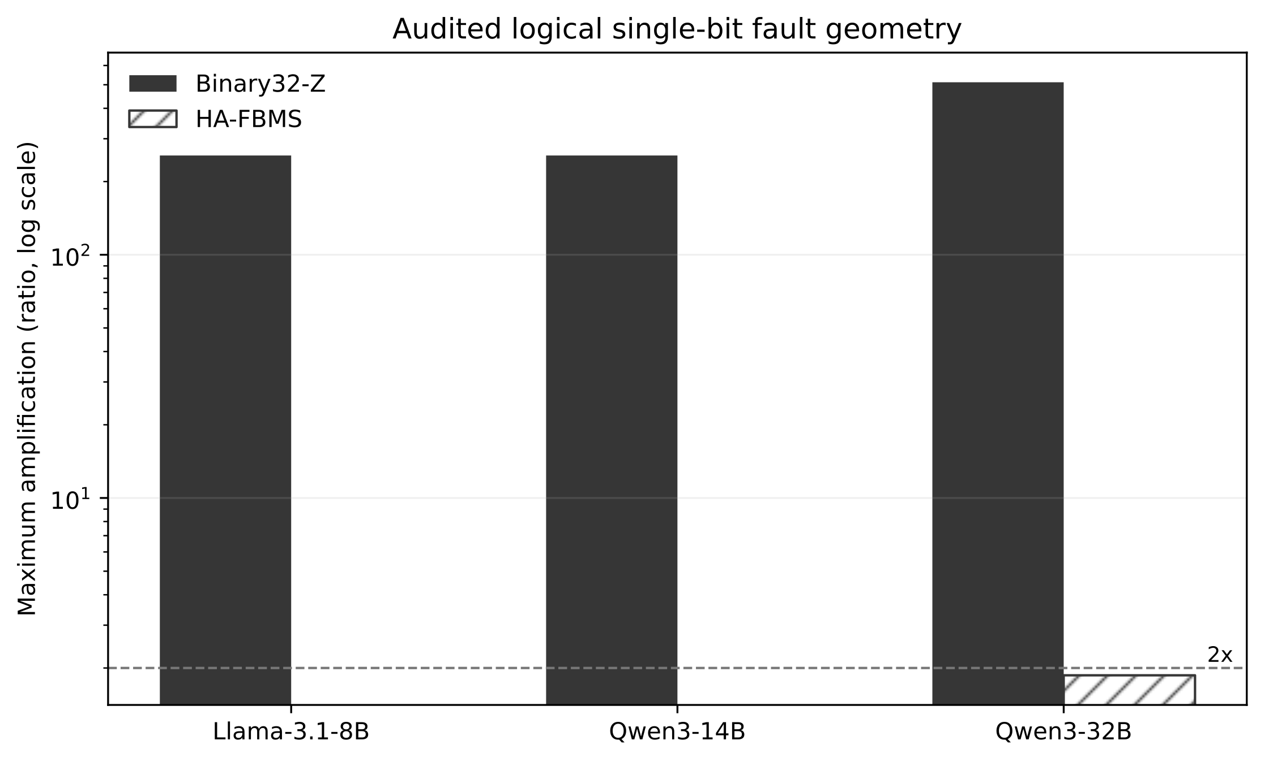
Figure 2. Same-width representations have different logical single-bit responses. Maxima summarize audited targets and intervals, not hardware event probabilities.

5.2 DDR-Weighted Evaluation
The DDR corpus contains 1,067,712 strict rows and 71,858,832 flip positions. Across 32 scenarios, mean H ≤ 3 coverage is 0.736. The integrated risk engine evaluates 352,657 masks over 699 samples and reports an exposure parameter of 0.066 and a total hybrid modeled quantity of 0.044. These quantities define the audited mapping objective; they are not absolute hardware probabilities. Table 2 summarizes the characterization evidence.

5.3 HBM2 Characterization and Cross-Technology Mapping
HBM2 observations are strongly non-uniform over logical positions. Aggregate CV is 0.883, the top eight positions carry 0.476 of observed mass, and mean cross-chip Spearman correlation is 0.948. Domain-relative transfer is asymmetric. The HBM-derived mapping has mean DDR reference ratio 1.006, while the DDR-derived mapping has mean HBM reference ratio 2.908. For eight robust selections, the mean maximum reference ratio is 1.002. These ratios motivate technology-specific weighting without placing the absolute DDR and HBM2 objectives on one scale. Figure 3 reports the characterization and transfer metrics.
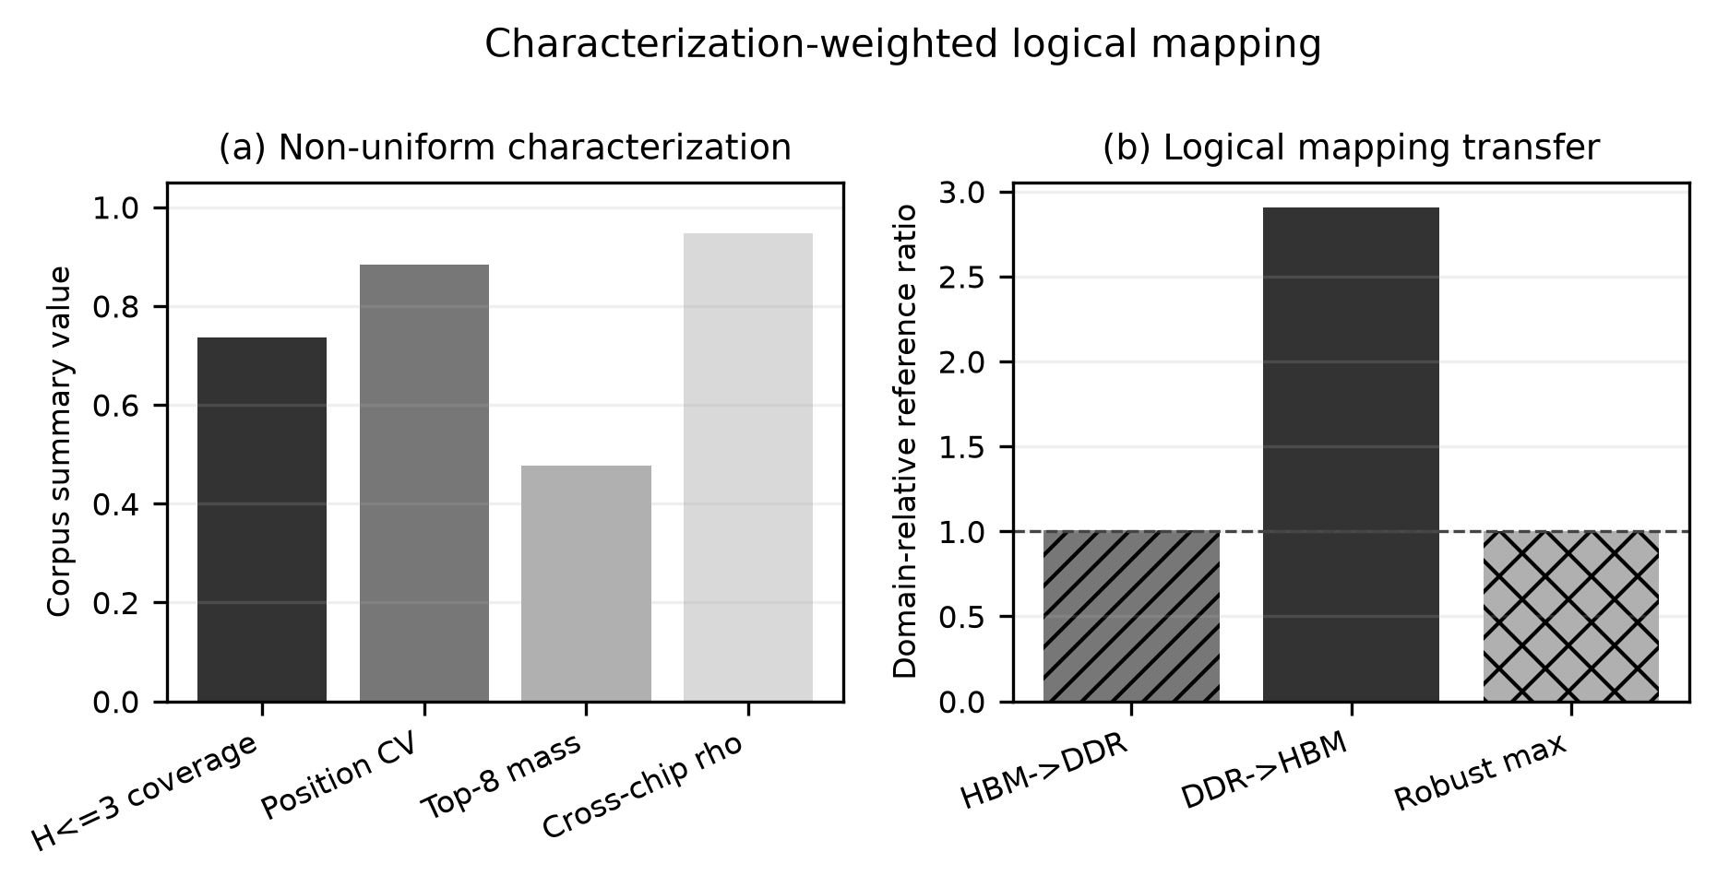
Figure 3. DDR and HBM2 characterization support technology-specific logical weighting. H ≤ 3 coverage is a DDR metric; concentration and cross-chip agreement describe HBM2. Transfer ratios are domain-normalized and do not compare absolute DDR and HBM2 objectives.

5.4 Mapping Observability and DDR Positional Generalization
Under the pooled-profile scrambling protocol, the HBM2 weighted ratio changes from 0.332 without scrambling to 0.988 under a full random permutation. Recalibration under a fixed hidden permutation gives 0.339, retaining approximately 98.9% of the original benefit. The corresponding pooled-profile DDR ratios are 1.058, 1.000, and 0.957. These DDR values are pooled-profile scrambling-sensitivity metrics and should not be interpreted as the source-aware generalization statistics reported separately.
Source-aware DDR validation finds weak positional agreement: mean and median pairwise Spearman correlations are 0.131 and 0.041, respectively, compared with 0.384 within source and 0.104 across sources. Nested validation selects complete shrinkage to uniform exposure in all five outer folds. The optimizer diagnostic finds no material headroom. The evaluated DDR position-specific exposure signal therefore does not generalize reliably under the source-aware held-out protocol.
The pooled-profile scrambling analysis and the source-aware held-out generalization analysis answer different questions and use different aggregation schemes. The former reports mean normalized ratios under the scrambling protocol, whereas the latter evaluates generalization across held-out source, scenario, and representation components. Their ratio statistics are therefore not directly comparable.

5.5 Heterogeneous Deployment Cost
On RTX5080, the four largest-workload mapped-vs-FP32 median estimates range from -1.023% to -0.013%; all intervals cross zero. On RTX4060Ti, estimates range from -0.019% to 0.159%, and all intervals again cross zero. We therefore observe no statistically resolved added cost under these two RTX protocols, and do not interpret negative medians as acceleration. Figure 4 and Table 3 summarize the kernel measurements.
The original passing H800 run reports material backend-dependent overhead. AMD gfx942-class hardware passes functional validation but has largest-workload mapped overhead between 154.974% and 165.067%. Across platforms, the kernels execute correctly but do not have uniform cost. Supplementary Table S2 reports all five execution-platform comparisons; the failed diagnostic H800 run is excluded.
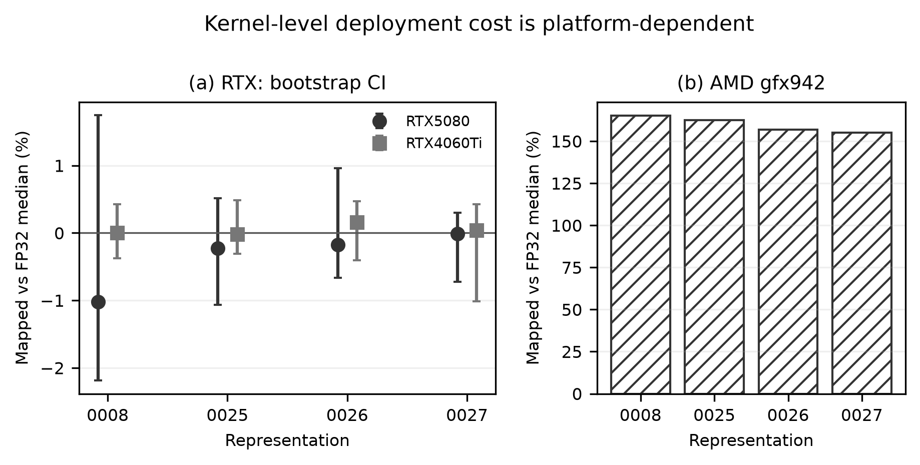
Figure 4. Functional deployment spans evaluated NVIDIA and AMD backends, while kernel cost is platform-dependent. Intervals crossing zero are not interpreted as acceleration.

5.6 Real-Model Scale Robustness
Coverage grows from 276,480 scale groups for Llama-3.1-8B to 317,440 for Qwen3-14B and 507,904 for Qwen3-32B. Zero clipping is observed at the calibrated intervals. The corrected Binary32-Z maximum doubles from approximately 256 on the two smaller configurations to approximately 512 on 32B, while HA-FBMS remains below 2 in the audited logical single-bit space. This coverage tests the same codec family across the three calibrated intervals. Figure 5 and Table 4 report the model-specific results.
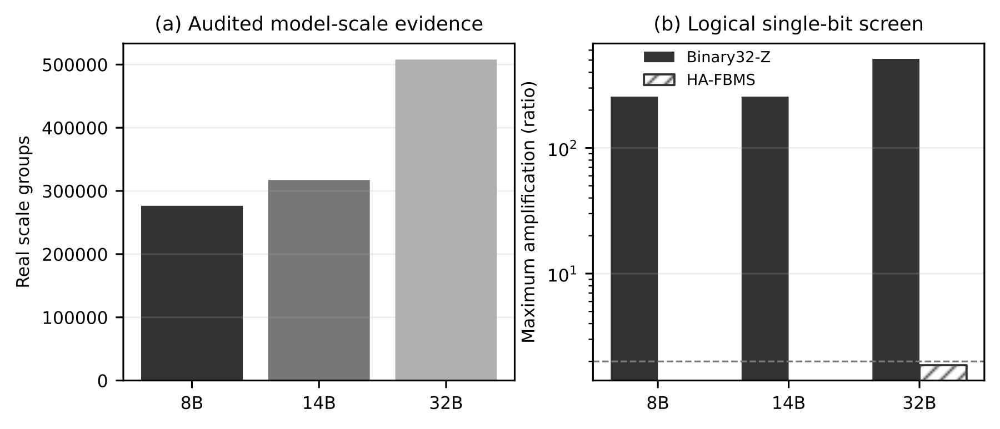
Figure 5. Model-specific calibration scales to Qwen3-32B with zero observed clipping; HA-FBMS remains below 2 in the audited logical single-bit space.

5.7 Full-Cache Clean Replay
Clean HA metadata reconstruction adds no observed logit perturbation relative to raw-scale INT4 replay in the tested one-step cases. For Qwen3-32B, eight prompt rows have zero clean HA top-1 changes. No additional observable semantic deviation from HA reconstruction appeared in this sample. It does not erase the quantization difference between raw INT4 and BF16. Table 5 summarizes clean replay.

5.8 Full-Cache Fault-Semantic Validation
In corrected Binary32-Z replay, Llama-3.1-8B has zero top-1 changes across 96 selected targets. For Qwen3-14B, the corrected global distribution contains 96 targets and two top-1 changes. Its KL median is 0.0, p95 is 4.19e-4, and maximum is 11.833; the mean is 0.207. The zero median and small p95 show that most selected targets have little or no response, while the extreme maximum raises the mean, showing that a small number of large responses dominate the target-level average. Qwen3-32B has zero Binary32-Z top-1 changes across 24 selected targets. Figure 6 and Table 6 summarize localized fault replay.
For Qwen3-32B HA-FBMS, all 24 selected scales remain valid, maximum amplification is 1.866, top-1 changes are zero, and maximum KL is 1.595e-3. This correspondence between bounded metadata response and limited observed semantic response is specific to the frozen targets and one-step replay.

5.9 Multi-Step Full-Cache Fault Propagation
To address the limitation of one-step replay, we ran a 32-step Qwen3-32B experiment on an AMD Instinct MI308X using the same 24 frozen logical targets across eight prompts. The manifest records three targets per prompt across early, middle, and late layer bands, with fixed K/V and full-cache group coordinates. The locations were selected by the frozen pre-response protocol before final fault-response analysis and were not reselected after replay outcomes were observed. Each encoding-specific bit fault was injected once into the initial full-cache representation without target reselection. The logical target locations were frozen before the AMD replay. Because small clean-state numerical differences existed across backends, the local clean raw scale, log scale, and metadata word were reconstructed on AMD at the same frozen logical location before the fault was applied. This is a frozen-location transfer, not exact clean-state reproduction. Greedy trajectories were evaluated at steps 1, 8, 16, and 32 in teacher-forced and free-running modes.
No tested valid Binary32-Z or HA-FBMS case changed the next-token argmax at step 1, but later steps exposed delayed divergence. By steps 8, 16, and 32, Binary32-Z had diverged in 4/24, 8/24, and 8/24 cases, compared with 2/24, 4/24, and 5/24 for HA-FBMS. At step 32, exact sequences were retained in 16/24 and 19/24 cases. In the teacher-forced comparison, mean token agreement was 0.967 for Binary32-Z and 0.991 for HA-FBMS. Maximum KL was 9.692 and 0.00778, and mean-case mean KL was 0.070 and 7.09e-4, respectively. These values apply to the frozen target set and do not imply universal or per-target dominance.
Free-running mean token agreement at step 32 was 0.773 for Binary32-Z and 0.888 for HA-FBMS. Once tokens diverge, later free-running KL is path-dependent because the branches are conditioned on different histories; free-running results therefore describe autoregressive propagation rather than pure metadata-fault magnitude. Teacher-forced replay is the cleaner multi-step logit comparison because both branches share the clean token history. All 24 tested FP32 sign-bit faults produced invalid scale metadata before replay, so FP32 replay metrics are not applicable and are not interpreted as zero divergence. Across this finite frozen target set, HA-FBMS reduced the aggregate incidence and severity of short-horizon divergence relative to Binary32-Z.
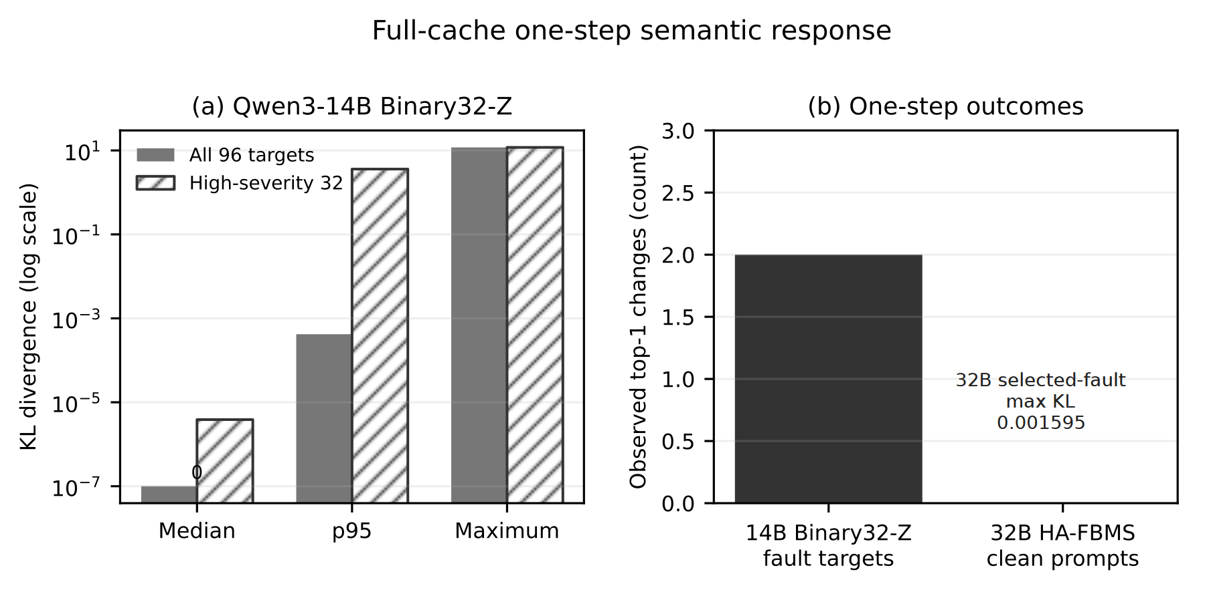
Figure 6. Localized full-cache one-step replay connects metadata fault geometry to semantic response. It is not long-sequence generation or a random hardware fault process.

5.10 Qwen3-32B Scale-Up
The 32B configuration provides the strongest integrated test: 64 layers, 507,904 real scale groups, an 18-wide calibrated interval, zero clipping, corrected Binary32-Z maximum amplification 512.000, and HA-FBMS maximum 1.866 with GE2=0. Clean replay remains unchanged at top-1 over eight prompts, and localized HA faults produce maximum KL 1.595e-3 over 24 targets. At 32B scale, the evidence connects model calibration, representation geometry, and the observed semantic response within the tested scope.

6. Discussion

6.1 Representation Geometry Versus Conventional Encoding
The main result is distributional. FP32 exposes invalid-value pathways, and Binary32-Z exposes high-significance integer jumps. HA-FBMS reallocates significance so that tested one-bit transitions remain within a controlled neighborhood. This geometry targets the response tail rather than mean quantization error, and the clean-error results show that it does not require a large fidelity penalty.

6.2 Role of Characterization-Weighted Mapping
HA-FBMS representation geometry is the primary mechanism that bounds logical single-bit amplification. Characterization-weighted logical metadata-bit mapping is an auxiliary optimization layer that uses characterization data to allocate logical bits within the software layout. Mapping effectiveness may vary across memory-characterization domains, but the intrinsic HA-FBMS amplification bound does not depend on the mapping layer. The pooled-profile scrambling and source-aware held-out analyses reveal two requirements for transferable benefit: the exposure structure itself must be sufficiently stable, and the characterization-to-deployment position correspondence must be observable, recalibratable, or explicitly controlled. The six-chip HBM2 corpus provides a repeatable positional structure, but commodity-GPU survival of that physical profile remains unproven.

The contrast between HBM2 and DDR is better explained by positional stability than by optimizer quality. The six-chip HBM2 corpus exhibits strong cross-chip rank agreement, with mean Spearman correlation 0.948, and recalibration under a fixed hidden permutation recovers approximately 98.9% of the original mapping benefit. In contrast, DDR mean and median pairwise Spearman correlations are 0.131 and 0.041. Source-aware nested validation therefore selects complete shrinkage to a uniform exposure profile in all five outer folds.

Individual DDR profiles may still be nonuniform, but their position-specific ordering is insufficiently stable across the evaluated scenarios to support a transferable fixed mapping. The frozen calibration-only diagnostic also found no material optimizer headroom from a fourfold multistart budget.

6.3 Heterogeneous Deployment Behavior
The deployment evidence rejects a single overhead narrative. On AMD gfx942, the frozen causal A/B isolates the nonidentity runtime bit permutation as the primary cause: the runtime-mapped condition increases median kernel latency from 1.025 to 1.333 ms (+30.074%), whereas the pre-permuted control returns to 1.024 ms (-0.078% versus identity). Static ISA and dynamic-counter evidence associate this cost with increased VALU pressure, not with a demonstrated physical DRAM or HBM lane mapping.
On NVIDIA H800, SASS inspection likewise shows that runtime permutation expands the instruction path with additional LOP3 and SHF operations around the common IMAD-based addressing path. However, the frozen latency A/B measured 0.038 ms for identity and 0.038 ms for runtime permutation (+0.847%), with runtime and prepermuted differing by only +0.084%; this experiment therefore did not observe a material runtime latency penalty on H800.
The RTX 5080 scale scan provides a second NVIDIA check: at N = 100,000,000, runtime permutation measured 1.044 ms versus 1.051 ms for identity (-0.648%), again showing no measurable penalty. Across these platforms, the same logical representation has backend-dependent implementation cost. These kernel microbenchmarks characterize the measured codec path; commodity-GPU physical mapping and end-to-end application latency remain outside their scope.
When deployment permits, pre-permutation at metadata construction or packing time is preferred on backends where runtime remapping incurs substantial execution cost because it avoids the measured runtime remapping path.
We tested whether the software environment explains the earlier H800 mapped-kernel overhead by repeating the microbenchmark on the same RTX 5080 under an H800-like Linux stack: Ubuntu 22.04.5, Linux 5.15.0-78, NVIDIA driver 580.82.07, CUDA 13.0, Triton 3.7.1, PyTorch 2.12.1+cu130, and Python 3.12.3. Across four metadata configurations at 4,194,304 groups, the maximum absolute median mapped-versus-FP32 difference was 0.169% (Table S1). Because this stack did not reproduce the larger H800 overhead, the result narrows the explanation to backend- and platform-sensitive execution without isolating one architectural or software cause. Controlled host-CPU replication covers Intel Core i7-14700KF and AMD Ryzen 7 7840HS on x86-64 and Apple M4 on ARM64. Across the 12 evaluated configurations, the maximum absolute mapped-versus-identity median differences were 5.277%, 6.303%, and 6.713%, respectively, and every case remained within 8%. These measurements establish cross-ISA codec portability rather than direct CPU-to-GPU performance comparability.

6.4 Generalization Across Model Scale and Platforms
The calibrated intervals differ across models, but the qualitative HA-FBMS behavior persists through Qwen3-32B and increasing real scale-group counts. Cross-platform execution likewise shows that the representation is implementable across the audited GPU and CPU environments, while optimization requirements vary by backend. This remains a three-model study over the measured platform set; broader architectures and tasks would test the limits of interval calibration and semantic response.

6.5 Practical Scope and Complementarity
MetaKV is a metadata reliability layer that can coexist with other memory-system mechanisms. Selective redundancy or ECC could be added, but no such allocation is implemented here. A controller-aware design could also bind logical mappings to verified physical structures; the current implementation uses a fixed software layout. The distinction keeps the present claims tied to the tested mechanism.
ECC protects storage integrity at the memory-system level, whereas MetaKV targets representation-level fault amplification after quantization. These mechanisms address different failure stages and can be combined rather than treated as alternatives. Conventional ECC mechanisms add redundancy to enable error detection or correction within the storage hierarchy. MetaKV instead preserves the original 32-bit metadata format without additional redundancy bits or memory capacity expansion.
Unlike hardware ECC policies controlled by memory controllers and device-level configurations, MetaKV provides software-level control through the KV-cache encoding and decoding path. This enables deployment-time adaptation without requiring modifications to GPU memory hardware or controller logic.
MetaKV targets the residual amplification of quantized metadata faults alongside correction-oriented mechanisms. Under the evaluated fault models, the representation limits extreme scale distortion while retaining the observed replay behavior.

7. Limitations
The logical fault model measures conditional sensitivity to injected perturbations; corpus counts and injections do not estimate live hardware bit-error rates or fault incidence. HBM2 weights come from a six-chip characterization corpus rather than direct HBM fault injection during the GPU experiments, and union-presence observations do not identify simultaneous events. The analytical bound covers single-bit metadata faults. A formal treatment of accumulated multi-bit or burst perturbations remains future work.
Characterization-weighted mapping assigns logical metadata bits within a fixed software layout, without verified physical DRAM/HBM lane placement or a global-optimality certificate. DDR position-specific orderings transfer weakly across the evaluated scenarios, whereas the HBM2 benefit is conditional on the more stable structure observed in its six-chip corpus. The mapping is therefore an auxiliary, characterization-dependent layer; the intrinsic HA-FBMS geometry does not rely on it.

Deployment measurements isolate kernel or codec paths rather than end-to-end serving latency, and implementation cost varies by platform. Full-cache replay covers 24 frozen logical locations over a 32-step horizon, not unrestricted long-form generation. AMD transfers preserve the frozen logical locations but reconstruct local clean scales and metadata words rather than reproduce the clean state bit for bit. Semantic response remains target dependent, and free-running KL becomes path dependent after token histories diverge. Clean equality refers to HA-versus-raw INT4 behavior in the tested cases; raw INT4 remains distinct from BF16. Representation-level resilience complements ECC, memory scrubbing, redundancy, and platform protection.

8. Conclusion
MetaKV treats low-precision KV-cache scale metadata as a reliability-sensitive control point. HA-FBMS restructures the same 32 metadata bits to constrain tested logical single-bit amplification, while characterization-weighted logical mapping uses empirical observations within a fixed software layout. Real-model replay and heterogeneous GPU and CPU deployment evidence connect the representation to practical inference systems and show that implementation cost remains backend dependent. Within the evaluated fault and deployment scope, the method provides a traceable basis for controlling metadata fault amplification in low-precision LLM inference.

CRediT author statement
Ziyang Yi: Conceptualization, Methodology, Software, Validation, Formal analysis, Investigation, Resources, Data curation, Writing – original draft, Writing – review & editing, Visualization, Project administration.

Funding
This research did not receive any specific grant from funding agencies in the public, commercial, or not-for-profit sectors.

Declaration of competing interest
The author declares no known competing financial interests or personal relationships that could have appeared to influence the work reported in this paper.

Data availability
The processed data, figure source data, reproducibility materials, and supporting implementation artifacts are publicly archived at Zenodo under DOI 10.5281/zenodo.22750136 and are also available through the MetaKV GitHub repository and the frozen v1.5.0-tjs-final release. Third-party model weights and the external HBM2 characterization corpus are not redistributed. Their sources and access instructions are documented in the public artifact.

Code availability
The MetaKV reference implementation, frozen experiment scripts, processed paper-number sources, and reproduction instructions are available at https://github.com/psybao/MetaKV. The frozen v1.5.0-tjs-final release is available at https://github.com/psybao/MetaKV/releases/tag/v1.5.0-tjs-final, with a permanent archive at https://doi.org/10.5281/zenodo.22750136.

Declaration of generative AI and AI-assisted technologies in the manuscript preparation process
During the preparation of this work, the author used ChatGPT and Codex to assist with code organization, language refinement, document organization, and consistency checking. The author reviewed and verified the resulting content and takes full responsibility for the content of the manuscript.

References
[1] Woosuk Kwon, Zhuohan Li, Siyuan Zhuang, Ying Sheng, Lianmin Zheng, Cody Hao Yu, Joseph E. Gonzalez, Hao Zhang, Ion Stoica, Efficient Memory Management for Large Language Model Serving with PagedAttention, Proceedings of the 29th Symposium on Operating Systems Principles, pp. 611-626, 2023. https://doi.org/10.1145/3600006.3613165.
[2] Ying Sheng, Lianmin Zheng, Binhang Yuan, Zhuohan Li, Max Ryabinin, Beidi Chen, Percy Liang, Christopher Re, Ion Stoica, Ce Zhang, FlexGen: High-Throughput Generative Inference of Large Language Models with a Single GPU, Proceedings of the 40th International Conference on Machine Learning (PMLR 202), vol. 202, pp. 31094-31116, 2023. https://proceedings.mlr.press/v202/sheng23a.html.
[3] Zirui Liu, Jiayi Yuan, Hongye Jin, Shaochen Zhong, Zhaozhuo Xu, Vladimir Braverman, Beidi Chen, Xia Hu, KIVI: A Tuning-Free Asymmetric 2bit Quantization for KV Cache, Proceedings of the 41st International Conference on Machine Learning (PMLR 235), vol. 235, pp. 32332-32344, 2024. https://proceedings.mlr.press/v235/liu24bz.html.
[4] Coleman Hooper, Sehoon Kim, Hiva Mohammadzadeh, Michael W. Mahoney, Yakun Sophia Shao, Kurt Keutzer, Amir Gholami, KVQuant: Towards 10 Million Context Length LLM Inference with KV Cache Quantization, Advances in Neural Information Processing Systems 37, vol. 37, 2024. https://doi.org/10.52202/079017-0040.
[5] Yefei He, Luoming Zhang, Weijia Wu, Jing Liu, Hong Zhou, Bohan Zhuang, ZipCache: Accurate and Efficient KV Cache Quantization with Salient Token Identification, Advances in Neural Information Processing Systems 37, vol. 37, 2024. https://proceedings.neurips.cc/paper_files/paper/2024/hash/7e57131fdeb815764434b65162c88895-Abstract-Conference.html.
[6] Yuhan Liu, Hanchen Li, Yihua Cheng, Siddhant Ray, Yuyang Huang, Qizheng Zhang, Kuntai Du, Jiayi Yao, Shan Lu, Ganesh Ananthanarayanan, Michael Maire, Henry Hoffmann, Ari Holtzman, Junchen Jiang, CacheGen: KV Cache Compression and Streaming for Fast Large Language Model Serving, Proceedings of the ACM SIGCOMM 2024 Conference, pp. 38-56, 2024. https://doi.org/10.1145/3651890.3672274.
[7] Zhenyu Zhang, Shiwei Liu, Runjin Chen, Bhavya Kailkhura, Beidi Chen, Zhangyang Wang, Q-Hitter: A Better Token Oracle for Efficient LLM Inference via Sparse-Quantized KV Cache, Proceedings of Machine Learning and Systems 6, vol. 6, 2024. https://proceedings.mlsys.org/paper_files/paper/2024/hash/bbb7506579431a85861a05fff048d3e1-Abstract-Conference.html.
[8] Tianyi Zhang, Jonah Yi, Zhaozhuo Xu, Anshumali Shrivastava, KV Cache is 1 Bit Per Channel: Efficient Large Language Model Inference with Coupled Quantization, Advances in Neural Information Processing Systems 37, vol. 37, 2024. https://proceedings.neurips.cc/paper_files/paper/2024/hash/05d6b5b6901fb57d2c287e1d3ce6d63c-Abstract-Conference.html.
[9] Hao Kang, Qingru Zhang, Souvik Kundu, Geonhwa Jeong, Zaoxing Liu, Tushar Krishna, Tuo Zhao, GEAR: An Efficient KV Cache Compression Recipe for Near-Lossless Generative Inference of LLM, arXiv, 2024. https://doi.org/10.48550/arXiv.2403.05527.
[10] Yuhwan Lee, Junho Kim, Minsoo Rhu, No Token Left Behind: Reliable KV Cache Compression via Importance-Aware Mixed Precision Quantization, arXiv, 2024. https://doi.org/10.48550/arXiv.2402.18096.
[11] Muhammad Adnan, Akhil Arunkumar, Gaurav Jain, Prashant Nair, Ilya Soloveychik, Purushotham Kamath, Keyformer: KV Cache Reduction through Key Tokens Selection for Efficient Generative Inference, Proceedings of Machine Learning and Systems 6, vol. 6, 2024. https://proceedings.mlsys.org/paper_files/paper/2024/hash/48fecef47b19fe501d27d338b6d52582-Abstract-Conference.html.
[12] James Elliott, Mark Hoemmen, Frank Mueller, Exploiting Data Representation for Fault Tolerance, Journal of Computational Science, vol. 14, pp. 51-60, 2016. https://doi.org/10.1016/j.jocs.2015.12.002.
[13] Jialai Wang, Yuxiao Wu, Weiye Xu, Yating Huang, Chao Zhang, Zongpeng Li, Mingwei Xu, Zhenkai Liang, Your Scale Factors are My Weapon: Targeted Bit-Flip Attacks on Vision Transformers via Scale Factor Manipulation, Proceedings of the IEEE/CVF Conference on Computer Vision and Pattern Recognition, pp. 20103-20112, 2025. https://openaccess.thecvf.com/content/CVPR2025/html/Wang_Your_Scale_Factors_are_My_Weapon_Targeted_Bit-Flip_Attacks_on_CVPR_2025_paper.html.
[14] Yoongu Kim, Ross Daly, Jeremie Kim, Chris Fallin, Ji Hye Lee, Donghyuk Lee, Chris Wilkerson, Konrad Lai, Onur Mutlu, Flipping Bits in Memory Without Accessing Them: An Experimental Study of DRAM Disturbance Errors, 41st Annual International Symposium on Computer Architecture, pp. 361-372, 2014. https://doi.org/10.1109/ISCA.2014.6853210.
[15] Michael B. Sullivan, Nirmal Saxena, Mike OConnor, Donghyuk Lee, Paul Racunas, Saurabh Hukerikar, Timothy Tsai, Siva Kumar Sastry Hari, Stephen W. Keckler, Characterizing and Mitigating Soft Errors in GPU DRAM, 54th Annual IEEE/ACM International Symposium on Microarchitecture, 2021. https://doi.org/10.1145/3466752.3480111.
[16] Ataberk Olgun, Majd Osseiran, Abdullah Giray Yaglikci, Yahya Can Tugrul, Haocong Luo, Steve Rhyner, Behzad Salami, Juan Gomez-Luna, Onur Mutlu, Read Disturbance in High Bandwidth Memory: A Detailed Experimental Study on HBM2 DRAM Chips, 54th Annual IEEE/IFIP International Conference on Dependable Systems and Networks, pp. 75-89, 2024. https://doi.org/10.1109/DSN58291.2024.00022.

Main tables

Table 1. Metadata representations and fault geometry
Representation | Width | Scale-domain interpretation | Tested fault response | Scope
FP32 | 32 bits | Direct IEEE-754 Binary32 scale metadata | Can become invalid in selected logical-fault screens | Logical single-bit screen
Binary32-Z | 32 bits | Uniform unsigned encoding of $\log_{2}(s)$ over the calibrated interval | Maximum amplification 256.000 on 8B/14B and 512.000 on 32B | Corrected implementations only
HA-FBMS | 32 bits | Structured $B_{c}/B_{f}$ log-scale metadata | Qwen3-32B maximum 1.866; GE2=0 | Audited model-calibrated configurations

Table 2. DDR/HBM2 characterization-weighted mapping evidence
Domain or transfer | Metric | Value | Interpretation
DDR corpus | Strict word-fault rows | 1,067,712 | Corpus scale, not a hardware rate
DDR scenarios | Mean $H≤3$ coverage | 0.736 | Mean across 32 unpooled scenarios
HBM2 corpus | Logical-position CV | 0.883 | Non-uniform logical-position observations
HBM2 corpus | Top-eight position mass | 0.476 | Descriptive corpus concentration
HBM→DDR | Mean domain-reference ratio | 1.006 | Relative to the DDR-native reference
DDR→HBM | Mean domain-reference ratio | 2.908 | Relative to the HBM-native reference
Robust selection | Mean maximum reference ratio | 1.002 | Eight selected representatives

Table 3. Largest-workload GPU deployment results
Platform | Representation | Mapped vs. FP32 median (%) | 95% CI (%) | Safe interpretation
RTX5080 | REP0008 | -1.023 | [-2.186, 1.747] | CI crosses zero
RTX4060Ti | REP0026 | 0.159 | [-0.404, 0.471] | CI crosses zero
AMD gfx942 | REP0008 | 165.067 | [165.003, 165.076] | Functional, not performance, portability
The RTX rows show the largest absolute median among the four reported representations on each platform. H800 is discussed separately because its authoritative timing experiment used a distinct protocol. REP identifiers denote frozen representative codec configurations used in the deployment timing protocol.

Table 4. Real-model scale robustness
Model | Layers | Scale groups | Calibrated interval | Width | Clip count | Corrected Binary32-Z max $A$ | HA-FBMS result
Llama-3.1-8B | 32 | 276,480 | [-13, 3] | 16 | 0 | 256.0 | $A<2$; GE2=0 in screen evidence
Qwen3-14B | 40 | 317,440 | [-11, 5] | 16 | 0 | 256.0 | $A<2$; GE2=0 in screen evidence
Qwen3-32B | 64 | 507,904 | [-13, 5] | 18 | 0 | 512.0 | $A=1.866$  GE2=0
Layer, interval, width, and clipping facts come from the audited model-scale evidence and method definitions.

Table 5. Full-cache clean replay
Model scope | Replay | Observed result | Interpretation
Llama-3.1-8B and Qwen3-14B | One-step next-token, captured full cache | No observed HA-vs-raw INT4 top-1 change or additional logit perturbation in tested prompts | Does not imply raw INT4 equals BF16
Qwen3-32B | Eight prompt rows | Clean HA-FBMS top-1 changes=0 | One-step replay, not long generation
The reported scope follows the audited model-scale evidence and replay protocol.

Table 6. Full-cache localized fault-semantic validation
Model | Encoding | Selected targets | Top-1 changes | KL median / p95 / maximum | Maximum amplification
Llama-3.1-8B | Corrected Binary32-Z | 96 | 0 | Not reported | 256.000
Qwen3-14B | Corrected Binary32-Z | 96 | 2 | 0 / 4.186e-4 / 11.833 | 256.000
Qwen3-32B | Corrected Binary32-Z | 24 | 0 | Not reported | 512.000
Qwen3-32B | HA-FBMS | 24 | 0 | Maximum 1.595e-3 | 1.866
Qwen3-14B corrected Binary32-Z has a heavy-tailed target-level response: KL median 0.0, p95 4.19e-4, maximum 11.833, and mean 0.207. These statistics were reconciled against the corrected global summary and all 96 target rows. The Llama-3.1-8B and Qwen3-32B Binary32-Z cells remain Not reported because their protocol-specific KL summaries were not promoted into the frozen cross-model publication table; no value is inferred from Top-1 agreement.

Table 7. AMD Qwen3-32B 32-step full-cache fault propagation
Metric | Binary32-Z | HA-FBMS
Maximum scale amplification | 512.000× | 1.866×
Diverged by step 1 | 0/24 | 0/24
Diverged by step 8 | 4/24 | 2/24
Diverged by step 16 | 8/24 | 4/24
Diverged by step 32 | 8/24 | 5/24
Exact sequence at step 32 | 16/24 | 19/24
Teacher-forced mean token agreement at step 32 | 0.967 | 0.991
Teacher-forced maximum KL | 9.692 | 0.00778
Teacher-forced mean-case mean KL | 0.070 | 7.09e-4
Free-running mean token agreement at step 32 | 0.773 | 0.888
FP32 replay metrics are N/A because all 24 tested sign-bit faults produced invalid scale metadata. Teacher-forced values hold token history fixed; post-divergence free-running KL is path-dependent.
Source: AMD MI308X formal replay summary and 3,072 step-level replay rows; 72/72 encoding cases completed with no target reselection.

