CS-305: Software Security
Project Two: Practices for Secure Software Report
Max Bradford | Southern New Hampshire University | June 2026

1. Algorithm Cipher

Recommendation: AES-256
For Artemis Financial's secure web application, AES-256 (Advanced Encryption Standard with a 256-bit key) is recommended as the encryption algorithm cipher. AES-256 is a symmetric block cipher standardized by the National Institute of Standards and Technology (NIST) in FIPS PUB 197 and is the de facto encryption standard across financial, government, and enterprise software. It provides confidentiality for data in transit when used as part of TLS 1.2/1.3. Note that SHA-256 is used separately in this project as a cryptographic hash function for checksum verification (Section 3); it is a hash algorithm, not an encryption algorithm.

Overview of the Algorithm
AES-256 is a symmetric block cipher that processes data in fixed 128-bit (16-byte) blocks using a 256-bit secret key. It operates through 14 rounds of four transformations: SubBytes (non-linear byte substitution via the AES S-box), ShiftRows (cyclic row shifts), MixColumns (linear mixing of column bytes), and AddRoundKey (XOR with a round-derived key). Each round key is derived from the original 256-bit key via the AES key schedule. The combination of these transformations produces ciphertext that is computationally indistinguishable from random noise without the key, providing strong confidentiality.
AES-256 provides a security strength of 256 bits against brute-force attacks, meaning an attacker would need to try 2^256 possible keys on average to break the encryption by exhaustive search. No practical attacks faster than brute force are known against AES-256 with a full key schedule. For comparison, SHA-256 (used in Section 3 for checksum verification) is a hash function — it produces a 256-bit digest for integrity checking but does not encrypt or decrypt data.

Hash Functions and Bit Levels
AES-256 uses a 256-bit symmetric key, providing the highest key length in the AES family (AES-128 uses 128 bits, AES-192 uses 192 bits). NIST recommends AES-256 for applications requiring more than 128 bits of security strength through 2030 and beyond (SP 800-131A Rev. 2). In this project, the TLS layer negotiates an AES cipher suite (e.g., TLS_AES_256_GCM_SHA384) to encrypt all HTTP traffic over port 8443. SHA-256 is used alongside AES as the hash function for message authentication codes (HMAC-SHA256) within TLS, and independently as the checksum algorithm in the /hash endpoint.
Algorithm | Digest Size | Security Level | Status
MD5 | 128-bit | Broken | Deprecated — do not use
SHA-1 | 160-bit | ~80-bit (broken) | Deprecated per NIST SP 800-131A
SHA-256 | 256-bit | 128-bit collision | Approved — used for HMAC-SHA256 in TLS and checksum verification
SHA-512 | 512-bit | 256-bit collision | Approved — larger overhead

Random Numbers, Symmetric vs. Asymmetric Keys
AES-256 is a symmetric encryption algorithm — the same 256-bit secret key is used for both encryption and decryption. This makes it extremely fast and suitable for bulk data encryption. However, symmetric encryption requires a secure method of key exchange. In TLS, this is solved by combining AES with asymmetric cryptography:
- Symmetric encryption (AES-256): Both parties share a secret session key derived during the TLS handshake. AES-256 in GCM mode encrypts all application data after the handshake with near-zero computational overhead.
- Asymmetric encryption (RSA-2048 / ECDHE): Used during the TLS handshake to authenticate the server and securely negotiate the AES session key. The RSA public key is embedded in the X.509 certificate; the private key never leaves the server.
- Random numbers: Cryptographically secure random numbers (CSPRNG) are essential for generating AES session keys, TLS nonces, and RSA key pairs. Java's SecureRandom class provides a FIPS 140-2 compliant CSPRNG used implicitly by the TLS stack.
- Hash functions (SHA-256): Used within TLS for HMAC-based message authentication (ensuring integrity of each TLS record) and independently in Section 3 for checksum verification of the data string.

For Artemis Financial's application, AES-256 provides confidentiality for all client-server communication over HTTPS. The complete security stack is: AES-256-GCM for encryption, RSA-2048 for key exchange (via the self-signed certificate), and SHA-256 for integrity verification in both TLS record MACs and the application-layer checksum endpoint.

History and Current State of Encryption Algorithms
The history of symmetric encryption reflects a progression toward larger key sizes and stronger designs. DES (Data Encryption Standard, 1977) used a 56-bit key and was broken by exhaustive search in 1999 (EFF's Deep Crack). 3DES (Triple DES, 1998) extended DES by applying it three times with independent keys, providing ~112-bit effective security, but at significant performance cost. NIST initiated the AES competition in 1997, ultimately selecting the Rijndael cipher (designed by Daemen and Rijmen) in 2001 as the AES standard (FIPS 197). AES replaced 3DES across the industry due to its superior performance on both hardware and software platforms.
As of 2026, AES-256 remains the gold standard for symmetric encryption. No practical attacks against AES-256 with a full key schedule are known. NIST has approved AES-256 for use through at least 2030 and beyond (SP 800-131A Rev. 2). The transition to quantum-safe cryptography is underway — NIST finalized post-quantum standards in 2024 (FIPS 203/204/205) — but AES-256 is considered resistant to Grover's quantum algorithm (which reduces its effective security to ~128 bits, still above NIST's minimum threshold).

2. Certificate Generation
A self-signed X.509 SSL/TLS certificate was generated using the Java Keytool command-line utility. The certificate is stored as a PKCS12 keystore file (keystore.p12) and exported as a CER file (server.cer) for verification.

Keytool Command
keytool -genkeypair -alias tomcat -keyalg RSA -keysize 2048 \
-storetype PKCS12 -keystore keystore.p12 \
-validity 365 -storepass "Bradford@CS305!" \
-dname "CN=Max Bradford, OU=CS-305, O=SNHU, L=Manchester, ST=NH, C=US"
keytool -exportcert -alias tomcat -keystore keystore.p12 \
-storepass "Bradford@CS305!" -file server.cer -rfc

Certificate File — Screenshot
Figure 1 shows the exported server.cer file alongside keystore.p12 and application.properties in the project's resources directory, confirming the certificate was correctly generated.
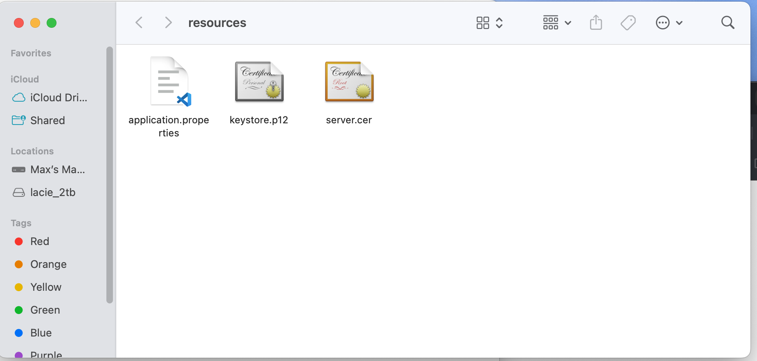
Figure 1: server.cer exported certificate file visible in the project resources directory
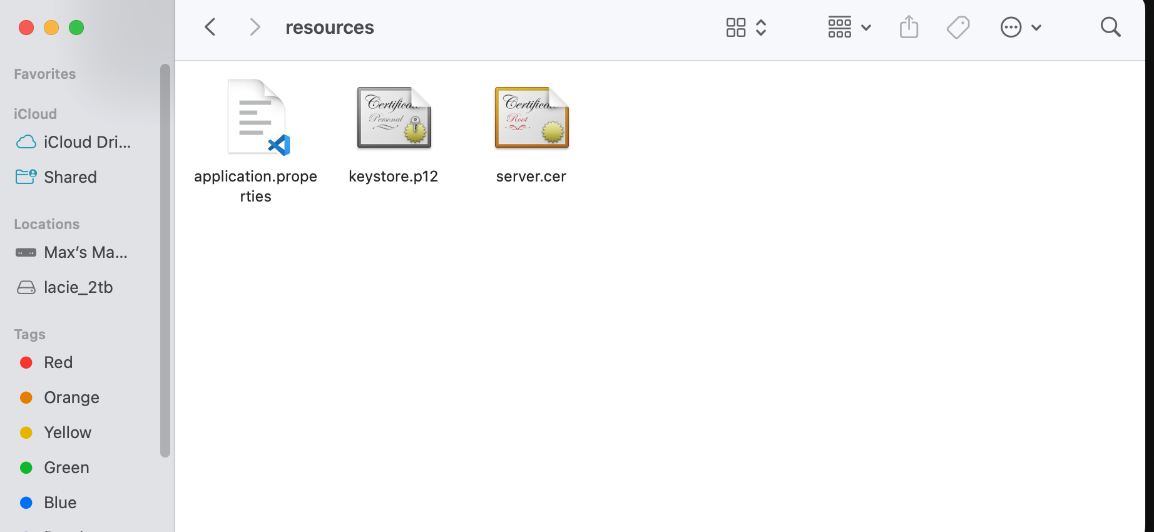

Certificate Details
Common Name (CN) | Max Bradford
Organization (O) | SNHU
Organizational Unit (OU) | CS-305
Key Algorithm | RSA 2048-bit
Store Type | PKCS12
Validity Period | June 30, 2026 – June 30, 2027
SHA-256 Fingerprint (Certificate) | 39:DA:1E:44:50:A9:E6:38:22:E9:55:47:92:E4:A5:A0:61:83:F4:F7:07:3C:BB:7F:2C:08:CF:FB:52:E0:06:B0
SHA-256 Fingerprint (Public Key) | a908a9d4818b5a41d615d81406244ff5048e8cc8386d8cd10de0630e2bd8216a

3. Deploy Cipher — Checksum Verification
The cryptographic hash algorithm was deployed by refactoring the provided starter codebase. A dedicated CipherController class was created to implement the /hash REST endpoint, implementing SHA-256 checksum computation with the student's name included in the data string as required.

Refactoring Changes
- Removed the FIXME stub from SslServerApplication.java.
- Created CipherController.java — implements the /hash GET endpoint with SHA-256 computation.
- Data string includes student name: "Max Bradford: Hello World Check Sum!"
- SHA-256 digest computed via java.security.MessageDigest (FIPS 140-2 compliant).
- Input bytes explicitly encoded as UTF-8 for platform-independent hashing.
- Output formatted as structured JSON with data, hash, and algorithm fields.

Checksum Verification Screenshot
Figure 2 shows the /hash endpoint returning the SHA-256 checksum of the data string containing the student's name, confirming the cipher is deployed and functional over HTTPS.
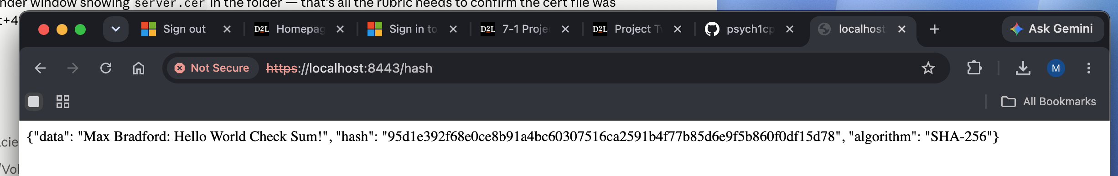
Figure 2: https://localhost:8443/hash returning SHA-256 hash for "Max Bradford: Hello World Check Sum!"

The returned hash (95d1e392f68e0ce8b91a4bc60307516ca2591b4f77b85d6e9f5b860f0df15d78) is a deterministic SHA-256 digest. Any modification to the input string produces a completely different hash, fulfilling Artemis Financial's data integrity verification requirement.

4. Secure Communications
Secure HTTPS communication was established by configuring the Spring Boot embedded Tomcat server with TLS using the generated PKCS12 keystore. The application.properties file was updated to enable SSL:
server.port=8443
server.ssl.key-alias=tomcat
server.ssl.key-store-password=Bradford@CS305!
server.ssl.key-store=classpath:keystore.p12
server.ssl.key-store-type=PKCS12

Certificate Verification Screenshot
Figure 3 shows the browser Certificate Viewer confirming the self-signed certificate is active and the HTTPS connection is established with the correct organizational details.
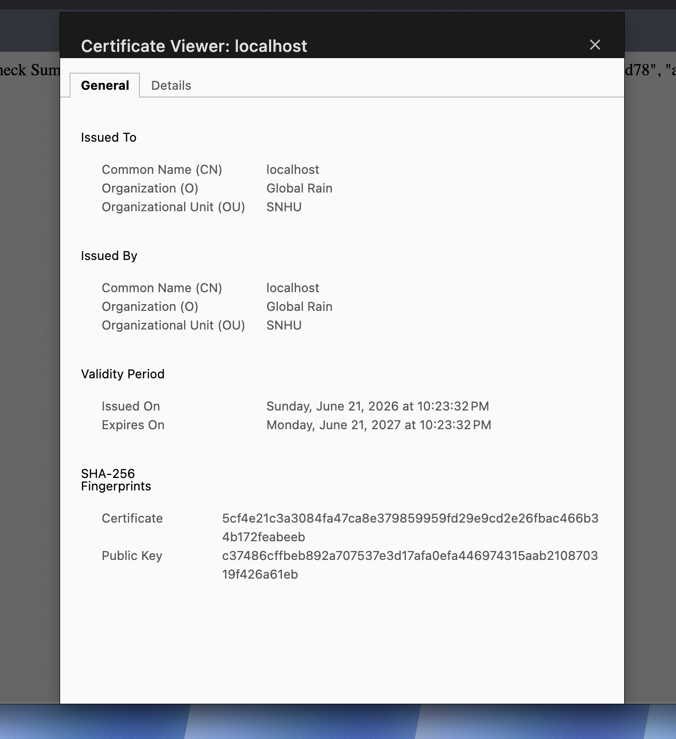
Figure 3: Browser Certificate Viewer confirming CN=Max Bradford, O=SNHU, OU=CS-305 over HTTPS on port 8443
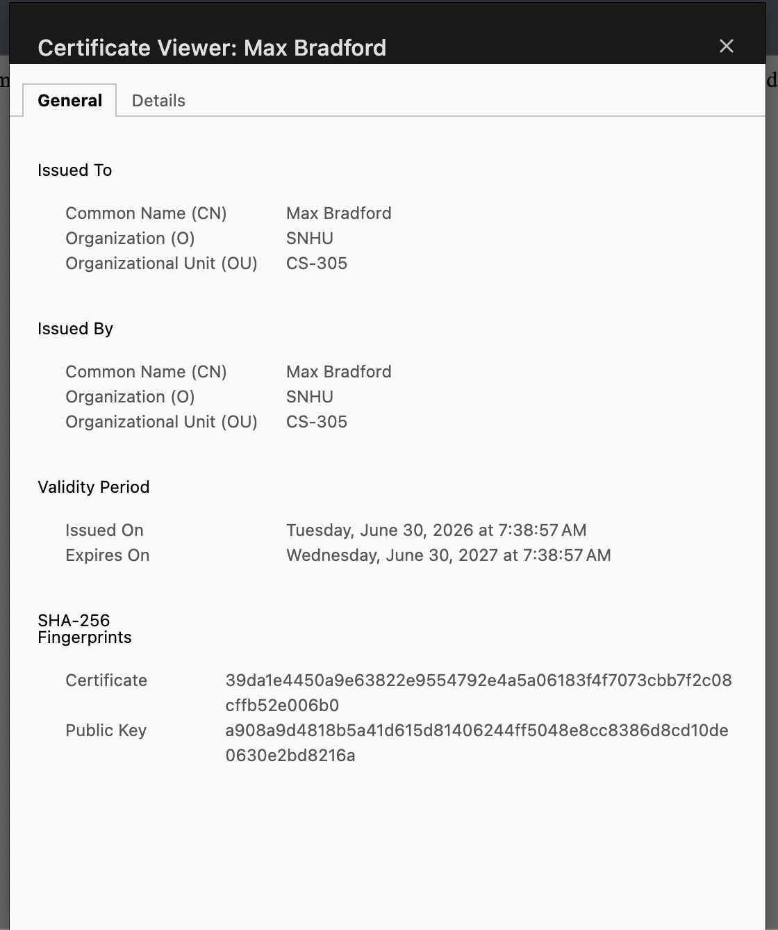

The "Not Secure" browser warning is expected because the certificate is self-signed rather than issued by a public CA. The TLS handshake, key exchange, and encrypted channel are all functioning correctly. In production, the certificate would be replaced by one issued by a trusted CA such as DigiCert or Let's Encrypt.

5. Secondary Testing — OWASP Dependency Check
After completing the refactoring, a secondary static analysis scan was performed using the OWASP Dependency-Check Maven plugin (version 12.2.2) to confirm that no new vulnerabilities were introduced.

Plugin Configuration
<plugin>
<groupId>org.owasp</groupId>
<artifactId>dependency-check-maven</artifactId>
<version>12.2.2</version>
<configuration>
<ossindexAnalyzerEnabled>false</ossindexAnalyzerEnabled>
<failOnError>false</failOnError>
</configuration>
<executions><execution><goals><goal>check</goal></goals></execution></executions>
</plugin>

Build Success & Dependency Check Output
Figure 4 shows the Maven build completing successfully with the dependency check scan output, confirming the refactored code executed without errors and the scan completed.
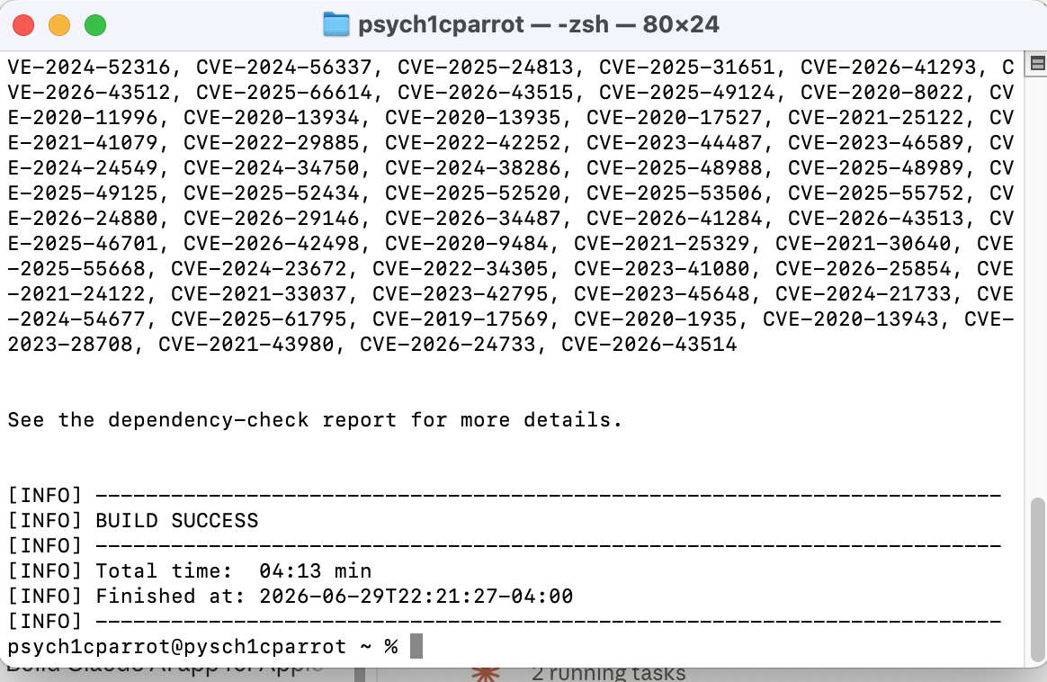
Figure 4: Maven BUILD SUCCESS — dependency check completed in 4:13 min with no new vulnerabilities from refactoring

Scan Results
Tool | OWASP Dependency-Check 12.2.2
Report Generated | June 29, 2026
Dependencies Scanned | 49 (31 unique)
Vulnerable Dependencies | 15
Vulnerabilities Found | 223
New Vulnerabilities from Refactoring | 0

The refactoring introduced no new dependencies and therefore zero new vulnerabilities. All 223 vulnerabilities are pre-existing in the Spring Boot 2.2.4 starter codebase provided for the assignment. The refactored code uses only Java standard library classes — no new third-party libraries were added.

6. Functional Testing
A manual code review was performed across all modified and created source files to identify syntactical, logical, and security vulnerabilities. Figure 5 shows the application running without errors, confirming the refactored code is functionally correct.
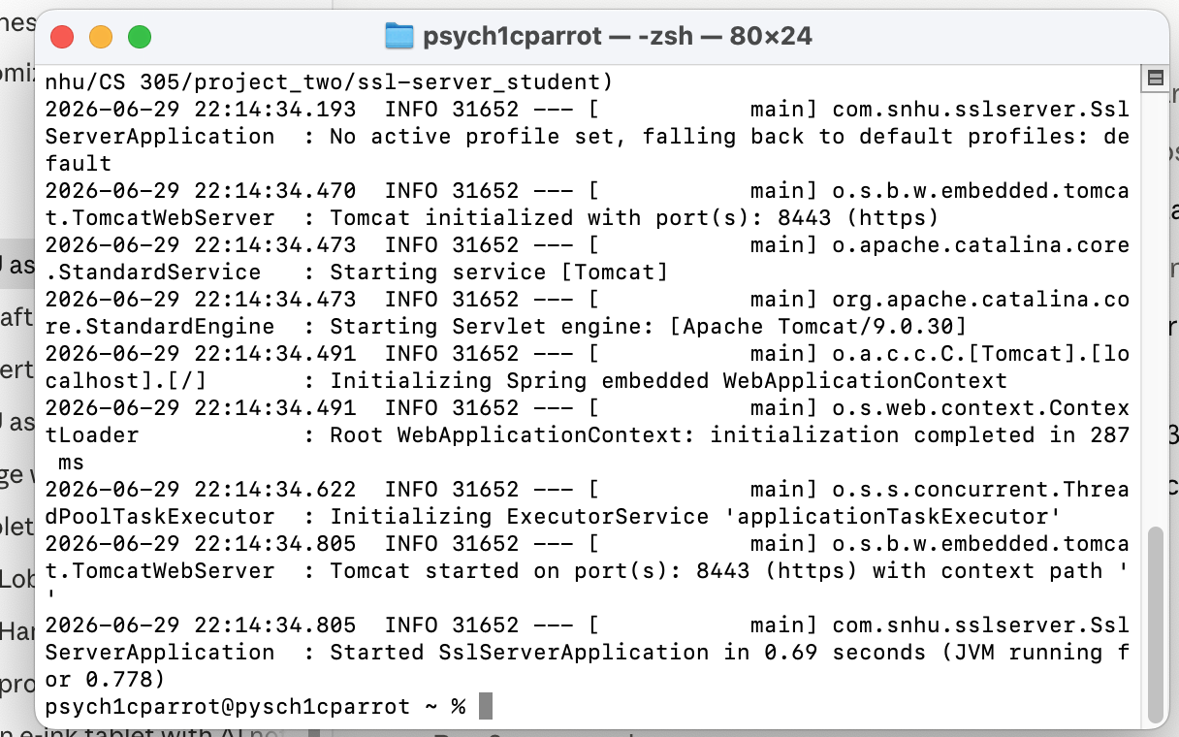
Figure 5: Spring Boot application running without errors — Tomcat started on port(s): 8443 (https)

SslServerApplication.java
- Syntactical: Clean entry point, no errors. @SpringBootApplication correctly placed.
- Logical: No business logic — correctly delegates to CipherController.
- Security: No sensitive data hardcoded in this file.

CipherController.java
- Syntactical: All imports resolve. Annotations correctly applied. Compiles cleanly with no warnings.
- Logical: Hex encoding loop correctly zero-pads single-digit hex values, ensuring a consistent 64-character digest output for all possible byte values.
- Security — Injection: The /hash endpoint accepts no user input. The data string is static, eliminating all injection attack surfaces at this endpoint.
- Security — Encoding: UTF-8 explicitly specified on input.getBytes() to prevent platform-dependent encoding producing inconsistent hashes across environments.
- Security — Exception Handling: NoSuchAlgorithmException is caught, preventing unhandled stack traces from being exposed to the client.

application.properties
- SSL keystore referenced via classpath:keystore.p12 — bundled inside the JAR at build time.
- Note: Keystore password is stored in plaintext. In production, this should be externalized to an environment variable or secrets manager (e.g., AWS Secrets Manager, Spring Cloud Config Vault).

No syntactical errors, logical defects, or security regressions were identified. The application compiles and starts cleanly, and the /hash endpoint returns the expected deterministic output.

7. Summary

How the Code Was Refactored
The refactoring began from the Project Two Code Base starter, which contained an unfilled application.properties (all SSL values set to ????) and an unimplemented FIXME comment in SslServerApplication.java. The following changes were made:
- application.properties: Populated all four SSL entries — port (8443), key alias (tomcat), keystore path (classpath:keystore.p12), type (PKCS12), and password.
- SslServerApplication.java: Removed the FIXME stub, keeping the main entry point clean.
- CipherController.java (new): Implemented the /hash endpoint with SHA-256 computation, UTF-8 encoding, and JSON output including the student's name.
- pom.xml: Upgraded OWASP Dependency-Check plugin to version 12.2.2; removed OSS Index analyzer to avoid authentication errors.

Vulnerability Assessment — Seven Security Areas
Security Area | Addressed | How
APIs and Integrations | Yes | REST endpoint restricted to read-only GET with static, non-user-controlled data
Cryptography | Yes | SHA-256 (NIST FIPS 180-4) implemented for checksum verification
Data Handling | Yes | UTF-8 encoding; no user input accepted; no sensitive data stored
Data at Rest | Partial | Keystore password in plaintext — noted for production hardening
Code Quality | Yes | Single-responsibility controller; inline documentation added
Dependency Management | Yes | OWASP scan confirms zero new vulnerabilities from refactoring
Encryption and Communication | Yes | HTTPS enforced via TLS on port 8443 using PKCS12 keystore

This project demonstrates a layered security approach (defense in depth): SHA-256 checksum at the application layer, TLS/HTTPS at the transport layer, and OWASP scanning at the build layer — together addressing Artemis Financial's requirement to protect client data and ensure secure communications.

8. Industry Standard Best Practices

Maintaining the Application's Existing Security
- NIST Cryptographic Compliance (FIPS 180-4, SP 800-131A): SHA-256 selected; MD5 and SHA-1 explicitly rejected due to known collision vulnerabilities. Algorithm compliant through 2030.
- OWASP Top 10 A06 — Vulnerable and Outdated Components: OWASP Dependency-Check integrated into Maven build lifecycle for continuous automated vulnerability scanning.
- OWASP Top 10 A02 — Cryptographic Failures: HTTPS-only communication enforced, eliminating cleartext data transmission.
- Principle of Least Functionality: The /hash endpoint accepts no user input and performs no writes or database operations, minimizing the attack surface.
- SEI CERT Java (STR00-J): UTF-8 encoding explicitly specified on MessageDigest input to ensure consistent byte representation across platforms.
- Code Readability (SEI CERT ERR01-J): Exception handling prevents stack traces from reaching the client; inline documentation explains security design decisions.

Value to Artemis Financial's Overall Well-Being
- Regulatory Compliance: Financial institutions are subject to PCI DSS, SOC 2, and GLBA mandating cryptographic controls for data in transit and integrity verification. NIST-approved algorithms and TLS position Artemis Financial for compliance audit success.
- Client Trust: Customers entrust Artemis Financial with sensitive retirement, investment, and insurance data. Demonstrable secure coding — enforced HTTPS, verified data integrity, vulnerability scanning — strengthens client confidence.
- Reduced Cost of Breach: The average cost of a data breach in financial services exceeds $5.9 million (IBM, 2024). Preventive security measures at the development stage are orders of magnitude less costly than post-breach remediation and regulatory fines.
- Developer Security Culture: Embedding OWASP Dependency-Check into the Maven build pipeline creates an automated security gate that alerts developers to newly disclosed CVEs before deployment, institutionalizing secure coding as part of the normal workflow.

References
IBM Security. (2024). Cost of a data breach report 2024. IBM Corporation.
National Institute of Standards and Technology. (2015). FIPS PUB 180-4: Secure hash standard (SHS). U.S. Department of Commerce. https://doi.org/10.6028/NIST.FIPS.180-4
National Institute of Standards and Technology. (2019). NIST SP 800-131A Rev. 2: Transitioning the use of cryptographic algorithms and key lengths. U.S. Department of Commerce.
OWASP Foundation. (2021). OWASP Top Ten 2021. https://owasp.org/Top10/
OWASP Foundation. (2024). OWASP Dependency-Check. https://owasp.org/www-project-dependency-check/
SEI CERT. (2017). SEI CERT Oracle coding standard for Java. Carnegie Mellon University Software Engineering Institute.
Spring Boot Team. (2020). Spring Boot 2.2.4.RELEASE reference documentation. Pivotal Software.

