**eLORETA implementation BRC – iSPOT**

**Preliminary checks:**

* For every EEG dataset (Eyes Open or Eyes Closed) and individual the number of available and rejected EEG epochs as well as number of interpolated and missing channels should be available.

**Requirements**

* Electrode coordinates: Electrodes_BRC26.sxyz
* eLORETA transformation matrix: eLORETA_BRC26.spinv
* Frequency bands file (custom): FFT_Bands_iSPOT.txt
* ROI file: eLORETA-9ROIs_iSPOT.csv or [Pizzagalli_rACC_ROI]
* Open **‘Main Utilities’** in LORETA software

**Step 1: EEG to Cross-spectrum**

* Check ‘Each folder to 1 CRS’
* Add the folders with EEG epochs by dragging them into ‘EEG folder/files’
* Check ‘Force average reference’ (**for EEG only!**).
* Fill in the details: # electrodes = 26; # time frames/epoch = 1024; SR=500 Hz
* Select ‘user defined bands’ and drag FFT_Bands_iSPOT.txt in the ‘File with user defined bands’ section (for fICA analysis use FFT_Bands_DMN_5BRC.txt)

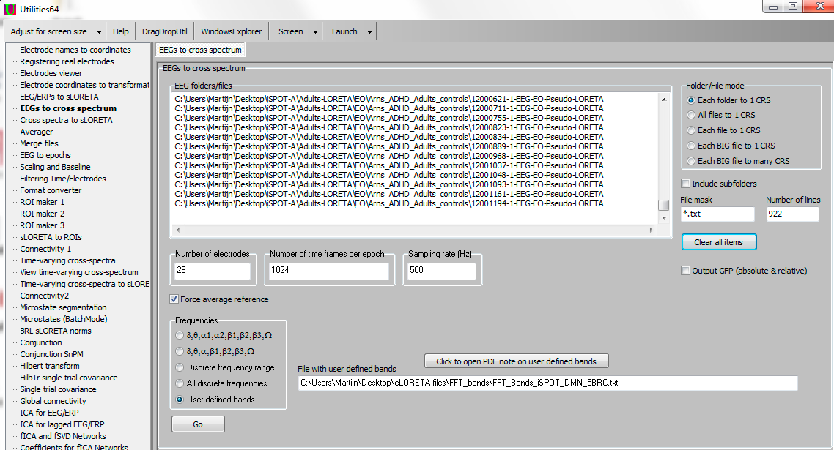

**Step 2: Cross spectra to sLORETA**

* Add the files obtained in step 1 to ‘Cross spectrum files’ under ‘Cross spectra to sLORETA’.
* Add the eLORETA transformation matrix eLORETA_BRC26.spinv to the ‘File with transformation matrix’ and press ‘Go’

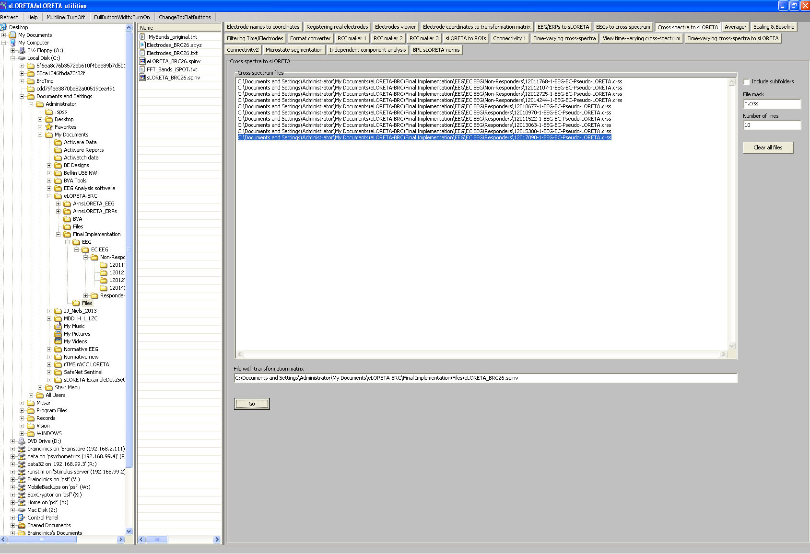

**Transposed functional ICA (fICA) Network analysis**

* Go to **Transposed fICA Networks** and input all .slor files to be used for extracting the shared networks (so when MDD is compared to controls, or ADHD to controls, input data from both groups, since this procedure will extract the brain networks common to both groups, and in subsequent steps the individual loading per network can be tested for groups separately).
* Set the ‘**number of components**’ to **7** and make sure the file type is set to sLORETA, scaling to Frequency/Time-Wise.
* Select a directory and provide an identifiable file-name.

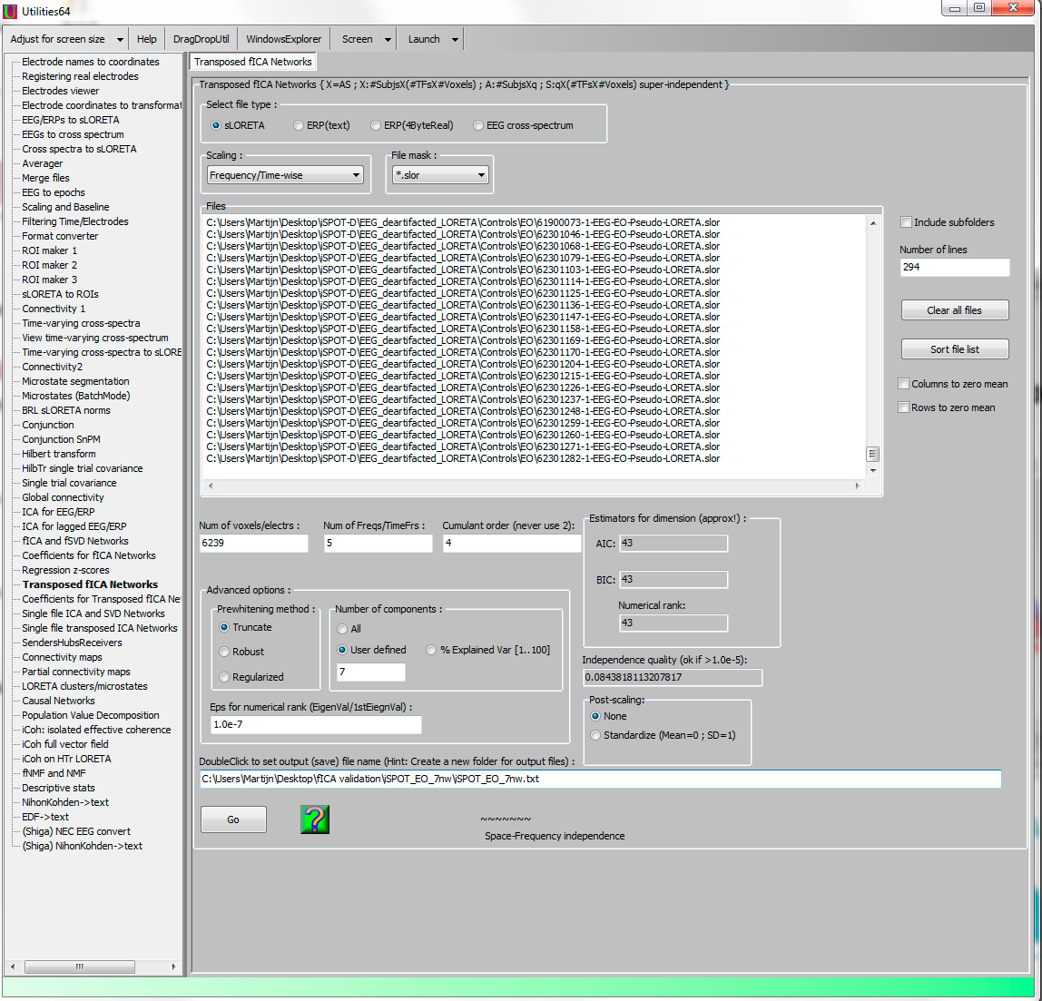

Now open the obtained .slor files (…HyperIndpndnt-001; 002…) in the Viewer and use the settings below: Scale exp=148.41; Scale Max =3 (followed by Enter!) and FixedMax.

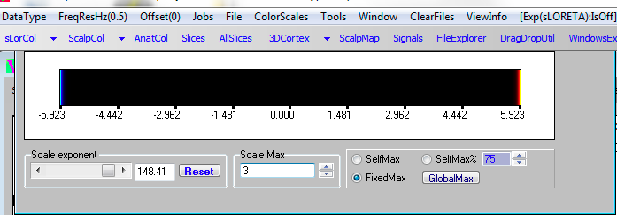**sLORETA procedure to extract EEG activity from specific ROIs**

**sLORETA to ROIs**

* Add the *.slor files from Step 2 to ‘Input sLORETA files’ and make sure the file mask is set correctly to *.slor
* Choose a transformation: ‘Log’
* Add the ROI file eLORETA-9ROIs_iSPOT.csv to ‘Input ROI-definitions file’ and hit Go.

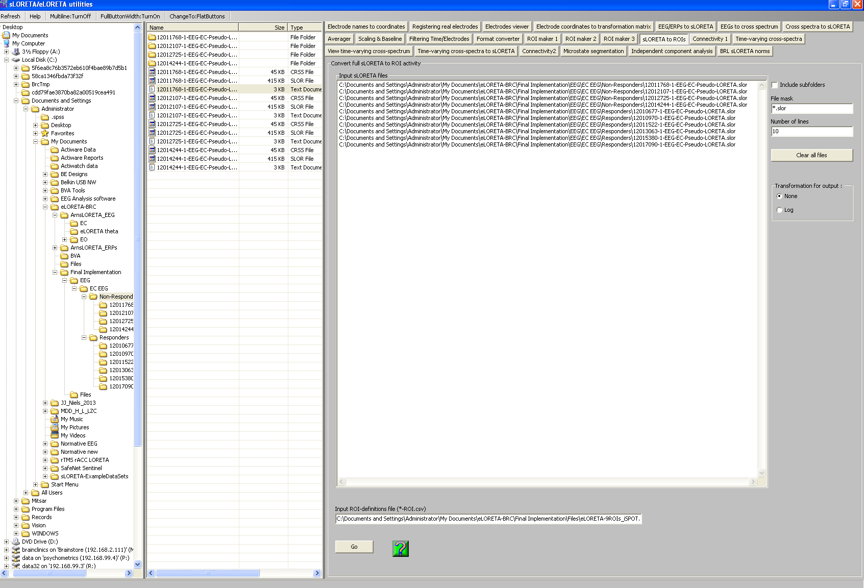

This will result in a single .txt file per subject. The rows in these files represent FFT frequency (hence 17 rows) and the columns represent ROIs (hence 9 columns), per subject (see below numbering of frequency and ROIs). These need to merged into 1 single file, where all values represent a unique column per subject (see attached example based on the rTMS N=90 data).

**BRC database:**

* Incorporate these txt. Files per subject which will provide: Log transformed current density per ROI (9) and per frequency band (17) resulting in 153 data-points per subject.
* Save all files such as Step 1: *.crss and Step 2: *.slor files in a separate location for future re-processing. *.slor files can be used for future exploratory topographical analyses e.g. where do R and NR differ in frequency A, B and C (current analyses have a-priori defined ROIs).

The frequency bands for the ROI analysis employed in the cross spectra step are the following:

|  |  |  |  |  |
| --- | --- | --- | --- | --- |
| **Standard BRC frequency bands:** | | **Additional frequency bands:** | | |
| **1) Delta: 1.5-3.5 Hz** |  | 15) ACC-Theta | 6.5-8.0 Hz | Pizzagalli et al. 2001; Mulert et al. 2007 |
| **2) Theta: 4-7.5 Hz** | Korb et al. 2009 |
| 3) Theta 1: 4-5 Hz | Narushima et al. 2010 |
| 4) Theta 2: 5-7.5 Hz |  |
| **5) Alpha: 8-13 Hz** |  |
| 6) Alpha 1: 8-11 Hz |  |
| 7) Alpha 2: 11-13 Hz |  |
| 8) SMR: 12-15 Hz |  |
| **9) Beta: 14.5-30 Hz** |  |
| 10) Beta 1: 14.5-20 Hz |  |
| 11) Beta 2: 20-25 Hz |  |
| 12) Beta 3: 25-30 Hz |  |
| **13) Gamma: 31-49 Hz** |  |
| 14) Total: 1.5-30 Hz |  |

**NOTE**: For the functional ICA (fICA) network analysis a different file for frequency bands is used with only 6 frequency bands: FFT_Bands_iSPOT_DMN_5BRC (#1, 2, 5, 9 & 13 in **bold** per above).

The Regions of Interest (ROIs) included are (also see excel file):

|  |  |  |
| --- | --- | --- |
| **ROI**  eLORETA-9ROIs_iSPOT.csv | **Brodmann areas** | **Reference.** |
| Occipital lobe (1) |  |  |
| Parietal lobe (2) |  |  |
| Temporal lobe (3) |  |  |
| Frontal lobe (4) |  |  |
| Parahippocampal gyrus (5) |  |  |
| Posterior cingulate (6) | 18; 23; 29; 30; 31 |  |
| rACC_Jaw (7) | 24ab; 25; 32 (ACC only) | Jaworska et al. (2012) |
| Insula (8) | 13; (22; 40; 41; 45; 47) |  |
| Uncus (9) | 20; 28; 34; 36; 38 |  |
| **Separate ROI file** | **Voxels** |  |
| rACC_Pizzagalli (1B) | 785, 779, 784, 792, 957, 965, 956, 964, 783, 963, 778, 974, 782, 962 |  |