**The spacecraft**

**Description:** The Psyche spacecraft consists of a body that is slightly larger than a smart car and about 10ft tall. Solar panels in a plus shape shall be attached to two opposite sides of the body. The body with the solar panels will be about the size of a singles tennis court. The spacecraft is equipped with a Gamma Ray and Neutron Spectrometer, a Multispectral imager, a Magnetometer and an x-band radio telecommunications system. It will also feature a new laser communication technology called Deep Space Optical Communication.



**Propulsion System**

The spacecraft will be propelled by solar electric propulsion. After the Psyche spacecraft has detached from the Falcon Heavy launch vehicle it will be propelled using solar electric propulsion. The thrusters on the spacecraft operate by using electromagnetic fields to accelerate and expel charged atoms, or ions of xenon. The expelled ions provide the thrust that will propel the spacecraft. The energy needed to operate the thrusters will be provided by the solar panels attached to the spacecraft.

The psyche spacecraft will have four of the described thrusters called Hall thruster. The thrusters provide a small amount of thrust but with no atmosphere the spacecraft will eventually reach speeds up to 124,000 miles per hour.

Psyche will cary 2,030 pounds of xenon for the thrusters; this amount of xenon will allow the thruster to operate nonstop for years.

If Psyche was to use traditional chemical thrusters it is estimated that the spacecraft would require about 15 times the amount of propellent than is required for the Hall thrusters.

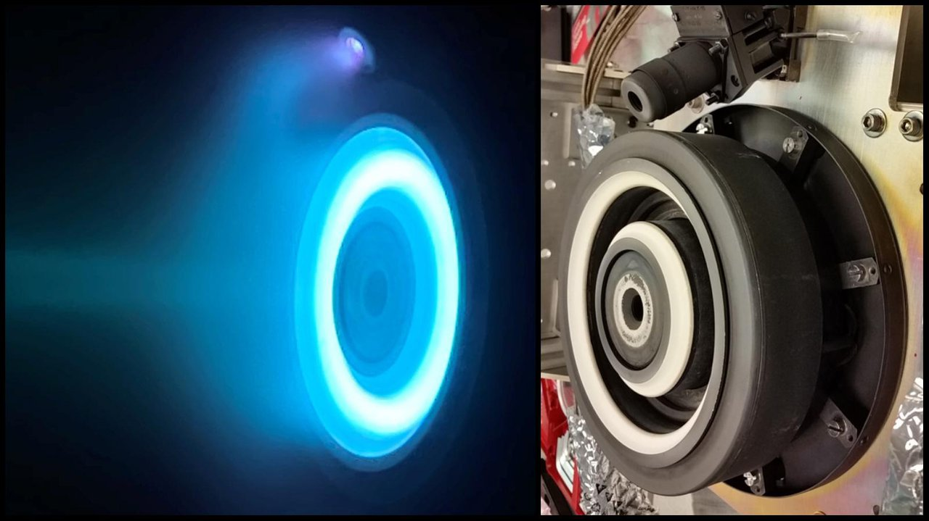

At left, xenon plasma emits a blue glow from an electric Hall thruster identical to those that will propel NASA's Psyche spacecraft to the main asteroid belt. On the right is a similar non-operating thruster.

Credit: NASA/JPL-Caltech