Student Information Management System Project Report

**Democratic Team**

Carlos A. Rios

Derek Jones

Ivan Sosa

Satish Subramanian

Phillipe Hehn

April 16, 2017

Table of Contents

1 Introduction 3

1.1 Documentation Description 3

1.2 System Overview 3

2 Architecture 4

2.1 Introduction 4

# 1 **Introduction**

## 1.1 Documentation Description

The purpose of this document is to describe the Student Information Management System (SIMS) its usage, implantation, and design of the program.

The student information Management System (SIMS) is a system that allows students to keep track of the progress and their standing within their courses throughout the year, and allows instructors to manage the distribution of assigned and completed assignments and a central area to store grades for easy access by students. These facets of the SIMS are all controlled by the system administrator, who creates the courses, teachers, and students within the system and modifies them as needed.

The necessary documentation and Unified Modeling Language (UML) of this program will be provided and presented throughout the documentation as visual aid and reference to the program design in order to provide better understanding to the readers of this document.

The program version that this document was written for was version 1.0 of the SIMS program.

## 1.2 System Overview

The purpose of this program is to replicate a Student Information Management System, in the likes of University of Houston-Downtown’s Blackboard or Houston Community College Eagle Online, to provide a graphic user interface (GUI) that allows Professors to do the following things:

1. Manage Class Materials (Uploading, Deleting, Updating, or Inserting Documents)
2. Manage Assignments (Updating or Insert Grades and Downloading Assignments)
3. View Class Roster By Course
4. View Course Teaching

Also, provides student with a GUI that allows them do the following things:

1. View Courses Currently Taking
2. View Assignment (Includes the grade of the assignment)
3. Manage Assignments (Downloading material and uploading assignment)

# 2 Architecture

## 2.1 Introduction

This program was design in the Java programming language using Netbeans as the Integrated Development Enviroment (IDE), and javax.swing.JFrame to build and design the GUI. Oracle’s MySQL was used as the Database choice for this program. The entity relationship (ER) diagram of the MySQL database design can be seen below in Figure 1.

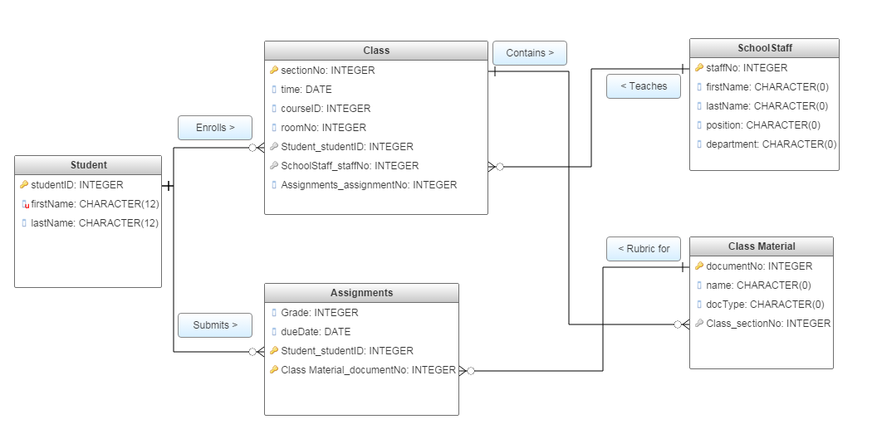  
Entity Relationship (ER) Diagram: Figure 1