PPIG Papers: Author Instructions and Template File

Alan F. Blackwell  Computer Laboratory  University of Cambridge  Alan.Blackwell@cl.cam.ac.uk | Luke Church  Computer Laboratory  University of Cambridge  luke@church.name | Mariana Mărășoiu  Computer Laboratory  University of Cambridge  mcm79@cl.cam.ac.uk

Abstract
This file both describes and exemplifies the required format for papers submitted to PPIG 2016. Please review this file even if you have submitted to PPIG before as some formatting details have changed relative to previous years.

1. Introduction
This format is to be used for all PPIG 2016 paper submissions for review and camera-ready versions. The easiest way to do this is to replace the current content of this file with your own material.
The rest of this document describes the format you should use when preparing your submission.

2. Formatting instructions

2.1. Page size
The paper should be A4 (21 × 29.7 cm or 8.27 × 11.69 inches). The margins around the text should be of 1 inch (2.54 cm) each and the text should be justified, not left-aligned/ragged. The length of the paper should not exceed the maximum page limit as given in the Call For Papers. Pages should not be numbered.

2.2. Fonts
The fonts used in this paper are Times Roman or Times New Roman, Arial or Helvetica for headings and Courier for source code. Table 1 summarises the font sizes and styles used for each part of this file. For Microsoft Word users, the default styles have been replaced to follow the settings here. For LaTeX users, the ppig.cls applies the settings described here to your .tex file.
Type of text | Font | Font size | Style
Paper title | Arial/Helvetica | 12pt | Bold
Author names | Times Roman | 11pt | Bold
Author affiliations | Times Roman | 11pt
The word “abstract” | Arial/Helvetica | 11pt | Bold
Abstract text | Times Roman | 11pt
Section level 1 | Arial/Helvetica | 11pt | Bold
Section level 2 | Arial/Helvetica | 11pt
Document text | Times Roman | 11pt
Caption | Times Roman | 11pt | Italic
Code | Courier | 11pt
Bibliography | Times Roman | 11pt
Footnotes | Times Roman | 10pt
Table 1 – Font guide.

2.3. Title and authors
The title, author’s name(s) and affiliation(s) should be centred at the top of the first page. The title should be in Arial or Helvetica 12pt bold font. The author’s name(s) should be in Times New Roman or Times Roman 11pt bold font, and their affiliation(s) should be in Times New Roman or Times Roman 11pt font.
The author’s name(s) and affiliation(s) is created using a table with invisible borders and one row in Microsoft Word and a table with no borders and a row for each line in LaTeX. In order to add a new author in Microsoft Word, add a new column to the table and enter the author’s details. For LaTeX users, please follow the instructions in the ppig-submission-template.tex file.
If all authors have the same affiliation, you may choose to have a single affiliation block, with author’s name(s) and email address(es) separated by commas. To do so, use a single column table.

2.4. References
The references section at the end of this template shows the style that should be used for references. The references themselves should preferably follow the format of the APA (American Psychological Association) style guide, although we won’t be too strict about the details. Citations should be in APA format: Blackwell (1999) says the year should be in parentheses after mention of the author’s name. In cases where the author’s name is not in the sentence, the citation gives name and year in parentheses (Blackwell, 1999).

2.5. Figures and Tables
Tables and Figures should fit within the boundaries of the text on this template file, and should be centred on the page. Both figures and tables can be placed inline with the text (e.g. Fig. 1), but the text shouldn’t wrap around their sides. Use your own judgement to create suitable tables and figures. Figures and tables should have captions. Captions for both figures and tables should use the caption style defined in Table 1.
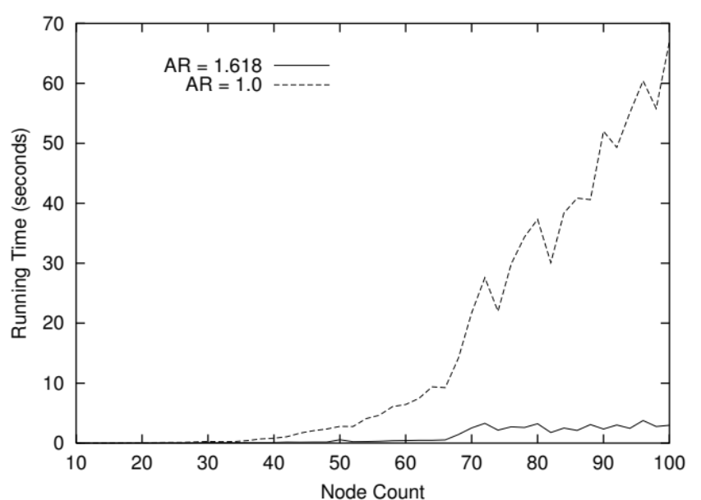
Figure 1 - An example figure, with caption

3. Submission Procedure

Submissions must be in PDF format. The submission deadline is 23rd of May, 2016. Submissions can be uploaded via EasyChair: https://easychair.org/conferences/?conf=ppig2016.

4. Acknowledgements
Thank you to Eleonora Bilotta, Thomas Green and Paola Kathuria for their help in defining and testing previous versions of this template.

5. References
Blackwell, A.F. (1999) How to format PPIG submissions. International Journal of PPIG Administrivia, 1(1), 1-3.

