**Mini Project**

**on**

**Designing and fabrication of an**

**Analog PID Controller**

**Linear integrated circuit laboratory (EELR14)**

*Submitted by*

|  |  |
| --- | --- |
| **107121039** | **Harshit Malik** |
| **107121045** | **Kshitij Kanade** |
| **107121055** | **Mayank Pachauri** |

*Faculty in charge*

**Dr. G. Saravana Ilango**

**Dept. of EEE**

**National Institute of Technology, Tiruchirappalli**

**Tamil Nadu 620015**

Date of submission: 01/12/2023

**PID Controller**

**Abstract**

This project aims to implement effective control mechanisms by compensating for present, past, and potential future errors using proportional, integral, and derivative control inputs. The circuit design involves regulating a variable DC supply with IC 7815 and IC 7915 used in conjunction to generate +15V and -15V to power the op-amps (IC 741). The schematic is divided into four sections: a self-power generation circuit, a square wave generator with input comparator, a PID controller (comprising proportional, integral, and derivative circuits), and an inverting summer along with a plant with a gain of 0.5. The plant's output, fed to the input through an error generator (subtractor), is controlled by the PID controller, and the resulting output is amplified using the plant with a gain of 0.5. An additional circuit for self-power generation operates within the range of 15V to 30V. To achieve a 2V target output, a 2V square wave input is maintained through a Schmitt Trigger whose upper and lower thresholds are maintained by the resistance divider circuit. The project integrates theoretical concepts, practical implementation, and testing of proportional, integral, and derivative components. Its goal is to develop a fully functional Analog PID controller, poised to enhance control systems in diverse industrial applications.

[**MATLAB Simulink Model link**](https://drive.google.com/file/d/1OQtOPzYYjXdZj7bTLKSxuImDcb78ryIq/view?usp=sharing) ( [**https://drive.google.com/file/d/1OQtOPzYYjXdZj7bTLKSxuImDcb78ryIq/view?usp=sharing**](https://drive.google.com/file/d/1OQtOPzYYjXdZj7bTLKSxuImDcb78ryIq/view?usp=sharing) )

1. **Introduction**

The concept of the project is to design and fabricate an Analog PID controller circuit specifically tailored for a given plant. A PID controller is a feedback control system widely used in industrial processes to regulate various parameters, ensuring the system's stability and optimal performance.

In the context of this project, the PID controller comprises three main components: proportional control, integral control, and derivative control. Proportional control responds to the present error, integral control addresses accumulated past errors, and derivative control considers the rate of change of the error. The combination of these three components allows for precise and dynamic control of the system.

The significance of this project lies in its practical application within industrial settings. PID controllers are crucial in processes, where maintaining a desired output or setpoint is essential. By customizing the Analog PID controller for a specific plant, the project aims to optimize control, reduce steady-state errors, and enhance the overall performance of the system. This type of tailored control system is particularly valuable in scenarios where digital controllers may not be suitable or where Analog control is preferred.

Importance: -

1. Precision Control: The precise and real-time control provided by PID controllers is essential in applications where maintaining specific conditions or setpoints is critical. This precision contributes to higher product quality and reliability.
2. Reduced Steady-State Errors: PID controllers are designed to minimize steady-state errors, ensuring that the system output closely follows the desired setpoint. This characteristic is vital in applications where maintaining consistency is paramount.
3. Versatility: PID controllers are versatile and applicable to a wide range of systems and industries. They find use in processes such as temperature control, motor speed regulation, fluid flow control, and more.

Challenges of the practical engineering applications: -

1. Tuning Difficulty: Tuning PID controllers for optimal performance requires a good understanding of the system dynamics. Finding the right combination of proportional, integral, and derivative gains can be a trial-and-error process.
2. Non-Linearity: Some processes may exhibit non-linear behavior, making it challenging to design a PID controller that performs well across the entire operating range.
3. The selection of component ratings requires repeated iterative calculation due to changing effective resistances (Rin & Rout) across the circuit.

Ultimately, the successful design and fabrication of the Analog PID controller for the given plant can contribute to increased efficiency, improved stability, and enhanced control in industrial processes, making it a project with practical and real-world significance.

*Objectives*

* Variation of the output signal with varying Kp, Kd, and Ki.
* Variation of the output signal with varying Input signal threshold levels.
* Variation of the output signal with varying plant gain.

Note: Here Kp, Kd, and Ki correspond to Gains of Proportional, Differential, and Integral OpAmp-based circuits.

1. **Methodology**
2. *Designing Proportional, Integrator, and Differentiator:*

* Initiated the circuit development by designing individual components such as the proportional amplifier, integrator, and differentiator.
* Utilized an Inverting Amplifier circuit and fixed the corresponding gains for each component.

1. *Summing Signals Using OpAmp as an Inverting Summer:*

* In the second stage, combined the signals from the proportional amplifier, integrator, and differentiator.
* Employed an OpAmp configured as an inverting summer to add these signals effectively.

1. *Passing Signal Through the Plant:*

* Passed the combined signal through the plant to obtain a stable output set at a reference voltage of 2 Volts.

1. *Feedback Loop and Error Signal Generation:*

* Introduced a feedback loop by routing the output to an inverting subtractor.
* The inverting subtractor compared the input and output voltages, generating an error signal representing the difference.

1. *PID Controller Integration:*

* Fed the error signal into the PID (Proportional-Integral-Derivative) controller block.
* The PID controller adjusted the system parameters based on the error signal to optimize the output response.

1. *Self-Power Generation Circuit:*

* Implemented a self-power generation circuit to ensure the availability of stable power.
* Accepted a DC input ranging between 15-30V.
* Utilized IC7815 and IC7915 voltage regulators to provide a constant +15V and -15V supply to power all the OpAmps IC741.

1. *Function Generator for Reference Signal:*

* Incorporated a function generator using OpAmp741 as a square wave generator (an application of Schmitt Trigger) to generate a reference 2V square voltage required just before the PID controller block.
* This reference signal served as a baseline for the PID controller to compare against the system output.

1. *Observing System Response:*

* Observed changes in the output voltage, including overshoot, rise time, and peak time, when the fixed point was set at 2V.

1. *Simulation Validation:*

* Conducted cross-validation to compare and verify the simulation results with the obtained waveforms.
* Calculated and analyzed the discrepancies between simulated and observed values for various parameters, such as overshoot, under different system changes as outlined earlier.

By systematically following these steps, the circuit development process aimed to achieve a controlled and optimized system response for the given specifications.

1. **Circuit Diagram**
2. *Block Diagram:*

* Figure 1 delineates the overall circuit into four primary blocks.

P1

Supply Voltage

(15-30V)

Self-Generation Circuit Block

+15V

0V

-15V

Square Wave Generator and Input Comparator Block

100kΩ

P2

P6

PID Block

P3

Summer and Plant Block

P5

P4

Fig. 1 Block Diagram of Entire Circuit

1. *Self-Generation Circuit Block:*

* Figure 2 elucidates the transformation of a 15 to 30V DC input into +15V, -15V, and a new ground for powering subsequent OpAmp-based circuits.
* This block incorporates IC 7815, and IC 7915, along with a combination of resistors and capacitors to generate the requisite voltages.

Fig. 2 Diagram of Self-Generation Circuit

1

2

3

2

1

3

1kΩ

1kΩ

47uF

Vo

Supply Voltage

(15-30V)

Vi

Vi

Vo

1kΩ

1kΩ

47uF

47uF

GND

GND

+15V

0V

-15V

1. *Square Wave Generator and Input Comparator Block:*

* Figure 3 illustrates a square wave generator created using a Schmitt Trigger application of OpAmp. Its output is then directed into a Comparator, which compares the set point (square wave) to the final output of the plant, generating the Error Signal.
* The signal pathways denoted by P1-P3 delineate the Error Signal, while the P6-P2 line signifies the Output Signal. This Output Signal is looped back into the comparator, where it undergoes comparison with the reference signal derived from the Square Wave.



Fig. 3 Diagram of Square Wave Generator and Input Comparator Circuit

1. *PID Block:*

* Figure 4 portrays the Proportional, Integrator, and Differentiator operations conducted on the Error Signal (path P2-P3) using OpAmps.
* The signal paths designated as P4 encompass three distinct signals, representing Proportional (P), Integral (I), and Derivative (D) components. These signals are subsequently directed into the next operational block for further processing.



Fig. 4 Diagram of PID Circuit

P3

10kΩ

10uF

100kΩ

100kΩ

P4



300kΩ

300kΩ

10uF

P4

1. *Summer and Plant Block:*

* Figure 5 showcases the output of the PID operations (path P4-P5) being fed into an Inverting Adder (Summer) and a plant of Gain 0.5, which produces the output waveform (path P6).
* This output waveform is looped back to the earlier comparator through a series resistor of 100kΩ, generating the Error Signal

Fig. 5 Diagram of Adder Circuit with Plant of Gain (Kplant) = 0.5

P5

100kΩ

100kΩ

100kΩ

100kΩ

100kΩ

50kΩ

P6

This comprehensive schematic encompasses a sophisticated control system design, harmonizing various operational blocks to achieve precise and effective control mechanisms. Each block plays a crucial role in the overall functionality, from voltage regulation and signal generation to the implementation of proportional, integral, and derivative components in the PID controller. The integrated design aims to enhance control systems across diverse industrial applications through theoretical foundations, practical implementation, and rigorous testing.

**3. Design**

Given Parameters: Ki = 10, Kd = 3, Kp = 1, and gain of plant as 0.5

Calculation of the Rd, Ri:

We have fixed the value of capacitance as 10µF for both the integral and derivative parts, For that-

For Rd-

We have fixed the value of capacitance as 10µF, according to that,

Rd×Cd = Kd

Rd×10µF = 3

Rd = 300 kΩ

For Ri-

1/(Ri×Ci) = Ki

Ri = 1/(Ki×Ci)

Ri = 1/(10×10µF)

Ri = 10 kΩ

Transfer Function Representation: -

The transfer function of the PID Controller is given by: -

G(s) = Kp + Ki/s + Kd s =

***Block Diagram of PID Controller:-***

Figure 6. showcases the expected PID controller design according to specifications mentioned in the problem statement.

Fig. 6 Block Diagram of PID Controller with Corresponding Gains

KP

Ki/s

Kd*s

K=0.5

Reference

Output

+

**-**

+

+

+

Figure 7 denotes the net Transfer function of the system after including the above Feed-Forward and Feedback Paths. It is worth mentioning that the system consists of negative feedback loop.

G(s)/(1+G(s))

Where G(s) = (KP + Ki/s + Kd*s) *Kplant

= (1 + 10/s + 3*s)*0.5

Reference Input

Output

Fig. 7 Block Diagram of Net Transfer Function of PID Controller

**4. Simulation and Experimental analysis**

*4.1 Simulation*

1. Simulating PID Controller Circuit:

* Utilized MATLAB Simulink to simulate the PID controller circuit.
* Input for the simulation was generated using a square wave generator.
* The software's extensive component library facilitated the incorporation of necessary elements, and adjustments were made as needed.
* Waveforms were generated, enabling a detailed examination of the system's response.
* This step allowed us to identify and rectify circuit faults before moving forward with the physical implementation.

1. Simulating Self-Generation Circuit:

* Employed MATLAB Simulink for simulating the self-generation circuit, incorporating IC 7815, IC7915, and a square wave generator circuit.
* The simulation aimed to validate the stability and performance of the self-power generation system.
* The software's capability to model complex systems ensured an accurate representation of the circuit's behavior.

1. Parameters and Software Selection:

* The MATLAB software was preferred due to its extensive library of components, allowing seamless integration of the required elements.
* The software provides a versatile platform where both PID controller and self-generation circuit simulations can be conducted effectively.
* Parameters such as input voltage (ranging from 2V to 4V), Rd, Ri, Ci, Cd, Rp1, Rp2, Kplant, R1sq, R2sq, and Csq were varied during the simulations.
* Waveforms were generated for each parameter variation, and crucial performance metrics like overshoot, rise time, and others were measured.

*4.2 Experiment*

1. In the experimental phase, the PCD design was simulated to analyze its real-world behavior. The schematic and routing of the PCD design were implemented using KiCAD software, ensuring an accurate representation of the physical circuit.
2. During the simulation, parameters were deliberately varied, and resulting waveforms were thoroughly examined. Essential metrics, including overshoot, rise time, and other pertinent characteristics, were measured to assess the performance of the physical circuit.
3. The use of KiCAD, a widely recognized electronic design automation (EDA) tool, enhances the credibility of the experimental analysis, facilitating the identification of potential discrepancies between design, simulation, and the practical circuit. This transition to KiCAD ensures a professional and widely accepted platform for the physical implementation of the circuit.

**MATLAB Simulation:-**

**Full Block Diagram Representation-**

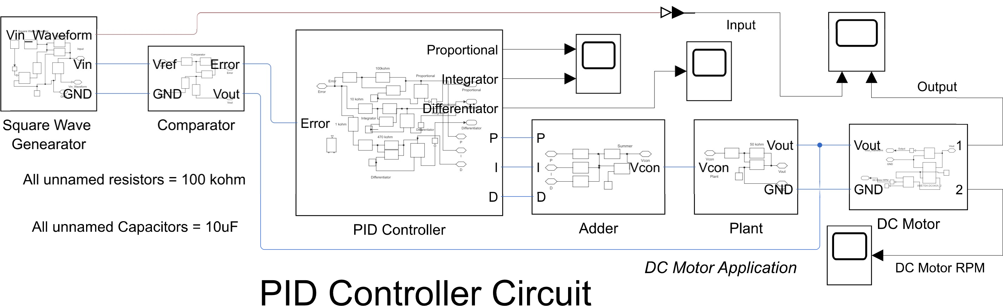

**Square Wave Generation Representation-**

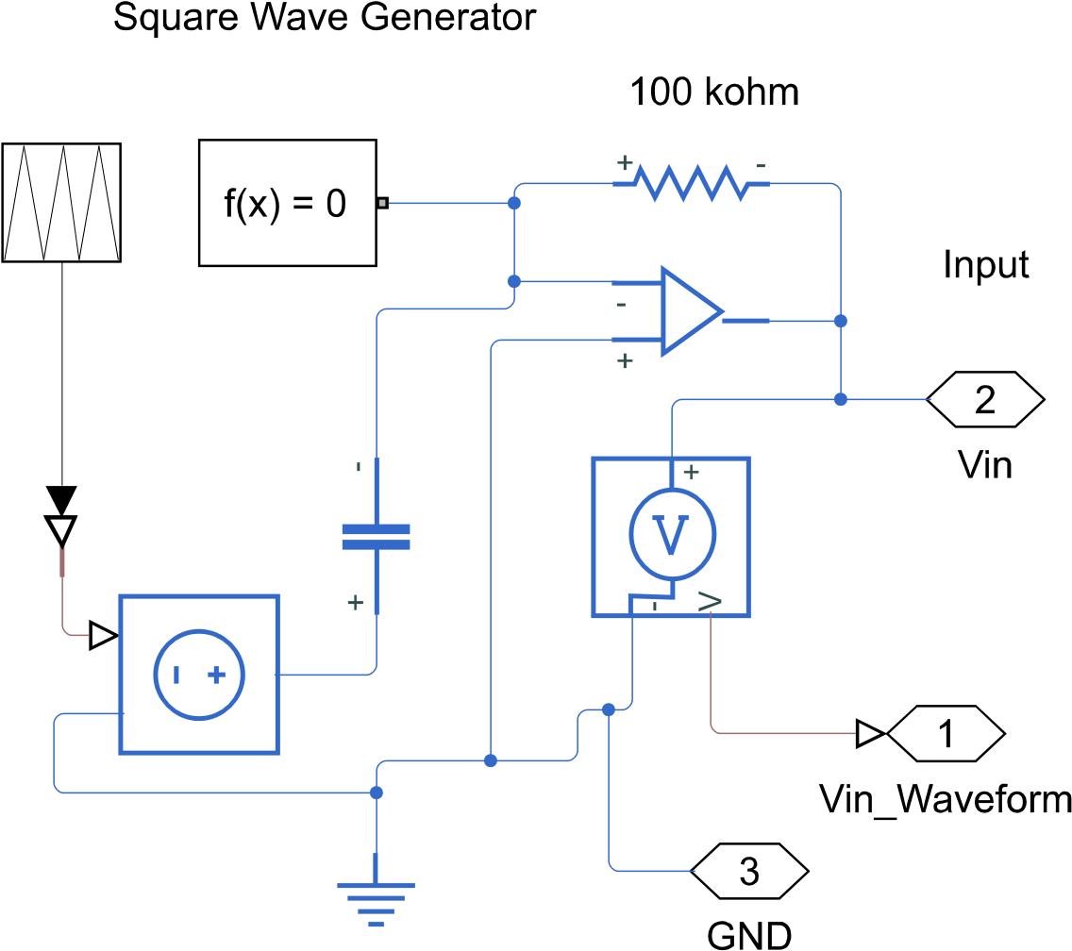

**Comparator Representation-**

**PID Representation-**

**Summer Representation-**

**Plant Representation-**

**DC Motor Representation-**

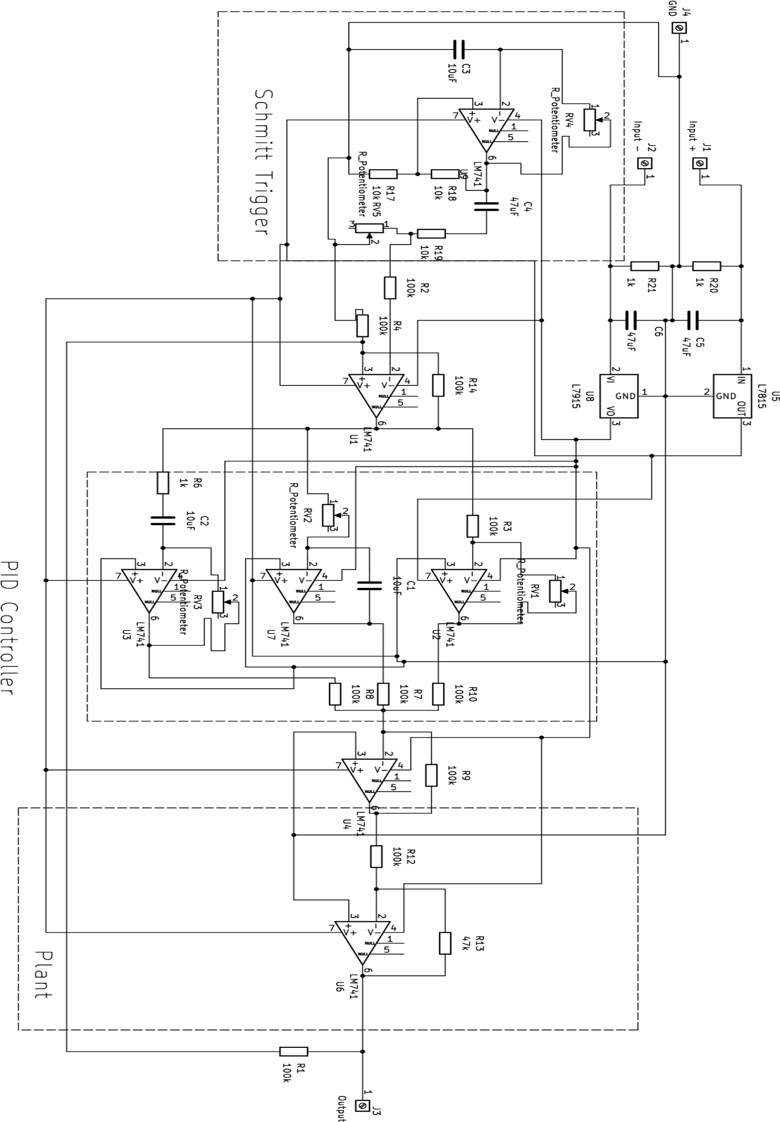**PCB Designing using KiCAD software:-**

PCB Schematic-

**PCB Routing Structure-**

**PCB 3D View-**

**Calculations & Formulae:-**

Taking kp =1, kd = 3 and Ki =10 we get open loop transfer function as G(s) = *0.5

With negative unity feedback our closed loop transfer function would be

=

Now to study the behaviour of the 2nd order system we can look at its time domain specifications with formulae:

1. Rise time (tr) =
2. Peak Overshoot (Mp) =
3. Delay time (td) =
4. Peak time (tp) =
5. Settling time (ts) =

Taking the ideal case we observed that our overshoot was 32.14% and rise time was 7.6µ sec and peak value as 2.04V hence,

=267606.8 rad/sec

With this we can calculate other parameters as:

Pek time = 11.8µ sec

Settling time = 44.4µ sec

Delay time = 3.37µ sec

Similarly we can solve for other cases.

For the simulations in MATLAB, we can use the cursor tool to get exact values of peak value, peak time, and other parameters.

**Simulation vs DSO waveforms by varying parameters and corresponding observations:-**

|  |  |
| --- | --- |
| **Simulation Waveforms** | **DSO Waveforms** |
| Initial Input/Output Waveform:-    Effect on Gain = None  Overshoot % = 29.6%  Delay time (td) = 3.21µ sec  Rise time (tr) = 7.52µ sec  Peak time (tp) = 11.4µ sec  Settling time (ts) = 43.14µ sec  Peak Value (Vp) = 1.41V | Initial Input/Output Waveform:-    Effect on Gain = None  Overshoot % = 32.14%  Delay time (td) = 3.37µ sec  Rise time (tr) = 7.6µ sec  Peak time (tp) = 11.8µ sec  Settling time (ts) = 44.4µ sec  Peak Value (Vp) = 1.48V |
| 2 * Rp2 Waveform:-    Effect on Gain = Kp is doubled  Overshoot % = 28.88%  Delay time (td) = 6.23µ sec  Rise time (tr) = 10.11µ sec  Peak time (tp) = 16.89µ sec  Settling time (ts) = 58.8µ sec  Peak Value (Vp) = 1.48V | 2 * Rp2 Waveform:-    Effect on Gain = Kp is doubled  Overshoot % = 31.03%  Delay time (td) = 6.415µ sec  Rise time (tr) = 10.6µ sec  Peak time (tp) = 17.28µ sec  Settling time (ts) = 59.29µ sec  Peak Value (Vp) = 1.52V |
| 0.5 * Rp2 Waveform:-    Effect on Gain = Kp is halved.  Overshoot % = 27.92%  Delay time (td) = 6.12µ sec  Rise time (tr) = 10.23µ sec  Peak time (tp) = 16.9µ sec  Settling time (ts) = 57.54µ sec  Peak Value (Vp) = 1.88V | 0.5 * Rp2 Waveform:-    Effect on Gain = Kp is halved.  Overshoot % = 29.72%  Delay time (td) = 6.57µ sec  Rise time (tr) = 10.8µ sec  Peak time (tp) = 17.67µ sec  Settling time (ts) = 58.33µ sec  Peak Value (Vp) = 1.92V |
| 2 * Ri Waveform:-    Effect on Gain = Ki is doubled.  Overshoot % = 22.32%  Delay time (td) = 6.12µ sec  Rise time (tr) = 10.34µ sec  Peak time (tp) = 17.32µ sec  Settling time (ts) = 47.23µ sec  Peak Value (Vp) = 1.4V | 2 * Ri Waveform:-    Effect on Gain = Ki is doubled.  Overshoot % = 24.13%  Delay time (td) = 6.47µ sec  Rise time (tr) = 11µ sec  Peak time (tp) = 17.32µ sec  Settling time (ts) = 48.76µ sec  Peak Value (Vp) = 1.44V |
| 0.5 * Ri Waveform:-    Effect on Gain = Ki is halved.  Overshoot % = 27.2%  Delay time (td) = 6.11µ sec  Rise time (tr) = 10.43µ sec  Peak time (tp) = 17.23µ sec  Settling time (ts) = 58.12µ sec  Peak Value (Vp) = 1.74V | 0.5 * Ri Waveform:-    Effect on Gain = Ki is halved.  Overshoot % = 29.72%  Delay time (td) = 6.62µ sec  Rise time (tr) = 11µ sec  Peak time (tp) = 17.82µ sec  Settling time (ts) = 58.85µ sec  Peak Value (Vp) = 1.92V |
| 2 * Rd Waveform:-    Effect on Gain = Kd is doubled.  Overshoot % = 23.83%  Delay time (td) = 7.23µ sec  Rise time (tr) = 11.56µ sec  Peak time (tp) = 19.83µ sec  Settling time (ts) = 62.8µ sec  Peak Value (Vp) = 1.89V | 2 * Rd Waveform:-    Effect on Gain = Kd is doubled.  Overshoot % = 26.58%  Delay time (td) = 7.74µ sec  Rise time (tr) = 12.4µ sec  Peak time (tp) = 20.76µ sec  Settling time (ts) = 62.8µ sec  Peak Value (Vp) = 2V |
| 0.5 * Rd Waveform:-    Effect on Gain = Kd is halved.  Overshoot % = 22.11%  Delay time (td) = 6.76µ sec  Rise time (tr) = 11.3µ sec  Peak time (tp) = 18.02µ sec  Settling time (ts) = 52.66µ sec  Peak Value (Vp) = 1.72V | 0.5 * Rd Waveform:-    Effect on Gain = Kd is halved.  Overshoot % = 24.32%  Delay time (td) = 7.06µ sec  Rise time (tr) = 12µ sec  Peak time (tp) = 18.91µ sec  Settling time (ts) = 53.57µ sec  Peak Value (Vp) = 1.84V |
| Error Waveform:-    Settling time (ts) = 42.7µ sec  Peak Value (Vp) = 1.40V | Error Waveform:-    Settling time (ts) = 43.8µ sec  Peak Value (Vp) = 1.42V |

**5. Results and Discussion**

1. Simulation and Experimental Analysis:

* The MATLAB Simulink simulations provided detailed waveforms for the PID controller circuit and the self-generation circuit.
* The KiCAD software allowed for PCB simulation, ensuring a thorough examination of the real-world behavior of the circuit.

1. Simulation of PID Controller:

* The PID controller, comprising proportional, integral, and derivative components, was simulated with varying parameters (Kp, Ki, Kd).
* Waveforms demonstrated the system's response to changes in input signal thresholds and plant gain.

1. Experimental Setup:

* The breadboard implementation of the entire circuit revealed a well-regulated supply and successful integration of the PID controller.
* Waveforms obtained during the experiment were compared with simulation results to assess the real-world performance.

1. Parameter Variation:

* Simulation results highlighted the impact of varying parameters such as Rd, Ri, Ci, Cd, Rp1, Rp2, Kplant, R1sq, R2sq, and Csq on the system response.
* Experimental analysis confirmed the sensitivity of the circuit to changes in these parameters.

1. Comparison between Simulation and Experiment:

* Discrepancies between simulation and experimental results were observed, as expected in real-world scenarios.
* Deviations were logically justified, considering factors such as component tolerances, non-linearities, and practical limitations.

**6. Conclusion**

1. Controller Component Impact:

* Proportional controller effectively reduced transients.
* The derivative controller, sensitive to input changes, converted the triangular wave to a square wave.
* The integral controller exhibited a slow rise and decay time, contributing to system sluggishness.

1. Overall Performance:

* The fabricated Analog PID controller demonstrated output waveforms aligning closely with expectations.
* The combination of simulation and experimentation provided valuable insights into the practical behavior of the circuit.

1. Challenges and Considerations:

* Tuning PID controllers remains a challenge, requiring a good understanding of system dynamics.
* Non-linearities and variations in component ratings contributed to iterative calculations in the design process.

1. Significance of Analog PID Controller:

* The designed circuit holds practical significance in industrial applications, offering precision control and reduced steady-state errors.
* Versatility allows for adaptation to various systems, making it suitable for temperature control, motor speed regulation, and fluid flow control.

1. Future Considerations:

* Further refinements and optimizations may be explored to enhance the circuit's performance.
* Continued experimentation and tuning can address challenges associated with non-linear behavior and component variations.

In conclusion, the Analog PID controller project successfully integrated theoretical concepts, practical implementation, and testing. The combination of simulation and experimental analysis provided a comprehensive understanding of the circuit's behavior, paving the way for potential improvements and real-world applications in industrial control systems.

**Breadboard & PCB Implementation of Entire Circuit:-** 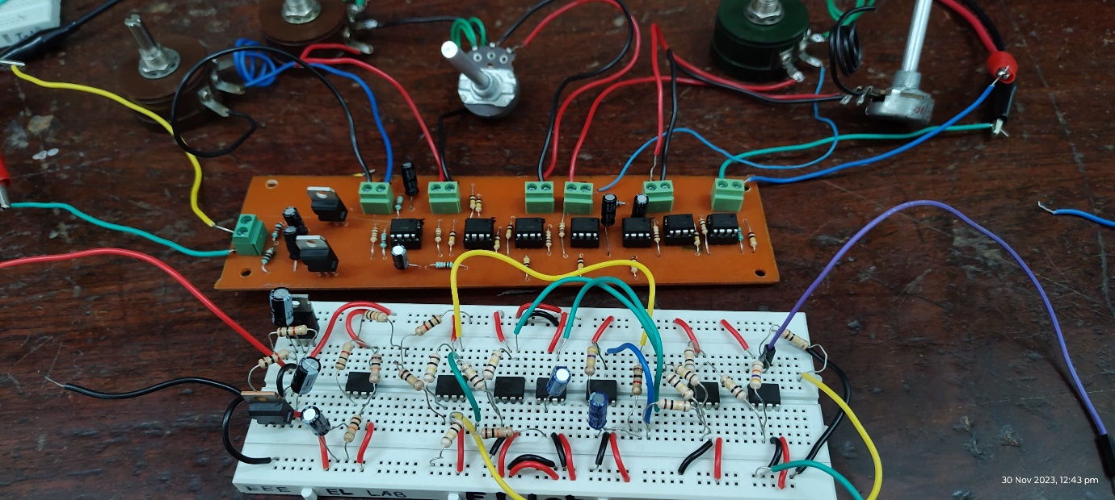

**7. Datasheets**

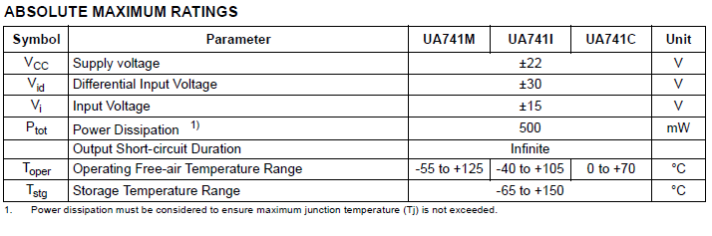

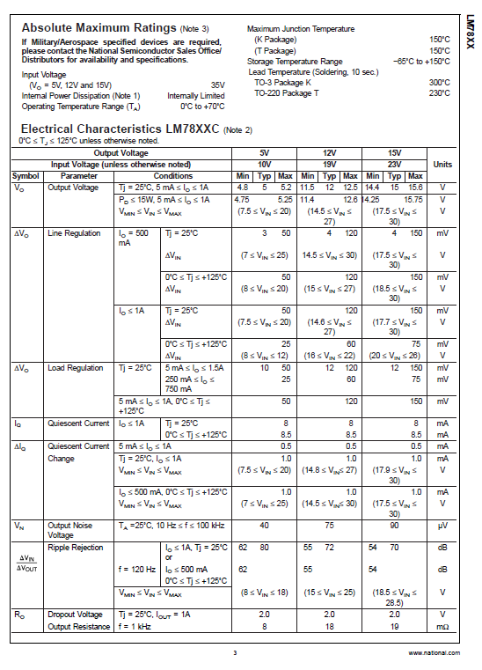

**8. References**

1. “Analog Fabrication of PID Controller” <https://core.ac.uk/download/pdf/53190057.pdf1>
2. IC741 Datasheet – ST Microelectronics
3. IC7815 , IC7915 Datasheets

[**MATLAB Simulink Model link**](https://drive.google.com/file/d/1OQtOPzYYjXdZj7bTLKSxuImDcb78ryIq/view?usp=sharing) **(** [**https://drive.google.com/file/d/1OQtOPzYYjXdZj7bTLKSxuImDcb78ryIq/view?usp=sharing**](https://drive.google.com/file/d/1OQtOPzYYjXdZj7bTLKSxuImDcb78ryIq/view?usp=sharing) **)**

Thank You