LIC-Mini Project

Date:- 06/11/2023

By:- Monday Batch 1

Team Members:-

1. Harshit Malik – 107121039
2. Kshitij Kanade – 107121045
3. Mayank Pachauri - 107121055

Task

Designing an Analog PID Controller

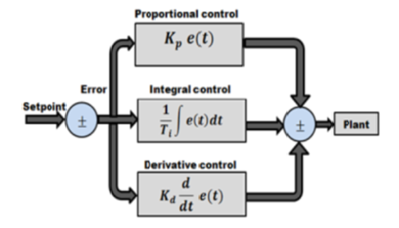

**Problem Statement:-**

Design and fabricate an analog PID controller circuit for the plant with following requirements:

i. The gain of the plant is 0.5.

ii. The controller parameters are Kp=1; Ki=10 and Kd=3.

iii. The output of the plant has to be maintained at 2V.

iv. Self-power generation circuit for signal conditioning circuit (Assume dc input voltage variation is from 15V to 30V).

(NOTE: Don't use external power supply in the circuits.)

**Abstract:-**

In this project, we're designing and building an Analog PID controller circuit using operational amplifiers to meet specific plant requirements. The PID controller will ensure stable and efficient control, with a target output of 2V. We'll also incorporate a self-power generation circuit for operation within a 15V to 30V voltage range. The project combines theory, practical implementation, and testing of proportional, integral, and derivative components. Ultimately, it aims to create a fully functional Analog PID controller, enhancing control systems in various industrial applications.

**Equipment Needed:-**

|  |  |  |  |
| --- | --- | --- | --- |
| **S No.** | **Equipment** | **Ratings** | **Quantity** |
| 1 | OP-AMP | LM741CN | 7 |
| 2 | Voltage Regulator | LM7815T,LM7915 (If required) | 1, 1 |
| 3 | Resistors | 100 kΩ,10 kΩ, 20 kΩ,  150 kΩ, 1 kΩ, 300 kΩ,  130 kΩ | 17,1,1,  1,1,1  1 |
| 4 | Capacitor | 10µF | 2 |
| 5 | Rheostats | 100 kΩ | 3 |
| 6 | Breadboard, PCB Board, DSO, Multimeter, Probes, Connecting Wires | --- | As required |

**Thought Process Behind Circuit Development:-**

1. Initially we designed the proportional amplifier, integrator, and differentiator using Inverting Amplifier circuit and fixed the corresponding gains.
2. In the second step, we added all these signals using OpAmp as inverting summer and passed the signal through the plant to get output at constant 2 Volts.
3. This output was also fed back to the inverting subtractor which compared the Input and output voltage and generated the error signal.
4. This error signal in turn was fed to the PID controller block.
5. The self-power generation circuit takes in a dc input between 15-30V and is passed through IC7815 voltage regulator which gives constant +15V supply; the -15V supply can be generated either by passing this signal though an inverting amplifier, or using separate IC7915 which are used to power the OpAmps.
6. A simple resistive voltage divider circuit can be used to generate the reference voltage required just before the PID controller block.
7. Else to observe the changes on setting the fixed point at 2V, pass a square wave with maximum amplitude of 2V and observe the changes in output voltage like overshoot, etc.

**Issues faced :-** Generating -15V for supplying to OpAmps, reference voltage generation.

**Basic Circuit Diagram of PID Controller:-**

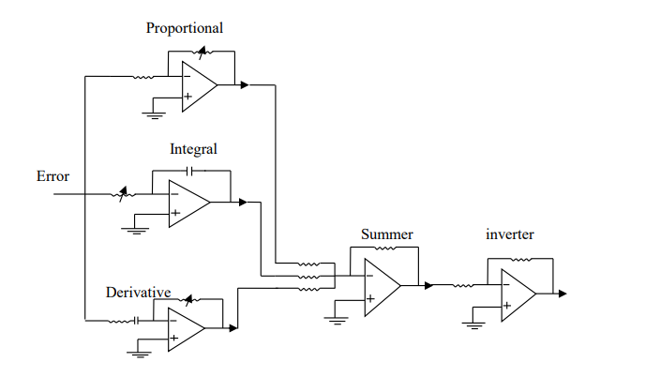

**TRANSFER FUNCTION REPRESENTATION:-**

Sometimes it is useful to write the PID control equation in Laplace transform form which is given by: G(s) = kp +ki/s + kd s =

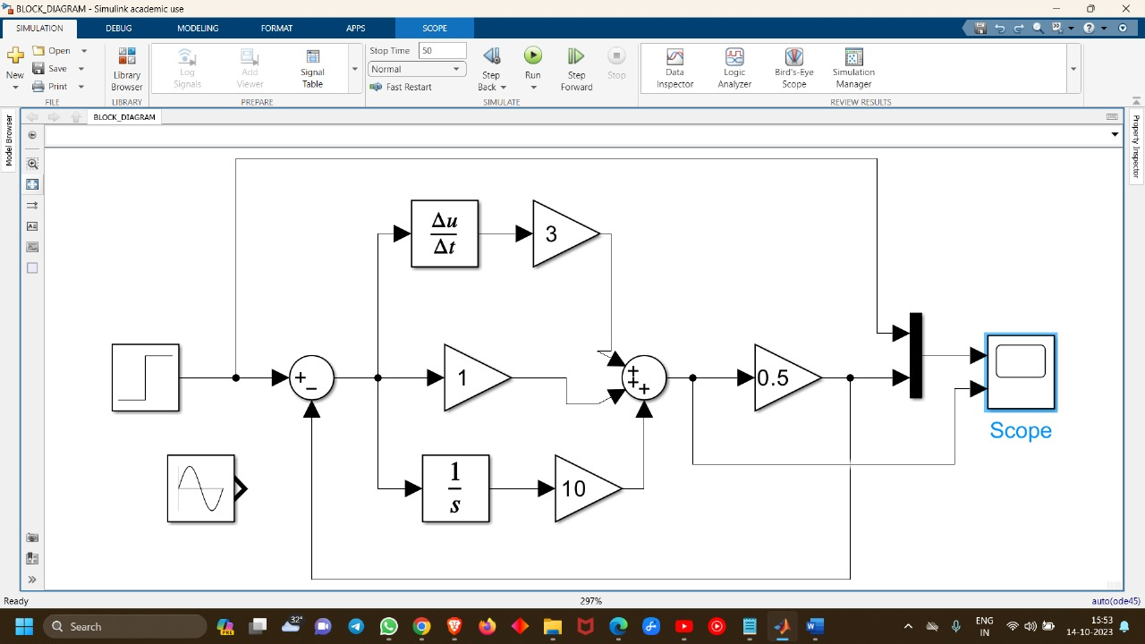**Block Diagram and Results of the circuit:-**

Corresponding Waveform-

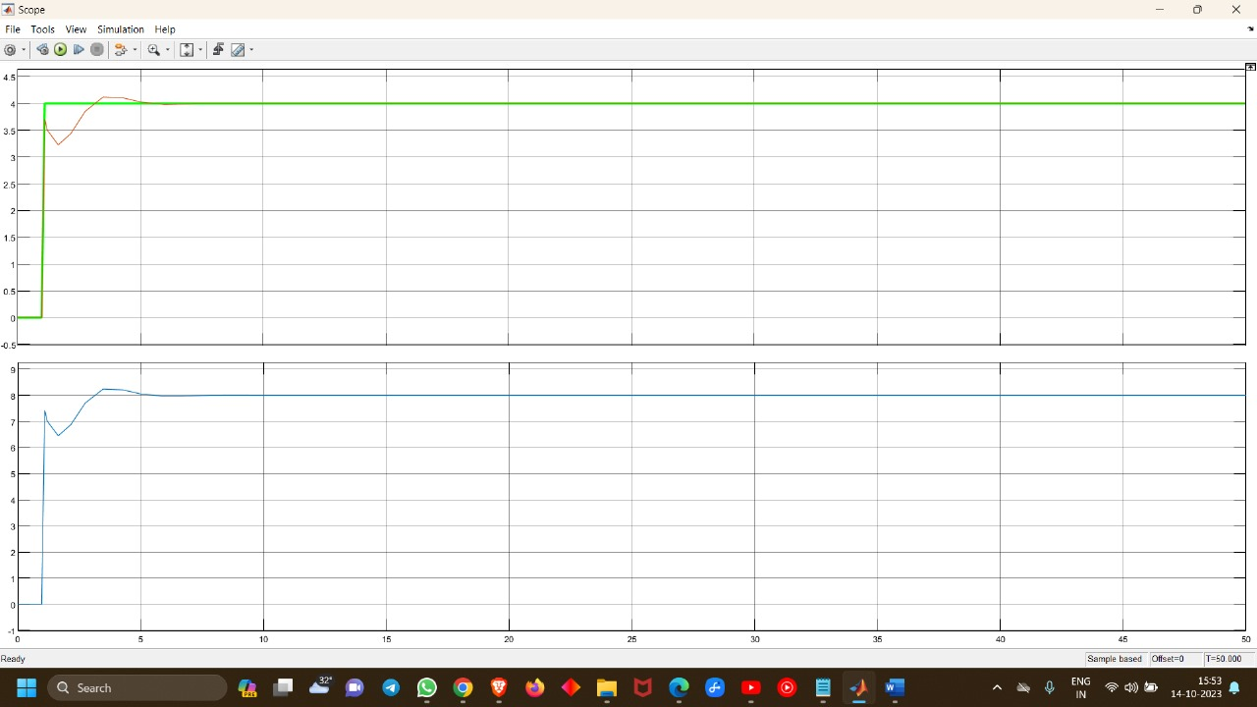

**MATLAB Simulation of Actual Circuit using OpAmps:-**

Corresponding Waveform-

**Self-power generation circuit for signal conditioning:-**

Corresponding Waveform-

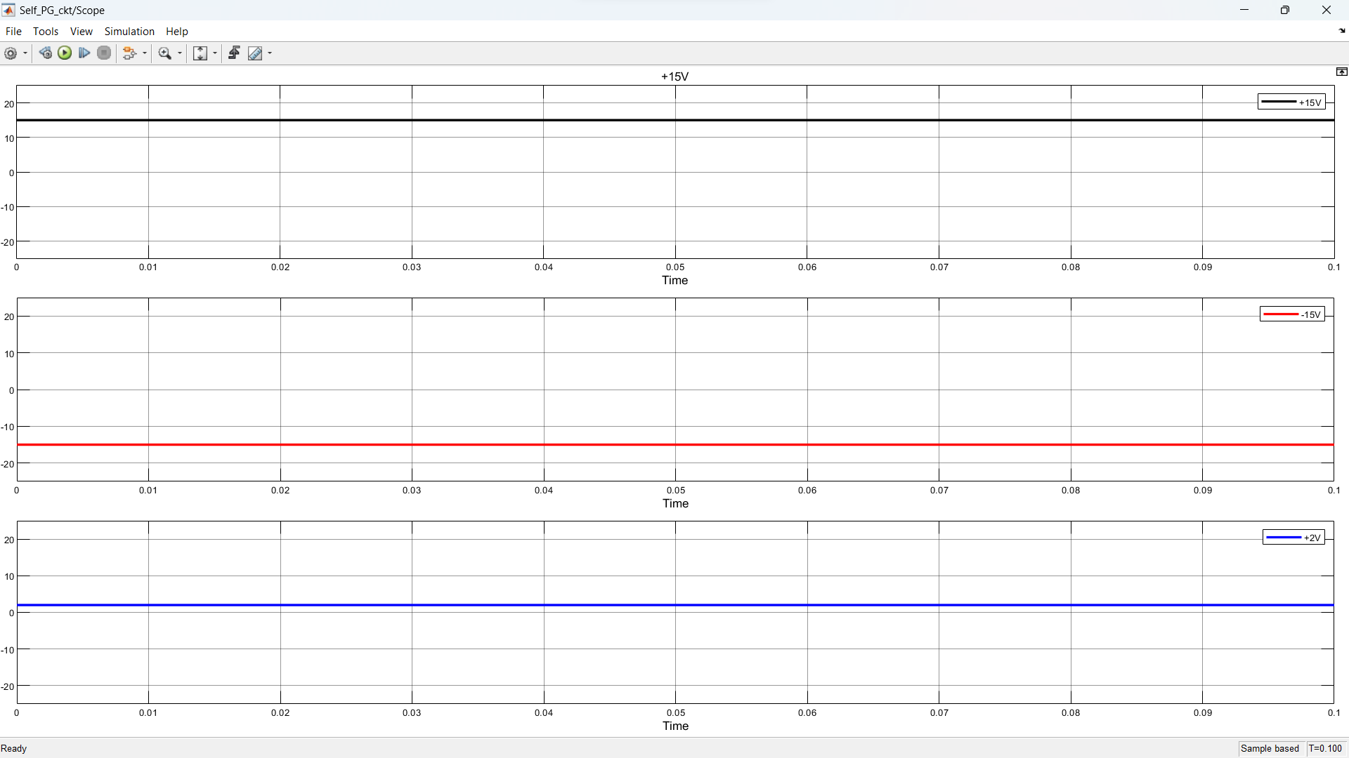

**PCB Simulation using easyeda:-**

PCB Schematic-

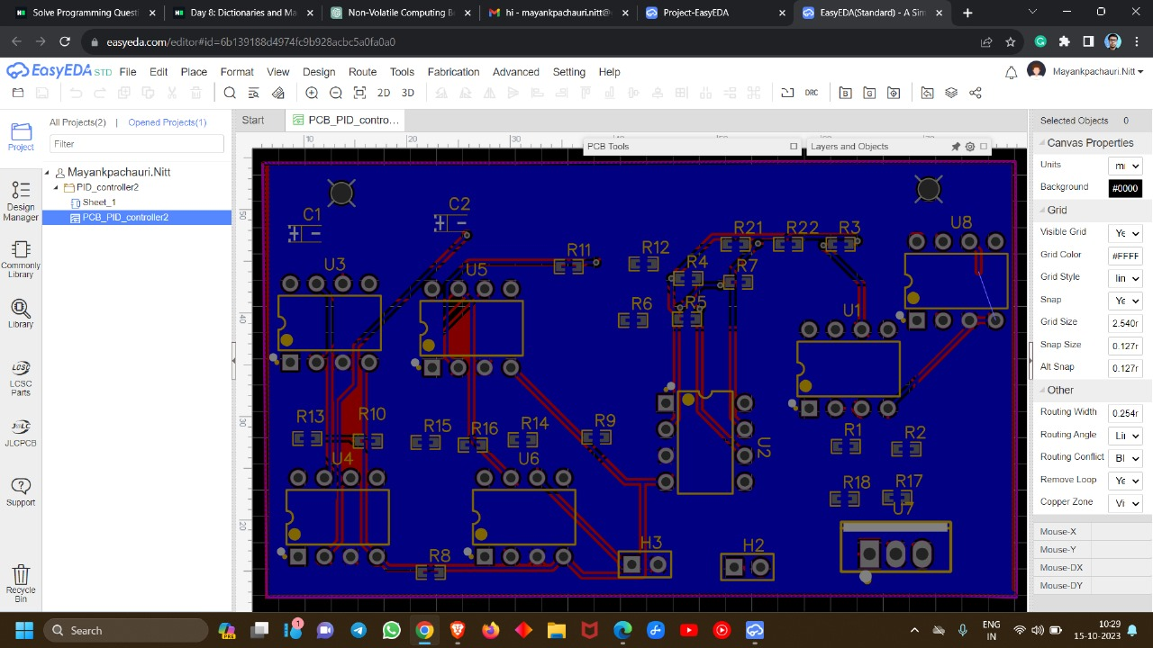

Final Circuit Diagram including Self-powering circuit-

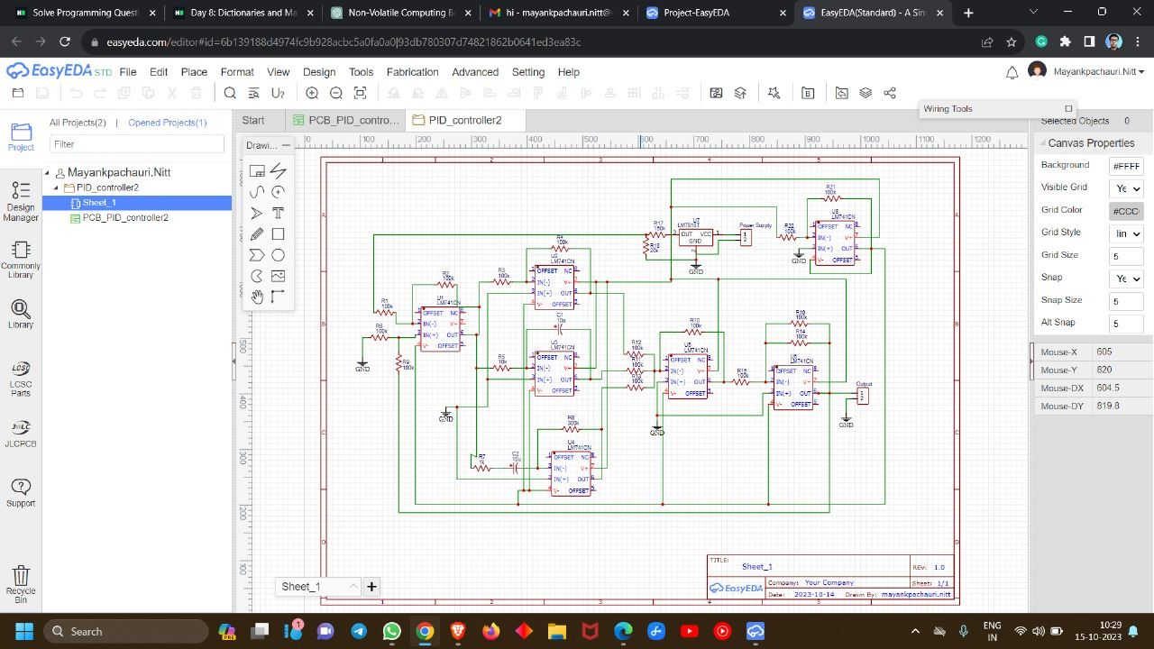

**Breadboard Implementation of Entire Circuit:-**

🡨-------------Supply + regulation

🡨--------------------------------PID

Zoomed image------------------------🡪

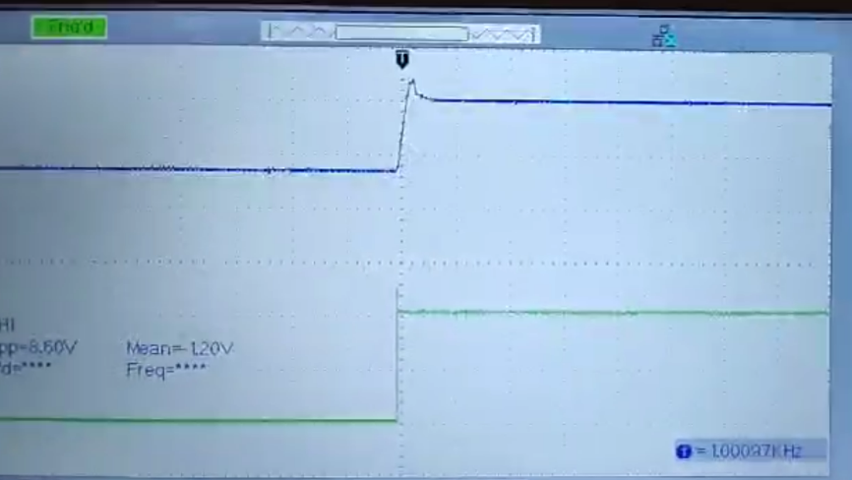

🡨----------------------Waveform at 2V change

**Conclusion:-**

It was found that the proportional controller reduces the transients to an appreciable extent and thus, should have a high value. The derivative controller acts on the rate of change of input and thus converts the triangular wave to a square wave. It is very sensitive to changes or variations in the input. As far as the integral controller was concerned, it had a slow rise and decay time making the system sluggish. The output waveforms were found almost as expected and thus, the analog pid controller was fabricated finally.

**Applications:-**

1. Industrial Furnaces and HVAC Systems:

* PID controllers regulate temperature in industrial furnaces, ensuring efficient and consistent heat.
* They maintain optimal temperatures in heating, ventilation, and air conditioning (HVAC) systems for comfort and energy efficiency.

1. Robotics and Conveyor Systems:

* Precise motor control in robotics for accurate movements and task execution.
* Conveyor systems use PID control to manage conveyor belt speed and product positioning.

1. Manufacturing Processes:

* PID controllers regulate chemical processes in manufacturing, ensuring product quality and consistency.
* They control variables like pressure, flow rates, and composition in chemical plants.

1. Aircraft Flight Control:

* Essential for maintaining stable flight by adjusting control surfaces and engine thrust.
* Ensures passenger safety and a smooth flying experience.

1. Renewable Energy Systems:

* Used in solar trackers and wind turbine controls to optimize energy production.
* PID control adapts to changing environmental conditions.

In summary, PID controllers play a crucial role in a wide range of applications, offering precise control and stability in diverse fields, from industrial processes to renewable energy systems and healthcare devices.

Thank You