**Mini Project**

**on**

**Designing and fabrication of an**

**Analog PID Controller**

**Linear integrated circuit laboratory (EELR14)**

*Submitted by*

|  |  |
| --- | --- |
| **107121039** | **Harshit Malik** |
| **107121045** | **Khsitij Kanade** |
| **107121055** | **Mayank Pachauri** |

*Faculty in charge*

**Dr. G. Saravana Ilango**

**Dept. of EEE**

**National Institute of Technology, Tiruchirappalli**

**Tamil Nadu 620015**

Date of submission: 14/11/2023

**PID Controller**

**Abstract**

This project endeavours to implement effective control mechanisms by compensating for present, past, and potential future errors using proportional, integral, and derivative control inputs.

The circuit design involves regulating a variable DC supply with IC 7815 to generate +15V and IC7660SAPAZ for generating -15V to power the op-amp (IC741). The schematic is divided into three sections: an input summer, a PID controller (comprising proportional, integral, and derivative circuits), and a plant with a gain of 0.5. The plant's output, fed to the input through an error generator (subtractor), is controlled by the PID controller, and the resulting output is amplified using the plant with a gain of 0.5.

An additional circuit for self-power generation operates within the range of 15V to 30V. To achieve a 2V target output, a 2V square wave input is maintained through a Schmitt Trigger whose upper and lower thresholds are maintained by the resistance divider circuit.

The project integrates theoretical concepts, practical implementation, and testing of proportional, integral, and derivative components. Its goal is to develop a fully functional Analog PID controller, poised to enhance control systems in diverse industrial applications.

1. **Introduction**

The concept of the project is to design and fabricate an Analog PID controller circuit specifically tailored for a given plant. A PID controller is a feedback control system widely used in industrial processes to regulate various parameters, ensuring the system's stability and optimal performance.

In the context of this project, the PID controller comprises three main components: proportional control, integral control, and derivative control. Proportional control responds to the present error, integral control addresses accumulated past errors, and derivative control considers the rate of change of the error. The combination of these three components allows for precise and dynamic control of the system.

The significance of this project lies in its practical application within industrial settings. PID controllers are crucial in processes, where maintaining a desired output or setpoint is essential. By customizing the Analog PID controller for a specific plant, the project aims to optimize control, reduce steady-state errors, and enhance the overall performance of the system. This type of tailored control system is particularly valuable in scenarios where digital controllers may not be suitable or where Analog control is preferred.

Importance: -

1. Precision Control: The precise and real-time control provided by PID controllers is essential in applications where maintaining specific conditions or setpoints is critical. This precision contributes to higher product quality and reliability.
2. Reduced Steady-State Errors: PID controllers are designed to minimize steady-state errors, ensuring that the system output closely follows the desired setpoint. This characteristic is vital in applications where maintaining consistency is paramount.
3. Versatility: PID controllers are versatile and applicable to a wide range of systems and industries. They find use in processes such as temperature control, motor speed regulation, fluid flow control, and more.

Challenges of the practical engineering applications: -

1. Tuning Difficulty: Tuning PID controllers for optimal performance requires a good understanding of the system dynamics. Finding the right combination of proportional, integral, and derivative gains can be a trial-and-error process.
2. Non-Linearity: Some processes may exhibit non-linear behaviour, making it challenging to design a PID controller that performs well across the entire operating range.
3. The selection of component ratings requires repeated iterative calculation due to changing effective resistances (Rin & Rout) across the circuit.

Ultimately, the successful design and fabrication of the Analog PID controller for the given plant can contribute to increased efficiency, improved stability, and enhanced control in industrial processes, making it a project with practical and real-world significance.

*Objectives*

* Variation of the output signal with varying Kp, Kd, and Ki.
* Variation of the output signal with varying Input signal threshold levels.
* Variation of the output signal with varying plant gain.

Note: Here Kp, Kd, and Ki correspond to Gains of Proportional, Differential, and Integral OpAmp based circuits.

**2. Methodology**

1. *Designing Proportional, Integrator, and Differentiator:*

* Initiated the circuit development by designing individual components such as the proportional amplifier, integrator, and differentiator.
* Utilized an Inverting Amplifier circuit and fixed the corresponding gains for each component.

1. *Summing Signals Using OpAmp as an Inverting Summer:*

* In the second stage, combined the signals from the proportional amplifier, integrator, and differentiator.
* Employed an OpAmp configured as an inverting summer to add these signals effectively.

1. *Passing Signal Through the Plant:*

* Passed the combined signal through the plant to obtain a stable output set at a constant 2 Volts.

1. *Feedback Loop and Error Signal Generation:*

* Introduced a feedback loop by routing the output to an inverting subtractor.
* The inverting subtractor compared the input and output voltages, generating an error signal representing the difference.

1. *PID Controller Integration:*

* Fed the error signal into the PID (Proportional-Integral-Derivative) controller block.
* The PID controller adjusted the system parameters based on the error signal to optimize the output response.

1. *Self-Power Generation Circuit:*

* Implemented a self-power generation circuit to ensure the availability of stable power.
* Accepted a DC input ranging between 15-30V.
* Utilized an IC7815 voltage regulator to provide a constant +15V supply.

1. *Generating -15V Supply:*

* For the -15V supply, either employed a DC-DC coupler IC7660 or utilized a separate IC7915.

1. *Function Generator for Reference Signal:*

* Incorporated a function generator to generate a reference 2V square voltage required just before the PID controller block.
* This reference signal served as a baseline for the PID controller to compare against the system output.

1. *Observing System Response:*

* Optionally, used a square wave with a maximum amplitude of 2V as an input.
* Observed changes in the output voltage, including overshoot, rise time, and peak time, when the fixed point was set at 2V.

1. *Simulation Validation:*

* Conducted cross-validation to compare and verify the simulation results with the obtained waveforms.
* Calculated and analyzed the discrepancies between simulated and observed values for various parameters, such as overshoot, under different system changes as outlined earlier.

By systematically following these steps, the circuit development process aimed to achieve a controlled and optimized system response for the given specifications.

Proportional

Integral

Derivative

Plant Gain of 0.5

Setpoint

Output

Block Diagram of Analog PID controller

Circuit Diagram:

MATLAB Simulation of the block Diagram: -

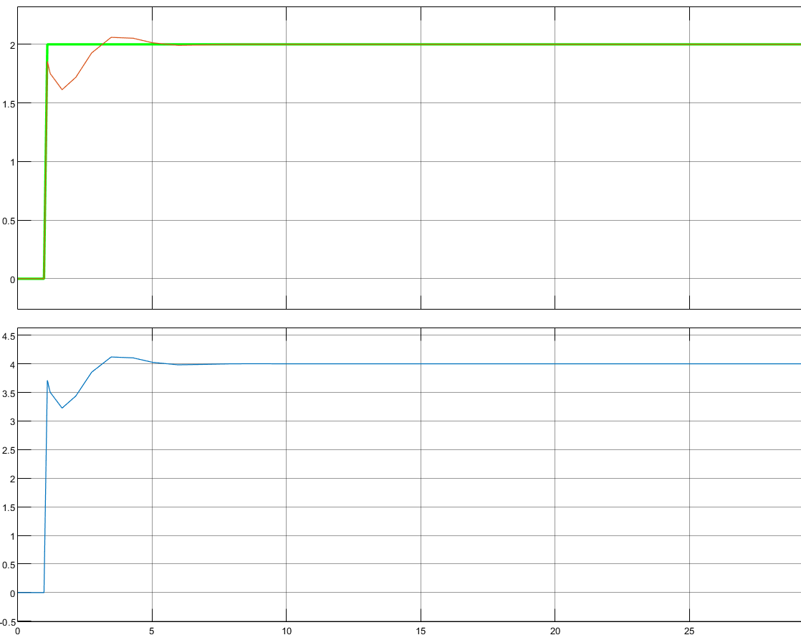

**3. Design**

Given Parameters: Ki = 10, Kd = 3, Kp = 1, and gain of plant as 0.5

Calculation of the Rd, Ri:

We have fixed the value of capacitance as 10µF for both the integral and derivative part, For that-

For Rd-

We have fixed the value of capacitance as 10µF, according to that,

Rd×Cd = Kd

Rd×10µF = 3

Rd = 300 kΩ

For Ri-

1/(Ri×Ci) = Ki

Ri = 1/(Ki×Ci)

Ri = 1/(10×10µF)

Ri = 10 kΩ

Transfer Function Representation: -

The transfer function of the PID Controller is given by: -

G(s) = Kp + Ki/s + Kd s =

**4. Simulation and Experimental analysis**

*4.1 Simulation*

1. Simulating PID Controller Circuit:

* Utilized MATLAB Simulink to simulate the PID controller circuit.
* Input for the simulation was generated using a square wave generator.
* The software's extensive component library facilitated the incorporation of necessary elements, and adjustments were made as needed.
* Waveforms were generated, enabling a detailed examination of the system's response.
* This step allowed us to identify and rectify circuit faults before moving forward with the physical implementation.

1. Simulating Self-Generation Circuit:

* Employed MATLAB Simulink for simulating the self-generation circuit, incorporating IC 7815 and a square wave generator circuit.
* The simulation aimed to validate the stability and performance of the self-power generation system.
* The software's capability to model complex systems ensured an accurate representation of the circuit's behavior.

1. Parameters and Software Selection:

* The MATLAB software was preferred due to its extensive library of components, allowing seamless integration of the required elements.
* The software provides a versatile platform where both PID controller and self-generation circuit simulations could be conducted effectively.
* Parameters such as input voltage (ranging from 2V to 4V), Rd, Ri , Ci , Cd, Rp1 , Rp2 , Kplant , R1sq , R2sq , and Csq were varied during the simulations.
* Waveforms were generated for each parameter variation, and crucial performance metrics like overshoot, rise time, and others were measured.

*4.2 Experiment*

Show the details process of experimental analysis, the deviation of component values from design and simulation, and Images of the experimental setup.

* The PCD design underwent simulation using the EASYEDA online software, allowing for a detailed examination of its real-world behavior.
* The parameters under consideration were systematically varied, and the corresponding waveforms were simulated.
* Key parameters such as overshoot, rise time, and other relevant metrics were measured to evaluate the performance of the physical circuit.

By combining simulation with both MATLAB Simulink and EASYEDA, we ensured a thorough analysis of the circuit's behavior in both virtual and real-world scenarios, facilitating the identification of potential issues and optimizations before the actual circuit implementation.

**MATLAB Simulation of Actual Circuit using OpAmps:-**

Corresponding Waveform-

**Self-power generation circuit for signal conditioning:-**

Corresponding Waveform-

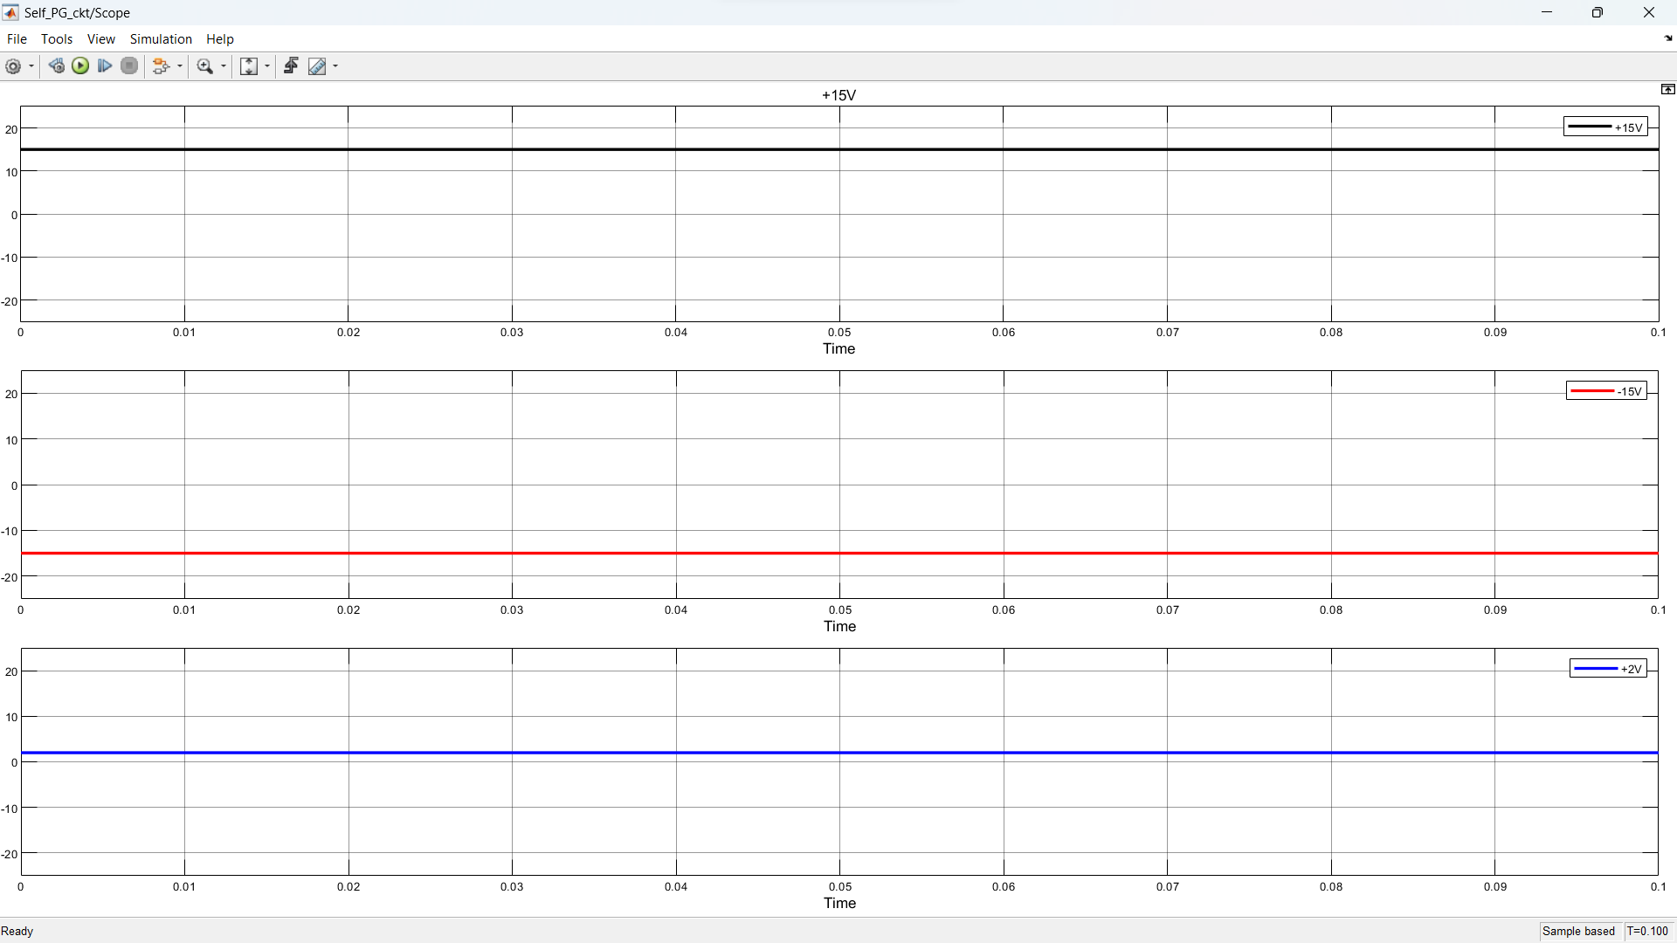

**PCB Simulation using easyeda:-**

PCB Schematic-

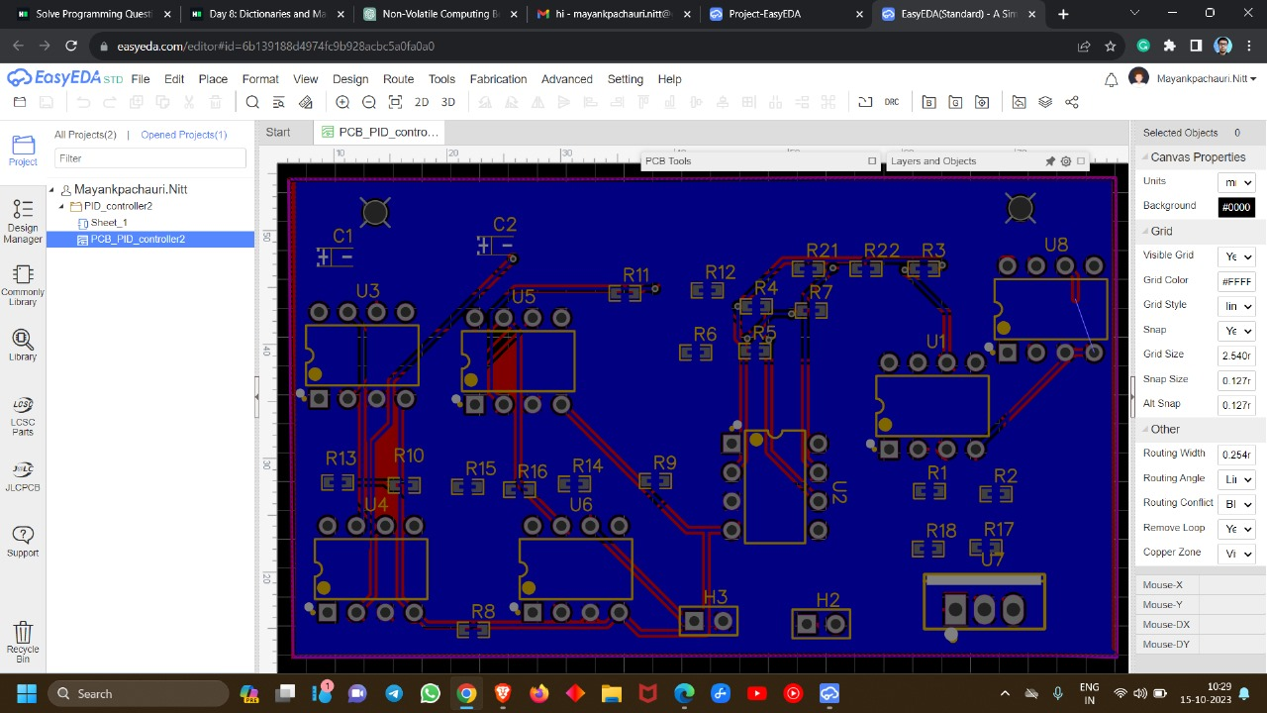

Final Circuit Diagram including Self-powering circuit-

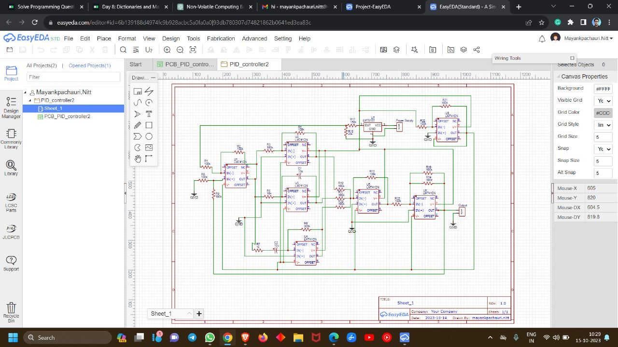

**Simulation by varying parameters:-**

|  |  |
| --- | --- |
| Initial Input Waveform:- | |
| Initial Output Waveform:- | |
| 2 * Rp2 Waveform:- | 0.5 * Rp2 Initial Waveform:- |
| 2 * Ri Waveform:- | 0.5 * Ri Waveform:- |
| 2 * Rd Waveform:- | 0.5 * Rd Waveform:- |

**5. Results and Discussion**

1. Simulation and Experimental Analysis:

* The MATLAB Simulink simulations provided detailed waveforms for the PID controller circuit and the self-generation circuit.
* The EASYEDA online software allowed for PCB simulation, ensuring a thorough examination of the real-world behavior of the circuit.

1. Simulation of PID Controller:

* The PID controller, comprising proportional, integral, and derivative components, was simulated with varying parameters (Kp, Ki, Kd).
* Waveforms demonstrated the system's response to changes in input signal thresholds and plant gain.

1. Experimental Setup:

* The breadboard implementation of the entire circuit revealed a well-regulated supply and successful integration of the PID controller.
* Waveforms obtained during the experiment were compared with simulation results to assess the real-world performance.

1. Parameter Variation:

* Simulation results showcased the impact of varying parameters such as Rd, Ri, Ci, Cd, Rp1, Rp2, Kplant, R1sq, R2sq, and Csq on the system response.
* Experimental analysis confirmed the sensitivity of the circuit to changes in these parameters.

1. Comparison between Simulation and Experiment:

* Discrepancies between simulation and experimental results were observed, as expected in real-world scenarios.
* Deviations were logically justified, considering factors such as component tolerances, non-linearities, and practical limitations.

**6. Conclusion**

1. Controller Component Impact:

* Proportional controller effectively reduced transients.
* Derivative controller, sensitive to input changes, converted the triangular wave to a square wave.
* Integral controller exhibited a slow rise and decay time, contributing to system sluggishness.

1. Overall Performance:

* The fabricated Analog PID controller demonstrated output waveforms aligning closely with expectations.
* The combination of simulation and experimentation provided valuable insights into the practical behavior of the circuit.

1. Challenges and Considerations:

* Tuning PID controllers remains a challenge, requiring a good understanding of system dynamics.
* Non-linearities and variations in component ratings contributed to iterative calculations in the design process.

1. Significance of Analog PID Controller:

* The designed circuit holds practical significance in industrial applications, offering precision control and reduced steady-state errors.
* Versatility allows for adaptation to various systems, making it suitable for temperature control, motor speed regulation, and fluid flow control.

1. Future Considerations:

* Further refinements and optimizations may be explored to enhance the circuit's performance.
* Continued experimentation and tuning can address challenges associated with non-linear behavior and component variations.

In conclusion, the Analog PID controller project successfully integrated theoretical concepts, practical implementation, and testing. The combination of simulation and experimental analysis provided a comprehensive understanding of the circuit's behavior, paving the way for potential improvements and real-world applications in industrial control systems.

**Breadboard Implementation of Entire Circuit:-**

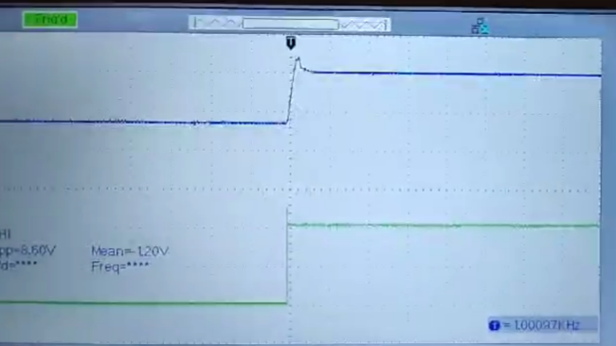🡨----------------------Waveform at 2V change

🡨-------------Supply + regulation

🡨--------------------------------PID

Zoomed image------------------------🡪



**7. Datasheets**

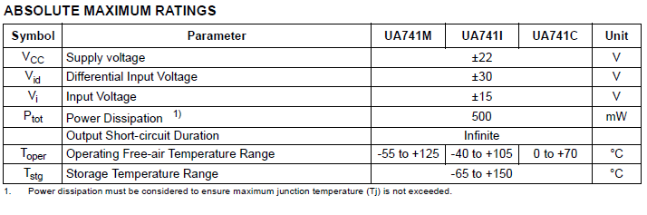****

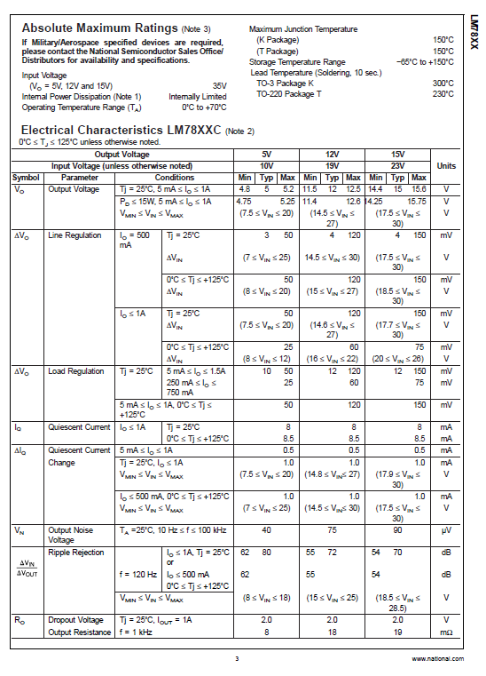

**8. References**

1. “Analog Fabrication of PID Controller” <https://core.ac.uk/download/pdf/53190057.pdf1>
2. IC741 Datasheet – ST Microelectronics
3. IC7815 Datasheet
4. ICL7660SAPAZ Datasheet

Thank You