

**SCHOOL OF COMPUTER SCIENCE AND ENGINEERING**

**COURSE: CSE 316 OPERATING SYSTEM**

*SUBMITTED TO:* **Dr. Hardeep Kaur**

**TOPIC**

“Efficient Page Replacement Algorithm Simulator”

|  |  |
| --- | --- |
| A. Full name |  |
| UID/Registration number |  |
| Roll No |  |
| B. Full name |  |
| UID/Registration number |  |
| Roll No |  |
| C. Full name |  |
| UID/Registration number |  |
| Roll No |  |

**Table of Contents**

1. **Project Overview**
   * Introduction
   * Objective of the Project
   * Scope of the Project
2. **Module-Wise Breakdown**
   * User Interface (UI) Module
   * Page Replacement Algorithms Module
   * Performance Metrics Module
   * Visualization Module
3. **Functionalities**
4. **Technology Used**
   * Programming Languages
   * Libraries and Tools
   * Other Tools
5. **Flow Diagram**
6. **Revision Tracking on GitHub**
   * Repository Name
   * GitHub Link
7. **Conclusion and Future Scope**
   * Conclusion
   * Future Scope
8. **References**
9. **Appendix**
   * A. AI-Generated Project Elaboration/Breakdown Report
   * B. Problem Statement
   * C. Solution/Code

**1. Project Overview**

**Introduction**

In modern computing, efficient memory management is crucial for optimizing performance. When a system runs out of available physical memory (RAM), it uses virtual memory and employs page replacement algorithms to manage memory pages. The goal of this project is to develop a Page Replacement Algorithm Simulator that allows users to test and compare different page replacement strategies, including FIFO (First-In-First-Out), LRU (Least Recently Used), and Optimal Page Replacement.

**Objective of the Project**

The primary objective of this project is to:

* Simulate page replacement algorithms using a user-defined page reference sequence.
* Provide a visual representation of memory frames and page faults.
* Compute performance metrics, such as the number of page faults and hit ratio for each algorithm.
* Allow users to experiment with different frame sizes and observe algorithm efficiency.

**Scope of the Project**

This project covers:

* Implementation of FIFO, LRU, and Optimal algorithms.
* Comparison of algorithm performance using test cases.
* Step-by-step visualization of page replacement processes.
* Analysis of performance metrics such as page faults and execution time.

**2. Module-Wise Breakdown**

The simulator consists of the following key modules:

**2.1 User Interface (UI) Module**

* Provides a graphical or command-line interface for users.
* Accepts page reference sequences and frame size as input.
* Displays step-by-step execution of page replacement algorithms.

**2.2 Page Replacement Algorithms Module**

* Implements FIFO, LRU, and Optimal page replacement algorithms.
* Tracks page faults and hit ratio for each algorithm.

**2.3 Performance Metrics Module**

* Computes:
  + Page Fault Count
  + Hit Ratio
  + Execution Time for Each Algorithm
* Displays performance comparisons.

**2.4 Visualization Module**

* Uses Matplotlib or Tkinter to graphically display:
  + Memory frames at each step.
  + Page replacements in real-time.
  + Bar graphs comparing performance.

**3. Functionalities**

The Page Replacement Algorithm Simulator provides the following functionalities:  
✔ User Input Handling – Accepts page reference sequences and frame size.  
✔ Algorithm Execution – Implements FIFO, LRU, and Optimal page replacement strategies.  
✔ Real-time Visualization – Displays memory status after each page replacement.  
✔ Performance Analysis – Computes and compares page faults across different algorithms.  
✔ Graphical Output – Uses bar graphs or tables for performance comparison.

**4. Technology Used**

**Programming Languages**

* **Python** – Used for implementing algorithms, handling logic, and visualization.

**Libraries and Tools**

* **Matplotlib** – For graphical representation of page faults.
* **Tkinter** – (Optional) For GUI-based input selection.
* **NumPy** – For efficient data handling.

**Other Tools**

* **GitHub** – For version control and collaboration.
* **Jupyter Notebook** – (Optional) For interactive algorithm testing.

**5. Flow Diagram**

**Flowchart Representation**

The flow of execution in the simulator is:

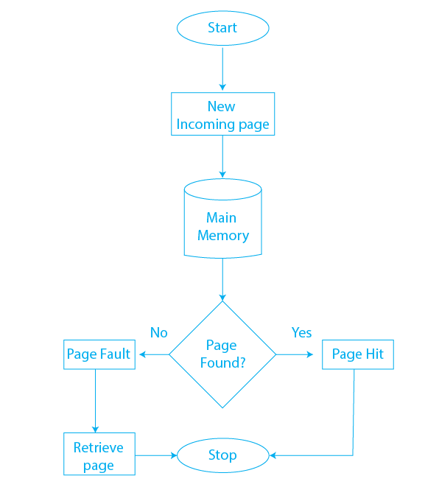

1️. **User Inputs**

* Page reference sequence
* Frame size
* Choice of page replacement algorithm

2️. **Algorithm Execution**

* Simulates memory replacement based on selected strategy
* Tracks page faults and hits

3. **Performance Calculation**

* Computes total page faults and hit ratio

4️. **Results Visualization**

* Displays graphs and tables comparing algorithms

**6. Revision Tracking on GitHub**

**Repository Name:**

[Insert Repository Name]

**GitHub Link:**

[Insert GitHub Repository Link]

**7. Conclusion and Future Scope**

**Conclusion**

This Page Replacement Algorithm Simulator successfully demonstrates how different memory management techniques handle page replacements. The FIFO, LRU, and Optimal algorithms were implemented, analysed, and compared based on page faults and hit ratios.

From the results:

* FIFO is simple but suffers from Belady’s anomaly.
* LRU is more efficient as it considers past usage patterns.
* Optimal provides the best results, but it is impractical for real-world systems.

**Future Scope**

Additional Algorithms: Implement Clock (Second Chance) and Random Page Replacement algorithms.  
 GUI Enhancements: Add interactive animations for real-time memory visualization.  
 Machine Learning: Train an AI model to predict and optimize page replacements.  
 Cloud-Based Simulation: Deploy the tool as a web application.

**8. References**

* **Operating System Concepts** – Silberschatz, Galvin, Gagne
* **Modern Operating Systems** – Andrew S. Tanenbaum
* [GeeksforGeeks – Page Replacement Algorithms](https://www.geeksforgeeks.org/page-replacement-algorithms-in-operating-systems/)
* TutorialsPoint – Virtual Memory

**Appendix**

1. **AI-Generated Project Elaboration/Breakdown Report**

**1. Project Overview**

**Goals**

The Efficient Page Replacement Algorithm Simulator is designed to simulate and analyse different page replacement algorithms used in virtual memory management. The goal is to help users understand and compare algorithms such as FIFO, LRU, and Optimal in terms of their efficiency and page fault rates.

**Expected Outcomes**

Accurate simulation of page replacement techniques.

Performance analysis with page fault tracking.

Graphical visualization to demonstrate memory operations.

Comparison of algorithms to determine the most efficient strategy under different conditions.

**Scope**

The simulator will implement and compare FIFO, LRU, and Optimal algorithms.

Users can input page reference sequences and define frame sizes.

The system will provide visual representations of page replacements

The tool will be useful for students, researchers, and educators in Operating System (OS) studies.

**2. Module-Wise Breakdown**

The project can be divided into three key modules:

2.1 User Interface (UI) Module

Purpose: Provides an interface for users to interact with the simulator.

Accepts page reference sequence and frame size input.

Allows users to choose an algorithm (FIFO, LRU, or Optimal).

Displays results in a user-friendly format.

2.2 Algorithm Processing Module

Purpose: Implements the logic for FIFO, LRU, and Optimal page replacement.

Stores pages in memory (simulating RAM).

Tracks page hits and page faults.

Implements different page replacement strategies.

2.3 Data Visualization Module

Purpose: Graphically represents memory state changes over time.

Step-by-step animation of how pages are replaced.

Graphical comparison of page faults across algorithms.

Uses bar charts or tables for result visualization.

**3. Functionalities**

Module Functionality Example

UI Module Accepts user input (page sequence, frame size, algorithm)

User enters 7 0 1 2 0 3 4 2 3 0 3 2 1 2 0 with 3 frames

UI Module Displays memory frame state after each page request Shows pages in memory at each step

Algorithm Processing Module Implements FIFO algorithm Oldest page is replaced first

Algorithm Processing Module Implements LRU algorithm Least recently used page is replaced

Algorithm Processing Module Implements Optimal algorithm Page used farthest in the future is replaced

Data Visualization Module Shows step-by-step memory status Animation of memory frames being updated

Data Visualization Module Compares page faults of algorithms Graph comparing FIFO vs. LRU vs. Optimal

**4. Technology Recommendations**

Programming Language

Python – Easy to implement algorithms, supports visualization libraries.

Libraries and Tools

Purpose Recommended Library/Tool

GUI Development Tkinter / PyQt

Graphical Visualization Matplotlib / Seaborn

Data Handling NumPy / Pandas

Code Version Control GitHub

Why These Technologies?

Python: Simple syntax and extensive libraries.

Matplotlib: Great for graphical comparison of page faults.

Tkinter/PyQt: Provides a simple GUI for user interaction.

**5. Execution Plan**

Step 1: Setup the Development Environment

Install Python (if not installed).

pip install matplotlib numpy pandas tkinter

Initialize a GitHub repository for version control.

Step 2: Implement the UI Module

Create a Tkinter or CLI-based input system.

Allow users to enter page sequence and frame size.

Add a dropdown menu to choose an algorithm.

Step 3: Implement the Algorithm Processing Module

Create a PageReplacementSimulator class.

Implement FIFO, LRU, and Optimal algorithms.

Store pages in a list or queue and track page faults.

Step 4: Implement the Data Visualization Module

Display memory step-by-step using Matplotlib.

Show page fault comparisons in a bar graph.

Animate the replacement process (if using a GUI).

**Step 5: Test with Sample Inputs**

Run test cases to validate the algorithms:

pages = [7, 0, 1, 2, 0, 3, 4, 2, 3, 0, 3, 2, 1, 2, 0]

frame_size = 3

simulator = PageReplacementSimulator(pages, frame_size)

print("FIFO Page Faults:", simulator.fifo())

print("LRU Page Faults:", simulator.lru())

print("Optimal Page Faults:", simulator.optimal())

**Step 6: Optimize and Refine**

Ensure efficient data structures are used.

Improve visualization clarity.

Test with larger datasets.

**Step 7: Document the Project**

Prepare a README.md file with instructions.

Add comments and explanations in the code.

Update GitHub repository with code versions.

**B. Problem Statement: Efficient Page Replacement Algorithm Simulator**

C. Solution/Code: