Pico MZ-80K

User and Systems Manuals

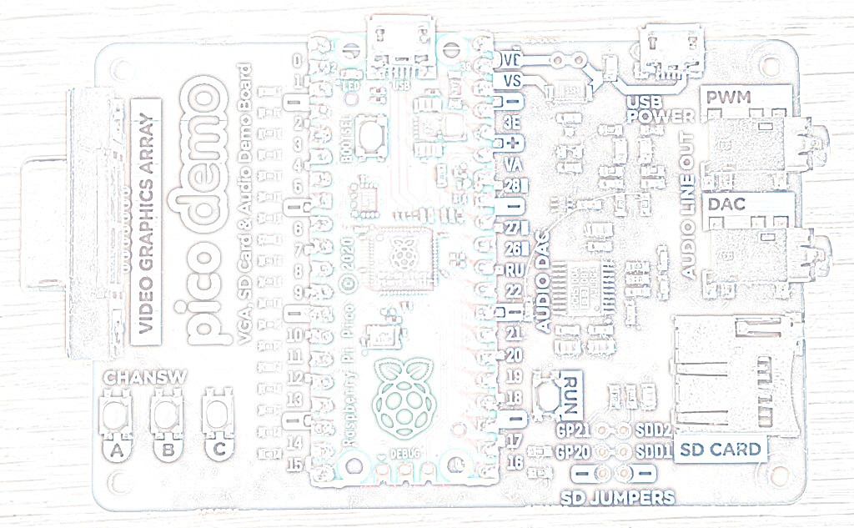
HELLO!
MY FRIEND
HELLO!
MY COMPUTER

Table of Contents
Introduction 3
Getting started 4
Hardware requirements 4
Installing / re-installing the Pico MZ-80K software 6
First boot 6
Keyboard layout 7
The MZ-80K keyboard layout 7
Mapping the MZ-80K keyboard to a UK USB keyboard 7
Black MZ-80K keys 7
Yellow MZ-80K keys 8
Blue MZ-80K keys 9
Function keys 9
F1 to F3 – Cassette Player Emulation 9
F4 – Emulator Status Area 9
F5 – Reverse Video 9
F9 – Keyboard Scan Mode 10
F11 and F12 – Fast Memory Dump File Handling 10
Unused Function Keys 10
Cassette tape emulation 11
Loading files from a microSD card 11
Saving files to a microSD card 12
Using a terminal emulator with the Pico MZ-80K 13
MicroSD card support 14
Troubleshooting 15
Systems manual 16
Compiling Pico MZ-80K for the Pimoroni VGA base 16
Pre-requisites for Raspberry Pi OS (Debian Bookworm) 16
Pico MZ-80K software architecture 18
Overview 18
The MZ-80K memory map 19
Memory dump files 20
Pico MZ-80K memory dump file format as of November 24th 2024. 20
Header 20
Monitor workarea and user RAM 20
Video RAM 20
Z80 state 20
8253 state 20
Acknowledgements 21

Introduction
The Sharp BASIC manual from 1979 introduces the user to the MZ-80K in this way.
Here’s a new friend for you
The MZ-80K is ready to enjoy conversation with you. Through conversation, it will help you solve difficult calculation problems or become a partner to play a game with. More than that, it has unknown potentialities to be opened up with you. This is just like a journey into unknown space. Together with your new friend, let’s make the journey now.
The Pico MZ-80K aims to faithfully re-create this iconic computer so that your conversation can carry on more than four decades after the journey began.
But first, you will need to understand a little more about how to set up the Pico MZ-80K, so that it can be your new friend.

Getting started

Hardware requirements
The Pico MZ-80K uses the Pimoroni VGA demo base with a Raspberry Pico or Pico 2 microcontroller to re-create the hardware of a Sharp MZ-80K. To run the emulator, you will need:
1. A Pimoroni VGA demo base
2. A Raspberry Pico H or Pico2 H (or solder headers to a standard Pico or Pico 2).
3. A VGA cable to enable your VGA demo base to be plugged into a suitable monitor.
4. An OTG adaptor or cable to allow a USB keyboard to be plugged into the micro USB port on your Pico or Pico 2.
5. A power supply. This must be plugged into the micro USB port on your VGA demo base marked ‘USB POWER’. An official Raspberry Pi 5V, 12.5W Micro USB Power Supply is suitable.
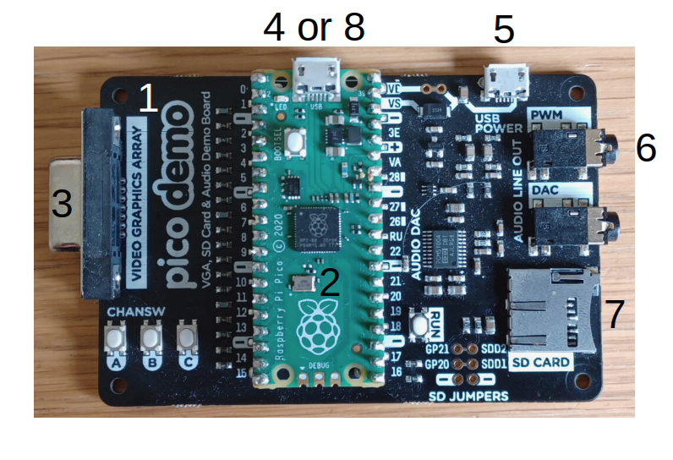
6. A speaker or speakers, connected to a 3.5mm stereo jack, and plugged into the PWM socket on the VGA demo base. The DAC socket is not currently supported.
7. A FAT32 formatted microSD card, containing the Sharp MZ-80K software you wish to run. These should be ‘.mzf’ format files. Other formats, such as .wav, .mzt and .m12 are not currently supported by the emulator.
Good sources of .mzf files include:
https://sharpmz.no/original/
https://mz-archive.co.uk/
https://github.com/psychotimmy/sharpmz-80k
As a minimum, a language interpreter (such as Sharp BASIC SP-5025) or Z80 development environment (such as Avalon ZEN) should be written to the microSD card. The Pico MZ-80K is of little use without an interpreter or development environment.
A copy of the Sharp MZ-80K SP-5025 BASIC manual can be found at:
https://archive.org/details/sharp-basic-manual-mz-80-k
8. A USB cable with a micro USB plug for the Pico, to enable the Pico MZ-80K software to be installed and re-installed from a computer.

Installing / re-installing the Pico MZ-80K software
The most recent release of the Pico MZ-80K software can be found at:
https://github.com/psychotimmy/picomz-80k
To install the software onto the Pico, download one of picomz-80k.uf2 or picomz-80k-diag.uf2 if you are using a Raspberry Pico, or pico2mz-80k.uf2 or pico2mz-80k-diag.uf2 if you are using a Raspberry Pico 2 and:
- Push and hold the BOOTSEL button while connecting your Pico/Pico 2 with a USB cable to a computer. Release the BOOTSEL button once your Pico appears as a Mass Storage Device called RPI-RP2 (RP2350 if you are using a Pico 2).
- Copy the .uf2 file onto the RPI-RP2 volume. Your Pico/Pico 2 will reboot.
- Disconnect the USB cable and plug in the OTG adaptor and USB keyboard to the Pico/Pico 2. Apply power to the USB POWER port. Alternatively, use a terminal emulator from the computer the .uf2 file was copied from to provide keyboard input to the Pico MZ-80K.
- You are now running the Pico MZ-80K emulator.

First boot
If everything is working as expected, your VGA monitor should display:
** MONITOR SP-1002 **
*
Use the F1 key to cycle to a m/c code ‘tape’ to load (for example, the SP-5025 BASIC interpreter).
Type LOAD <return>
The ‘tape’ will take some time to load (although not quite as long as a real tape on a Sharp MZ-80K).
If you choose to load the SP-5025 BASIC interpreter, you should see the message:
* SHARP BASIC SP-5025
34680 BYTES
READY
▒

Keyboard layout

The MZ-80K keyboard layout
The Sharp MZ-80K keyboard has 78 keys, arranged in five rows. There are 14 keys on the bottom row, and 16 keys on each of the other four.
The rightmost 5 keys on each row are blue and allow access to 75 of the Sharp’s character graphics.
The remainder of the bottom row are yellow, and implement the space bar, carriage return, shift keys, break key, cursor movement and editing functions.
The first 11 keys on each of the other four rows (with the exception of the 11th key on the second row from the bottom – SML/CAP) implement alphanumeric and punctuation characters. By default, the alpha characters are upper case.
The shift key enables the character on the top of the key to be used – for example, shift Q returns >, and shift S the heart graphic.
The SML/CAP key allows lower case characters to be used on the alpha keys or if a symbol is printed on the lower right hand side of a key, that symbol. If the SML/CAP key is selected, the led to the right of the MZ-80K keyboard (usually green when power is on) is turned red. When deselected, the led returns to green.

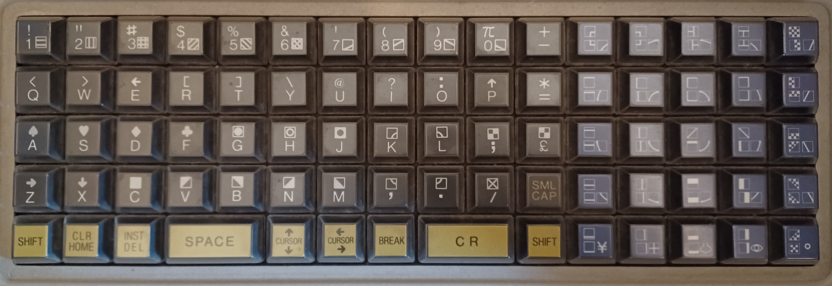
Mapping the MZ-80K keyboard to a UK USB keyboard

Black MZ-80K keys
With Caps Lock off, the lower case alpha keys on a USB keyboard are mapped to the upper case alpha keys on the MZ-80K keyboard. Numeric keys are mapped to the numeric keys as expected.
With Caps Lock on (or shift <character> used), most of the alphanumeric keys on a USB keyboard are mapped to the shifted MZ-80K keys (for example, shift <1> maps to !, shift <Q> maps to > and shift <S> maps to the heart symbol).

The exceptions are:
<shift> 3 – maps to £, rather than #
<shift> 6 – maps to π, rather than ^
<shift> 7 – maps to &, rather than ‘
<shift> 8 – maps to *, rather than (
<shift> 9 – maps to (, rather than )
<shift> 0 – maps to ), rather than π.
Where a punctuation symbol appears on the USB keyboard and there is a match on the Sharp MZ-80K keyboard, that key corresponds to the Sharp MZ-80K key. For example, ‘:’ maps to ‘:’ (<shift> O on the MZ-80K keyboard) and ‘@’ maps to ‘@’ (<shift> U>).
The SML/CAP key is mapped to the ‘~’ (tilde) key. When selected, the Pico’s green led is lit. This is equivalent to the Sharp MZ-80K’s power led turning red (from green). When the SML/CAP key is deselected, the Pico’s led is turned off.

Yellow MZ-80K keys
The yellow keys are mapped as follows:
Left hand shift key – mapped to either USB shift key. Because shifted characters are taken care of automatically, use <Ctrl> L if a program is expecting only a left hand shift key as input.
Right hand shift key – mapped to either USB shift key. Because shifted characters are taken care of automatically, use <Ctrl> R if a program is expecting only a right hand shift key as input.
CLR – mapped to the End key
HOME – mapped to the Home key
INST – mapped to the Insert key
DEL – mapped to the Delete and Backspace keys. <Ctrl> H will also work.
SPACE – mapped to the spacebar
Cursor up, down, left, right – mapped to the cursor up, down, left, right keys respectively
BREAK – mapped to the PgDn key
SHIFT BREAK – mapped to the PgUp key
CR – mapped to the carriage return key and the numeric keypad’s Enter key. <Ctrl> M will also work.

Blue MZ-80K keys
The blue graphics keys are mapped to Alt keys as shown in the table below.
Alt Q  Top left blue key | Alt W | Alt E | Alt R | Alt T  Top right blue key
Alt Y | Alt U | Alt I | Alt O | Alt P
Alt A | Alt S | Alt D | Alt F | Alt G
Alt H | Alt J | Alt K | Alt L | Alt M
Alt Z  Bottom left blue key | Alt X | Alt C | Alt V | Alt B  Bottom right blue key

In common with the black keys, <shift><Alt><key> selects the symbol on the top of the MZ-80K key. If SML/CAP is active (steady green led lit on Pico), the symbol on the bottom right of the MZ-80K key is selected instead.

Function keys
The function keys allow the following tasks to be accomplished.

F1 to F3 – Cassette Player Emulation
F1 – Step ‘forwards’ through files on the microSD card ‘tape’.
F2 – Step ‘backwards’ through files on the microSD card ‘tape’.
When F1 or F2 are pressed, the next tape file that a LOAD command will use is displayed in the emulator status area.
F3 – Reset the tape counter in the emulator status area to 000.
Note: F3 does not affect the next tape file that a LOAD command will use.

F4 – Emulator Status Area
F4 – Clear the emulator status area.
Note: F4 does not affect the next tape file that a LOAD command will use.

F5 – Reverse Video
F5 – Toggles between normal and reverse video.
While this was not possible on a standard MZ-80K, a Sharp Users’ Club article presented the hardware modifications necessary to implement it.

F9 – Keyboard Scan Mode
F9 – Change the keyboard scan mode.
The default is 1, which is correct for most programs.
However, some programs (usually games written in machine code) require the scan mode to be set to 2 or 3 to ensure that all keypresses are reported correctly. If F9 is pressed, the keyboard scan mode (1,2 or 3) is displayed in the bottom right of the emulator status area.
This was not required on a standard MZ-80K. It is only necessary in this emulator to resolve the differences between the way USB keyboards and the MZ-80K keyboard matrix work.

F11 and F12 – Fast Memory Dump File Handling
F11 – Read a memory dump file (MZDUMP.MZF) from the microSD card.
This restores the state of user RAM, video RAM and the z80 to the point at which the memory dump was created.
F12 – Store the contents of user RAM, video RAM and the z80 state to a memory dump file (MZDUMP.MZF).
Note that the previous contents of this file are always overwritten by F12 as only a single memory dump file per microSD card is currently supported.

Unused Function Keys
F6, F7, F8 and F10 are not used by the Pico MZ-80K.

Cassette tape emulation

Loading files from a microSD card
The microSD card acts in much the same way as a cassette tape works on a real Sharp MZ-80K.
Use the F1 key to position the tape read head at the start of a new file. This is the equivalent of using the fast forward key and tape counter on a real machine. Repeatedly pressing F1 will cycle forwards through all of the files on the microSD card before stopping at the last file.
Use the F2 key to position the tape read head at the tape file before the current one. Repeatedly pressing F2 will cycle backwards through the files on the microSD card until the first file is reached.
F3 resets the tape counter. It does not affect the currently selected tape file – use F1 or F2 to change the tape file selected.
The bottom five lines of the Pico MZ-80K’s display are used to display ‘tape’ status. The name of the next file to be loaded is displayed (note that this is not necessarily the same name that the file has on the microSD card), along with the file type (one of m/c code, BASIC etc. data or unknown).
Files of type m/c code must be read directly from the SP-1002 monitor.
Files of type Sharp BASIC etc. must be read from the appropriate interpreter or development environment.
Files of type data are for use by the originating program. For example, the game “The Valley” allows your character to be saved and loaded from tape. These are stored in files of type data.
Use the LOAD command when in the SP-1002 monitor or BASIC SP-5025 (or the equivalent if you are using another interpreter or development environment) to transfer this file into the Pico MZ-80K’s memory.
Unlike on a real Sharp MZ-80K, using the LOAD command simulates you pressing the PLAY button on the cassette deck automatically, and stops once the end of the file is reached.
Loading files from the microSD card takes a little time as it is emulating a real tape. However, tapes are read slightly more quickly than on a real machine.
The F4 key will clear the ‘tape’ status display until the next time F1, F2, F3 or F9 is pressed.

Saving files to a microSD card
Use the SAVE command when in BASIC SP-5025 (or the equivalent if you are using another interpreter or development environment) to write the contents of the Pico MZ-80K’s memory to the microSD card.
The name of the file saved to the microSD card is not necessarily the same as the name given to the SAVE command. This is because the permitted characters in a FAT32 file name are not equivalent to the ones permitted in Sharp MZ-80K file names (and vice-versa).
Note that if a file on your microSD card already exists it will be overwritten.

Using a terminal emulator with the Pico MZ-80K
A terminal emulator, such as minicom, may be used to provide power and keyboard input to the Pico MZ-80K instead of a USB keyboard and 5V power supply. If you choose to run the emulator in this way, the (diagnostics) picomz-80k-diag.uf2 image must be used.
For example, using minicom 2.8 from a Raspberry Pi computer requires the following settings:
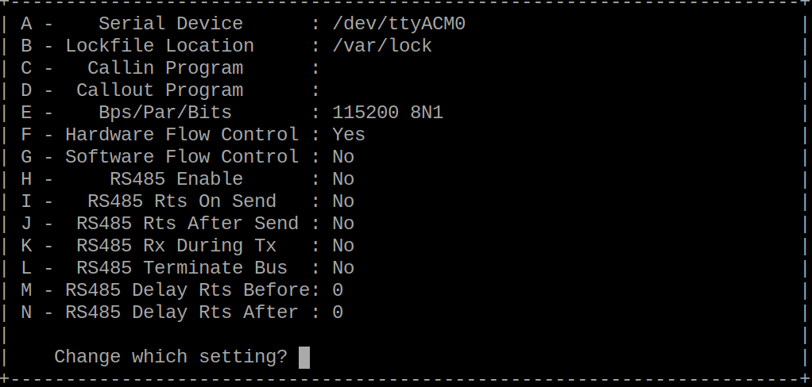

Ensure that the minicom window has keyboard focus before changing from HDMI input on the Raspberry Pi to VGA input from the Pico, otherwise the emulator will not see the keystrokes sent from minicom.
Information will be echoed back to the minicom window when a SHOW (printf) statement is executed by the emulator. For example:
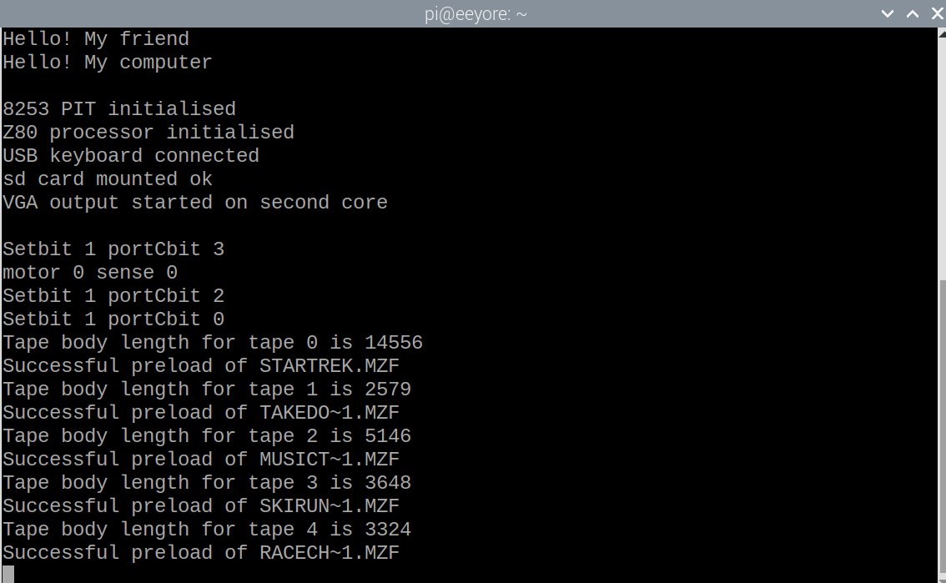

MicroSD card support
The following microSD cards and formats are known to work in the emulator.
microSD card make / type | microSD card format and partition sizes
Transcend 16GB microSDHC, Class 10, UHS 1 | FAT32, partition sizes up to and including the whole card
Kingston 32GB microSDHC, Class 10, UHS 1 | FAT32, 2GB partition size

The following microSD cards and formats are known not to work in the emulator.
microSD card make / type | microSD card format and partition sizes
SanDisk Ultra 32GB microSDHC Class 10, A1, UHS 1 | FAT32, all partition sizes

Troubleshooting
Symptom | Likely cause | Remedy
Fast flashing green led (200ms) on the Pico or Pico 2; no output seen on the VGA display. | A USB keyboard (or terminal emulator) is not active. | Check connections and try again by pressing the RUN button on the VGA base.
Slow flashing green led (1s) on the Pico or Pico 2; no output seen on the VGA display. | There is no microSD card present, or the microSD card cannot be read. | Review the manual section that discusses SD card support.
‘tapes’ fail to load or save correctly. | The cassette tape deck emulation is out of synchronisation. | Press the ‘BREAK’ key (PgDn) or the shifted ‘BREAK’ key (PgUp) and try again.  If this fails, restart the emulator by pressing the RUN button on the VGA base.
‘tapes’ fail to save correctly and the cassette tape deck emulation is not out of synchronisation. | The microSD card (or partition being used on the card) is full. | Remove the microSD card from the emulator and delete unwanted files. Reinsert the card and try again.
Keypresses are not recognised by the emulator in some programs. | Some machine code games read data from the keyboard without using the monitor subroutines provided for this purpose. | Use the F9 key to try again using keyboard mode 2 or 3. The mode that the keyboard is in is reported in the bottom right hand side of the emulator status area.

Systems manual

Compiling Pico MZ-80K for the Pimoroni VGA base

Pre-requisites for Raspberry Pi OS (Debian Bookworm)
CMake (version 3.13 or later) and a gcc cross compiler.
sudo apt install cmake
sudo apt install gcc-arm-none-eabi libnewlib-arm-none-eabi build-essential
The Pico MZ-80K emulator relies on the latest stable release of the Raspberry Pico SDK. This and the Pico Extras repository must be available on your computer if you wish to compile the emulator.
Assuming that you are already in the subdirectory in which you wish to install the Pico SDK, Pico Extras and Pico MZ-80K repositories, issue the commands:
git clone --recursive https://github.com/raspberrypi/pico-sdk.git -b master
git clone https://github.com/raspberrypi/pico-extras.git -b master
Then clone either the current release of the Pico MZ-80K repository:
git clone https://github.com/psychotimmy/picomz-80k.git -b 1.1.0
or the latest stable version:
git clone https://github.com/psychotimmy/picomz-80k.git -b main
Ensure that the Pico SDK and Pico Extras subdirectories have been exported.
For example, if these libraries have been installed under /home/pi, use:
export PICO_SDK_PATH=/home/pi/pico-sdk
export PICO_EXTRAS_PATH=/home/pi/pico-extras
For a Pico build, issue the commands:
cd picomz-80k
mkdir build
cd build
cmake -DPICO_BOARD=vgaboard ..
make
For a Pico 2 build, issue the commands:
cd picomz-80k
mkdir build
cd build
cmake -DPICO_BOARD=vgaboard -DPICO_PLATFORM=rp2350 ..
make

There should now be two .uf2 files in the build directory for the emulator that can be installed on your Pico or Pico 2.
picomz-80k.uf2 or pico2mz-80k.uf2 are for standard use. They assume a UK USB keyboard connected directly to the Pico or Pico 2.
picomz-80k-diag.uf2 or pico2mz-80k-diag.uf2 can only be used through a terminal emulator (such as minicom) as diagnostic messages are output to the Pico's USB port.

Pico MZ-80K software architecture

Overview
sharpmz.h  Common header file for the emulator | sharpmz.c  Main entry point for the emulator.
sharpmz.h  Common header file for the emulator | sharpcorp.c  The decoded SP-1002 monitor and computer graphics ROM (UK version) for the Sharp MZ-80K.
sharpmz.h  Common header file for the emulator | 8255.c  A simplified Intel 8255 emulator, specifically for use in this emulator.
sharpmz.h  Common header file for the emulator | 8253.c  A simplified Intel 8253 emulator, specifically for use in this emulator. The mechanism for producing sounds from the Pico’s PWM is also included in this source file.
sharpmz.h  Common header file for the emulator | keyboard.c + tusb_config.h  Emulates a Sharp MZ-80K keyboard on a UK USB keyboard or via a terminal emulator.
sharpmz.h  Common header file for the emulator | cassette.c  Emulates reading and writing Sharp MZ-80K tapes (.mzf format) using the VGA board’s microSD card.
sharpmz.h  Common header file for the emulator | vgadisplay.c  Provides a monochrome VGA representation of the Sharp MZ-80K’s display, plus emulator status information in the lower 40 scanlines.
Third party libraries

zazu80 – a z80 instruction set emulator.
Forked from https://github.com/superzazu/z80
fatfs – a file system for the Raspberry Pico microSD card.
Version 0.15 w/ patch 1 forked from http://elm-chan.org/fsw/ff/00index_e.html
sdcard – low level routines for the fatfs library.
Forked from https://github.com/elehobica/pico_fatfs with changes made to support the pinout used by the Pimoroni VGA demo base sd card.
Raspberry Pi libraries

Pico SDK – Version 2.0.0 master branch or later, including TinyUSB.
Pico Extras – Version 2.0.0 master branch or later.

The MZ-80K memory map
MZ-80K Addresses |  | Pico MZ-80K Emulator
0xF000 – 0xFFFF  (61440 – 65535)  FD ROM uses first 1024 bytes of this space when installed | FD ROM and unused addresses | Not implemented
0xE000 – 0xEFFF  (57344 – 61439)  Only addresses  0xE000 – 0xE008 used | Devices  (8255, 8253, Sound) | Implemented by 8255.c and 8253.c
0xD000 – 0xDFFF  (53248 - 57343) | Video RAM | Stored in mzvram[]
0x1200 – 0xCFFF  (4608 – 53247) | User RAM | Stored in element 512 onwards of mzuserram[]
0x1000 – 0x11FF  (4096 - 4607) | Monitor stack and workarea | Stored in elements 0 - 511 of mzuserram[]
0x0000 – 0x0FFF  (0 - 4095) | Monitor ROM | Stored in mzmonitor[]

Memory dump files
The Pico MZ-80K, through the F12 function key, supports storing the state of monitor stack and workarea, user RAM, video RAM, z80 and 8253 at the point in time when the key is pressed.
This state can be restored later by using the F11 function key.
The memory dump file is based on the .mzf format with extensions and omissions.
At the time of writing, this format is still subject to change, so should not be used as a permanent storage mechanism for your Pico MZ-80K programs.

Pico MZ-80K memory dump file format as of November 24th 2024.

Header
The first 128 bytes of the file. The first byte stores the value 0x20, to identify that this is a Pico MZ-80K format memory dump file. The next 12 bytes are used to store a file name (in the same way that an .mzf file does). These are:
0x4d 0x92 0xb3 0xb7 0x9d 0xbd 0x20 0x9c 0xa5 0xb3 0x9e 0x0d
M e m o r y <sp> d u m p <cr>
The remainder of the header block is undefined and unused.

Monitor workarea and user RAM
The next 49,152 bytes. Populated with the contents of the monitor workarea and user RAM at the time the F12 key is pressed.

Video RAM
The next 1024 bytes. Populated with the contents of the video RAM at the time the F12 key is pressed.

Z80 state
The next 56 bytes. Populated with the contents of the mzcpu global structure, used to maintain the state of the Z80 cpu.

8253 state
The final 12 bytes. Populated with the contents of the mzpit global structure, used to maintain the state of the 8253 programmable interval timer (PIT).

Acknowledgements
As well as directly including the third party libraries detailed in the architectural overview of the Pico MZ-80K, some of the code was also inspired by other projects. These include:
The KM-Z80 MZ-80K emulator by Katsumi
A MZ-80 series emulator for Raspberry Pi by Nibbles Lab
VHDL implementations of Sharp MZ series computers by Philip Smart
Picoterm by RC2014
The RC2040 by Extreme Electronics
… and, of course, the people who run and take part in RetroChallenge. Much of the work completing the first version of this emulator was performed during the October 2024 event.
My own notes made during this time can be found at retrocomputing ephemera.

An alternative to using a separate keyboard and power supply is to connect the Pico’s USB port to a computer’s USB port. A terminal emulator, such as minicom, can then be used to provide input to the emulator using the computer’s keyboard. If the debug version of the emulator is to be used, this type of setup is essential. See the section on using a terminal emulator with the Pico MZ-80K later on in this manual for more details.
As footnote 1. A separate power supply is not used if the Pico’s USB port is connected to a computer.
See the section on microSD card support for known working / not working microSD cards.
picomz-80k.uf2 and pico2mz-80k.uf2 require a physical UK USB keyboard to be plugged into the Pico/Pico 2. If you are going to be using a terminal emulator (such as minicom) from another computer to provide keyboard input, you will need to use picomz-80k-diag.uf2 or pico2mz-80k-diag instead.

