VELLORE INSTITUTE OF TECHNOLOGY, VELLORE
[School / Department name]
[Course Code – Course Title]
Lab Assessment 9 — Project Review 2
PAGEWISE
Semantics-Aware Neural Page Prefetching for Irregular Memory Access Patterns in SQLite
Pipeline, system architecture, module workflows, implementation status and preliminary results
Submitted by
Vikash Vaibhav
Registration No. 24BDS0316
B.Tech. Computer Science and Engineering with Specialization in Data Science
Under the guidance of
[Faculty Name and Designation]
Slot: [Slot] | Fall Semester 2026–27
14 October 2026

Contents
[Table of contents — right-click and choose Update Field, or press F9]
If the table of contents appears empty, right-click it and choose “Update Field” (or press F9) in Microsoft Word.
List of figures. Figure 1 – End-to-end pipeline; Figure 2 – Runtime architecture; Figure 3 – Module workflows; Figure 4 – Held-out prediction accuracy; Figure 5 – Paired latency deltas.

Abstract
Pagewise investigates whether application-level semantic information about SQLite database pages — the table or index a page belongs to, its B-tree page type and depth, and the query-plan context in which it is requested — improves learned next-page prefetching over a history-only predictor, and whether any prediction gain survives inference and scheduling overhead to become a measurable latency improvement under a controlled cache budget. This Review 2 report documents the complete experimental pipeline (synthetic database generation, VFS-level page tracing with query context, per-query page sequences, matched training of a history-only MLP (Model A) and a semantic MLP (Model B), offline evaluation, a bounded-cache asynchronous prefetch runtime and a paired, bootstrap-based evaluation suite), the runtime architecture, and the workflow of each of the four major modules. Measured results on a frozen 800-page (3.2 MB) database show that semantic features raise held-out top-1 accuracy from 17.2% (Model A) to 28.1% (Model B), with page metadata — chiefly object identity — accounting for most of the gain, but that simple Markov tables remain more accurate (53.1% for Markov-2). In latency-injected runtime trials (0.2 ms per miss) Markov-2 and sequential prefetching significantly reduce paired per-query latency versus the no-prefetch baseline, whereas the neural predictors are limited by inference cost; on real storage with an in-memory database every prefetcher is slower than the baseline. A benchmark audit identified and repaired queue staleness and storage-contention modelling defects, and a pre-registered v2 protocol with an oracle headroom bound, a context-keyed Markov control and a virtual-time simulator has been defined for the final evaluation.
Keywords: SQLite, page prefetching, learned prefetching, semantic features, VFS tracing, bounded page cache, Markov predictor, paired bootstrap.

1. Introduction

1.1 Background and motivation
Database engines spend a significant fraction of query latency waiting for pages that are not resident in memory. SQLite stores a database as fixed-size pages (4 KiB in this project) organised into B-trees for tables and indexes [3]; the pages a query touches, and the order in which it touches them, depend on the B-tree layout, the chosen query plan and the data distribution. For indexed lookups, joins and recursive traversals this access pattern is irregular, so classical sequential read-ahead — the default assumption of operating-system and hardware prefetchers [8], [14] — is frequently wrong.
Learned prefetchers from the computer-architecture community predict future addresses from address history alone [5], [6]. A database engine, however, knows more than the address: it knows which table or index a page belongs to, whether the page is an interior or leaf node, how deep it sits in the B-tree, and which query plan is executing. The informed-prefetching literature [9] and context-based prefetching [7] suggest that such semantic hints can improve prediction. Pagewise tests this idea for SQLite under a deliberately conservative, pre-registered methodology that reports negative and inconclusive outcomes with the same prominence as positive ones.

1.2 Problem statement
Given a static, read-only SQLite database and a mixed workload of indexed point lookups, joins, range scans and recursive traversals, the system must — on every observed page request — predict which page(s) will be demanded next, prefetch them into a bounded page cache that sits beneath SQLite’s own pager, and quantify (a) the prediction accuracy of a semantic predictor relative to an otherwise identical history-only predictor and to simple statistical baselines, and (b) the resulting change in per-query latency under a controlled cache budget and a controlled storage-latency model.

1.3 Research question and hypotheses
Research question. Can application-level semantic information about SQLite pages (table/index identity, page type, B-tree depth and query-plan context) improve learned next-page prefetch predictions over history-only predictors, and does any accuracy gain translate into a real wall-clock latency improvement under a controlled cache budget?
The pre-registered evaluation protocol (v2) fixes the following hypotheses. Each outcome is reported as supported, not supported or inconclusive (95% confidence interval includes zero).
- H1. On held-out query parameters, Model B has higher top-1 accuracy than Model A.
- H2. Model B beats markov_ctx (a context-keyed Markov table using the same semantic key, with no neural network) and markov2 in top-1 accuracy.
- H3. The best Model B variant has total workload time below the no-prefetch baseline none.
- H4. The best Model B variant has lower total time than sequential, markov2, markov_ctx and model_a.
- H5. H1 and H3 still hold on held-out query templates.

1.4 Objectives
1. Build a reproducible, instrumented SQLite experiment pipeline: synthetic database, workload generator, and a VFS-level page trace enriched with query context and page metadata.
2. Train matched predictors — Model A (history-only) and Model B (semantic) — under an identical candidate set, network shape and training budget, and compare them with sequential, Markov and oracle references.
3. Implement a bounded-cache asynchronous prefetch runtime beneath SQLite’s pager with a controllable storage-latency model and complete per-job diagnostics.
4. Evaluate all strategies with a pre-registered protocol: paired per-query comparisons, bootstrap confidence intervals, and explicit labelling of latency-injected versus real-storage measurements.
5. Publish the findings as a consolidated research report and an interactive dashboard driven only by measured artefacts.

1.5 Scope, assumptions and boundaries
- The prefetch runtime operates on a static, read-only database snapshot; concurrent writers are out of scope.
- VFS xRead events are not a complete logical page-reference trace: SQLite’s own page cache satisfies many requests before they reach the VFS, and a VFS read does not prove that physical disk I/O occurred.
- Runs with --miss-delay-ms are explicitly latency-injected experiments. Their numbers must never be presented as measured NVMe, SATA, HDD or general operating-system results.
- No performance gain is assumed. A fixed or Markov baseline may equal or beat an MLP, and semantics may add no useful signal.
- The frozen experiment database is small (800 pages, 3.2 MB) and fits in the operating-system page cache; the large-database branch of the v2 protocol addresses this limitation if the oracle headroom analysis requires it.

2. Review 2 deliverables and progress summary
This review covers the design artefacts requested for Lab Assessment 9 together with the implementation progress and measured evidence that back them. Table 1 maps each deliverable to the section of this report in which it appears.
Table 1. Review 2 deliverables and where they are addressed
Deliverable | Where addressed | Evidence in repository
End-to-end pipeline diagram with stage descriptions | Section 3, Figure 1, Table 2 | backend/review2/figures/fig1_pipeline.png, backend/pagewise/cli.py
System / runtime architecture diagram | Section 4, Figure 2, Table 3 | backend/pagewise/runtime.py, tracing.py, runner.py
Workflow diagrams for the major modules | Section 5, Figure 3, Table 4 | backend/review2/figures/fig3_module_workflows.png
Predictor design, baselines and feature schema | Section 6, Tables 5–6 | backend/pagewise/models.py
Experimental design and pre-registered protocol | Section 7, Tables 7–8 | FINAL_EVALUATION_PROTOCOL.md, FINAL_EVALUATION_PROTOCOL_V2.md
Preliminary measured results with caveats | Section 8, Figures 4–5, Tables 9–12 | public/pagewise-dashboard.json, FINAL_SUMMARY.md
Implementation status, test coverage, next-review plan | Sections 9–10, Tables 13–14 | PROGRESS.md, DECISIONS.md, backend/tests/

Progress since the previous review. The complete pipeline is implemented and exercised end to end on a frozen medium-scale database; the predeclared final evaluation protocol v1 (three categories, eight strategies, three seeds) has been run; a benchmark audit identified and repaired three measurement defects (stale prediction jobs, an infinitely parallel storage model, and inconsistent prefetch-rate denominators); protocol v2 has been pre-registered with an oracle headroom bound, a context-keyed Markov control and a virtual-time simulator; and milestones M0–M2 of the v2 plan (housekeeping and frozen manifest, oracle repair, offline prediction study with two held-out splits) are complete. The automated test suite currently contains 61 tests across 12 modules.

3. End-to-end pipeline
Figure 1 shows the seven stages of the Pagewise pipeline. Each stage is a sub-command of the unified command-line interface (python -m pagewise.cli <command>), consumes the artefacts of the previous stage and writes self-describing JSON/JSONL files, so any stage can be re-run or audited independently; Table 2 lists the inputs, outputs and entry points of each stage. Stages 1–5 constitute the offline study; stages 6–7 constitute the online (runtime) study. The two are coupled at run time because the observed demand-page stream is the live input to the predictors.
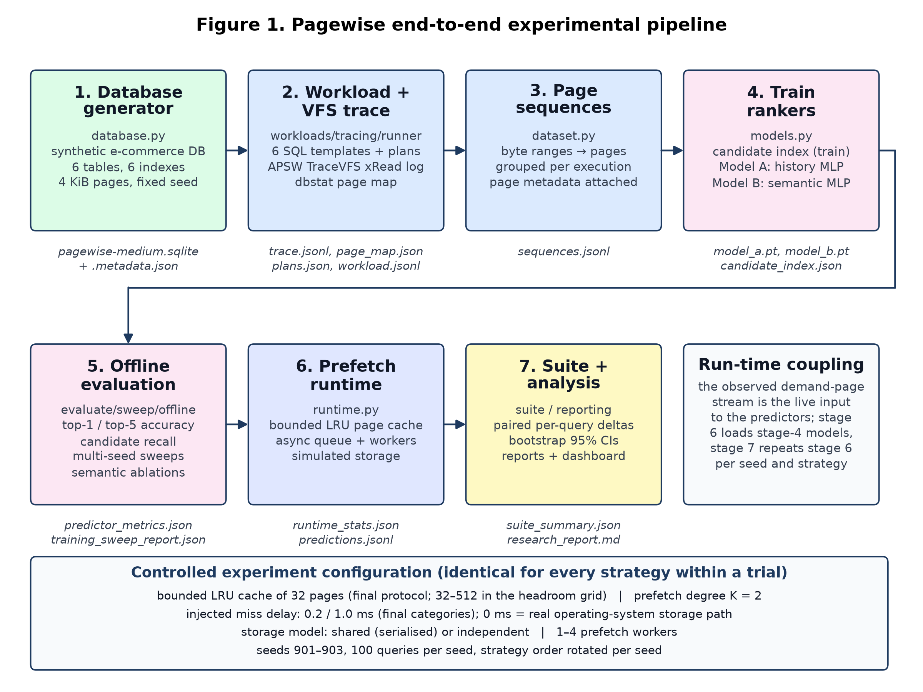
Figure 1. Pagewise end-to-end experimental pipeline. Colours distinguish data generation (green), tracing (blue), learning (pink), runtime (indigo) and analysis (yellow). The strip at the bottom lists the experiment controls held identical across strategies within a trial.
Table 2. Pipeline stages, responsible modules, inputs, outputs and the key design decision of each stage
Stage | Module(s) | Input → Output | Key design decision
1. Database generator | database.py | size parameters, seed → pagewise-medium.sqlite + .metadata.json | Deterministic synthetic e-commerce schema (6 tables, 6 secondary indexes, 4 KiB pages) with Pareto-skewed customer activity so that the working set is non-uniform.
2. Workload + VFS trace | workloads.py, tracing.py, metadata.py, runner.py | database → trace.jsonl, page_map.json, plans.json, workload.jsonl | An APSW custom VFS intercepts every xRead on the main database file and tags it with the executing query’s context; dbstat supplies the page → object/type/depth map; memory-mapped I/O is disabled so reads reach the VFS.
3. Page sequences | dataset.py | trace + page map → sequences.jsonl | Byte ranges are expanded to page numbers and grouped per query execution; events without a query context (schema reads, PRAGMAs) are excluded from supervised examples.
4. Train rankers | models.py | sequences → candidate_index.json, model_a.pt, model_b.pt, training_report.json | Candidate dictionary built from training executions only; Model A and Model B share the candidate set, network shape, seed set and epoch budget, so the only difference is the semantic feature block.
5. Offline evaluation | evaluate.py, sweep.py, offline.py | test split + models → predictor_metrics.json, sweep and ablation reports | Top-1/top-5 accuracy and candidate recall against sequential, Markov-1/2 and oracle references; multi-seed sweeps and semantic ablations (inference-time and retrained).
6. Prefetch runtime | runtime.py, tracing.py | database, models, strategy, cache/delay settings → runtime_stats.json, predictions.jsonl | Bounded LRU cache beneath SQLite’s pager, an asynchronous prediction queue served by a worker pool, and a simulated storage device with a shared (serialised) or independent latency model.
7. Suite + analysis | suite.py, reporting.py, dashboard.py, React UI | repeated runs → suite_summary.json, Markdown reports, pagewise-dashboard.json | Identical workload per seed across strategies with rotated order; paired per-query deltas with bootstrap confidence intervals; reports generated mechanically from artefacts.

4. System architecture
Figure 2 presents the runtime architecture used in stages 6–7. It separates a demand path, executed on the SQLite query thread, from an asynchronous prefetch path, executed by background worker threads, with three shared components: the page predictors, the candidate index and page map, and the simulated storage device that models contention between demand and speculative I/O.
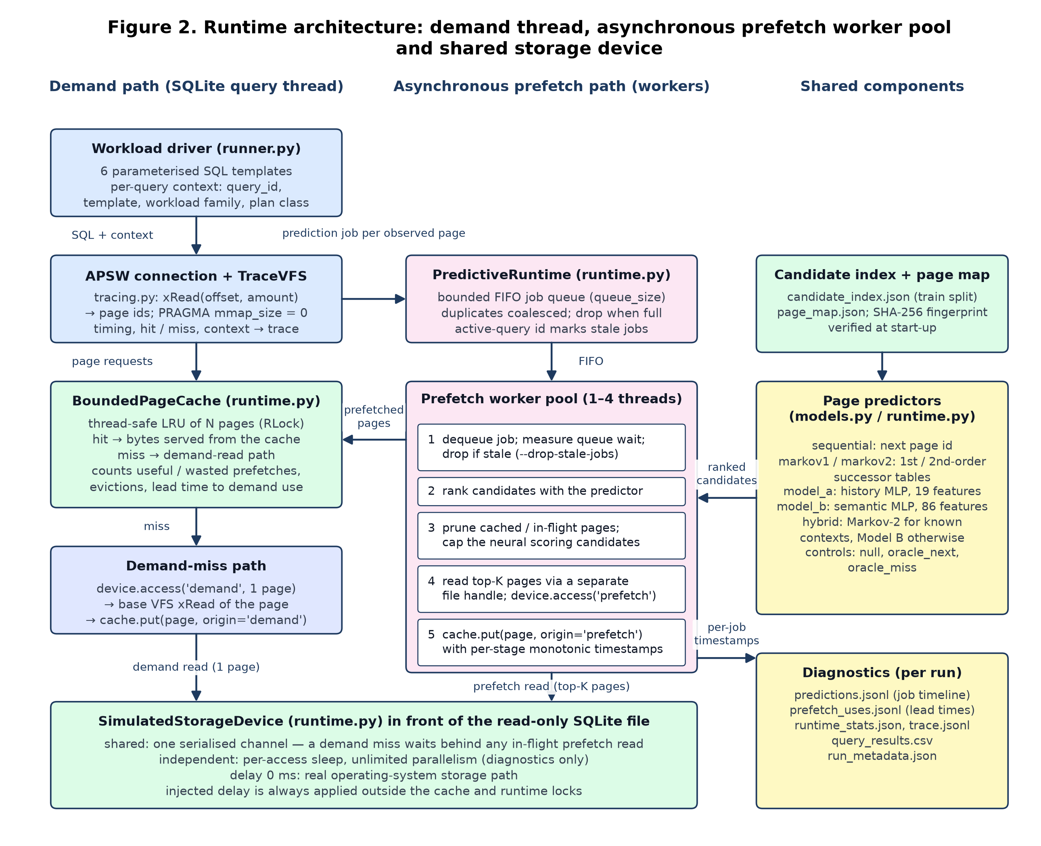
Figure 2. Runtime architecture. The demand path (left) is the SQLite query thread; the prefetch path (centre) is the worker pool; shared components are on the right. Both demand misses and prefetch reads pass through the simulated storage device, which under the shared model serialises them on one channel.

4.1 Demand path
The workload driver (runner.py) opens the database read-only through an APSW connection whose VFS is the project’s TraceVFS [1], [4]. Memory-mapped I/O is disabled (PRAGMA mmap_size=0) and the SQLite page cache is fixed (PRAGMA cache_size), so page requests that miss SQLite’s pager reach TraceVFSFile.xRead. Before each query the driver publishes a context record (query identifier, template, workload family, plan class) through a context variable; every intercepted read is tagged with it. Each read’s byte range is converted to page numbers and looked up in the BoundedPageCache, a thread-safe LRU of N pages. A hit is served from the cache; a miss performs one access on the storage device, reads the page through the base VFS and inserts it with origin='demand'. The cache records hits, misses, evictions, useful and wasted prefetches, and the lead time between a prefetch completing and its first demand use.

4.2 Asynchronous prefetch path
For every observed page (subject to the predict_on and predict_every scheduler settings) the VFS calls PredictiveRuntime.request_prediction() with the last eight page numbers and the live query context. Requests are placed on a bounded FIFO queue; identical keys are coalesced, requests arriving at a full queue are dropped (and counted), and each job carries the identifier of the query that issued it so that a worker can detect — and, with --drop-stale-jobs, skip — jobs whose query has already finished. A pool of 1–4 daemon worker threads dequeues jobs and (i) ranks candidate pages with the configured predictor, (ii) prunes candidates that are already cached or in flight and caps the number scored neurally (max_score_candidates), (iii) reads the top-K remaining pages through a separate ordinary file handle — so prefetch reads never recurse through the tracing VFS — after acquiring the storage device, and (iv) inserts them with origin='prefetch' together with monotonic timestamps for request, dequeue, inference and read completion. Shutdown waits for accepted jobs to drain and records whether every worker exited cleanly; a non-clean shutdown invalidates the run.

4.3 Shared components
- Page predictors (models.py, runtime.py): sequential, markov1, markov2, model_a, model_b, the hybrid gate (Markov-2 when an exact second-order context exists in the training-derived table, Model B only for unseen contexts), and the controls null, oracle_next and oracle_miss. Section 6 defines each.
- Candidate index and page map: the training-only candidate_index.json (first- and second-order successor lists, popular pages, next-page heuristic) and page_map.json. The runtime verifies the SHA-256 fingerprint of the page map against the one stored at training time, so a model can never be run against a database whose page layout differs from the one it was trained on.
- SimulatedStorageDevice: under the shared model a single lock serialises every demand and prefetch access, so a demand miss waits behind any in-flight speculative read — the realistic case for a single storage channel. Under the independent model each access sleeps independently (unlimited parallelism), retained for diagnostics only. With a delay of 0 ms the real operating-system storage path is used. Injected delay is always applied outside the cache and runtime locks (verified by test_benchmark_audit_and_repair.py).
- Diagnostics: predictions.jsonl (per-job timeline), prefetch_uses.jsonl (lead-time events), runtime_stats.json, trace.jsonl, query_results.csv and run_metadata.json are written per run directory.

4.4 Key design decisions
Table 3 records the architectural decisions that shape the runtime, the reason for each and the evidence or decision record (DECISIONS.md, D1–D12) that supports it.
Table 3. Architectural decisions, rationale and supporting evidence
Decision | Rationale | Evidence / where recorded
Custom bounded cache beneath SQLite’s pager rather than patching SQLite | Keeps the experiment reproducible from Python, allows an identical cache for every strategy, and exposes hit/miss accounting per page origin. | BoundedPageCache in runtime.py; README boundaries
Asynchronous prediction queue + worker pool instead of inline prediction | Prediction and prefetch I/O must not block the demand thread; a pool lets a parallel device actually serve concurrent reads while a shared device remains serialised by its lock. | Decision D8 (DECISIONS.md); --prefetch-workers
Separate file handle for prefetch reads | Prevents prefetch reads from recursing through the tracing VFS and contaminating the demand trace. | PredictiveRuntime._run_worker
Shared storage model as the v2 primary | Independent per-access sleeping modelled infinite bandwidth and hid the cost of wasted prefetches; a serialised channel charges demand misses for speculative I/O. | Benchmark audit; protocol v2 (FINAL_EVALUATION_PROTOCOL_V2.md)
Stale-job detection via the active query identifier | 71–74% of queued jobs were executing for queries that had already finished; dropping them cut queue wait by 52.7% and neural inference overhead by 76.6%. | IMPLEMENTATION_STATUS.md; set_active_query, --drop-stale-jobs
Candidate pruning and a neural scoring cap (12 candidates) | Avoids scoring pages that are already cached or in flight and bounds per-job inference cost (Model A −34%, Model B −22% inference time at medium scale). | max_score_candidates; IMPLEMENTATION_STATUS.md
Page-map SHA-256 fingerprint check | A model trained on one page layout is meaningless on another; the runtime refuses to start on a mismatch. | CandidateIndex.page_map_sha256; PredictiveRuntime.__init__
Consistent prefetch-rate denominators | Useful % + wasted % must equal 100% of prefetched pages so that efficiency figures are comparable across strategies. | BoundedPageCache.snapshot(); audit milestone
No spin-waits in the threaded runtime | Spin-waits hold the Python GIL and starve the worker thread; delay accuracy is instead reported as the measured sleep error. | Decisions D5, D6

5. Module workflows
The backend package backend/pagewise/ is organised into four functional modules — tracing, learning, runtime and evaluation. Figure 3 shows the workflow of each; the sub-sections below give the details that the diagram abbreviates, and Table 4 maps modules to source files and tests.
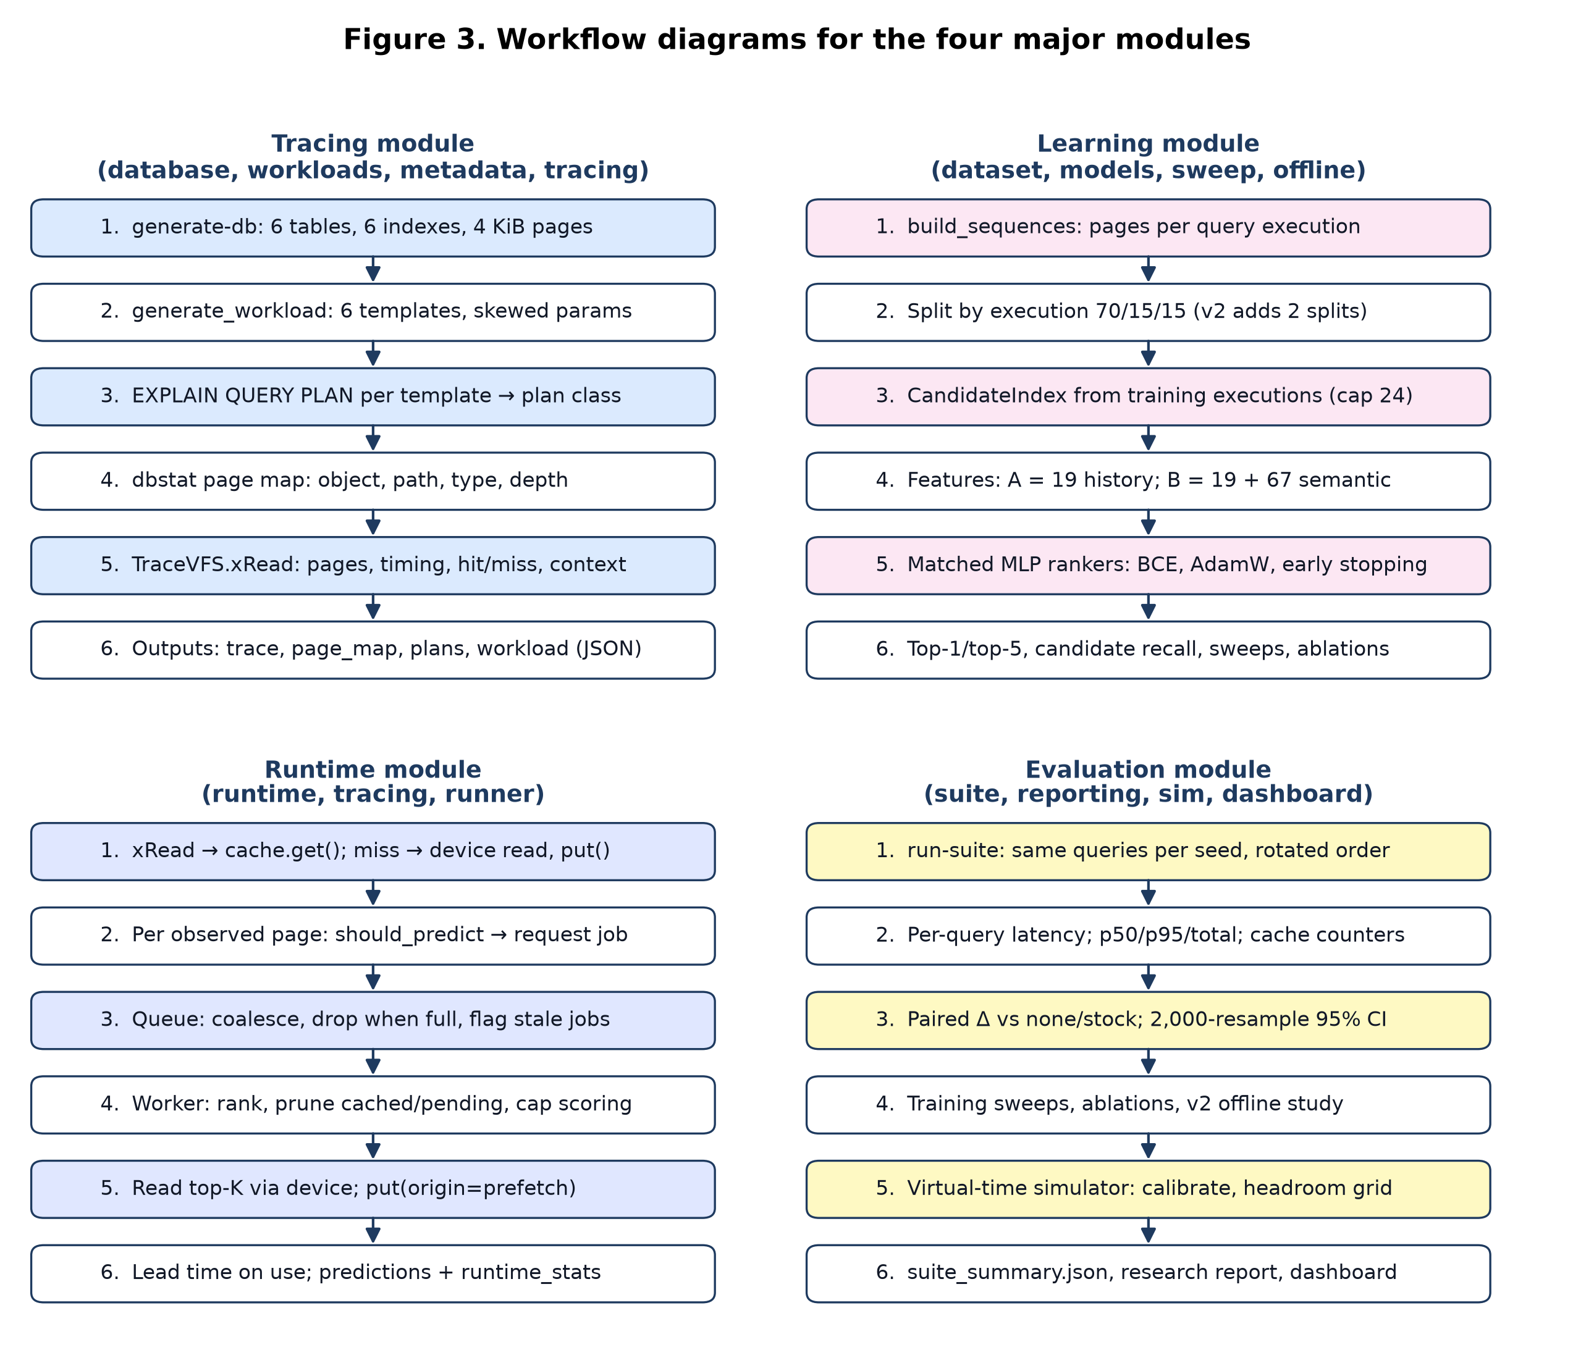
Figure 3. Workflow diagrams for the four major modules (tracing, learning, runtime and evaluation). Each panel lists the ordered steps executed by the module and names the artefacts it produces.

5.1 Tracing module
generate-db builds the database deterministically from a seed (tables customers, categories, products, orders, order_items, account_edges; six secondary indexes; ANALYZE statistics). generate_workload draws query cases from six parameterised SQL templates with fixed weights and Pareto-skewed customer identifiers, so a hot subset of customers dominates. Query plans are obtained once per template with EXPLAIN QUERY PLAN on a separate connection, so plan exploration cannot contaminate the trace, and are classified into search_index, search_other, scan, join or recursive. The page map is read from the dbstat virtual table [2] (stdlib SQLite first, APSW’s SQLite as a fallback) and records, for each page, the owning object, B-tree path, page type (interior/leaf/overflow) and depth. TraceVFS then executes the workload and writes one JSON line per intercepted xRead with offset, length, derived page range, duration, cache status and the query context.

5.2 Learning module
build_sequences converts the trace into one record per query execution holding the ordered list of pages that reached the VFS and their metadata. Executions — never individual reads — are split 70/15/15 into training, validation and test sets; the v2 study adds a parameter-bucket split (whole hashed parameter buckets held out) and a held-out-template split. The CandidateIndex is built from training executions only and, for a given history, proposes first-order successors of the last page, second-order successors of the last pair, the numerically next page and globally popular pages, capped at 24 candidates in the frozen models (32 by default). Each (history, candidate) pair is vectorised: Model A uses 19 history features; Model B appends 67 semantic features (Table 5). Both are scored by an identical multilayer perceptron trained as a binary ranker with one positive and up to 16 sampled negatives per step, binary cross-entropy loss, AdamW and early stopping on validation loss. Evaluation reports top-1 and top-5 accuracy and candidate recall per policy, multi-seed sweeps with bootstrap intervals, and semantic ablations that either zero a feature group at inference time or retrain without it.

5.3 Runtime module
The runtime module realises the architecture of Section 4: BoundedPageCache, SimulatedStorageDevice and PredictiveRuntime in runtime.py, the xRead interception in tracing.py and the per-query driver loop in runner.py. run-prefetch executes one strategy for one seed; it writes per-query latencies, runtime counters (prediction requests, queued/completed/dropped/coalesced/stale jobs, pruned candidates, inference and queue-wait time, prefetch read time, device wait time), cache statistics and the diagnostics files listed in Section 4.3. The oracle_miss control requires a demand reference — a prior none run of the same workload and cache size that records, per query, the ordered demand pages and which of them missed — and prefetches the next K pages that would otherwise miss.

5.4 Evaluation module
run-suite executes every strategy on the identical generated query parameters for each seed, rotating the strategy order per seed to reduce order bias, and summarises run-level p50/p95/total latency together with paired per-query latency differences versus none and stock. Confidence intervals come from a 2,000-resample bootstrap over matched queries (10,000 resamples in the v2 offline study) [12]; a strategy counts as a win only if its 95% interval excludes zero in its favour, with Holm correction [13] across the H3/H4 comparison families in v2. train-sweep and offline-study cover the offline side; sim.py provides a virtual-time discrete-event simulator that replays a demand reference without threads or sleeping to calibrate costs and compute the oracle_miss headroom grid; report, research-report and dashboard-export render Markdown tables, the consolidated research report and the JSON snapshot consumed by the React dashboard.
Table 4. Module-to-source mapping and automated test coverage
Module | Source files (backend/pagewise/) | Automated tests (backend/tests/)
Tracing | database.py, workloads.py, metadata.py, tracing.py, runner.py | test_database_and_workloads.py (3), test_metadata_fallback.py (1), test_vfs_integration.py (2, APSW-gated)
Learning | dataset.py, models.py, sweep.py, offline.py, evaluate.py | test_dataset_and_model.py (6), test_offline_study.py (7)
Runtime | runtime.py, tracing.py, runner.py | test_runtime_cache.py (7), test_benchmark_audit_and_repair.py (5), test_controls_null_oracle.py (13), test_oracle_miss_integration.py (1)
Evaluation | suite.py, reporting.py, sim.py, dashboard.py, cli.py | test_suite_summary.py (4), test_reporting.py (4), test_simulator.py (8)
Numbers in parentheses are test functions per file (61 in total). The VFS integration tests are skipped when APSW is unavailable and must pass on the measurement machine.

6. Predictors, feature schema and baselines

6.1 Feature schema
Table 5. Feature schema of the two matched MLP rankers (per history–candidate pair)
Feature group | Dimensions | Model A | Model B | Description
History pages | 8 | ✓ | ✓ | Last eight page numbers, normalised by the maximum page
History deltas | 8 | ✓ | ✓ | Successive page differences, clipped to [−1, 1]
Candidate position | 3 | ✓ | ✓ | Normalised candidate page, delta from the last page, same-as-last flag
Candidate page type | 5 | — | ✓ | One-hot: unknown / leaf / interior / internal / overflow (from dbstat)
Candidate B-tree depth | 1 | — | ✓ | Depth of the page in its B-tree, scaled by 1/32
Candidate object identity | 32 | — | ✓ | Hashed one-hot of the owning table or index name
Query-plan class | 6 | — | ✓ | One-hot plan class from EXPLAIN QUERY PLAN
Query template | 16 | — | ✓ | Hashed one-hot of the template identifier
Workload family | 6 | — | ✓ | One-hot: point lookup, indexed join, range scan, recursive traversal, indexed lookup
Position in query | 1 | — | ✓ | Number of page requests observed so far in the query, capped at 512 and normalised
Total input dimension |  | 19 | 86

The semantic block is grouped for ablation: page_metadata = page type + depth + object; query_context = plan + template + workload family + position. Each group can be zeroed at inference time or excluded during retraining.

6.2 Network and training configuration
Both models use the same scorer: Linear(input, H) → ReLU → Dropout(0.15) → Linear(H, H/2) → ReLU → Dropout(0.10) → Linear(H/2, 1), trained with BCEWithLogitsLoss, AdamW (learning rate 10⁻³, weight decay 10⁻⁴), batch size 512 and early stopping with patience 4 on validation loss. The frozen medium-scale models use H = 64, 12 epochs, 24 candidates and training seed 7 (run_medium_experiment.ps1); the multi-seed ablation sweep used seeds 7, 13 and 31 on a fixed split (seed 42) with 8 epochs. Model A and Model B always receive the same seed set, epochs, hidden size and candidate cap (Decision D12) [11].

6.3 Strategies and controls
Table 6. Runtime strategies and controls (all rows are always reported; none is removed for performing badly)
Strategy | Type | Definition
stock | reference | Unmodified SQLite with no custom cache; a practical reference, not a same-cache comparison.
none | baseline | Custom bounded cache with no prefetching — the primary baseline for paired comparisons.
sequential | heuristic | Prefetch the numerically next page after the last demanded page.
markov1 | statistical | First-order successor table built from training executions.
markov2 | statistical | Second-order successor table keyed by the last two pages; falls back to first order.
model_a | neural | History-only MLP ranker over the candidate set (19 features).
model_b | neural | Semantic MLP ranker over the candidate set (86 features).
hybrid | gated | Exact training-derived Markov-2 transition when present, otherwise Model B scoring.
null | control | Pays the scheduling cost of a prediction job but prefetches nothing (overhead control).
oracle_next | control | Original trace-next oracle; targets pages that are often already cached, so it under-states headroom.
oracle_miss | upper bound | Prefetches the next K pages that would miss under none (from a demand reference); the v2 headroom bound.
markov_ctx, model_b_table | v2 offline | Context-keyed tables (page + template + plan class + depth) with no neural network; isolate the value of the semantic key.

7. Experimental design

7.1 Database and workload
The frozen experiment database (runs/experiment-latest/pagewise-medium.sqlite) was generated with 2,000 customers, 500 products, 15,000 orders (about three items each), 2,000 graph nodes with three edges each and seed 42, giving 800 pages of 4 KiB (3.2 MB). The traced workload comprised 300 query executions (seed 1234) drawn from the six templates in Table 7 with a 128 KiB SQLite page cache during tracing; the runtime suites use a 4,096 KiB SQLite cache above the 32-page custom cache.
Table 7. Workload templates, families, sampling weights and parameter skew
Template | Family | Weight | Shape of the query | Parameters
customer_orders | point_lookup | 0.28 | Orders of one customer, newest first, LIMIT | customer (70% Pareto-skewed), limit 5–30
order_items_join | indexed_join | 0.24 | orders ⋈ order_items ⋈ products for one customer | customer (skewed), limit 10–50
product_sales | indexed_join | 0.16 | products ⋈ order_items for one product | product, limit 10–100
created_range | range_scan | 0.14 | Orders in a time window ordered by created_at | window 600–14,400 s, limit 20–200
graph_walk | recursive_traversal | 0.10 | Recursive CTE walk over account_edges | start node, depth 2–5, limit 30–200
customer_profile | indexed_lookup | 0.08 | customers LEFT JOIN orders, grouped count | customer (skewed)

7.2 Pre-registered final protocol (v1) and its v2 revision
Table 8 lists the settings that were frozen in FINAL_EVALUATION_PROTOCOL.md and experiment_protocol_v1.json before the final v1 runs, together with the changes introduced by the pre-registered v2 protocol.
Table 8. Fixed settings of the final evaluation protocol v1 (frozen before the runs) and the main v2 changes
Parameter | Protocol v1 (results in Section 8.3) | Protocol v2 (final run pending)
Strategies | stock, none, sequential, markov1, markov2, model_a, model_b, hybrid | v1 set + null, oracle_next, oracle_miss, markov_ctx, model_b_table, model_b_gated
Seeds / queries | 901, 902, 903; 100 queries per seed and strategy | fresh seeds 911–915 after code and configuration freeze; tuning only on 101–110
Custom cache / degree / queue | 32 pages / K = 2 / queue 32 | cache chosen from the headroom grid (≤ working set / 4)
Scheduler | predict on miss, every observation, neural cap 12 | unchanged plus stale-job dropping
Storage model | independent per-miss delay (0.2 ms, 1.0 ms, 0 ms) | shared serialised device is primary; measured sleep error reported
Primary endpoint | paired mean per-query latency vs none | total workload time under the shared model; p50/p95, accuracy, useful-prefetch % secondary
Statistics | 2,000-resample paired query bootstrap; CI crossing zero = inconclusive | 10,000 resamples; Holm correction within H3/H4 families; mechanical claim mapping
Headroom rule | — | if oracle_miss headroom < 10% everywhere → large-database branch (≥ 2 GB) or NO_HEADROOM

7.3 Metrics and statistical treatment
- Offline: top-1 and top-5 next-page accuracy over all prediction points of held-out executions; candidate recall (share of targets that the candidate generator could propose at all), which bounds MLP accuracy.
- Runtime: per-query wall-clock latency, run-level p50/p95 and total; cache hit %, useful and wasted prefetched pages, inference and queue-wait time, dropped/stale jobs, prefetch lead time, device wait time.
- Pairing: the same seed produces identical query parameters for every strategy, so differences are computed per matched (seed, query) pair; a negative delta favours the candidate strategy.
- Uncertainty: percentile bootstrap intervals over matched queries; the seed is the independent replication unit and intervals are read as effect-size estimates rather than as proof of generalisation.
- Labelling: every table states whether a run is latency-injected or real-storage-no-injected-delay, and injected delays are reported with their measured sleep overshoot (0.2 ms requested ≈ 0.56 ms achieved; 1.0 ms ≈ 1.54 ms).

8. Results to date
All numbers in this section are read from the measured artefacts exported to public/pagewise-dashboard.json (source directory backend/runs/experiment-latest/). They are preliminary with respect to the v2 protocol: the runtime results pre-date the audit repairs (single prefetch worker, independent delay model, no stale-job dropping) and will be re-run under protocol v2.

8.1 Offline next-page prediction accuracy
Figure 4 and Table 9 report accuracy on the held-out split of the frozen trace (45 test executions, 919 next-page prediction points). Semantic features improve the neural ranker substantially — Model B reaches 28.1% top-1 against 17.2% for the otherwise identical Model A — but the second-order Markov table is the most accurate predictor at 53.1% top-1, and the first-order table has the best top-5 accuracy (73.6%). Both MLPs are bounded by the candidate generator’s recall of 82.5%.
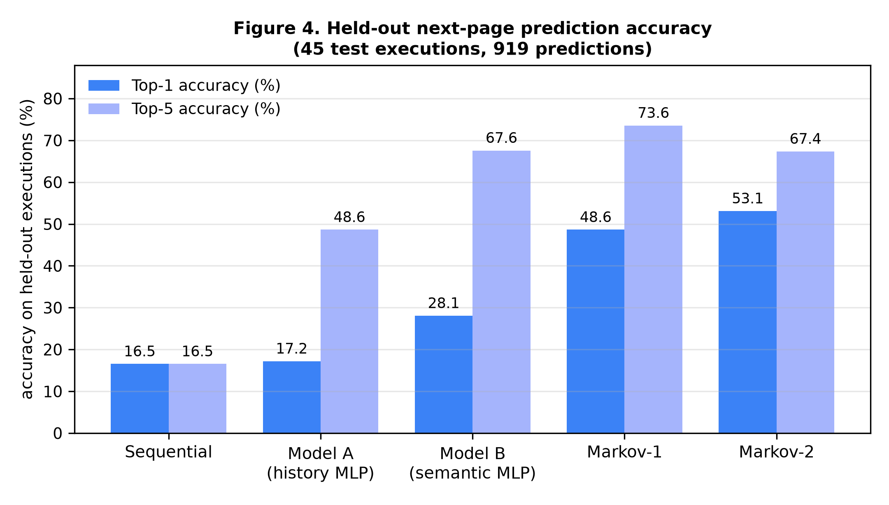
Figure 4. Held-out next-page prediction accuracy on the frozen trace (45 test executions, 919 predictions). Top-1 (dark) and top-5 (light) accuracy per policy; the oracle reference (100%) is omitted.
Table 9. Held-out prediction accuracy per policy (single split, seed 7; 919 predictions)
Policy | Top-1 (%) | Top-5 (%) | Candidate recall (%) | Note
oracle | 100.00 | 100.00 | n/a | perfect-future reference, not deployable
markov2 | 53.10 | 67.36 | n/a | second-order successor table
markov1 | 48.64 | 73.56 | n/a | first-order successor table
model_b | 28.07 | 67.57 | 82.48 | semantic MLP
model_b_retrained_no_query_context | 25.35 | 62.68 | 82.48 | retrained without plan/template/family/position
model_b_retrained_no_object | 21.55 | 55.06 | 82.48 | retrained without object identity
model_b_retrained_no_page_metadata | 19.37 | 55.06 | 82.48 | retrained without page type/depth/object
model_a | 17.19 | 48.64 | 82.48 | history-only MLP
sequential | 16.54 | 16.54 | n/a | next page heuristic
model_b_ablate_no_query_context | 14.15 | 42.22 | 82.48 | query-context block zeroed at inference
model_b_ablate_no_page_metadata | 5.55 | 18.06 | 82.48 | page-metadata block zeroed at inference

8.2 Seed sensitivity and semantic ablation
Table 10 repeats training with three model seeds (7, 13, 31) on a fixed split (seed 42, 8 epochs). The Model B advantage over Model A is stable across seeds (31.0% vs 21.8% mean top-1, non-overlapping intervals). Removing page metadata — above all object identity — costs the most accuracy, whereas removing query context costs comparatively little; this ordering holds for both inference-time zeroing and retraining. The v2 ablation on the parameter-bucket split (Section 8.5) reached the same conclusion: object identity alone accounts for 30.7 of the 33.5 top-1 points that the full semantic block adds, and removing page metadata costs 10.15 points.
Table 10. Multi-seed training sweep: mean top-1 / top-5 accuracy with bootstrap 95% CI over seeds 7, 13, 31
Policy | Top-1 mean (%) | Top-1 95% CI (%) | Top-5 mean (%)
markov2 | 63.40 | [63.40, 63.40] | 75.71
markov1 | 58.27 | [58.27, 58.27] | 79.59
model_b | 30.98 | [29.53, 33.41] | 68.07
model_b_retrained_no_query_context | 24.52 | [23.49, 25.43] | 61.61
model_b_retrained_no_object | 23.38 | [21.09, 25.09] | 57.39
model_a | 21.78 | [18.24, 24.86] | 48.69
model_b_retrained_no_page_metadata | 17.52 | [16.31, 19.16] | 47.78
sequential | 15.73 | [15.73, 15.73] | 15.73
model_b_ablate_no_object | 14.67 | [11.74, 16.76] | 33.64
model_b_ablate_no_query_context | 14.14 | [13.46, 14.94] | 37.67
model_b_ablate_no_page_metadata | 3.34 | [2.17, 4.22] | 22.73
Markov tables and the sequential heuristic are deterministic for a fixed split, so their intervals collapse to a point.

8.3 Runtime latency under the pre-registered protocol v1
Table 11 and Figure 5 summarise the three final categories (seeds 901–903, 100 queries per seed and strategy, 32-page custom cache, degree 2). Category A injects a per-miss delay and is latency-injected evidence only; Category B uses the real storage path on a database that fits in the Windows operating-system cache, so its VFS reads are sub-millisecond.
Table 11. Final evaluation suites (protocol v1): paired per-query latency delta versus none, bootstrap 95% CI and predictor time per run, for the three categories
 | 0.2 ms injected miss delay (≈ 0.56 ms achieved) |  |  | 1.0 ms injected miss delay (≈ 1.54 ms achieved) |  |  | Real storage, no injected delay
Strategy | Δ (ms) | 95% CI (ms) | Infer. (ms) | Δ (ms) | 95% CI (ms) | Infer. (ms) | Δ (ms) | 95% CI (ms) | Infer. (ms)
stock | +2.60 | [+1.95, +3.24] | — | +6.94 | [+6.08, +7.84] | — | −0.12 | [−0.15, −0.09] | —
none | 0.00 | baseline | 0 | 0.00 | baseline | 0 | 0.00 | baseline | 0
sequential | −3.81 | [−4.52, −3.13] | 3 | +0.96 | [+0.21, +1.75] | 5 | +0.62 | [+0.57, +0.68] | 0
markov1 | −2.60 | [−3.30, −1.93] | 8 | +1.21 | [+0.33, +2.13] | 12 | +0.67 | [+0.61, +0.74] | 1
markov2 | −4.18 | [−4.94, −3.51] | 10 | +0.52 | [−0.31, +1.40] | 16 | +0.60 | [+0.55, +0.65] | 1
model_a | −1.37 | [−2.08, −0.71] | 434 | +1.57 | [+0.74, +2.45] | 706 | +0.72 | [+0.65, +0.78] | 78
model_b | +0.20 | [−0.50, +0.92] | 585 | +3.00 | [+2.01, +4.00] | 860 | +0.75 | [+0.69, +0.82] | 89
hybrid | −0.32 | [−0.95, +0.33] | 280 | +0.78 | [−0.04, +1.61] | 341 | +0.72 | [+0.65, +0.79] | 28
Δ: paired mean per-query latency difference versus none (negative = faster) over 300 matched queries (seeds 901–903 × 100 queries); bold = the 2,000-resample bootstrap 95% CI excludes zero. Infer.: mean total predictor time per run. Median per-query p50 latency of none was 12.41 ms, 21.41 ms and 0.52 ms in the three categories; Category A rows are latency-injected evidence only. Full per-run p50/p95/total latency, cache statistics and useful/wasted prefetch counts are in suite_summary.json and the dashboard snapshot.
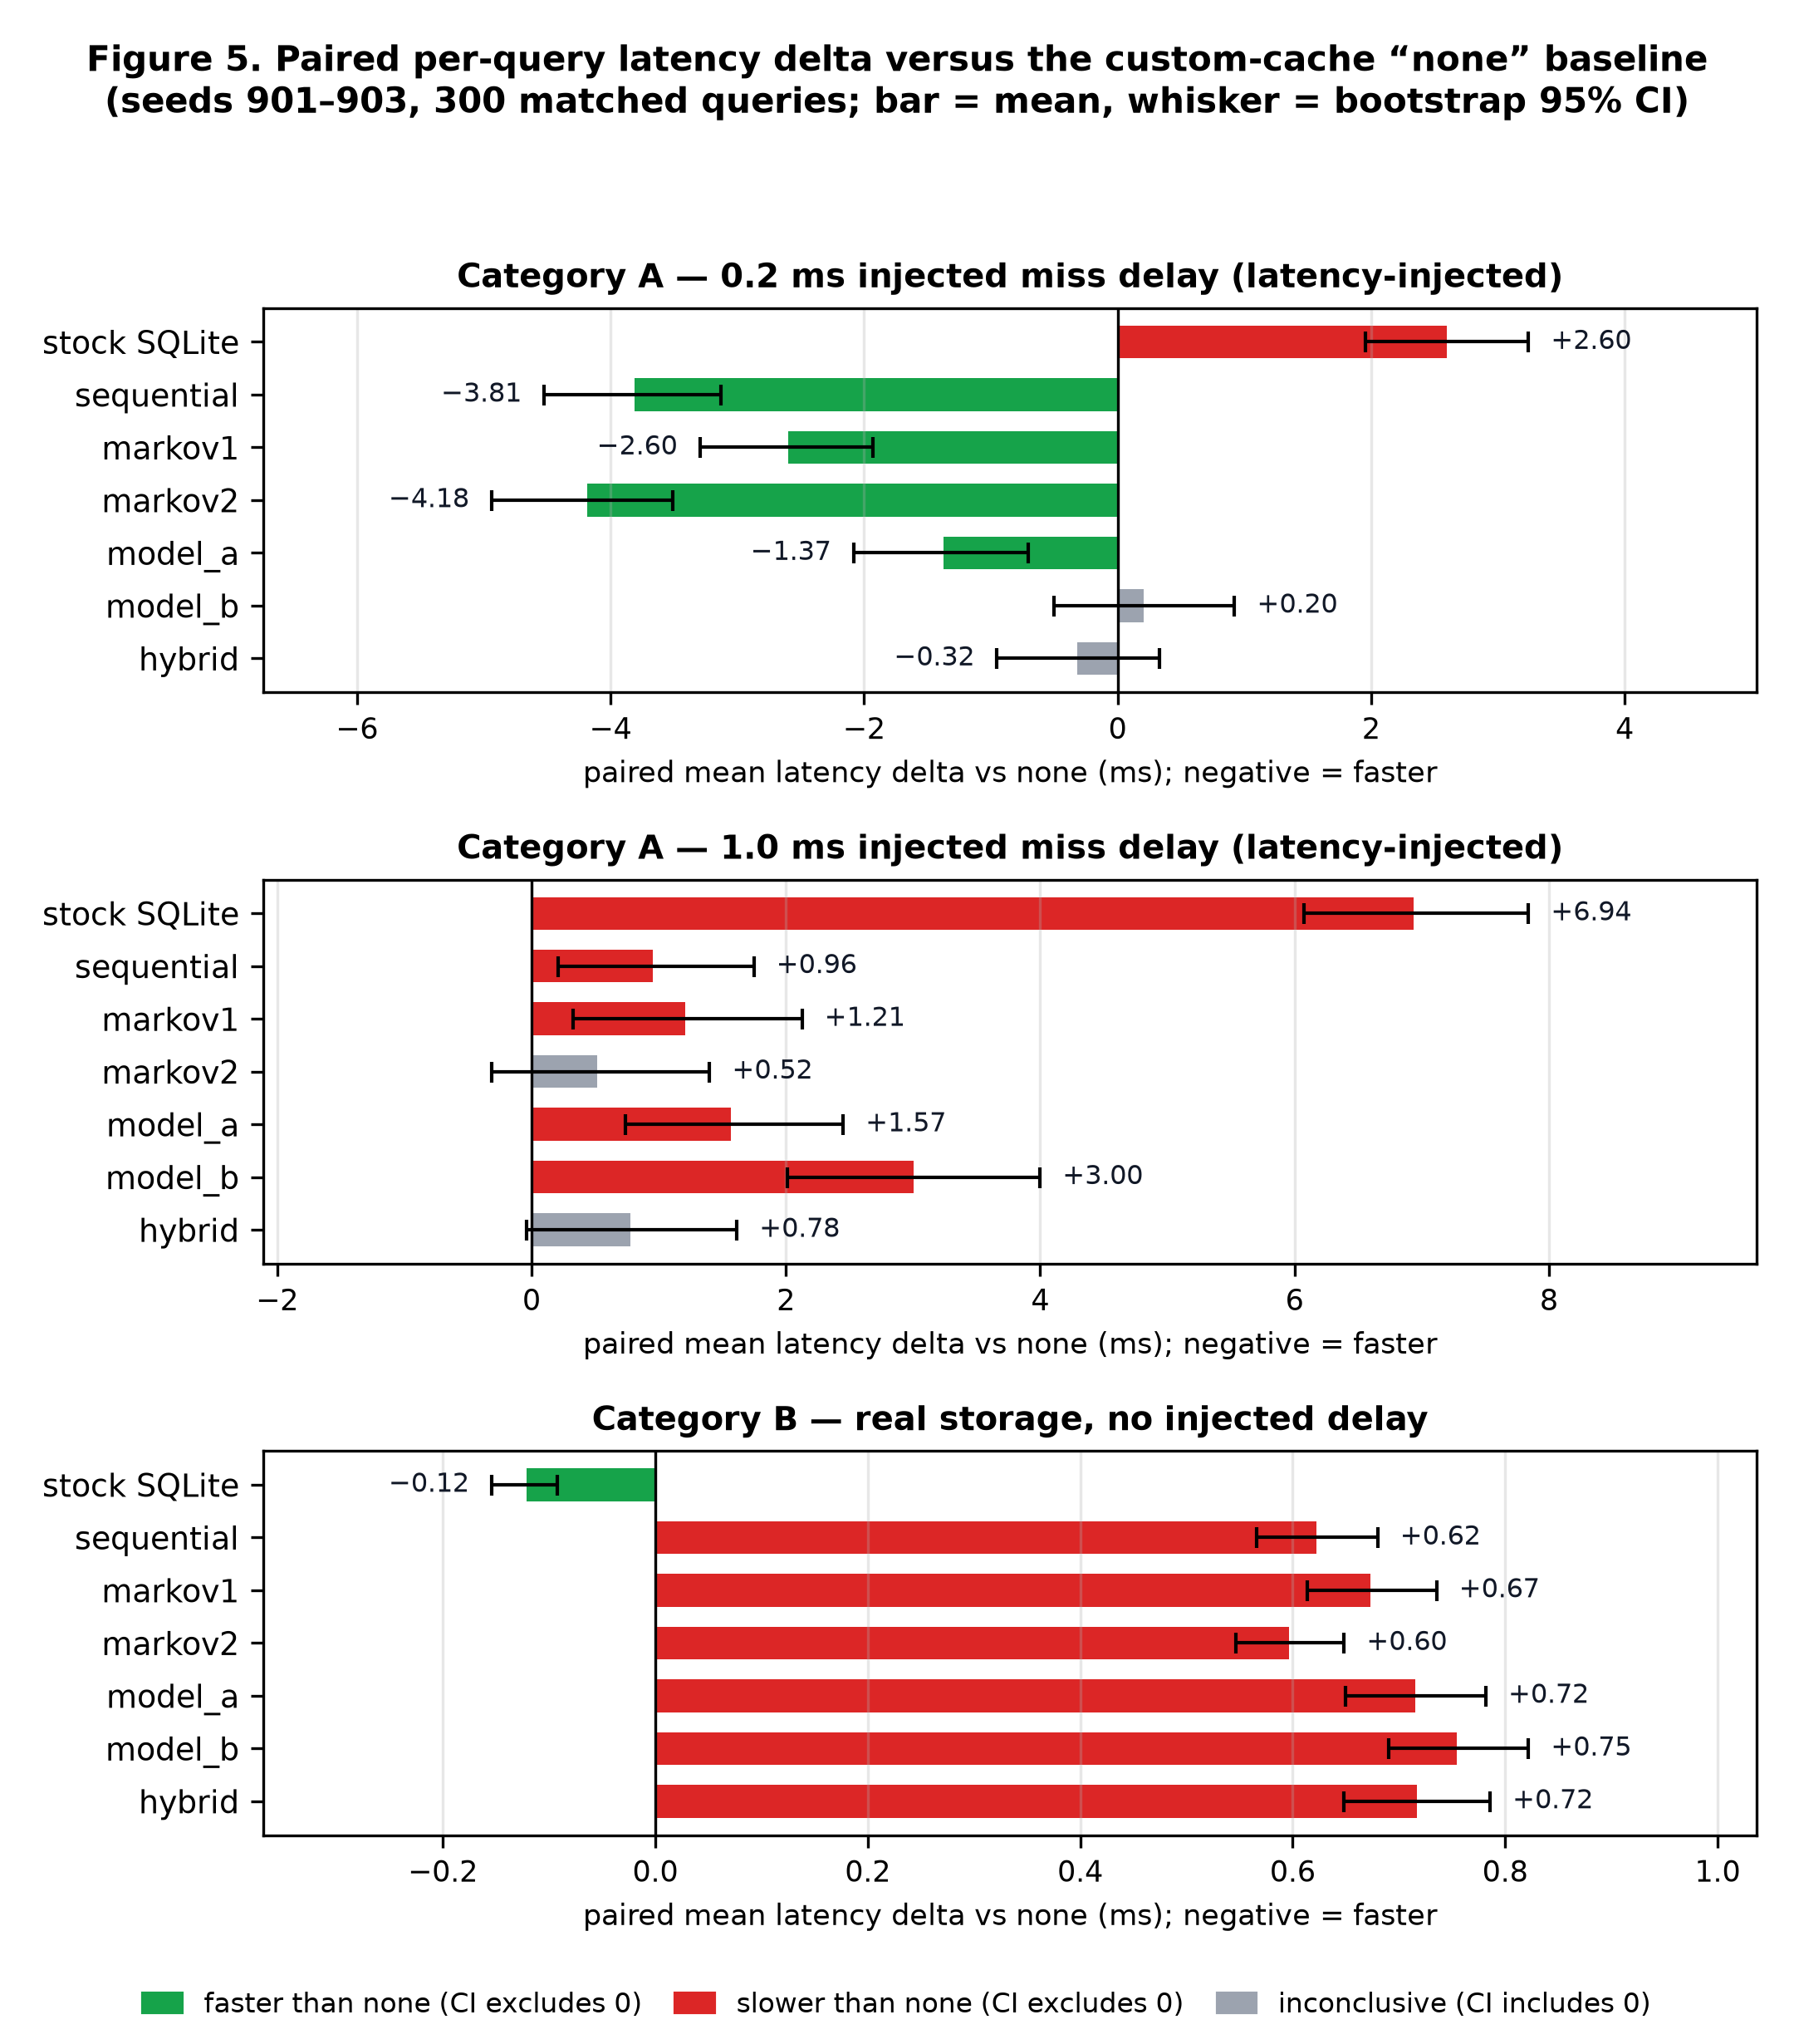
Figure 5. Paired per-query latency delta versus the custom-cache none baseline for the three final categories (bar = mean, whisker = bootstrap 95% CI; green/red = interval excludes zero, grey = inconclusive).
Observations.
- At 0.2 ms per miss, Markov-2 gives the best paired improvement (−4.18 ms per query, 85.7% of queries faster), followed by sequential (−3.81 ms) and Markov-1 (−2.60 ms); all three intervals exclude zero. Model A is also significant (−1.37 ms), whereas Model B (+0.20 ms) and hybrid (−0.32 ms) are inconclusive.
- The neural strategies prefetch about as usefully as Markov-2 (105 vs 108 useful pages per run) and waste fewer pages, but spend 585 ms (Model B) and 434 ms (Model A) per run in inference against 10 ms for Markov-2, and complete only about half as many jobs — inference cost, not accuracy, is the binding constraint.
- At 1.0 ms per miss no strategy significantly beats none; Markov-2 is closest (+0.52 ms, interval includes zero). The larger delay amplifies both the benefit of a correct prefetch and the cost of serialising behind speculative reads at this cache and queue configuration.
- On real storage every prefetching strategy is slower than none (all intervals positive, +0.60 to +0.75 ms), and the custom-cache none is itself slower than stock SQLite (−0.12 ms): with a 3.2 MB database resident in RAM there is no I/O latency to hide, so any scheduling work is pure overhead.
- The hybrid gate cuts Model B’s inference time by half or more in every category; in the earlier three-seed development validation (200 queries per seed) it reduced Model B inference from 979.9 ms to 403.1 ms per run and achieved a −3.19 ms paired delta versus none (Markov-2: −3.42 ms). That suite was a tuning artefact and is not pooled with the final results.

8.4 Benchmark audit and repairs
Before protocol v2 was frozen, the runtime measurement harness was audited. The audit found and repaired three defects and verified one invariant, each with a regression test in test_benchmark_audit_and_repair.py:
- Queue staleness. Timestamped diagnostics showed that 71–74% of queued prediction jobs executed for queries that had already finished. Active-query synchronisation and --drop-stale-jobs cut queue wait by 52.7% and neural inference overhead by 76.6%.
- Storage-channel contention. Independent time.sleep delays modelled infinite storage bandwidth, hiding the cost of wasted prefetches. SimulatedStorageDevice with --storage-model shared serialises access and charges demand misses for in-flight speculative I/O.
- Lock boundaries. It was verified that injected delay is executed strictly outside BoundedPageCache._lock and the runtime locks on both the demand and prefetch paths.
- Consistent denominators. Useful-prefetch % and total-wasted-prefetch % now share the same denominator (the number of pages prefetched), so they sum to 100%.
In addition, the original oracle was found to target pages that were often already cached, under-stating the attainable headroom by roughly an order of magnitude (Decision D7). The replacement oracle_miss, combined with a prefetch worker pool, achieves −11.2 / −17.3 / −28.5 / −65.7 ms per query versus none at 0.5 / 1.0 / 2.0 / 5.0 ms delay under the independent model (cache 32, K = 4, four workers, 70–75% useful prefetches). Under the shared model the oracle still loses (+4.6 to +10.5 ms per query), which is recorded as genuine device saturation rather than a harness bug (Decision D9) and feeds the headroom decision of milestone M4.

8.5 Offline study under protocol v2 (milestone M2)
The v2 offline study re-evaluated prediction on the frozen 300-execution trace with five model seeds, 12 epochs, a parameter-bucket split and a held-out-template split, and added the two context-keyed table controls. Table 12 gives the mean top-1 accuracy on the parameter split.
Table 12. v2 offline study — mean top-1 accuracy on the held-out-parameter split (5 model seeds, 12 epochs)
Policy | Top-1 (%) | Policy | Top-1 (%)
markov1 | 56.78 | model_a | 22.15
markov2 | 59.93 | model_b | 34.66
markov_ctx (context-keyed table) | 58.78 | model_b_table (Model B top-k per context key) | 31.84

- H1 — supported. Model B − Model A = +12.52 top-1 points, 95% CI [11.10, 13.96].
- H2 — not supported. Model B − markov_ctx = −24.12 [−28.01, −20.20]; Model B − markov2 = −25.26 [−29.25, −21.30].
- H5 (offline part) — inconclusive. On held-out templates Model B − Model A = +0.13 [−0.13, +0.41]; both models are near chance and the context table has 0% coverage, so it falls back to Markov-1.
- The mechanical claim mapping therefore currently selects: “Semantic context helps, but a cheap context-keyed table captures it, so a neural network is not required.” The final sentence is produced by the report generator after milestone M7, not written by hand.

8.6 Interpretation and threats to validity
Taken together, the evidence supports a precise and modest claim: semantic page metadata — object identity in particular — carries real predictive signal for SQLite page sequences, but on this workload the signal is captured at least as well by a second-order or context-keyed transition table whose cost is negligible, and the neural ranker’s inference cost cancels its benefit at sub-millisecond storage latencies. The main threats to validity are:
- Trace completeness. VFS reads under-represent logical page references and do not prove physical I/O; results describe the VFS layer of a specific configuration.
- Synthetic latency. Injected delays are software sleeps with measurable overshoot; they emulate, rather than measure, slow storage.
- Scale. An 800-page database with a 32-page cache is a small working set; headroom may differ on a multi-gigabyte database (addressed by the v2 large-database branch).
- Replication. Three workload seeds per category give coarse run-level uncertainty; the per-query bootstrap quantifies effect size, not generalisation.
- Implementation language. A Python runtime inflates scheduling and inference costs relative to an engine-native implementation; the virtual-time simulator will separate algorithmic headroom from harness overhead.
- Candidate ceiling. With 82.5% candidate recall, roughly one target in six cannot be predicted by either MLP regardless of features.

9. Implementation status
Table 13 summarises the status of every milestone of the v2 plan.
Table 13. Milestone status of the v2 plan (from PROGRESS.md, FINAL_SUMMARY.md and the current source tree)
Milestone | Status | Evidence
Pipeline, protocol v1 runs, dashboard | Done | three final suites, research_report.md, pagewise-dashboard.json, React dashboard
Benchmark audit and repairs | Done | stale-job dropping, shared storage device, lock-boundary verification, consistent denominators, lifecycle timestamps
M0 Housekeeping | Done | FROZEN_MANIFEST.json (SHA-256 of 1,338 frozen files, verified by scripts/verify_frozen.py), protocol v2, PROGRESS.md, DECISIONS.md D1–D12
M1 Oracle repair | Done | oracle_miss, oracle_next relabelled as naive control, --prefetch-workers, sanity checks (a)–(c) pass under the independent model
M2 Offline prediction study | Done | offline.py, parameter-bucket and template splits, markov_ctx, model_b_table, 10,000-resample paired bootstrap, H1/H2/H5-offline outcomes, feature ablation and charts
M3 Virtual-time simulator | Implemented; calibration runs pending | sim.py (discrete-event replay, no threads or sleeping), scripts/run_sim_studies.py (calibrate / validate / headroom), 8 unit tests; measured calibration and headroom grid not yet frozen
M4 Headroom decision | Pending | depends on M3 headroom heatmap (≥ 10% rule, large-database branch)
M5 Runtime pipeline repair | Pending (gated on M4) | deep-queue bottleneck, shared-model defaults
M6 Cheaper Model B | Pending (gated on M4) | model_b_table / model_b_gated runtime variants
M7 Tuning and final protocol v2 run | Pending | seeds 911–915 after freeze; Holm-corrected H3/H4
M8 Report and paper | Pending | hypothesis_report.py claim mapping to be implemented
M9 Dashboard and demo | Partially done | React/Vite dashboard loads measured snapshot; v2 rows and demo pending

Verification record. On the measurement machine, check-env reports APSW 3.54.0.0 with SQLite 3.54.0 and dbstat support through APSW, the APSW VFS integration test passes, and the frozen manifest verifies unchanged; the most recent logged run of the test suite passed in full (53 tests at the M2 log; the current tree contains 61 tests). The suite (python -m pytest -q from backend/) and verify-frozen will be re-run and the output attached before Review 3.

10. Plan for the next review
Table 14 lists the work scheduled between this review and Review 3, in dependency order, with the acceptance criterion for each item.
Table 14. Work plan from Review 2 to Review 3
# | Task | Deliverable | Acceptance criterion
1 | Calibrate and validate the virtual-time simulator | runs/calibration.json, validation table | simulated vs real run time within 15% on at least three configurations
2 | Compute the oracle_miss headroom grid | heatmap over cache ∈ {32…512} × delay ∈ {0.1…1.0} ms | primary configuration selected by the pre-registered rule, or large-database branch triggered
3 | Runtime pipeline repair (M5) | shared-model defaults, stale-job dropping, worker pool | null control overhead and queue wait reported; no spin-waits
4 | Cheaper Model B variants (M6) | model_b_table, model_b_gated runtime strategies | inference µs per prediction within an order of magnitude of Markov-2
5 | Final protocol v2 run (M7) | suites on seeds 911–915 under the shared model | all strategies reported; Holm-corrected H3/H4 decisions with raw CIs
6 | Report generator and paper draft (M8) | hypothesis_report.py, consolidated report | headline sentence selected mechanically from H1–H5 outcomes
7 | Dashboard v2 and demonstration (M9) | updated pagewise-dashboard.json, demo script | every dashboard number traceable to a measured artefact

11. Conclusion
Review 2 delivers a complete, reproducible and audited experimental system for studying semantics-aware page prefetching in SQLite: a seven-stage pipeline, a runtime architecture that separates demand and speculative work while modelling their contention, and four well-tested modules exposed through a single command-line interface. The measured evidence so far is consistent and honest — semantic features (chiefly object identity) improve neural next-page prediction markedly over a history-only model, yet inexpensive Markov and context-keyed tables are more accurate still, and at the storage latencies tested the neural predictors' inference cost prevents the accuracy gain from becoming a latency gain. The remaining work is fully specified by the pre-registered v2 protocol: establish the achievable headroom with the virtual-time simulator and the oracle_miss bound, repair the runtime pipeline, evaluate cheaper semantic predictors, and run the final protocol once on fresh seeds so that the final claim is selected mechanically from the hypothesis outcomes.

References
[1] SQLite Consortium, “The SQLite OS Interface or ‘VFS’,” SQLite Documentation. [Online]. Available: https://www.sqlite.org/vfs.html
[2] SQLite Consortium, “The DBSTAT Virtual Table,” SQLite Documentation. [Online]. Available: https://www.sqlite.org/dbstat.html
[3] SQLite Consortium, “Database File Format,” SQLite Documentation. [Online]. Available: https://www.sqlite.org/fileformat2.html
[4] R. Binns, “APSW: Another Python SQLite Wrapper,” Documentation. [Online]. Available: https://rogerbinns.github.io/apsw/
[5] M. Hashemi, K. Swersky, J. A. Smith, G. Ayers, H. Litz, J. Chang, C. Kozyrakis, and P. Ranganathan, “Learning memory access patterns,” in Proc. 35th Int. Conf. Machine Learning (ICML), 2018.
[6] Z. Shi, A. Jain, K. Swersky, M. Hashemi, P. Ranganathan, and C. Lin, “A hierarchical neural model of data prefetching,” in Proc. 26th ACM Int. Conf. Architectural Support for Programming Languages and Operating Systems (ASPLOS), 2021.
[7] L. Peled, S. Mannor, U. Weiser, and Y. Etsion, “Semantic locality and context-based prefetching using reinforcement learning,” in Proc. 42nd Annu. Int. Symp. Computer Architecture (ISCA), 2015.
[8] K. J. Nesbit and J. E. Smith, “Data cache prefetching using a global history buffer,” in Proc. 10th Int. Symp. High-Performance Computer Architecture (HPCA), 2004.
[9] R. H. Patterson, G. A. Gibson, E. Ginting, D. Stodolsky, and J. Zelenka, “Informed prefetching and caching,” in Proc. 15th ACM Symp. Operating Systems Principles (SOSP), 1995.
[10] T. Kraska, A. Beutel, E. H. Chi, J. Dean, and N. Polyzotis, “The case for learned index structures,” in Proc. ACM SIGMOD Int. Conf. Management of Data, 2018.
[11] A. Paszke et al., “PyTorch: An imperative style, high-performance deep learning library,” in Advances in Neural Information Processing Systems 32 (NeurIPS), 2019.
[12] B. Efron and R. J. Tibshirani, An Introduction to the Bootstrap. New York, NY, USA: Chapman & Hall, 1993.
[13] S. Holm, “A simple sequentially rejective multiple test procedure,” Scandinavian Journal of Statistics, vol. 6, no. 2, pp. 65–70, 1979.
[14] A. J. Smith, “Cache memories,” ACM Computing Surveys, vol. 14, no. 3, pp. 473–530, 1982.

Appendix A. Command-line reference
All commands run from backend/ as python -m pagewise.cli <command>.
Table 15. Unified CLI sub-commands and their purpose
Command | Key arguments | Purpose
check-env | — | Report Python, SQLite, APSW, PyTorch and dbstat support
generate-db | --db --customers --products --orders --seed | Generate the reproducible synthetic database
trace | --db --out --queries --seed --cache-kib | Trace VFS xRead requests with query context and page map
build-sequences | --trace --page-map --out | Convert the trace to per-query page sequences
train | --sequences --page-map --out --seed --epochs --candidates --hidden [--semantic-ablations] | Train matched Model A and Model B (plus retrained ablations)
train-sweep | --seeds --split-seed --epochs | Multi-seed training and evaluation on a fixed split
evaluate | --sequences --candidate-index --model-a --model-b --out | Held-out top-1/top-5, candidate recall, baselines, ablations
offline-study / offline-ablation | --split params|templates --seeds --epochs | v2 offline study with context-keyed tables and paired bootstrap
run-prefetch | --db --model-dir --strategy --cache-pages --degree --miss-delay-ms --storage-model | One strategy, one seed, with the bounded cache and async prefetcher
run-suite | --seeds --strategies --queries --drop-stale-jobs --prefetch-workers | Repeated paired multi-strategy benchmark
runtime-sweep | grid of cache/scheduler settings | Sensitivity sweep with ranked report
summarize-suite / recover-suite | --out | Rebuild summaries or recover an interrupted suite
report / research-report | --input / --run-dir --out | Markdown tables and the consolidated research report
dashboard-export | --run-dir --out public/pagewise-dashboard.json | Snapshot for the React dashboard

Appendix B. Pre-submission verification record
In line with the assessment requirement that students verify technical accuracy, grammar and formatting before submission, the following checks were performed while preparing this document.
Table 16. Verification checklist
Check | Method | Result
Template count and weights (Table 7) | workloads.py → TEMPLATES, weights | 6 templates; weights sum to 1.00 ✓ (the stale count of 7 in PROJECT_CONTEXT.md was corrected)
Schema: tables, indexes, page size | database.py → SCHEMA, INDEXES | 6 tables, 6 indexes, PRAGMA page_size=4096 ✓
Feature dimensions 19 / 86 | models.py → HISTORY_FEATURE_DIM, SEMANTIC_FEATURE_GROUPS | 8+8+3 = 19; 5+1+32+6+16+6+1 = 67; 19+67 = 86 ✓
Network shape and optimiser | models.py → MLPScorer, _fit | H → H/2 → 1, dropout 0.15/0.10, AdamW 1e-3, wd 1e-4, batch 512, patience 4 ✓
Frozen-model hyper-parameters | scripts/run_medium_experiment.ps1 | seed 7, 12 epochs, 24 candidates, hidden 64, 300 traced queries ✓
Final protocol settings | experiment_protocol_v1.json, run_final_evaluation.ps1 | seeds 901–903, 100 queries, cache 32, degree 2, queue 32, miss-only, cap 12 ✓
All result tables and Figures 4–5 | generated programmatically from public/pagewise-dashboard.json | no hand-typed measurements ✓
Runtime behaviour described in Section 4 | runtime.py, tracing.py read line by line | queue coalescing, drop-on-full, stale detection, pruning, cap, separate handle, clean shutdown ✓
Test count | grep -c "def test_" backend/tests/*.py | 61 test functions in 12 files ✓
Figures | regenerated with diagrams.py at 300 dpi on 8-inch canvases; every panel inspected at print size for clipped or overlapping labels | ✓
Language and formatting | British spelling throughout; Times New Roman 12 pt body, numbered headings, captioned figures and tables, page numbers | ✓ — placeholders highlighted in yellow must be completed before submission

