Proxy Dataset Detail Report
AI-Assisted Code Enforcement
INST623, Spring 2026 — Group 1

Chihao Li | April 2026

━━━━━━━━━━━━━━━━━━━━━━━━━━━━━━━━━━━━━━━━━━━━━━━━━━━━━━━━━━━━

This report documents the 7 proxy datasets (28,620 images, 4.3 GB) assembled for the AI-Assisted Code Enforcement project for the Town of Riverdale Park, MD.

TL;DR — Quick Start Guide
All 7 proxy datasets (28,620 images, 4.3 GB) are pre-packaged as a single zip file on our shared Google Drive. Download → extract → done.

Step 1: Get the Data
 | Details
Where | Google Drive → INST623 shared folder → proxy-datasets-raw.zip
Link | https://drive.google.com/drive/folders/14RHtv3yM_0KEOFBtuuSLw9G9kDeEuxzj
File | proxy-datasets-raw.zip (4.3 GB)
Action | Download the zip, then extract (right-click → Extract All on Windows, double-click on Mac)

Step 2: Check What You Got
After extracting, you should see a raw/ folder containing 7 dataset subfolders (28,620 images total):
Folder Name | Images | What It Contains
BD3/ | 3,965 | Building surface defects (cracks, peeling, stains)
TACO/ | 1,500 | Outdoor litter and trash (bottles, wrappers, cigarettes)
grass-weeds/ | 2,486 | Overgrown grass and weeds
aerial-dumping/ | 1,555 | Aerial photos of illegal dumping sites
broken-fence/ | 1,297 | Damaged/broken fences
garbage-object-detection/ | 10,464 | Various garbage types
building-surface-defect/ | 7,353 | Building cracks, rust, spalling

Project Repository
 | Details
GitHub | https://github.com/psylch/code-enforcement-cv
What's there | Training pipeline (src/), cleaning script (scripts/), experiment notebooks, docs
Clone | Open the link above → green 'Code' button → Download ZIP (or use Git)

Step 3: What's Next
- Place the extracted raw/ folder under FinalProject/data/ in the project repo
- The training pipeline (src/data.py) automatically scans all 7 folders, maps labels, and builds a unified dataset
- The cleaning script (scripts/data_cleaning.py) audits the data for corrupt images, duplicates, and quality issues

Important: Before training, we need to downsample trash_debris from 11,964 to ~3,000 images to fix the 9.9:1 class imbalance. See Section 1 for details.

1. Overview
Dataset | Source | Images | Disk Size | Format
BD3 | GitHub | 3,965 | 108 MB | Folder-based
TACO | tacodataset.org | 1,500 | 2.6 GB | COCO JSON
Grass-Weeds | Roboflow 100 | 2,486 | 115 MB | COCO JSON
Aerial Dumping | Roboflow Universe | 1,555 | 291 MB | COCO JSON
Broken Fence | Roboflow Universe | 1,297 | 99 MB | COCO JSON
Garbage Obj. Det. | HuggingFace | 10,464 | 409 MB | COCO JSON
Building Surface Defect | HuggingFace | 7,353 | 865 MB | YOLO

Mapping to Riverdale Park Violations
# | Riverdale Park Violation | Unified Label | Proxy Dataset(s) | Coverage
1 | Overgrown Grass & Weeds | overgrown_vegetation | Grass-Weeds | Direct
2 | Garbage & Rubbish | trash_debris + illegal_dumping | TACO + Garbage + Aerial | Direct
3 | Peeling & Flaking Paint | exterior_deterioration | BD3 + Building Surface | Direct
4 | Damaged Structures | damaged_structures | Broken Fence | Partial
5 | Missing Address Numbers | — | — | Not covered

Class Imbalance Warning
⚠ After merging all 7 datasets, trash_debris dominates at 11,964 images (41.8%) while structural_damage has only 1,204 (4.2%) — a 9.9:1 imbalance ratio.
Mitigation: Downsample trash_debris to ~3,000 images before training, bringing the ratio to ~2.5:1. Additionally use weighted cross-entropy loss.

Label | Before Downsample | After (est.) | Change
trash_debris | 11,964 | ~3,000 | ↓ 75%
exterior_deterioration | 9,514 | 9,514 | —
overgrown_vegetation | 2,486 | 2,486 | —
illegal_dumping | 1,555 | 1,555 | —
damaged_structures | 1,297 | 1,297 | —
structural_damage | 1,204 | 1,204 | —
Total | 28,020 | ~19,056

2. BD3 — Building Defect Detection

Basic Information
Full Name | BD3 (Building Defect Detection Dataset)
Source | github.com/Praveenkottari/BD3-Dataset
Total Images | 3,965 (+ 600 'plain' excluded)
Resolution | Uniform 512×512 px
Median File Size | 20 KB
Format | JPEG, folder-based classification
License | Academic use

Directory Structure
BD3/BD3_original_dataset/train/
├── algae/ (620) → exterior_deterioration
├── major_crack/ (580) → structural_damage
├── minor_crack/ (624) → structural_damage
├── peeling/ (520) → exterior_deterioration
├── plain/ (600) → EXCLUDED
├── spalling/ (500) → exterior_deterioration
└── stain/ (521) → exterior_deterioration

Label Mapping
Original Class | Count | Unified Label
major_crack | 580 | structural_damage
minor_crack | 624 | structural_damage
peeling | 520 | exterior_deterioration
spalling | 500 | exterior_deterioration
algae | 620 | exterior_deterioration
stain | 521 | exterior_deterioration
plain | 600 | EXCLUDED

Example Images
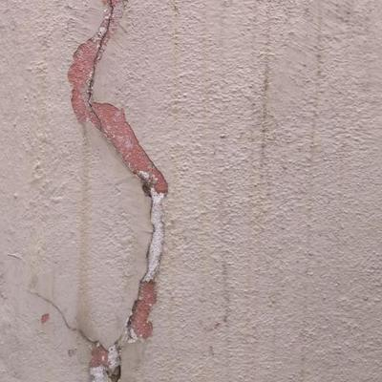 | 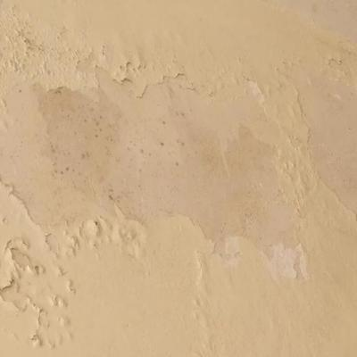
Major Crack | Peeling
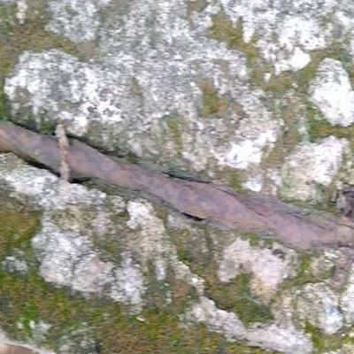
Spalling

Data Quality Notes
- 12 low-variance images (nearly solid color, std < 3.0)
- 70 exact duplicates across class folders (35 groups) — labeling noise
- All images uniform 512×512

3. TACO — Trash Annotations in Context

Basic Information
Full Name | TACO (Trash Annotations in Context)
Source | tacodataset.org
Total Images | 1,500
Object Annotations | 4,784 across 60 categories
Resolution | Variable; median 2,921×3,264 (842–6,000 px)
Median File Size | 1,694 KB (~1.7 MB)
Format | COCO JSON + polygon segmentation
License | CC BY-NC-SA 4.0

Directory Structure
TACO/data/
├── annotations.json ← COCO format
├── batch_1/
├── batch_2/
└── ... (15 batches)

Example Images
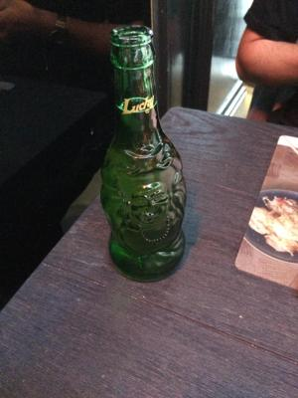 | 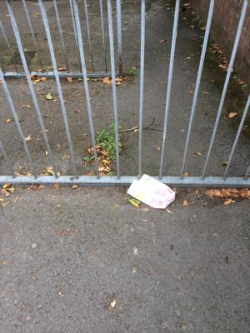
Example 1 | Example 2

Data Quality Notes
- 0 issues detected
- Highest resolution — will be resized at training time
- 53 unique resolutions (real-world Flickr photos)
- Bounding boxes + segmentation available but unused

4. Grass-Weeds — Roboflow 100

Basic Information
Full Name | Grass-Weeds (Roboflow 100 benchmark)
Source | universe.roboflow.com/roboflow-100/grass-weeds
Total Images | 2,486 (train 1,661 / valid 501 / test 324)
Resolution | Uniform 416×416 px
Median File Size | 44 KB
Format | COCO JSON with bounding boxes
License | CC BY 4.0

Directory Structure
grass-weeds/
├── train/ (1,661 images)
├── valid/ (501 images)
└── test/ (324 images)

Example Images
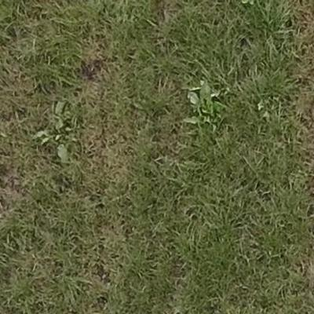 | 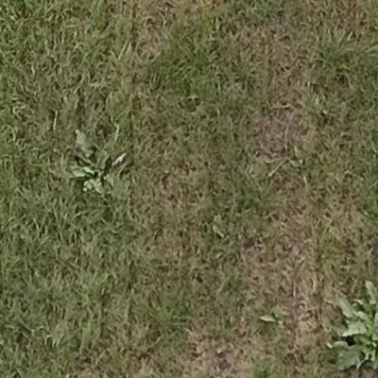
Example 1 | Example 2

Data Quality Notes
- 0 issues detected
- Smallest resolution (416×416) among all datasets

5. Aerial Dumping Sites

Basic Information
Full Name | Aerial Dumping Sites
Source | universe.roboflow.com/.../aerial-dumping-sites
Total Images | 1,555 (train 1,492 / valid 32 / test 31)
Resolution | Uniform 1,024×1,024 px
Median File Size | 195 KB
Format | COCO JSON with bounding boxes
License | CC BY 4.0

Directory Structure
aerial-dumping/
├── train/ (1,492 images)
├── valid/ (32 images)
└── test/ (31 images)

Example Images
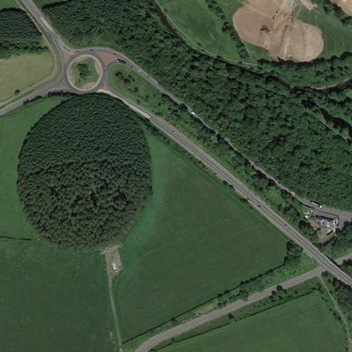 | 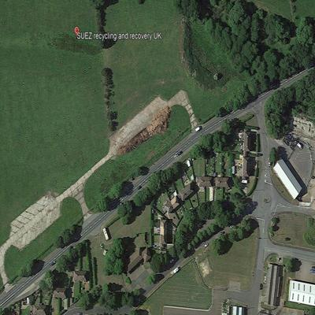
Example 1 | Example 2

Data Quality Notes
- 0 issues detected
- Aerial perspective — domain gap with ground-level inspection photos
- High annotation density (7.5 objects/image)

6. Broken Fence Detection

Basic Information
Full Name | Broken Fence Detection
Source | universe.roboflow.com/uji-thesis/broken-fence-detection
Total Images | 1,297 (train/valid/test)
Resolution | Uniform 640×640 px
Median File Size | 74 KB
Format | COCO JSON with bounding boxes
License | CC BY 4.0

Directory Structure
broken-fence/
├── train/
├── valid/
└── test/

Example Images
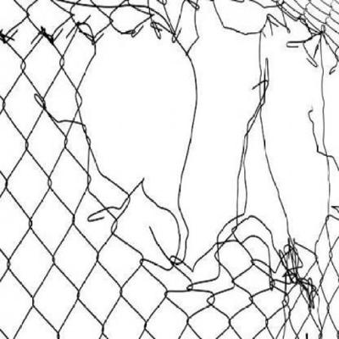 | 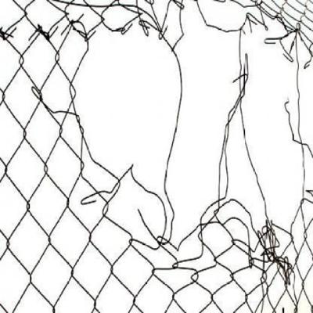
Example 1 | Example 2

Data Quality Notes
- 0 issues detected
- Only covers fences — not garages, sheds, or retaining walls
- Uniform 640×640

7. Garbage Object Detection

Basic Information
Full Name | Garbage Object Detection
Source | huggingface.co/datasets/keremberke/garbage-object-detection
Total Images | 10,464 (train 7,324 / valid 2,098 / test 1,042)
Resolution | Uniform 416×416 px
Median File Size | 16 KB
Format | COCO JSON (zip archives)
License | CC BY 4.0

Directory Structure
garbage-object-detection/
├── data/ ← original zips
├── train/ (7,324 extracted)
├── valid/ (2,098 extracted)
└── test/ (1,042 extracted)

Example Images
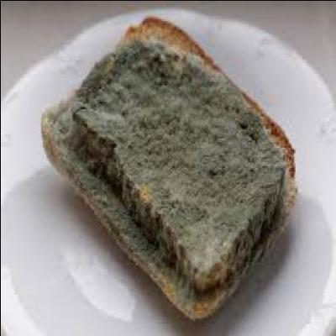 | 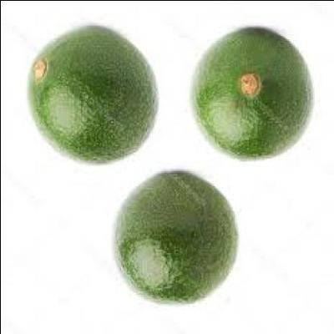
Example 1 | Example 2

Data Quality Notes
- 5 low-variance images (nearly blank)
- Very small file sizes (16 KB median) — heavily compressed thumbnails
- Largest single dataset — causes class imbalance when combined with TACO

8. Building Surface Defect Detection

Basic Information
Full Name | Building Surface Defect Detection
Source | huggingface.co/datasets/xueaidezhouzhou/buildingsurfacedefectdetection
Total Images | 7,353 (train 5,882 / val 735 / test 736)
Label Files | 7,355 YOLO-format .txt files
Resolution | Uniform 640×640 px
Median File Size | 54 KB
Format | YOLO (images/ + labels/ directories)
License | Not specified

Directory Structure
building-surface-defect/
├── images/{train,val,test}/
├── labels/{train,val,test}/
└── dataset.7z (original archive)

Example Images
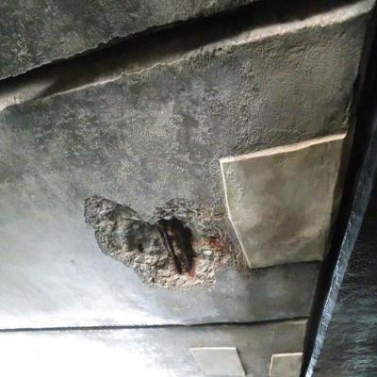 | 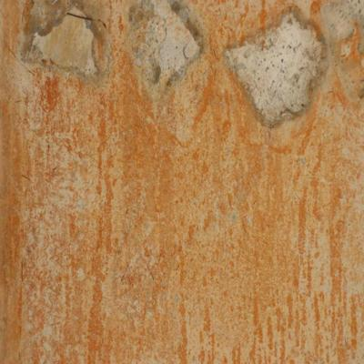
Example 1 | Example 2

Data Quality Notes
- 2 low-variance images
- ~88 perceptual duplicate groups with BD3 — similar building surface imagery
- Risk of data leakage if not handled during train/test splitting

9. Unified Dataset Summary

Combined Label Distribution
Unified Label | Violation # | Source | Images | %
trash_debris | #2 Garbage | TACO + Garbage Obj. | 11,964 | 41.8%
exterior_deterioration | #3 Paint | BD3 + Building Surface | 9,514 | 33.2%
overgrown_vegetation | #1 Overgrown | Grass-Weeds | 2,486 | 8.7%
illegal_dumping | #2 Garbage | Aerial Dumping | 1,555 | 5.4%
damaged_structures | #4 Structures | Broken Fence | 1,297 | 4.5%
structural_damage | #3 Paint | BD3 (cracks) | 1,204 | 4.2%
Total |  |  | 28,020 | 100%

Resolution Comparison
Dataset | Resolution | Pixels/Image | Median File Size
Grass-Weeds | 416×416 | 173K | 44 KB
Garbage Obj. Det. | 416×416 | 173K | 16 KB
BD3 | 512×512 | 262K | 20 KB
Broken Fence | 640×640 | 410K | 74 KB
Building Surface | 640×640 | 410K | 54 KB
Aerial Dumping | 1,024×1,024 | 1,049K | 195 KB
TACO | ~2,921×3,264 | ~9,534K | 1,694 KB

Data Quality Summary
Check | Result
Corrupt / unreadable | 0
Tiny (< 32×32) | 0
Extreme aspect ratio | 0
Low variance (blank) | 19 (BD3: 12, Garbage: 5, Building: 2)
Exact duplicates | 74 images in 39 groups
Cross-source perceptual dupes | 100 groups
Overall clean rate | 99.9%

Known Limitations
- Domain gap — proxy datasets not captured by Riverdale Park inspectors
- Aerial vs. ground perspective — Aerial Dumping uses drone/satellite imagery
- Missing violation #5 — Missing Address Numbers has no proxy coverage
- Class imbalance — trash_debris requires downsampling (9.9:1 ratio)
- Cross-source overlap — BD3 and Building Surface Defect share similar imagery (100 perceptual dupe groups)
- Label granularity loss — BD3 (7 classes → 2), TACO (60 → 1), Garbage (multiple → 1)

Appendix A — Original Data Sources
For reference, here are the original sources where each dataset was downloaded from. You don't need to visit these — the zip on Google Drive already contains everything.

Dataset | Size | Original Source
BD3 | 108 MB | github.com/Praveenkottari/BD3-Dataset
TACO | 2.6 GB | tacodataset.org
Grass-Weeds | 115 MB | universe.roboflow.com/roboflow-100/grass-weeds
Aerial Dumping | 291 MB | universe.roboflow.com/.../aerial-dumping-sites
Broken Fence | 99 MB | universe.roboflow.com/uji-thesis/broken-fence-detection
Garbage Obj. Det. | 409 MB | huggingface.co/datasets/keremberke/garbage-object-detection
Building Surface | 865 MB | huggingface.co/datasets/xueaidezhouzhou/buildingsurfacedefectdetection

