Domestic Medical Exam Clinical Decision Support: Guidelines for Implementation

## Contents

Introduction 2

CDS Components Overview 4

OME Documentation 5

Migration Documentation 5

DME Documentation (adult) 6

DME Documentation (child) 6

Build Components (Lists, Criteria, Restrictors, etc.) 7

Pre-Visit SmartSet 8

Domestic Medical Exam SmartSet 13

# Introduction

### Purpose:

This document includes instructions for building a customized version of the Refugee Epic User Group consensus order sets and documentation templates for the Domestic Medical Examination in Epic 2014 or later. These tools are intended to simplify and standardize completion of the refugee Domestic Medical Examination. This document describes the new version of the clinical decision support module and is intended for institutions looking to develop decision support with limited resources to support either the initial build or project maintenance. The initial build process is intended to be completed in 10 hours of analyst time. It is anticipated that testing and revisions at each local site would be accomplished within a reasonable time frame (similar to other operational projects). Organizations looking to develop or support a comprehensive registry for refugee health management decisions would likely need to consider adding in additional components.

### Background:

The content for this CDS module was informed by the Refugee Epic User Group. This workgroup included 21 clinicians, administrators, and informatics specialists from 13 institutions that care for refugee populations in the United States and Canada. A core group from the Center for International Health at the University of Minnesota, the Minnesota Department of Public Health, and the Children’s Hospital of Philadelphia was responsible for closely reviewing the CDC’s guidelines for the U.S. domestic medical examination for newly arriving refugees, soliciting and collating user group input, reviewing feedback from state refugee health epidemiologists, and piloting the order sets and documentation templates. Building upon this work, we have sought feedback from members of this initial workgroup on the components that could be removed to support a smaller module while not compromising care delivery to patients.

This suite of clinical decision support tools was developed after discussion with the Refugee Epic User Group about the most common workflows used to complete the Domestic Medical Exam. This type of decision support allows for flexibility, customization, avoids interruptive alerts, and has low information systems overhead. Based on this model, the Refugee Epic User Group agreed on the following tools:

* Pre-Visit Tools:
  + Pre-Visit SmartSet (For OME abstraction and lab orders and/or an RN/APP visit)
  + Overseas Medical Exam (OME) Abstraction Template
* Medical Home Visit Tools (Domestic Medical Exam):
  + Migration History Documentation Template
  + Domestic Medical Exam Documentation Template
  + Domestic Medical Exam SmartSet

### Local CDS Assumptions: Physical Exams, Vital Signs, Hearing/Vision, and Immunizations

It was noted during the development of this CDS module that certain tasks relevant to the care of the newly arrived refugee would likely be supported by existing CDS and would not need to be tailored to this population. These include physical exam and vital sign documentation. For these components, we recommend utilization of templates and orders already maintained by your institution.

Hearing and Vision screening in the pediatric patient is not unique for the refugee patient. Hearing and Vision Screening may have local differences and should be adapted to adhere to organizational policies. We included orders for this in the CDS using content maintained by our organization for well child care. This both decreases the build time and allows for changes to periodic screening requirements to be automatically populated into the refugee CDS module.

Due to the complexity of immunization scheduling in refugee patients, handling of immunizations is not addressed within this CDS module. Many organizations have immunization CDS within their EHR, however, these may be insufficient for the needs of newly arrived refugee patients. Newly arrived refugees may or may not have been vaccinated and EHRs may not sufficiently handle immunization spacing or dose counting in refugee patients. We suggest cautious use of EHR-based CDS for immunizations in these patients and manual verification of all immunization ordering. Publicly available immunization CDS has been developed by the CDC, the **Clinical Decision Support for Immunization (CDSi),** and may be a useful reference for organizations looking to implement immunization rules.

Reference: <https://www.cdc.gov/vaccines/programs/iis/cdsi.html>

### Smart Data Elements

Smart Data Elements are useful for data aggregation and public health surveillance across sites. However, they are time intensive to build and maintain. Heavy utilization of Smart Data Elements in the documentation template is recommended for the comprehensive build. However, these require approximately 30 hours to build on top of the build time for the rest of the module. Organizations interested in using Smart Data Elements should refer to the comprehensive build documentation. For this version, we have identified certain highly relevant SDEs that can be quickly added with approximately 30 minutes added to build time: Alien #, OME Tuberculosis Status, OME Classification, and Domestic Tuberculosis status).

### A Note on Changes to the Refugee Health Guidelines

###### The CDC refugee health guidelines are updated periodically. See the current version of the guidelines at

[**https://www.cdc.gov/immigrantrefugeehealth/guidelines/domestic/domestic-guidelines.html**](https://www.cdc.gov/immigrantrefugeehealth/guidelines/domestic/domestic-guidelines.html). Users of this CDS module should check the refugee health guideline website periodically. This document has been updated to provide recommendations concordant with those within CareRef

([**https://careref.web.health.state.mn.us/refugee-info**](https://careref.web.health.state.mn.us/refugee-info)) and the guidelines published on the CDC

###### website through 2/1/2020. Guideline published after this date will be evaluated when possible, and supplemental implementation statements may be included as addendums between version releases.

# CDS Components Overview

This remainder of this guide is arranged by CDS component

1. OME Documentation
2. Migration Documentation
3. DME Documentation (adult)
4. DME Documentation (child)
5. Other Text Components
6. Build Components (Lists, Criteria, Restrictors, etc.)
7. Pre-Visit SmartSet
8. Domestic Medical Exam SmartSet

In RED within each of these sections you may note “Customization Points” and “Notes”. These indicate areas where we suggest localization decisions may be needed.

**Note:** Certain components of the module utilize hyperlinks, primarily to the CDC or CareRef website. Hyperlinks may need to be added to your institution’s Browser Whitelist depending on your version of EPIC and configuration settings. The link below brings you to information on how to set the EPIC. Browser Whitelist: **https://galaxy.epic.com/?#Browse/page=1!68!50!3194400,3194402,3194508**

Build Workflow, Quality Control and Testing Support

Within the BuildList.xlsx file, we have included several tabs for implementation support. These include all texts (with references to the word files containing content), lists (expanded), Smart Data Elements, BPA elements (bases and criteria), SmartSets, SmartGroups, and Components of SmartGroups. The remaining tabs are for QC and to facilitate replacement of non-generic EPIC local codes with your system codes.

**Suggested Build Order:** The lists should be built (or downloaded through EPIC userweb) first. The list numbers used locally may differ from those in our build and would need to be replaced in the documentation texts. Once these have been replaced, the documentation texts can be copied/pasted into EPIC. After completing the documentation, populate and release the bases and criteria (BPA elements). Next the SmartSet structures can be started. In general, we have found building the diagnosis SmartGroup first to be more efficient but defer to organizations’ existing workflows. Once the diagnosis SmartGroups have been added to a SmartSet, orders can be associated with contained diagnoses.

SmartDataElements can be added at any time after the lists are built.

The hyperlink tab helps with both testing of link validity and can be used to populate EPIC’s white list (to prevent the browser blocking these sites).

The SmartGroup Component tab can be used to develop a QC tool. Once all the CDS components are ‘test released’ in EPIC a trained clinician can run through age-based scenarios and confirm the appropriate documentation templates/orders are displayed. This script would need to be modified based on any customizations.

# OME Documentation

#### Overview:

The OME Documentation template provides clinicians with guidance through the abstraction of relevant information from the overseas medical exam and related documents. See ome-smart-text.docx for expansion of the documentation template. All SmartLists and hyperlinks within this template are expanded in the build-list-v4.3.xlsx file.

#### System Name:

###### OME Abstraction

#### Synonyms:

Overseas Medical Exam, Refugee OME

#### Implementation/Restrictors:

Limit use by: MR Charting [1]

#### Comments:

**Customization point:** SmartDataElements (SDEs): There are 2 SDEs within the OME Abstraction documentation template. These are documented fully within the accompanying Build List (Smart Lists Tab). Please note, for *Alien Number*, the purpose of this SmartList with only a wildcard (***) is to allow the data entered by the clinician to be captured in a SDE. This SmartList must be *refreshable, even though it is just a *** wildcard. If not using SDE then this can just be a wildcard without a SmartList.*

# Migration Documentation

#### Overview:

The Migration Documentation template provides a template for capturing the migration events prior to arrival in the United States. This is intended to be placed in the Social History section of the chart. The content for this portion of the CDS is within: migration-history.docx

#### System Name:

###### SmartText: Migration History

SmartPhrase: MIGRATIONHISTORY

#### Synonyms:

SmartText: Refugee Migration History, Refugee Social History SmartPhrase: REFUGEESOCIALHISTORY, REFUGEEMIGRATIONHISTORY

#### Implementation/Restrictors:

Limit use by: MR Charting [1]

#### Comments:

**Customization point:** Add the resettlement agencies that work with refugees at your institution to the list and remove agencies that you do not work with.

**Customization Point:** We supported two mechanism to access the migration history template: SmartText and SmartPhrase. This was to support clinician workflow differences. The contents of these are identical.

# DME Documentation (adult)

#### Overview:

These templates provide a structured pathway for documentation.

#### System Name:

Domestic Medical Exam Adult

#### Synonyms:

DME Adult, Refugee DME Adult

#### Implementation/Restrictors:

Limit use by: MR Charting [1]

Age 12yrs Minimum to 150 yrs Maximum

#### Comments:

**Note:** We specifically did not use the abbreviation DME in the primary system name as it would be confusing for the Durable Medical Equipment abbreviation.

**Customization Point:** We used the cutoff of age 12 for this documentation template to align with recommendations for testing and patient care practices. Other sites may choose a different age cutoff.

**Customization Point:** To keep the build process simple we used as few SmartLists as possible to meet clinical needs. Organizations may wish to use additional SmartLists for areas of interest (e.g. pregnancy, hepatitis C plans). On average, each additional SmartList would take 5 minutes to build and implement.

**Customization Point:** Sites may have interest in documenting female genital cutting as it is prevalent and underreported. Diagrams to aid in diagnosis and to support documentation are available at: **Female Genital Mutilation: A Visual Reference and Learning Tool for Health Care Professionals.**

# DME Documentation (child)

#### Overview:

The child template follows the same general structure of the adult with 4 differences.

1. A question on birth history has been added to the past medical history.
2. The questions on pregnancy and family planning have been removed.
3. The question in environmental exposures on alcohol has been removed.
4. The question in environmental exposures on other substances has been removed.

#### System Name:

Domestic Medical Exam Child

#### Synonyms:

DME Child Refugee DME Child

#### Implementation/Restrictors:

Limit use by: MR Charting [1]

Age Birth Minimum to 11yrs Maximum

#### Comments:

See previous section: DME Documentation (Adult)

## Other Text Components

#### Overview:

A few additional SmartText blocks were created to improve the efficiency of using the CDS. These are discussed in the table below along with the file name (if applicable) of the resource and relevant implementation information.

|  |  |  |
| --- | --- | --- |
| Smart Text | File Name | Use |
| OME Not Available | N/A | “Overseas medical exam not available” text that should be inserted into a progress  note for patients with no OME available |
| Hepatitis B Patient Instructions | hep-b-patient-instructions.docx | Text that should be inserted into the AVS for patients with Hepatitis B |
| LTBI Patient Instructions | ltbi-patient-instructions.docx | Text that should be inserted into the AVS for patients with Latent Tuberculosis (LTBI) |
| DME Patient Instructions | dme-patient-instructions.docx | Used to insert standard patient instructions in the after-visit summary from within the DME SmartSet |

# Build Components (Lists, Criteria, Restrictors, etc.)

#### Overview:

We have included in the BuildList spreadsheet all the components that would need to be created within the EHR to support functionality of documentation templates and triggering of SmartGroups. These include SmartLists, SmartGroups, and Base Elements (e.g. Restrictors, Criteria). All SmartLists are fully expanded, with defaults identified. Combinations of Criteria are listed for each Restrictor. All Smart Groups are fully expanded and orders linked to the Reference Information Model (RIM).

#### Comments:

**Note:** We have found that building out the criteria/restrictors/bases and then the SmartGroups decreases build time marginally. We would defer to each organization’s build process workflow.

**Customization Point:** In some instances, we have used system generics. These are clearly indicated in the document. To promote build efficiency, we suggest using build generics whenever possible. This will also support maintenance of the CDS module and allow for system updates to propagate to this CDS intervention.

**Customization Point:** Orders will likely need to be organization specific. Many are easy to identify through name alone. Others will need to be located within your system via the RIM identifier and terminology (e.g. LOINC, RxNorm, ICD10).

# Pre-Visit SmartSet

#### Overview (Screen Shot)

Each section of the screen shot is discussed in detail with implementation instructions in the attached build list. “Description Text” for each section is included within this document.

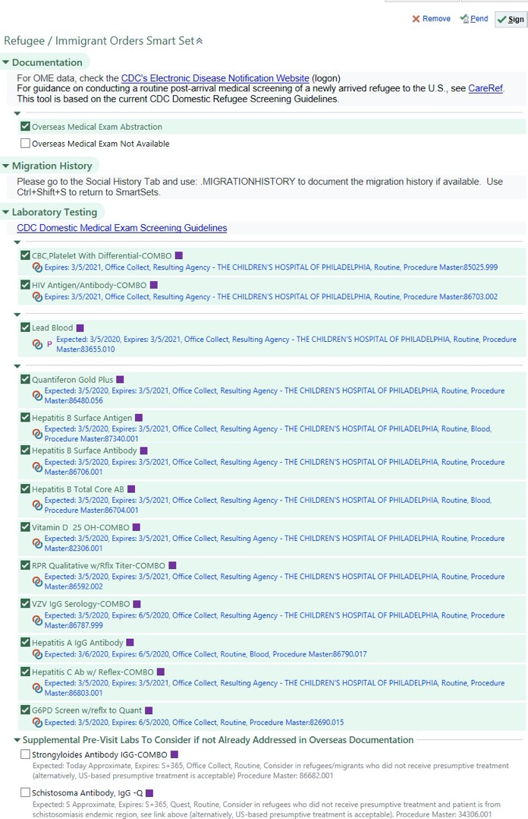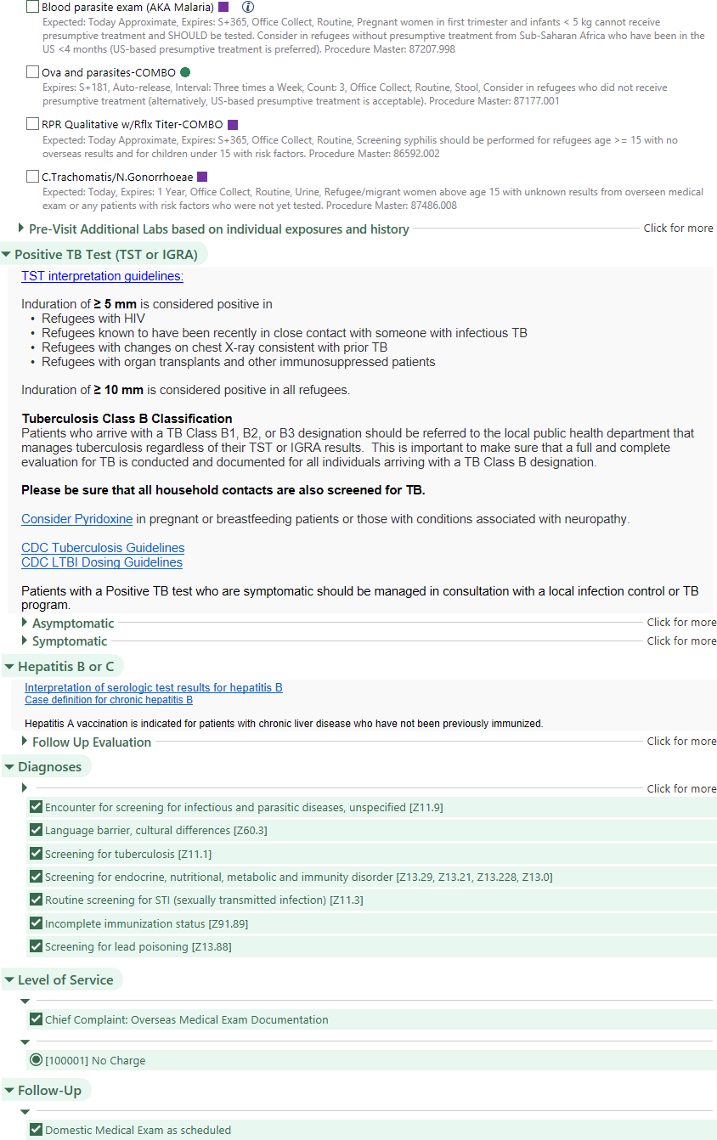

### Section: Documentation

#### Overview:

There are two options for documentation: OME Abstraction and OME Not Available.

#### Description Text:

For OME data, check the **CDC's Electronic Disease Notification Website** (logon)

For guidance on conducting a routine post-arrival medical screening of a newly arrived refugee to the U.S., see **CareRef**. This tool is based on the current CDC Domestic Refugee Screening Guidelines.

#### Comments:

**Customization point:** We recommend that institutions who receive patients seen for an initial visit at a different location use the “OME Abstraction” text to included information from the prior institution.

### Section: Migration History

#### Overview:

This section is a placeholder to remind clinicians to use the Social History tab to document the migration history

#### Description Text:

#### Please go to the Social History Tab and use: .MIGRATIONHISTORY to document the migration history if available. Use Ctrl+Shift+S to return to SmartSets.

#### Comments:

None

### Section: Laboratory Testing

#### Overview:

One key component of pre-visit workflow is laboratory test ordering. This section was developed to facilitate this workflow. The description text points to the base CDC guideline hyperlink.

#### Description Text:

CDC Domestic Medical Exam Screening Guidelines

#### Comments:

This section includes several SmartGroups. The groups help to cluster the lab orders by patient criteria and organize ordering to support observed workflows. Please see the table below for groups. Those with restrictors are organized first, as this supports organizational workflow. Please see the build list for detailed orders, restrictor, and criteria development instructions.

| **SmartGroup** | **Header** | **Purpose** | **Restrictors** |
| --- | --- | --- | --- |
| TB testing | N/A | Support specific lab testing for tuberculosis in children where IGRA is inconclusive.  Is pre-checked to support workflow. | Age < 24 mo |
| Intestinal Parasite Testing | N/A | Support specific lab testing for intestinal parasites in children unable to receive presumptive treatment.  Is pre-checked to support workflow. | NOT (Age <6 mo) and Age < 12 mo |
| Lead testing | N/A | Support specific lab testing for lead in children and women of ‘childbearing age’. Is pre-checked to support workflow. | Age < 16 yr OR (Age < 50 yr and female) |
| Pregnancy Test | N/A | Test pregnancy based on age and gender. Is pre-checked to support workflow. | Not (Age < 12 yr) AND female |
| Standing Labs | N/A | Lab tests recommended for all patients.  Is pre-checked to support workflow. | N/A |
| Supplemental Pre-visit Labs | Supplemental Pre- Visit Labs To Consider if not Already Addressed in Overseas Documentation | Lab tests recommended that may be addressed in overseas documentation (either through testing or presumptive treatment). Are NOT pre-checked, Group is defaulted open, each test has guidance in the comment field. | N/A |
| Additional Labs | Pre-Visit Additional Labs  based on individual exposures and history | Lab tests to be considered based on the results of overseas examinations or known  exposures. Are NOT pre-checked, group is defaulted closed, some tests have guidance in  comment field. | N/A |

**Customization Point:** Because of local considerations in the population, many institutions have additional standing labs that they will order on all refugee patients even if those labs are not currently in the CDC Refugee Health Guidelines. Please work with your local clinician to determine if any additional labs should be added to the Standing Labs sections. We at CHOP included the following labs in our local standing orders: Hep A screening, Vitamin D screening, G6PD, and Hepatitis C screening.

**Customization Point:** Childbearing age is a loosely defined concept. We have used age cutoffs of 16 years through 50 year as this fit well with other age-based restrictors and to conform to local testing plans.

**Customization Point:** Timing and age-ranges for HIV, urine pregnancy, and C. Trachomatis/N. Gonorrhea testing may vary between institutions. Please adjust as necessary in the SmartGroups below.

**Customization Point:** Sites caring for young children may wish to develop a Restrictor based pre- checked order for Strongyloides IgG for children under age 3.

**Customization Point:** Sites caring predominantly for patient from Schistosomiasis endemic areas may wish to develop a Restrictor based pre-checked order for Schistosoma IgG for children under age 5.

**Customization Point:** The CDC recommends conducting infant metabolic screening for newborns, according to state guidelines. In practice, many states will allow newborn screening for older children born outside of the US. Sites may want to customize this order by adding it to the Standing Labs.

**Customization Point**: The CDC notes “immunizations administered outside the United States can be accepted as valid if the schedule was similar to that recommended in the United States.” However, “checking for laboratory evidence of immunity is an acceptable alternative for certain antigens when previous vaccination or exposure is likely.” Sites that routinely screen for laboratory evidence of immunity may decide to add these to the Standing Labs.

**Note:** HIV Testing is typically accomplished through antibody testing (3rd or 4th generation). For refugee/immigrant patients it is important that you choose a test that either differentiates HIV-1 and HIV-2 or reflexes to HIV-1/2 specific testing. HIV DNA/RNA testing is currently preformed routinely for HIV-1 and not for HIV-2. Positive HIV-1 tests should either reflex to DNA/RNA testing or the system should include order options for both.

### Section: Positive TB Test (TST or IGRA)

#### Overview:

This section provides guidance for further testing of refugees with known positive tuberculin skin test (TST) or interferon-gamma release assay (IGRA) based on overseas testing without evidence of previous treatment for active or latent tuberculosis. This is NOT the step where providers would initiate treatment for latent tuberculosis infection. There are SmartGroups for Asymptomatic and Symptomatic patient evaluations.

#### Description Text:

TST interpretation guidelines:

Induration of **≥ 5 mm** is considered positive in

* + Refugees with HIV
  + Refugees known to have been recently in close contact with someone with infectious TB
  + Refugees with changes on chest X-ray consistent with prior TB
  + Refugees with organ transplants and other immunosuppressed patients

Induration of ≥ 10 mm is considered positive in all refugees.

Tuberculosis Class B Classification

Patients who arrive with a TB Class B1, B2, or B3 designation should be referred to the local public health department that manages tuberculosis regardless of their TST or IGRA results. This is important to make sure that a full and complete evaluation for TB is conducted and documented for all individuals arriving with a TB Class B designation.

Please be sure that all household contacts are also screened for TB.

Consider pyridoxine in pregnant or breastfeeding patients or those with conditions associated with neuropathy.

CDC Tuberculosis Guidelines CDC LTBI Dosing Guidelines

Patients with a Positive TB test who are symptomatic should be managed in consultation with a local infection control or TB program.

#### Comments:

The SmartGroup for asymptomatic patients contains orders to support evaluation for Latent TB. The SmartGroup for symptomatic patients guides providers to refer to Infectious Disease and institute tuberculosis precautions.

**Customization Point:** We include a Hepatic Function Panel for convenience based on the feedback from clinical end users.

### Section: Hepatitis B or C

#### Overview:

This section provides guidance for further evaluation of refugees with positive hepatitis B surface antigen testing (and likely chronic hepatitis B infection) from the overseas medical exam.

**Note (Hepatitis B):** If interested, sites can develop a Hepatitis B panel or a reflex order for testing of positive hepatitis B samples. This would potentially add to the build time but has been shown to decrease errors of omission in Hepatitis B follow up orders and decrease clinician clicking within the module.

#### Description Text:

**Interpretation of serologic test results for hepatitis B**

**Case definition for chronic hepatitis B**

*Hepatitis A vaccination is indicated for patients with chronic liver disease who have not been previously immunized.*

#### Comments:

**Note:** To support maintenance of the CDS module, the OME and DME SmartSets reference the SAME SmartGroup. This results in tests from this SmartGroup potentially being ‘future ordered’ if signed immediately even during the DME, which is different from the rest of the DME SmartGroups. Given the number of orders and likely need for long term revisions, this was considered the optimal approach for efficient CDS build and maintenance.

**Customization Point:** Sites with additional build resources could consider developing a separate OME and DME version to decrease the potential for clinician issues related to future ordering lab tests accidentally.

**Customization Point:** Referral practices for Hepatitis B and C may vary by institution.

**Customization Point:** Sites that vaccinate during the OME visit should include a Hepatitis A immunization prompt either within this module or elsewhere within the pre-visit smart set.

### Section: Diagnoses

#### Overview:

List of diagnoses for Pre-Visit; Includes relevant pre-checked diagnoses and additional diagnoses that automatically become selected when associated labs are ordered.

#### Descriptive Text:

None

### Section: Level of Service

#### Overview:

This section supports efficient chart completion by automating the insertion of a Chief complaint and billing code for the encounter.

#### Comments:

**Customization Point:** Pre-Visit coded as “No Charge” assuming a provider (MD, DO, PA, or NP) generally has not seen the patient. At some institutions, a provider sees the patient during the Pre-Visit, in which case sites may customize the Level of Service based on their own institutional rules and arrangements with payer.

### Section: Follow-Up

#### Overview:

Follow-up with scheduled Domestic Medical Exam.

#### Comments:

**Customization Point:** At some institutions, a provider sees the patient during the Pre-Visit, in which case sites may customize Follow-Up based on their own institutional practices.

# Domestic Medical Exam SmartSet

##### Overview (Screen Shot)

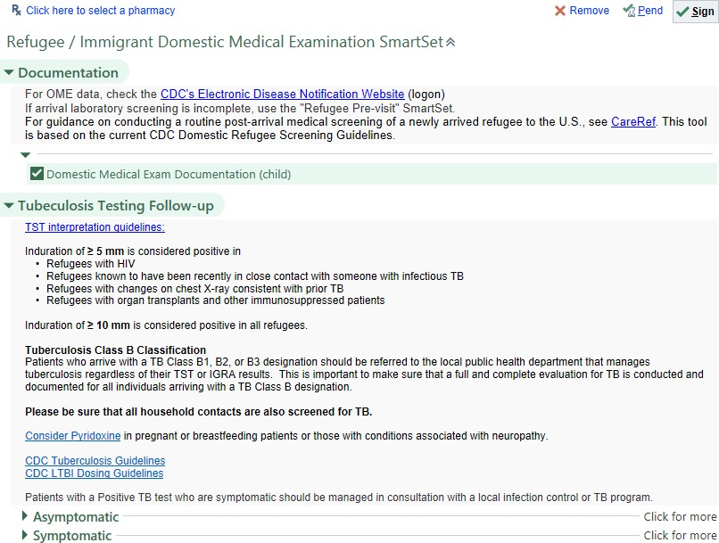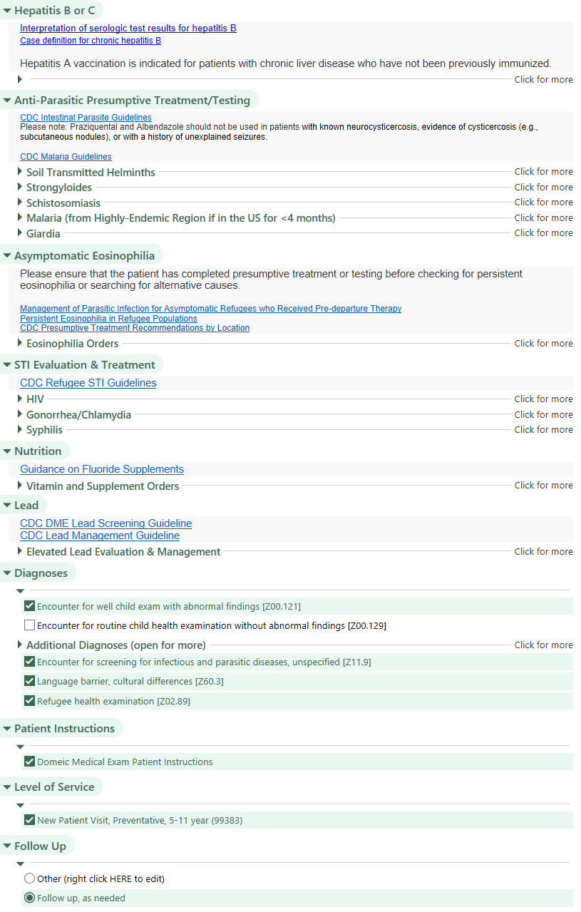

### Section: Documentation

#### Overview:

This section contains documentation templates, with age-based restrictors.

#### Description Text:

For OME data, check the **CDC's Electronic Disease Notification Website** (logon)

If post-arrival laboratory screening is incomplete, use the Refugee/Immigrant Orders Smart Set.

For guidance on conducting a routine post-arrival medical screening of a newly arrived refugee to the U.S., see **CareRef.** This tool is based on the current CDC Domestic Refugee Screening Guidelines.

#### Comments:

It may be possible to directly obtain these documentation templates via the EpicUser web. If attempted, care must be undertaken to import SmartLists appropriately.

Unlike other components of EPIC, SmartTexts with different age restrictors can be included within the same SmartGroup. Two versions of the Document Template were developed: Child (0-11 years) and Adolescent/Adult (12 + years).

**Customization Point:** Under Past Medical History, the document provides limited support for assessing Mental Health Concerns. For sites that want to enter the results of a screening instrument, this instrument could be inserted into the document at this point.

### Section: Tuberculosis Testing Follow Up

#### Overview:

These sections provide guidance for further testing of refugees with (1) known positive tuberculin skin test (TST) or interferon-gamma release assay (IGRA) based on overseas testing without evidence of previous treatment for active or latent tuberculosis and for (2) symptomatic tuberculosis. It also includes treatment options for latent tuberculosis infection. This is NOT the recommended location for providers to initiate treatment for symptomatic tuberculosis disease.

#### Description Text:

**TST interpretation guidelines:**

Induration of **≥ 5 mm** is considered positive in

* Refugees with HIV
* Refugees known to have been recently in close contact with someone with infectious TB
* Refugees with changes on chest X-ray consistent with prior TB
* Refugees with organ transplants and other immunosuppressed patients Induration of **≥ 10 mm** is considered positive in all refugees.

**Tuberculosis Class B Classification**

Patients who arrive with a TB Class B1, B2, or B3 designation should be referred to the local public health department that manages tuberculosis regardless of their TST or IGRA results. This is important to make sure that a full and complete evaluation for TB is conducted and documented for all individuals arriving with a TB Class B designation.

Consider pyridoxine in pregnant or breastfeeding patients or those with conditions associated with neuropathy.

**Please be sure that all household contacts are also screened for TB. CDC Refugee Tuberculosis Guidelines**

**CDC LTBI Dosing Guidelines**

**Recommended Medical Follow-Up for TB Class B Arrivals**

#### Comments:

**Customization Point:** Referral practices for latent tuberculosis infection may vary by institution.

**Customization Point:** Treatment regimens can include options such as 3HP. This may require directly observed therapy (DOT) and availability for this may vary by institution. DOT was not included within this Smart Set as it is not orderable within our system.

**Customization Points:** Some EPIC implementations provide mechanisms to document nurse/ancillary orders or a referral to TB CLINIC or Department of Public Health. These could be used to document the public health reporting of LTBI. Public Health referral was not included within this Smart Set as it is not orderable within our system.

### Section: Hepatitis B or C

See Section: Hepatitis B or C from the Pre-Visit portion. As there is no management difference between pre-visit and DME for Hepatitis B or C based upon the reference guidelines, we developed a single SmartGroup for this.

### Section: Anti-Parasitic Treatment & Testing

#### Overview:

Has 5 SmartGroups: Soil-transmitted helminths, Strongyloidiasis, Schistosomiasis, Malaria, and Giardia.

By default all subsection displays are closed. Giardia has subsection text that is inserted within the SmartGroup.

#### Description Text:

**CDC Intestinal Parasite Guidelines**

Please note: Praziquantel and Albendazole should not be used in patients with known neurocysticercosis, evidence of cysticercosis (e.g., subcutaneous nodules), or with a history of unexplained seizures without guidance from Infectious Disease.

**CDC Malaria Guidelines**

#### Subsection: Soil-transmitted helminths

**Customization Point:** Institutions looking to optimize for age may consider restricting this group based on patient age.

#### Subsection: Strongyloidiasis

**Customization Point:** Please discuss the best practice for ordering Loa-loa testing within your institution.

#### Subsection: Schistosomiasis

No Comments

#### Subsection: Malaria (from Highly-Endemic Region if in the US for <4 months)

**Customization Point:** For organizations that serve youth/adolescent patients you can consider splitting doses of medications by weight (see screen shot example). This should be a resource driven decision.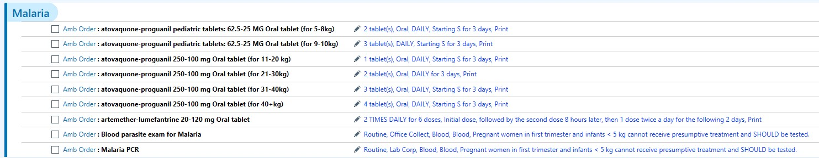

**Customization Point:** You may need to discuss with your laboratory department. Traditional testing is an option, and almost universally available, but PCR testing is preferred. Guidance is given on including these two lab options. Rapid Diagnostic Malaria testing is an option, but only PCR testing is widely available in the United States. Check with your local organization to determine the optimal testing strategy.

#### Subsection: Giardia

Sub-Section Text:

Refugees are not presumptively treated for Giardia before departure. Screening asymptomatic children younger than 5 years of age for Giardia stool antigen and treating those who test positive may be beneficial and is done by some experts in refugee children, although data supporting this approach are lacking. Further information is available on the guideline linked above.

**Customization Point:** You may need to discuss which specific tests for Giardia are available with your laboratory department.

### Section: Asymptomatic Eosinophilia

#### Overview:

Contains repeat CBC at time of Domestic Medical Exam and 3 months later, option for ova & parasites, Strongyloides antibody, and Schistosoma antibody as well as associated diagnosis of Eosinophilia.

#### Description Text:

Please ensure that the patient has completed presumptive treatment or testing before checking for persistent eosinophilia or searching for alternative causes.

**Management of Parasitic Infection for Asymptomatic Refugees who Received Pre-departure Therapy Persistent Eosinophilia in Refugee Populations**

**CDC Presumptive Treatment Recommendations by Location**

##### Comments:

None

### Section: STI Evaluation & Treatment

#### Overview:

Contains 3 SmartGroups for STI Evaluation and Treatment: Baseline Sexual Health testing (HIV, pregnancy test), Gonorrhea/Chlamydia (testing and treatment), and Syphilis (testing and treatment).

#### Description Text:

**CDC Refugee STI Guidelines**

#### Comments:

**Note:** Although STI evaluation is typically considered in adolescents and adults, we did not use age restrictors. Congenital HIV/Syphilis also occur and this section supports evaluation and initial management.

#### SmartGroup: HIV

**Customization point:** Specific testing practices (especially for HIV-2) will need to be discussed with your lab. Management of patients with HIV is often through Infectious Disease or an HIV clinic, but his is organization specific.

#### SmartGroup: Gonorrhea/Chlamydia

**Customization point:** In office treatment options are site and organization specific.

#### SmartGroup: Syphilis

Customization point: In office treatment options are site and organization specific.

### Section: Nutritional Supplements

#### Overview:

Provides a list of orders for multivitamins, fluoride, vitamin D, calcium and iron based on frequent orders placed by providers for this population.

#### Description Text:

Guidance on fluoride supplements

#### Comments:

**Customization point:** Formulations and approaches to nutrient supplementation vary. Update to reflect local practice.

### Section: Lead

#### Overview:

Contains orders for elevated lead level, including repeat lead level and multivitamin with iron.

#### Description Text:

CDC Domestic Medical Exam Lead Screening Guideline CDC Lead Management Guideline

#### SmartGroup: Elevated Lead Evaluation & Management Comments:

**Customization Point:** Some sites send zinc protoporphyrin for all or select patients.

### Sections on Health Care Maintenance (Not Specific for Refugee/Migrant)

#### Overview:

Our SmartSet references SmartGroups elsewhere in the institution for E.P.S.D.T., Hearing, Vision, Dental Documentation, and Immunizations. These are important for the visit but are not population specific.

#### Comments:

**Customization Point:** These sections are all customization points and should be copied/built upon existing organizational structures as needed.

### Section: Diagnoses

#### Overview:

Contains 3 SmartGroups: Well Visit Diagnoses (Pediatric), Well Visit Diagnoses (Adult), and Additional Diagnoses. If planning to bill as a New Patient Well Visit with an E5 supplemental visit, the well visit

must be WITH abnormal findings (the defaulted selection). Please discuss with your organization’s billing compliance if there are any questions.

#### Description Text:

None

#### SmartGroup: Well Diagnoses (Pediatric)

Restricted to Age < 18 years, contains well visit child without abnormal and with abnormal findings. Sufficient for billing a preventative care visit.

#### SmartGroup: Well Diagnoses (Adult)

Restricted to Age >= 18 years, contains routine visit adult without abnormal and with abnormal findings. Sufficient for billing a preventative care visit.

#### SmartGroup: Additional Diagnoses (Open for More) (Adult)

Contains a list of all diagnoses use to associate orders in the preceding sections and other relevant orders as identified by content experts. As most orders will auto populate a diagnosis, there should be limited need for this SmartGroup, except as a collection of diagnoses.

### Section: Patient Instructions

#### Overview:

Contains SmartText with basic Patient Instructions that will print on the After Visit Summary.

#### Description Text:

None

### Section: Level of Service

#### Overview:

Support selection of New Patient Visit based on Age. This SmartGroup is required without a default to enforce selection of a visit level of service.

#### Comments:

**Customization Point:** Dynamically populates with a New Patient Visit, Preventative Care by Age. Contains SmartGroups for <1 year old, 1-4 years, 5-11 years, 12-17 years, 18-39 years, 40-64 years, and Initial Preventive Medicine New Patient 65 years and older.

**Customization Point:** Appropriate codes may vary by state – please adjust for your location as needed.

### Section: Follow Up

#### Overview:

Defaults to “Follow up, as needed” under the assumption that most refugees continue care outside the facility that performs the Domestic Medical Exam.

**Customization Point:** If most refugees continue to get their primary care in the same institution where the Domestic Medical Exam is performed or the institution routinely sees refugees for more than 1 appointment, consider adjusting the defaults.