Group

4

the Softwarecidesquad

Second Year Group Project

Data Shuffle’s User Manual

How-to: Data Shuffle

d

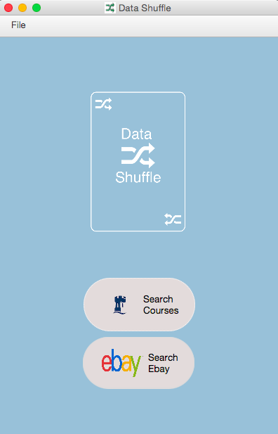ata Shuffle is a way to visualize data scarped for the internet. You’re able to search any course within the University of Nottingham, and it will categorize and present to you all of your modules by year, and it will also organize them into optional and compulsory modules. This is a great way for students at the University to make decisions regarding their course / module choices. Data shuffle also has the same functionality for receiving listings for eBay: search what you want, and it shows it to you for a great medium of analysis and decision-making.

Once launched, data shuffle will present you with a Splash Screen:

From here, you are able to choose what you website you would like to search from: eBay, by clicking Search eBay, and Courses, through Search Courses. Clicking **Open** from the **File** menu allows the user to choose their state save from previous sessions, if they would like to.

There are two possible windows, depending on the user’s choice. The *Course* search window allows you to search either with a course code, or by entering your course name.

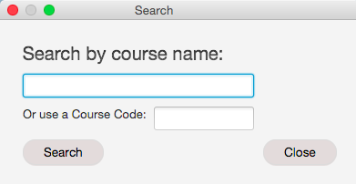 There is the *eBay* search window, which allows you to enter what you want to search, but also specify a price range, and if it’s being sold via auction or sale.

From either window, the user **must** enter their search terms, and then click **Search.** From here, the application will begin scarping the user’s data, which may take up to 15 seconds.

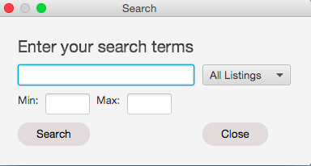

However, if you are using the course scraper, it may return a window for the user to make a decision, to specific which course they meant.

The User **must** pick one, then **click “**OK”.

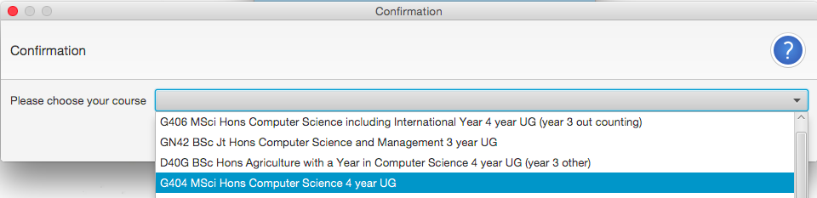

Using the Interface

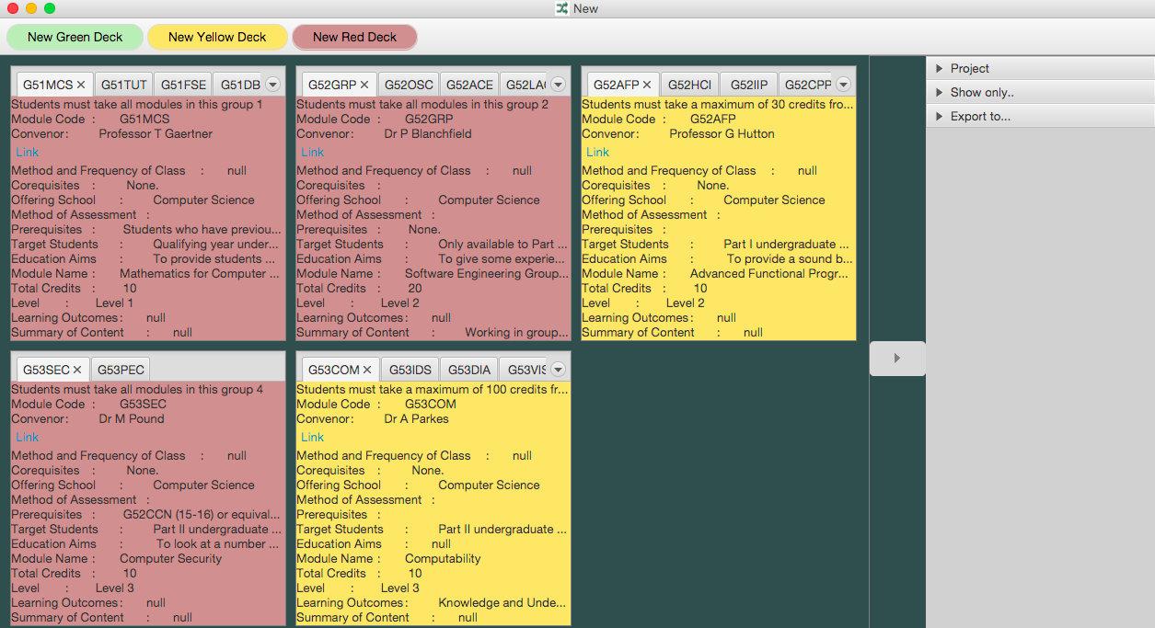

This part of the application is the ‘Digital Desk’, where all the data is presented in ‘Decks.’ Above shows the results for a course search of *Computer Science.* Initially, all of the data is presented by each year, and also categorized by red and yellow containers, red for all the optional modules, yellow for the optional modules. The user is then allowed to move pages, known as cards, between decks, by clicking the **tab** of the card, and **dragging** it into the desired deck.

Right clicking on the card’s tab results in a menu, which has options to color the tab, rename the tab, and delete the tab’s respective card.

Right clicking within the boundaries of the card will prompt the user with another menu, this time to resize the whole deck, as well as a delete option, to either delete the whole deck, or just the card that’s chosen in the deck.

To create a new deck, the user must **click** one of three *“*create new deck*”* options at the top of the app, to create either a green, yellow or red deck.

The collapsible side bar contains functionality, to start a new project, save the current project, filer fields within each card, and export the project’s state to excel.

To start a new project, **click** new. To save the current project, click **Save As**

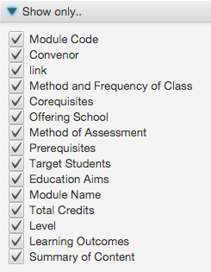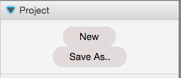By **clicking** any of these fields, the user is able to filter the respective data within each card, to remove fields that may not be wanted by the user.

**Clicking** excel will export the project’s state into excel.

