Report: Human-Computer Interaction Assignment 2

Group 27

Members: Chiyuan Mei(s1927134)

Ruofei Qian(s1872408)

Contents

1 Introduction 2

2 Reasoning for selecting interview 2

3 Methodology 2

3.1 advertisement 2

3.2 Participants 2

3.3 protocol 3

3.4 Data 3

3.5 Analysis 3

4 Results 4

4.1 Task 1 – Create a new album 4

4.2 Task 2 – Remotely send a photo 4

4.3 Task 3 – Photo navigation 4

4.4 Task 4 – Photo editing 5

4.5 General review 5

5. Recommendation 6

6. Reflection 7

6.1 from s1872408 7

6.2 from s1927134 7

Appendix 8

A. the question list 8

B. Sample of data from interview 11

C. Ethic Form 20

D. Consent Form Template 23

E. Participants Sheet Template 24

1 Introduction

This report is aimed to evaluate another group’s interface design about a photo frame which should include 2 basic functionalities 1) create a new album and 2) remotely add a photo to someone else’s photo frame and some other functionalities (based on the number of groups). This group add two extra functions include photo navigation and photo editing.

The evaluation is based on that group’s report, their demonstration from the given Figma URL and the participants’ feedback in our interview.

2 Reasoning for selecting interview

We use Interview methodology to do this study. Concretely, we make interview with 3 people, asking them some questions for their opinions about some important points in each task.

After receiving work from another group, we have evaluated it ourselves and thus obtain some conclusion about this design. Based on the study that we achieved, we are able to make interview more pinpointed with prepared questions. So, we believe interview, especially structured interview will be more suitable to verify the correctness of our conclusion.

3 Methodology

3.1 advertisement

The interviewees were told to have an interview of evaluating a user interface design of our HCI coursework2. We generally invited the students of Informatics from the University of Edinburgh. We reposted this advertisement to our WeChat group and received 6 response. Finally, we invited 3 of them to attend our interview.

3.2 Participants

The 3 participants are all MSc Computer Science students. Generally, they all have some relevant background knowledge about UI design so that we may be able to get more reasonable answers from them.

3.3 protocol

We used structured interview because we have already reviewed the work from other group, so that we have had some basic conclusion about its design. But we still felt confused about some parts of the design. For the confused part we made a specific question list for our interviewees. The prepared questions are all in the Appendix A.

For each interviewee, from the beginning, they will be told what exactly they will be interviewed is to evaluate a photo frame application on the phone. Then for each task, they will be given some time to get familiar with the interface and after that, we would ask them several questions for that part. Meanwhile, we will take notes according to their answers for later analysis. These notes will be placed in Appendix B.

3.4 Data

Each interview may last half an hour for about 20 questions in total for 5 parts (4 tasks and a general part). We invited 3 people to do this interview and the notes will be recorded by handwriting. Besides, the records of these data will be destroyed after finishing Human-Computer Interaction course this semester.

3.5 Analysis

We will compare answers from different people for same question. Generally, based on whether the majority provide similar answers for same question. If yes, the answer will be our final conclusion and we will put forward our suggestion / evaluation based on that. If not, or the answers are various, we will list most common choices and suggest that the designer provide multiple choices for users to select as their preference.

4 Results

4.1 Task 1 – Create a new album

a) 2 participants believe that they need the functionality to build an empty album while another believes this function may be useless. So that it is likely that the designer may need to take this into consideration, whether add this option as a choice when create a new album.

b) All the participants show their demand to import pictures from local file system and only one said he also need to import photos from social platforms. Additionally, he requires to use WeChat which is not presented in current available list.

c) As to the ways of connecting devices, everyone has their own preference (URL, Blue-tooth and from phone contact list and etc), so It can be necessary to allow users themselves to select the way they prefer to connect to others’ devices.

4.2 Task 2 – Remotely send a photo

a) all interviewees think they need the functionality to send an entire album other than send some photos remotely.

b) 2 participants think they should be able to select multiple photos from different albums while the other one says he do not need this function.

4.3 Task 3 – Photo navigation

a) All participants think they should be able to select some pictures in an album to play rather than select an album to play all the photos in it.

b) All participants wish to select play mode when playback (loop play or stop play at the end).

c) The design on Playback page is confusing, most interviewees think button Play / Pause / Next / Previous are work with music control rather than photo playback control. It may be a misleading place in the UI design.

d) Participants give different answer about whether the music player should be built-in function or from external source, but they all think they should be able to import their own play lists.

4.4 Task 4 – Photo editing

a) 2 participants have no experience in editing photo and do not know what exactly the given icons mean, which may lead to some incorrect operations.

b) All participants believe that the original pictures do not present completely in size and scale, which may cause some trouble in editing.

4.5 General review

a) All interviewees hope to have “backward” button (<) for them to get back to the previous page.

b) When cancelling some operations, all interviewees wish to have a confirmation prompt to avoid mis-operation.

c) 2 interviewees think icons with only symbols is good while the other think icons with symbols and words are better. Anyway, symbol can be seen as a necessary part in icon which can make interface clear and simple.

d) 2 participants think they need drop-down list instead of the bottom tool bar while the other think the function content should be modified rather the bottom tool bar. They all think the icons with only words are not suitable and should be changed.

e) Participants have different preference on the background colour, but they all believe that the colour of the bottom tool bar is not recognizable enough and need to be modified.

f) For the slide bar, all interviewees think there should be numerical value provided to indicate what values they are at.

5. Recommendation

The provided demonstration is not interactive without prototype, so we are not able to understand totally how the interface works exactly and its inner logic. The recommendation are put forward based on the given sequence diagrams.

For task 1, this design does not provide the function to allow user to create an empty album, which can be added to the interface as a new option.

For task 2, it may be better to allow user to be able to select albums other than pictures that they want to share with others.

For task 3, can add a function that allow user to select some photos to play rather than play all the contents in an album. Besides, the UI design of the Playback page is confusing and need to be re-designed, the suggestion is not to use classic music play symbols to control photo playback. Additionally, make play modes be available for users to select may be a good idea.

For task 4, explanations for the edit icons are needed to avoid wrong operations, for example, add a guidance when first time user opens that page, or generate a document about the meanings and how they work exactly. And when editing photos, their original size and scale should be respected.

Finally, “backward” button with confirmation should be added to each single page except the initial one. Some icons like “undo”, “send to device” should be changed from word-based icons to symbol-based icons to keep the interface simple and clear. Besides, the colour of the tool bar at the bottom should be more recognizable (grey and white show low contrast). There should be digital values on each slide-bar that allow users to adjust some values

6. Reflection

6.1 from s1872408

I think the number of our interviewees are still too small, sometimes there are various answers for same questions, every time this condition can make us feel difficult because it is still hard to see the mainstream view about some specific points, or exactly different people have different views about them. Besides, during our structured interview, we found that some parts / questions are useless. That maybe because we do not have enough number of participants to support unstructured interview that can help us understand what exactly users are concerned. Next time if we choose interview as our methodology, we may need to plan to have more participants to make a larger sample to get data from.

6.2 from s1927134

In my opinion, some questions of the interview prepared in advance are not structed actually. Some questions are useless and meaningless about the evaluation. For the next time doing the interview, some questions should be modified or even removed and other questions should be added to adjust the questionnaire during the whole process of the interviews. Furthermore, participants should get the chance to talk about his feeling about the target application rather than just answering questions.

# Appendix

1. the question list

Hello, my name is Ruofei Qian and today I will be interviewing you about your opinion with a photo frame application on the phone. This is Chiyuan Mei who will be taking notes. We may use some of the information you give us in our HCI coursework2, but we will not use your name or any other identifying information. Please remember that our goal today is to get your feedback about the photo frame interface design. There are no wrong answers. I have a set of questions on a sheet right here in front of me, and I will be asking them to you one by one. We will provide you several interfaces which provide different functionalities including creating new albums, remotely sending photos, photo navigation and photo editing. Then I will give you several minutes to get familiar with the interfaces respectively, when you say “OK” then we start.

Now you are familiar with the first interface about creating a new album, then we start:

1. when creating album, do you wish the frame provides the function to create an empty album or you must create album with photos?

2. Where do you always import photos from? Social platform or local file system? If Social platforms, are there some missing platforms that you used?

3. Do you like to create / modify a special alias to each device you want to connect with? Which way do you prefer to add target devices, URL, IP address, Bluetooth or WiFi?

Then I will give you several minutes to get familiar with the next interface, then we start:

1. Do you like to select photos first then the target device or select target device first then photos?

2. Do you want to have a functionality that allow you select an album to send all the photos in it directly when you want to send photos?

3. Do you want to have a functionality that allow you select multiple photos from multiple albums?

Then I will give you several minutes to get familiar with the next interface, then we start:

1. When play photos, do you like to have a functionality that allow partial photos in an album instead of selecting an album to play all the pictures?

2. Do you prefer to loop photo and music playback or stop at the end?

3. What the functions of the Pause button?

a) stop photo playing

b) stop music playing

c) both stop

4 What the functions that the Next / Previous button?

a) next / previous photo

b) next / previous music

c) both

5. What the functions that the “Turn Off” button?

a) stop photo playing

b) stop music playing

c) both stop

6. What the functions that the Speed bar?

a) change speed of photo playing

b) change speed of music playing

c) both change

7. Do you want to have a music player provided by this application or some external music application? If external application, which one do you prefer? If not, do you want to load music from local file system or from Internet?

Then I will give you several minutes to get familiar with the next interface, then we start:

1. Have you learnt something about editing photos? Do you the meaning of the 3 icons in the edit photo page? If not, do you need some explanation about each of them or you want to find how to use them yourself?

2. In the photo editing page, the scale of the photo has been changed, do you want to keep the original size?

3. About UNDO function, do you want to undo all the changes or step by step?

Generally, after finishing all the parts above, I now have some general questions about the design:

1. Do you prefer to have a backward button to let you get to the previous page?

2. When you do such kind of backward operation, do you want to have a confirm prompt?

3. What kind of icon do you like?

a) only words

b) only symbol

c) both

4. Do you like the style of the toolbar at the bottom and the other icons? If not, what style do you prefer, what kind of modification do you want to make?

5. Do you like the general colors of each part of interface? Do you think it is hard to recognize?

6. About the bars for making edit, is it necessary to show you the exact numerical values?

1. Sample of data from interview

Interviewee A

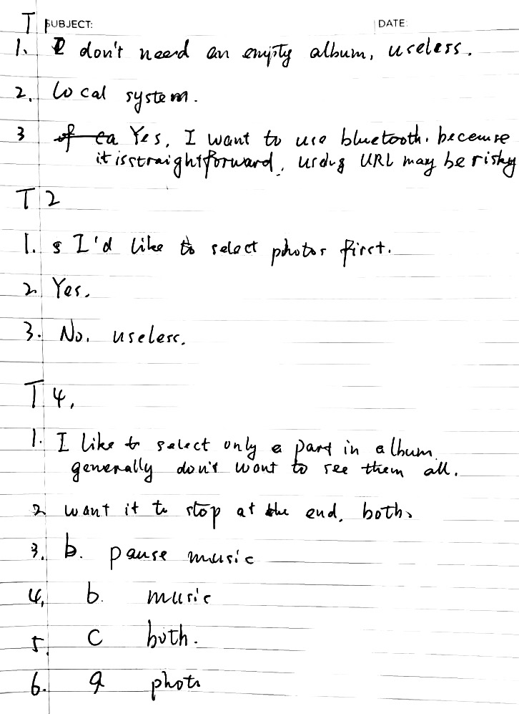

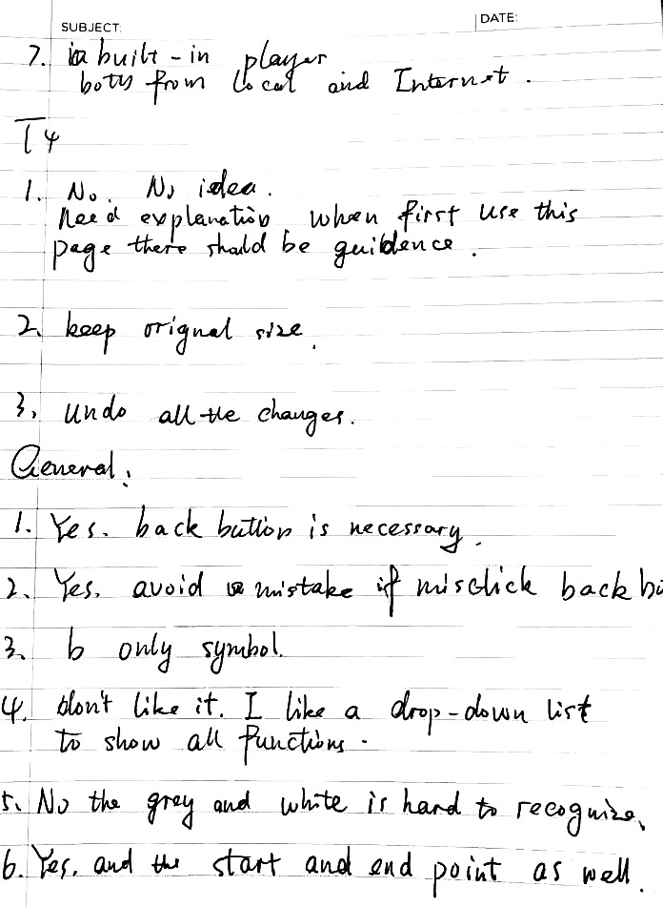

Interviewee B

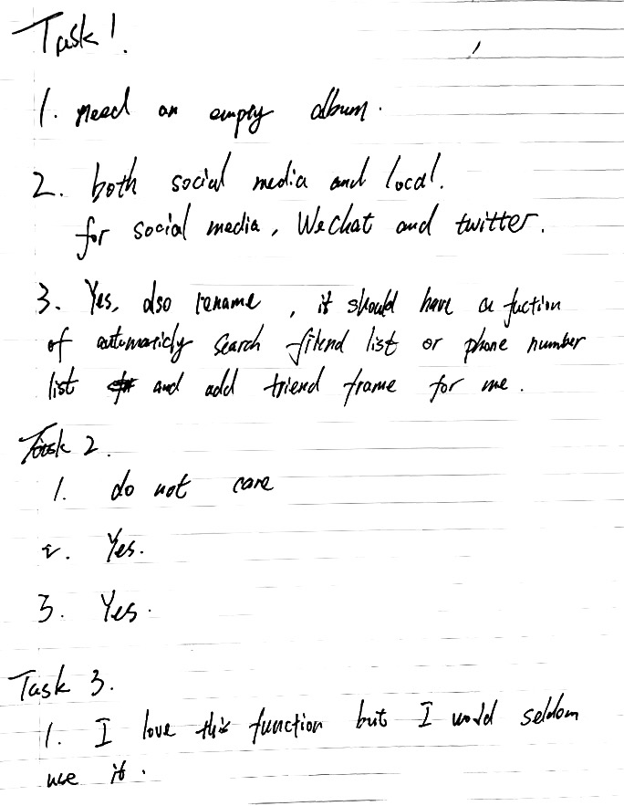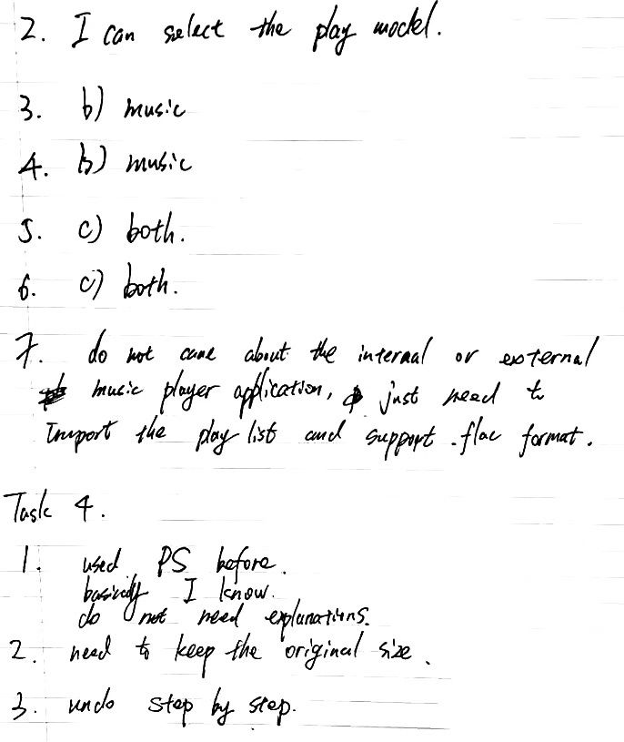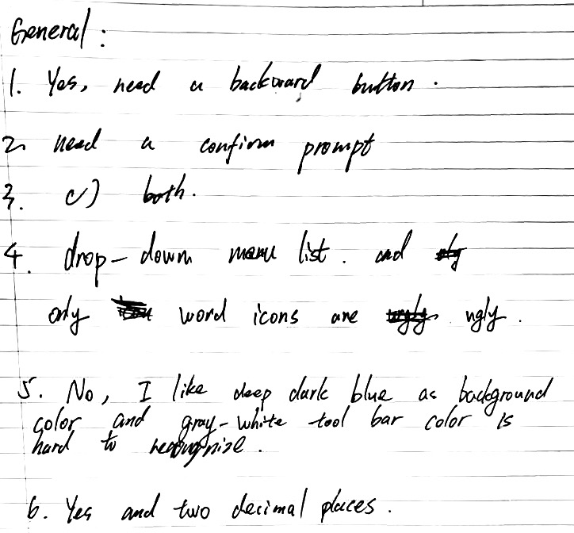

Interviewee C

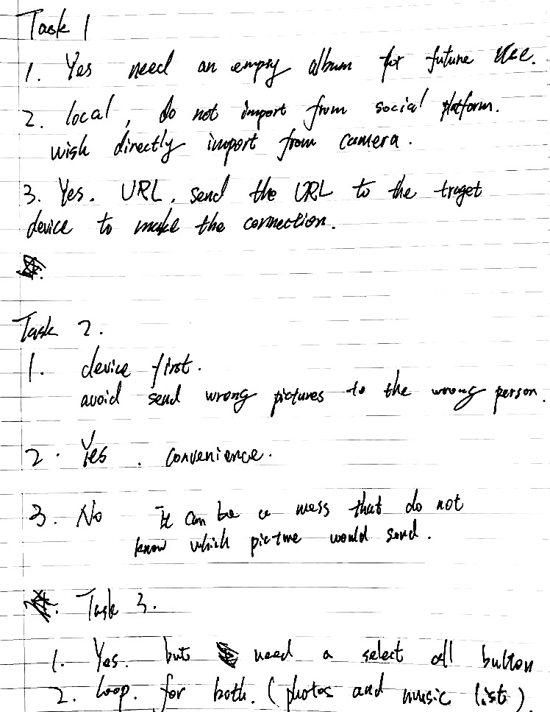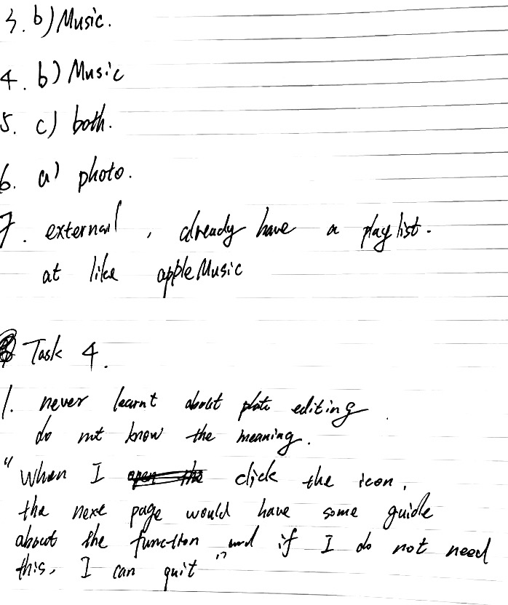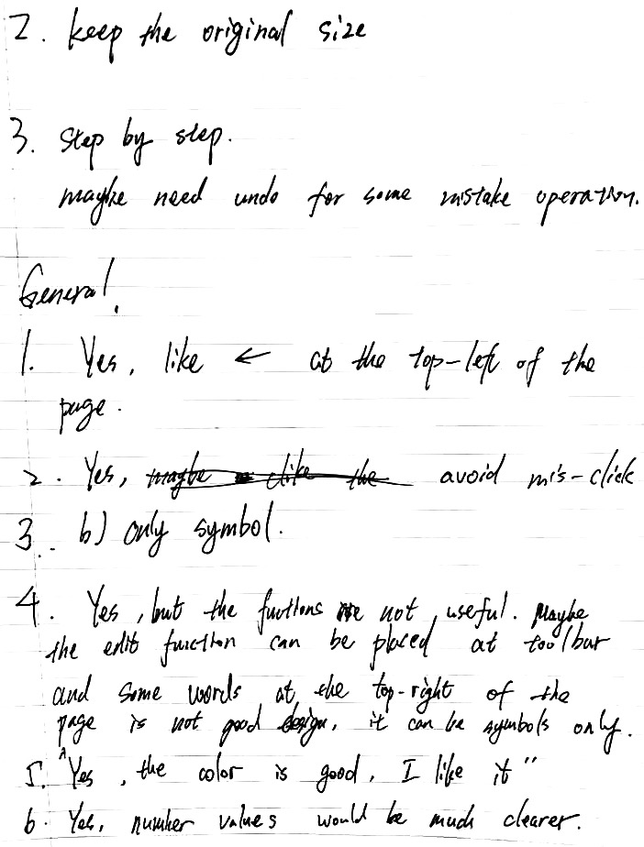

1. Ethic Form

**HCI Coursework 2 Ethics -**

The form consists of three parts. The first part is the project form, which is a list of questions specific to the HCI coursework. The later parts are taken from the official Ethical Reviews Procedure for Level 0 and 1, used by the School of Informatics.

Please fill out all sections and submit the final document on Learn.

**Project Details**

1. Name and UUN of Students involved:

Name 1: Ruofei Qian__________________UUN1: s1872408____________________

Name 2: Chiyuan Mei_________________ UUN2: s1927134____________________

2.In 3-4 sentences, please briefly explain what your project is, the goal, and the intended protocol for each participant:

We are studying the mocked-up Pix-Star photo frame app which allows users to create images locally in self-created albums and share them online / on others’ album remotely. This study is aimed to evaluate the usability of the app interface based on design principles.

3. Which methodology does your team intend to use?

Interview

4. How many participants do you intend to have?

Between 2 and 4

**Do You Need Ethics? Level 0 Check**

These questions help determine whether you need to submit a full Level 1 or Level 2 Ethics application, and whether the School of Informatics is the appropriate institution for granting permission.

1. Does your work involve human participants?

Yes

No

2. Does your work involve confidential or personal data? This includes, for example, information about physical and mental health, race, ethnicity, political opinions, religious beliefs, trade union membership, sexual orientation, genetic data, biometric data.

Yes

No

3. Will you need to use tools or services that do not comply with General Data Protection Regulations (GDPR) 2018 to collect data from human participants or to collect secondary data (e.g., from Social Media)?

Yes

No

4. State which professional organisation guidelines you are using:

School of Informatics research ethics code: <http://www.inf.ed.ac.uk/research/ethics/>

Other ethics code as required by funding body or professional organization:

Title: _______________________________URL:_____________________________

**Working with Human Participants**

Working with Human Participants

This section applies to you if your research involves working with people or actively observing people (e.g., ethnography).

Note that you need consent so that you can collect data ethically form participants. However, consent is no longer the legal basis for processing data - this is Article 6(1)(e), the public task of the University.

Consent can be withdrawn - the University's public task remains.

1. Are all participants aged 18 and over?

Yes

No, but we will seek consent from both children and parents/guardians for those who are under age

No, and we will not seek consent from parents/guardians

2. Are all participants able to understand their rights and provide informed consent to data collection?

Yes

No

3. How do you obtain informed consent? This also involves telling your participants about your obligations under the General Data Protection Regulation Act (GDPR, 2018). Tick all that apply.

Participants will complete a paper consent form

Participants will consent using an electronic form

Other, please explain:

__________________________________________________________________

4. How do you ensure confidentiality? Describe your procedures for anonymisation / pseudonymisation, ensuring differential privacy, and other relevant procedures. Recommended length: 50 words.

Interview recordings are being collected for note taking purposes only. Any inadvertent mention of names or identifying information will not be recorded in coursework documents.

**Data Protection and Management**

We confirm that all researchers from the University of Edinburgh have completed the mandatory data protection training on LEARN. If you are not sure what the training is or what it involves, the link will take you to the University web page that explains what is involved.

Yes

No

1. What information about participants or data subjects will you collect or use?

we will ask participant to attend an interview that will contain some general questions about the app interface design and only the answers provided by participants will be recorded for note taking purpose. The whole procedure will keep anonymous, all personal information like name, ID number, e-mail will not be involved / recorded.

2. What safeguards do you have in place that ensure that you will only use the absolute minimum of personal data required, anonymise personal data where possible, pseudonymise where anonymisation is not possible?

Your data will be referred to by a unique participant number and will only be viewed by the students and instructors on the Human-Computer Interface course.

3. If any part of the research involving participants will be recorded using any electronic medium, what medium is to be used and how will the recordings be used?

Interview recordings will only be used for notes. They will not be shown outside the research group.

All electronic data will be stored on a password-protected encrypted computer, on the School of Informatics’ secure file servers.

4. Who will have access to the raw data?

The students on the project, the lecturers may also see the files if there is a problem.

5. How will you store data securely?

Interview recordings will be saved on the School of Informatics’ secure file servers or an encrypted computer.

6. Will the datafiles/audio tapes, etc. be disposed of after the study?

Yes.

1. Consent Form Template

**Participant Consent Form**

|  |  |
| --- | --- |
| Project title: | Evaluate mocked-up Pix-Star photo frame App Interface |
| Principal investigator (PI): | [Aurora Constantin](http://www.inf.ed.ac.uk/people/staff/Aurora_Constantin.html) ([Aurora.Constantin@ed.ac.uk](mailto:Aurora.Constantin@ed.ac.uk))  [Kami Vaniea](mailto:Kami%20Vaniea) ([Kami.Vaniea@ed.ac.uk](mailto:Kami.Vaniea@ed.ac.uk)) |
| Researcher: | Ruofei Qian ([s1872408@ed.ac.uk](mailto:s1872408@ed.ac.uk))  Chiyuan Mei ([s1927134@ed.ac.uk](mailto:s1927134@ed.ac.uk)) |
| PI contact details: |  |

**Please tick yes or no for each of these statements.**

|  |  |  |  |
| --- | --- | --- | --- |
|  |  | **Yes** | **No** |
| **1.** | I confirm that I have read and understood the Participant Information Sheet for the above study, that I have had the opportunity to ask questions, and that any questions I had were answered to my satisfaction. |  |  |
|  |  | **Yes** | **No** |
| **2.** | I understand that my participation is voluntary, and that I can withdraw at any time without giving a reason. Withdrawing will not affect any of my rights. |  |  |
|  |  | **Yes** | **No** |
| **3.** | I agree to being audio recorded |  |  |
|  |  | **Yes** | **No** |
| **4.** | I consent to my anonymised data being used in academic publications and presentations. |  |  |
|  |  | **Yes** | **No** |
| **5.** | I understand that my anonymised data can be stored for a minimum of one years |  |  |
|  |  | **Yes** | **No** |
| **6.** | I allow my data to be used in future ethically approved research. |  |  |
|  |  | **Yes** | **No** |
| **7.** | I agree to take part in this study. |  |  |

|  |  |  |  |  |
| --- | --- | --- | --- | --- |
| Name of person giving consent |  | Date |  | Signature |
|  |  |  |  |  |

1. Participants Sheet Template

**Participant Information Sheet**

|  |  |
| --- | --- |
| Project title: | The mocked-up Pix-Star photo frame App |
| Principal investigator: | [Aurora Constantin](http://www.inf.ed.ac.uk/people/staff/Aurora_Constantin.html) ([Aurora.Constantin@ed.ac.uk](mailto:Aurora.Constantin@ed.ac.uk))  [Kami Vaniea](http://www.inf.ed.ac.uk/people/staff/Kami_Vaniea.html) ([Kami.Vaniea@ed.ac.uk](mailto:Kami.Vaniea@ed.ac.uk)) |
| Researcher collecting data: | Ruofei Qian ([s1872408@ed.ac.uk](mailto:s1872408@ed.ac.uk))  Chiyuan Mei ([s1927134@ed.ac.uk](mailto:s1927134@ed.ac.uk)) |
| Funder (if applicable): |  |

This study was certified according to the Informatics Research Ethics Process, RT number 1432.

**Who are the researchers?**

This study is being conducted as part of the Human-Computer Interaction course at the University of Edinburgh. The researchers are Ruofei Qian (s1872408), and Chiyuan Mei (s1927134). The course lecturers are Dr Kami Vaniea, and Dr Aurora Constantin.

**What is the purpose of the study?**

We are studying the mocked-up Pix-Star photo frame app which allows users to create images locally in self-created albums and share them online / on others’ album remotely. This study is aimed to evaluate the usability of the app interface based on design principles.

**Why have I been asked to take part?**

We are advertising the study to people who are currently at University of Edinburgh and are over 18 years old.

**Do I have to take part?**

No – participation in this study is entirely up to you. You can withdraw from the study at any time, without giving a reason. Your rights will not be affected. If you wish to withdraw, contact the PI. We will stop using your data in any publications or presentations submitted after you have withdrawn consent. However, we will keep copies of your original consent, and of your withdrawal request.

**What will happen if I decide to take part?**

We will ask you to evaluate the mocked-up Pix-Star photo frame app interface based on the given report in Human-Computer Interface assignment 1. Concretely, we will ask you to attend an interview that will contain some general questions about the app interface design, like do you think it is easy to use? which part do you think can be improved to be more user-friendly?

**What kind of data will be collected during the study?**

We will only collect the answers you provided during the interview. Your personal information will not be recorded.

**Are there any risks associated with taking part?**

There are no significant risks associated with participation.

**Are there any benefits associated with taking part?**

You will receive no compensation for participating in this study.

**What will happen to the results of this study?**

The results of this study will only be used within Human-Computer Interface assignment 2. We will delete all recordings at the end of the study.

**Data protection and confidentiality.**

Your data will be processed in accordance with Data Protection Law. All information collected about you will be kept strictly confidential. Your data will be referred to by a unique participant number and will only be viewed by the students and instructors on the course.

All electronic data will be stored on a password-protected encrypted computer, on the School of Informatics’ secure file servers, or on the University’s secure encrypted cloud storage services (DataShare, ownCloud, or Sharepoint) and all paper records will be stored in a locked filing cabinet in the PI’s office. Your consent information will be kept separately from your responses in order to minimise risk.

**What are my data protection rights?**

The University of Edinburgh is a Data Controller for the information you provide. You have the right to access information held about you. Your right of access can be exercised in accordance Data Protection Law. You also have other rights including rights of correction, erasure and objection. For more details, including the right to lodge a complaint with the Information Commissioner’s Office, please visit [www.ico.org.uk](http://www.ico.org.uk). Questions, comments and requests about your personal data can also be sent to the University Data Protection Officer at [dpo@ed.ac.uk](mailto:dpo@ed.ac.uk).

**Who can I contact?**

If you have any further questions about the study, please contact the instructors for the course: Dr Kami Vaniea (kvaniea@inf.ed.ac.uk) or Aurora Constantin ([aconsta2@staffmail.ed.ac.uk](mailto:aconsta2@staffmail.ed.ac.uk)).

If you wish to make a complaint about the study, please contact [inf-ethics@inf.ed.ac.uk](mailto:inf-ethics@inf.ed.ac.uk). When you contact us, please provide the state and detail the nature of your complaint.

**Updated information.**

If the research project changes in any way, an updated Participant Information Sheet will be made available on <https://web.inf.ed.ac.uk/infweb/research/study-updates>.

**General information.**

For general information about how we use your data, go to: edin.ac/privacy-research