**﻿Hippocampus serve as multimodal transdiagnostic biomarker**

**Introduction**

#para01

The Kraepelinian dichotomy, the broad classification of major mood and psychotic illness into ‘manic–depressive’ psychosis and schizophrenia, has been enshrined for over a century and highly influenced the development of modern psychiatry (Kraepelin, 1920). The main principle of modern psychiatry argues that mental disorders are separate diagnostic categories with distinct neurobiological borders and clinical presentations. However, there are no clear-cut boundaries among different mental disorders. On the one hand, comorbidity (the presence of two or more disorders) is common in mental health. Clinically, the schizophrenia (SZ), major depressive disorder (MDD), bipolar disorder (BP), and obsessive-compulsive disorder (OCD) shared symptoms such as depression and anxiety (Barch and Sheffield, 2014, world psychiatry; Lee et al. 2015, Translational psychiatry). (however#1, done) One the other hand, genetic, molecular and neuroscientific research over recent decades have failed to identify specific sets of genetic or neural dysfunction that can differentiate different illness categories (Cross-disorder group…Lancet, 2013). For example, of substantial overlap in the genetic factors that increase risk for both affective and psychotic disorder (Purcell et al., 2009, nature; Lichtenstein et al., 2009, Lancet). Consistently, a broad range of mental disorders were found to share the same brain network dysfunction (Matthews and Hampshire, 2016; Baker et al., 2019, PNAS). (however#2, done) These evidences indicated that each mental disorder is better understood and defined as a combination of diagnosis-specific as well as transdiagnostic features.

#para02

Identifying the shared and specific vulnerabilities across psychiatric disorders could light the development of novel transdiagnostic treatments to decrease risk of psychopahthology across disorders, also be helpful for future classification schemes (Husain, 2017, Brain). Many studies, however, utilize case-control design and have only compared single of psychiatric disorder with healthy controls (HC). Which may mask the substantial overlap and give the illusion of group specificity. Recently, some empirical transdiagnostic studies have investigated the shared and distinct neurobiological features in large-scale brain networks, grey matter or white matter across multiple mental-disorders. For example, affective and psychotic illness shared disruption in frontoparietal network (Baker et al., 2019, PNAS), and all showed lower fractional anisotropy values in callosal, limbic-paralimbic-heteromodal white matter relative to healthy controls (Chang et al., 2018, SB). SZ, MDD, BP and PTSD patients were all characterized by greater gray matter volume in the putamen than healthy controls (Gong et al., 2019). But whether there were some consistent transdiagnostic markers or psychiatric core areas across illness categories in multimodal imaging? Identifying these regions, or one of core regions, may shed light on developing new generation of anatomically directed brain stimulation treatments for mental disorders.

#Para03-introducing the hippocampus

We hypothesize the hippocampus, could be the transdiagnostically central hub across mental disorders in multimodal imaging. Previous large-scale meta-analyses of structural neuroimaging studies across diverse diagnostic groups (SZ, BP, MDD, addiction, OCD, anxiety) found that the grey volume loss in hippocampus was one of the common features across diagnoses, specifically, this feature was more evident in nonpsychotic disorder group (i.e., exclude the SZ group) (Goodkind et al., 2015, JAMA psy). Moreover, hippocampus is a critical brain region to regulate stress response in humans. Loss of hippocampal neurons due to exposure to stress has been reported in several psychiatric disorders that are related to stress events, such as SZ and MDD (Phillips et al., 2006; Driessen et al., 2000).

#Para04-introducing the current study

The aim of the present study was therefore to investigate whether the deficits in hippocampus was common across four psychiatric disorders (bipolar disorder, major depression disorder, obsessive-compulsive disorder, schizophrenia). Critically, this study combined multi-modal neuroimaging included structural MRI, resting state fMRI, and diffusion tensor imaging, which may give us full perspective about the trans-diagnostic neural features underlying different illness categories. To exclude the possibility that some results might be attributed to treatment effects, the current study only recruited medication-naïve individuals suffering from four psychiatric disorders, including BP (n=49), MDD (n=100), OCD (n=56), SZ (n=168), and healthy controls (n=210). Of note, all participants’ data were collected using the same scanner and acquisition sequence to ensure the data comparability.

**Method**

***Ethic approval****.* The experimental protocol was in accordance with principles of the Declaration of Helsinki and approved by a local Research Ethics Committee of the Second Affiliated Hospital of Xinxiang Medical University (Xinxiang, China). All participants provided written informed consent after the experimental procedure had been fully explained and were informed of their right to withdraw at any time during the study.

***Participants.*** We collected resting-state functional magnetic resonance imaging (fMRI) data from 583 individuals, including 210 healthy controls (HC, free of current or a history of psychiatric disorders) and 373 patients who were diagnosed with bipolar depression (BP, *N* = 49), major depression disorder (MDD, *N* = 100), obsessive compulsive disorder (OCD, *N* = 56), and schizophrenia (SZ, *N* = 168). All patients were screened using non-structured interviews based on the diagnostic criteria of the DSM-IV by independent experienced psychiatrists from the Second Affiliated Hospital of Xinxiang Medical University (Xinxiang, China). Thirty-eight participants (MDD = 2, OCD = 4, SZ = 26, HC = 6) were excluded from the subsequent resting-state analyses due to significant head motion (above 2.5 mm or 2.5° in any directions, see *Data preprocessing for resting state* for more details). Thus, data from 545 participants were included in the formal data analysis: 49 with BP, 98 with MDD, 52 with OCD, 142 with SZ, and 204 HCs. Seven participants (SZ = 2, HC =5) had abnormal T1 image, thus we included 576 participants into voxel-based morphometry analyses, including 49 with BP, 100 with MDD, 56 with OCD, 166 with SZ, and 205 healthy controls. There were 389 participants who also had their diffusion imaging data, including 49 BP patients, 94 MDD patients, 51 OCD patient, 87 SZ patients and 108 healthy controls. Demographics information and clinical characteristics of all patients and healthy controls were shown in Table S1.

***Neuropsychological and neuropsychiatric assessment.*** We also asked participants to complete questionnaires to assess related symptoms of each disorder. Psychiatry symptoms of SZ patients were obtained using the Positive and Negative Syndrome Scale (PANSS) (Kim et al., 2012). BP and MDD patients completed the Beck Anxiety Inventory (BAI) (Beck et al., 1988) and Beck Depression Inventory (BDI) (Beck et al., 1961) assess their affective symptoms. The Yale-Brown Obsessive-Compulsive Scale (Y-BOCS) (Goodman et al., 1989) were employed to assess the obsessive thoughts and compulsive behaviors of OCD patients. We calculated the total scores of each questionnaire and reported them in Table S1.

***Image acquisition***. Functional brain images were acquired using a 3-Tesla Siemens Trio scanner at the Second Affiliated Hospital of Xinxiang Medical University (Xinxiang, China). Blood oxygen level-dependent (BOLD) gradient echo planar images (EPIs) were obtained using a 12-channel head coil [64 × 64 × 33 matrix, voxel size = 3.44 × 3.44 × 4 mm3, repetition time (TR) = 2000 ms, echo time (TE) = 30 ms, flip angle = 70°, field of view (FOV)=256 × 256mm2]. A high-resolution T1-weighted structural image was subsequently acquired (256 × 256 × 144 matrix with a spatial resolution of 1 × 1 × 1 mm, TR = 2530 ms, TE = 3.37 ms, inversion time (TI) = 1100 ms, flip angle = 70°).

The dMRI images were acquired using a diffusion-weighted echo-planar imaging (EPI) sequence covering the whole brain. Imaging parameters were as follows: 50 axial slices, 3.0 mm slice thickness, Repetition Time (TR)=8400 ms, Echo Time (TE)

=91 ms, Field of View (FOV)=128 mm2, b-values of 0 and 1000 s/mm2, in 64 non-collinear diffusion directions.

***Data preprocessing for resting state.***

The fMRI data was preprocessed using SPM12 (Wellcome Trust Centre for Neuroimaging, London). Similar to previous studies (Hampson et al., 2002, HBM; Long et al., 2008, JNmethod), the first 10 functional images were discarded to avoid initial steady-state problems. Remaining images were spatially realigned for head motion correction, and corrected for slice acquisition temporal delay. Functional images were then co-registered to each participant’s segmented gray matter T1-weighted image, spatially normalized to a common the Montreal Neurological Institute (MNI) space, and resampled into 3 × 3 × 3 mm3 voxels. Finally, all functional images were spatially smoothed with an isotropic 4mm FWHM Gaussian kernel.

***Diffusion magnetic resonance imaging data pre-processing***

The diffusion-weighted imaging datasets were analyzed within the FMRIB software library framework (http://fsl.fmrib.ox.ac.uk) using a MATLAB toolbox named “pipeline for analyzing brain diffusion images” (PANDA) (Cui et al., 2013). The raw data for each participant were corrected for head motion, adopting eddy current correction, by registering the diffusion weighted images to the b = 0 images with an affine transformation. Diffusion tensor metrics were then calculated (applying dtifit of FSL) in a voxel-wise fashion within the brain mask including fractional anisotropy (FA), mean diffusivity (MD), axial diffusivity (AD), and radial diffusivity (RD). For normalization, each patient’s FA images in the native space were non-linearly registered to the FA template in MNI space. Then the resulting images of the diffusion metrics (FA, MD, RD, AD) were normalized to the Montreal Neurological Institute (MNI) space and were resampled to 2 mm isotropic voxels, followed by spatial smoothing with a 4 mm Gaussian kernel to reduce image noise and misalignment between participants.

***Voxel-based morphometry.***

We used voxel-based morphometry from Computational Anatomy Toolbox 12 (CAT12; <http://www.neuro.uni-jena.de/cat/>). All T1-weighted images were preprocessed with default settings of the CAT12 toolbox, including corrections for bias-field inhomogeneties, segmentation into gray matter, white matter, and cerebrospinal fluid (CSF). The aforementioned segmented images were then normalized to the DARTEL template in standard Montreal Neurological Institute (MNI) space and resampled to 1.5⨯1.5⨯1.5 mm3. Modulated gray matter images were smoothed with an 8-mm full-width-half-maximum isotropic Gaussian kernel and used for further analysis.

***Calculation of degree centrality maps***

We computed degree centrality maps for each subject employing the similar approach shown in previous studies (Buckner et al., 2009; Zuo et al. 2012). Specifically, for each voxel *k*, we first calculated the functional connectivity between the whole BOLD signal time series within this given voxel *k* and the time-course of any other voxel within the mask of gray matter. Then the functional connectivity map was thresholded (r=0.25, consistent with previous study: Buckner et al., 2009;Hampson et al., 2012; Van Dijk et al., 2012) to yield binary map, that is, connections below this threshold were set to zero while the remaining connections were set to 1. The Degree centrality for this voxel was the sum of all non-zero connections within the binary map. This process was repeated for every voxel and resulted a whole-brain degree centrality maps for each subject. The Individual-level voxel-wise degree centrality maps were normalized by converting to z-scores, the resulting z maps were then smoothed (FWHM = 4 mm), and entered into group analysis.

***Node-wise structure-function relationships.***

To estimate the link between structure and function for each brain region, we adopted a multilinear regression model as same as previous literature did (Vazquez-Rodriguez et al., 2019), that relates node-wise structural and functional connection properties. Structural network for each participant was estimated from diffusion spectrum imaging (DSI), was constructed using deterministic streamline tractography, and the nodes of the structural network were adopted in a same manner as the nodes in the functional network. We constructed a multilinear regression model (Equation 1) for each given node *i*, the dependent variable and predictors kept same with previous work (Vazquez-Rodriguez et al., 2019), that is, we used the resting state functional connectivity (FC) between node *i* and all other nodes within in the network which was not *i* (for example, node *k*≠*i*) as dependent variable. And adopting Euclidean distance, path length and communicability as predictor variables. Specifically, path length and communicability were estimated from the binarized structural connectome based on Brain Connectivity Toolbox (<https://sites.google.com/site/bctnet/>; Rubinov and Sporns, 2010). The regression coefficients (*b*1, *b*2, *b*3) and intercept (*b*0) were estimated via ordinary least squares, then we adopted the goodness-of-fit to represent the correspondence between structural and functional networks for the given node, which was quantifying by the adjusted R-square.

*FCi* = *b*0 + *b*1*Euclidean distance i* + *b*2*Path lengthi* + *b*3Communicability*i*  (Equation 1)

**Automated Fiber Quantification**

Automated Fiber Quantification (AFQ; https://github.com/jyeatman/AFQ) was used as an independent validation method in order to confirm the mean FA of the manual tractography obtained across the entire tract. Instead of calculating mean diffusion properties across entire tracts, this method allowed for a more precise localization of group differences. The AFQ analysis pipeline is described extensively in Yeatman, Dougherty and Myall et al. (2012). Description of the steps with specific parameters used in this study is provided here:

1. whole-brain tractography was computed using a deterministic streamline tracking algorithm seeded with a white matter mask defined as all voxels with an FA value >0.1. Fiber tracking was terminated if the minimum angle between the last path segment and the next step direction was greater than 40°;

(2) individual fibers were assigned to a particular tract if they cross through the 2 waypoint ROIs that characterize the central portion of that tract. These ROIs were anatomically defined using the subject’s T1-image based on the procedure proposed by Wakana et al. (2004) and were created in MNI space on a group-average diffusion dataset. These ROIs were converted into each subject’s native space based on an estimated nonlinear transformation into MNI template space.

(3) Then, fiber tract probability maps developed by Hua et al. (2008) were transformed into each subject’s native space and used to determine the probability of individual fibers belonging to their assigned fiber group based on the voxels that they pass through. Fibers that passed through low-probability voxels were excluded from the fiber group. The fiber groups were further cleaned by removing all fibers that were >4 standard deviations.

The portion of fibers between two waypoint ROIs was clipped. And the resulting clipped tract was segmented into 100 equidistant nodes. Spline interpolation was used to calculate FA, radial diffusivity (RD), and axial diffusivity (AD) across each tract and at each of the 100 nodes of each tract for each subject. These diffusion properties were calculated by taking a weighted average of the measures of each fiber at that node. The weight of each fiber was determined based on the probability that the fiber belonged to the fiber group.

Because AFQ uses strict criteria for tract identification, the tracts of interest could not be located in all subjects (Langer et al., 2015). The number of participants in which automated tractography was successfully obtained for each tract are as follows: 23 BP patients, 24 MDD patients, 28 OCD patients, 29 SZ patients, and 33 healthy controls for the left uncinate. And 32 BP patients, 41 MDD patients, 30 OCD patients, 36 SZ patients, and 44 healthy controls for the right uncinate.

**Statistical analyses for grey volume, degree centrality, structural-functional coupling.**

We first examined the difference of the properties mentioned above in left and right hippocampus (HIP) of all groups (i.e., HC, BP, MDD, OCD and SZ) by adopting one-way analysis of covariance (ANCOVA), with Group (HC vs. BP vs. MDD vs. OCD vs. SZ) as factor, and with age, gender and education as covariates. Then did *post hoc* analyses to reveal the difference between each kind of disorder and healthy controls, as well to unravel the difference between any pair of disorder. All multiple comparisons were corrected by false-discovery rate (FDR), and significance was set to a corrected p < 0.05.

**Statistical analyses for Automated Fiber Quantification**

In order to statistically test group difference in diffusion properties in each segment of the left and right UF, we conducted pointwise comparison among all groups, with age, gender and education as covariates. All results were correct for multiple comparisons at each node along the tract.

**Results**

**Decreased grey matter volume in bilateral hippocampus were shared across psychiatric disorders compared with HC, also were distinct between SZ and OCD patients.**

Using one-way analysis of covariance (ANCOVA), with Group (HC vs. BP vs. MDD vs. OCD vs. SZ) as factor, and with age, gender and education as covariates, we found the main effect of Group was significant in bilateral hippocampus (left HIP: F(4,526)=9.205, p < 0.001, η2 = 0.066; right HIP: F(4,526)=11.523, p < 0.001, η2 = 0.082). *Post hoc* analyses revealed a significantly decreased grey matter volume of bilateral hippocampus in the BP, MDD, OCD, and SZ groups compared with HCs (all P < 0.050, FDR correction). And the SZ were associated with higher grey volume than OCD (SZ vs. OCD, left HIP: F(1,187)=7.854, p = 0.006, η2 = 0.041; right HIP: F(1,187)=8.459, p = 0.004, η2 = 0.044). MDD patients showed more grey volume than OCD patients in right hippocampus (right HIP: F(1,147)=5.871, p = 0.017, η2 = 0.039; Figure 1A, B). No differences were found other comparisons after FDR correction (all p > 0.070).

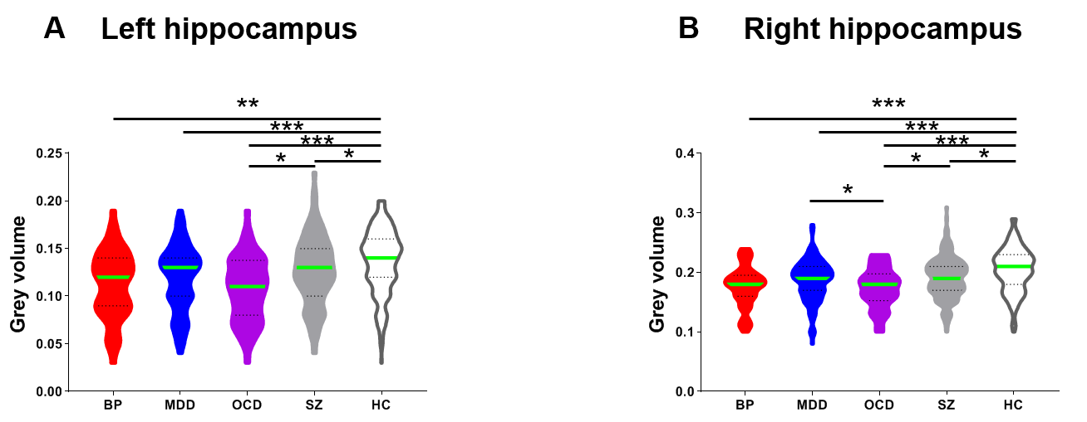

Figure 1. Results of grey volume within bilateral hippocampus.

(A, B) Differences in grey matter volume in bilateral hippocampus among the five groups. Violin plots represent the distribution of grey matter volume, parameter in each group and solid lines indicate the medians.

(Error bars represent standard error. p<0.05*, p<0.01**, p<0.001***).

**Decreased degree centrality in bilateral hippocampus were shared across psychiatric disorders compared with HC, also were distinct among all patients.**

Consistently, we did the same analyses and identified the significant main effect of Group (left HIP: F(4,500)=14.417, p < 0.001, η2 = 0.105; right HIP: F(4,500)=13.003, p < 0.001, η2 = 0.095). All patients had decreased degree centrality of bilateral hippocampus compared with HCs (all P < .001, FDR correction). Moreover, SZ were associated with higher dwell time than BP (SZ vs. BP, left HIP: F(1,162)=10.481, p = 0.001, η2 = 0.062; right HIP: F(1,162)=6.395, p = 0.012, η2 = 0.039) , MDD(SZ vs. MDD, left HIP: F(1,211)=11.869, p = 0.001, η2 = 0.054; right HIP: F(1,211)=11.240, p = 0.001, η2 = 0.052) and OCD (SZ vs. OCD, left HIP: F(1,165)=6.549, p = 0.011, η2 = 0.039; right HIP: F(1,165)=7.440, p = 0.007, η2 = 0.044; Figure 2A, B). No differences were found among other kinds of comparison (all p > 0.250). All results still remained unchanged after FDR correction.

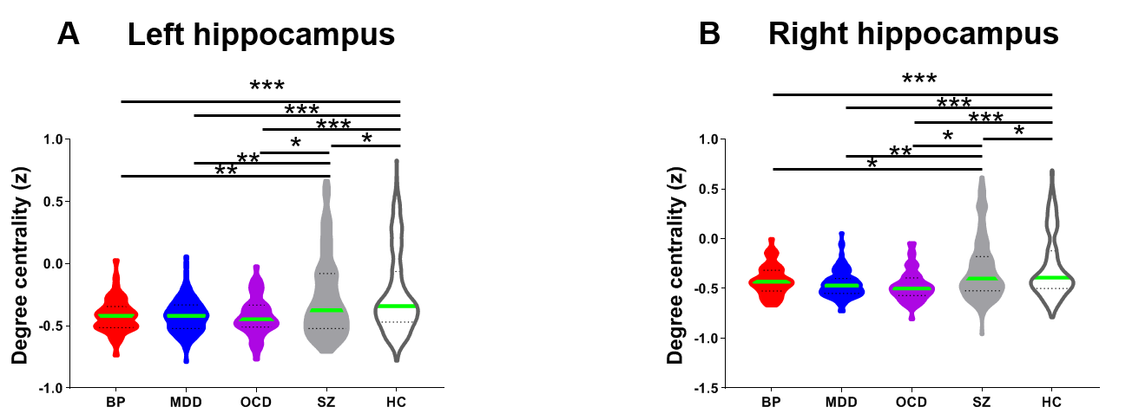

Figure 2. Results of degree centrality within bilateral hippocampus.

(A, B) Differences in degree centrality within bilateral hippocampus among the five groups. SZ patients revealed significantly higher degree centrality within bilateral hippocampus than BP , MDD, and OCD patients.

Violin plots represent the distribution of degree centrality, parameter in each group and solid lines indicate the medians. Error bars represent standard error. p<0.05*, p<0.01**, p<0.001***).

**Shared and distinct structure-function correlation in bilateral hippocampus across psychiatric Disorders**

We found significant main effect of Group on the structure-function associations in left hippocampus (F(4,354)=3.641, p=0.006, η2 = 0.040) but not right hippocampus (F(4,354)=1.906, p=0.109, η2 = 0.021; see Figure 3). *Post hoc* analyses revealed that only BP and MDD patients showed distinct weaker structure-function associations in left hippocampus than healthy controls (BP vs. HC: F(1,148)=9.269, p=0.003, η2 = 0.060; MDD vs. HC: F(1,192)=10.340, p=0.002, η2 = 0.052). No significant differences were detected from other comparisons (all p > 0.200). All results still remained unchanged after FDR correction.

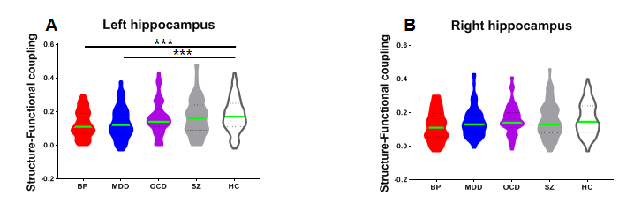

Figure 3. Results of structure-function correlation in bilateral hippocampus.

(A) BP and MDD patients showed weaker structure-function correlation in left hippocampus compared with HC. No differences were found for SZ and OCD patients when compared with HC.

(B) No significant difference was found among all groups in right hippocampus.

Violin plots represent the distribution of structure-function correlation, parameter in each group and solid lines indicate the medians. (Error bars represent standard error. p<0.05*, p<0.01**, p<0.001***).

**Group differences in tract profile of FA in bilateral uncinate**

In pointwise comparison of FA profile in bilateral uncinate, we found the inferior portion of the bilateral uncinate, and the 20%-30% percentile, as well as end of the right uncinate revealed significant difference among all groups (Figure 4). Specifically, in the inferior portion of bilateral uncinate, only BP and OCD patients showed distinct FA value relative to healthy controls. And the SZ patients showed larger FA than BP patients and OCD patients. BP patients had higher FA than OCD patients, then no difference was detected for any other comparisons. In the 20-30% percentile of the right uncinate, MDD and BP patients were distinct from healthy control, no differences were found between SZ and healthy control, neither for the OCD patients. No significant differences were found for other comparisons. In the end portion of right uncinate, only MDD and OCD patients were distinct from healthy controls. Moreover, MDD patients still showed largest FA, as well the OCD patients showed smallest FA than any other patients. And the difference between BP and OCD was not significant.

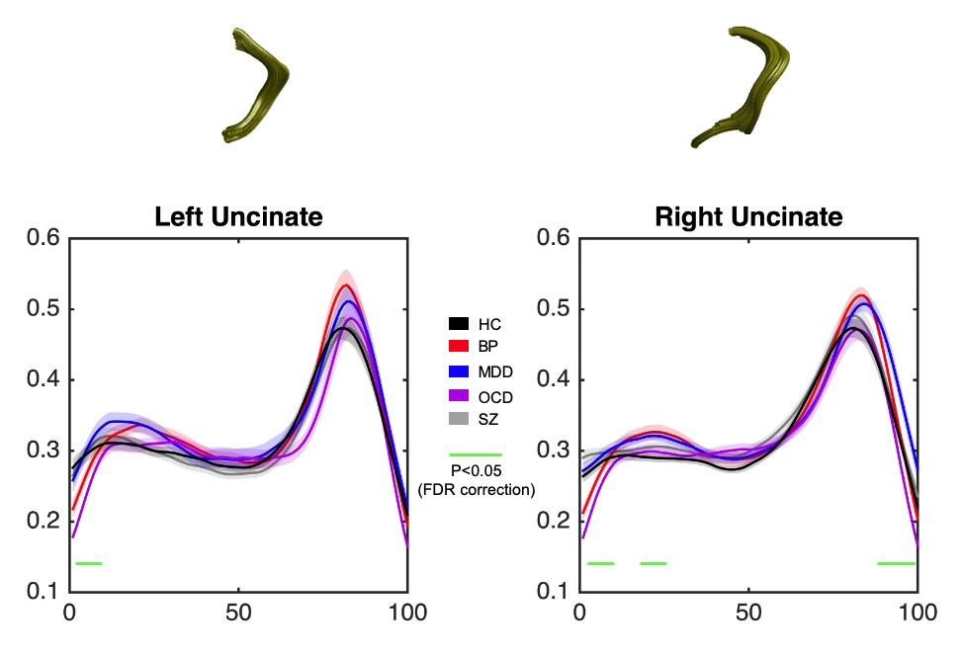

Figure 4. The plots of FA profiles of bilateral uncinate among all groups (solid lines for mean value and shaded areas for SE). The green bar under the FA profile indicate the regions of significant difference among all groups. The x-axis represents the location between the beginning and termination waypoint regions.

**Discussion**

**#para01-results summary**

The current study revealed the existence of critical brain region---hippocampus, across multimodal imaging that bridge several diagnostic categories. Here, we identified a decrease in gray matter volume of the bilateral hippocampus, as well as decreased degree centrality within hippocampus in all patient groups relative to healthy controls. Interestingly, the information sharing (degree centrality) within hippocampus was also distinct between schizophrenia and affective disorders (i.e., bipolar disorder and major depression disorder) in a graded fashion (SZ > BP; SZ > MDD). The functional link between structure and function in hippocampus showed diagnostic-specific property, that is, affective disorders revealed less function-structure association in left hippocampus than healthy controls but OCD and SZ patients were not different with healthy participants. Highlighting the patients were all medication-free at the time of the scanning, thus the current results cannot be explained by treatment effects.

**#para02-transdiagnosis & hippocampus & HPA axis**

Our investigation showed that the hippocampus was the potential transdiagnostic neural marker in multimodal fashion. The hippocampus, one important brain corticosteroid feedback site, was considered as a potential regulator of the hypothalamic-pituitary-adrenocortical (HPA) axis (Jacobson and Sapolsky, 1991, endocrine reviews) —the major system involved in orchestrating the psychological experience of stress. HPA hyperactivity have been implicated in individuals with SZ and other psychotic symptoms (Phillips et al., 2006, Australian and New Zealand Journal of Psychiatry), it also has been found in affective disorder (Belvederi Murri et al., 2015, psychoendo) and obsessive compulsive disorder (Labad et al., 2018, psychonendo). And heightened HPA-axis and excessive levels of cortisol would dampen the neuronal processes, also be correlated with senescent losses of both corticosteroid receptors in the hippocampus, then lead to the reduced gray volume and dysfunction (McEwen, 1999, annual review of neurosci). Thus, it was not surprise to find the hippocampus as the transdiagnostic brain region.

**#para03-** **Diagnostic-specific results among the 4 patients**

Interestingly, the hippocampus is also associated with diagnostic-specific properties among the four groups. The depression and bipolar disorder are two major illness belong to affective disorder. The separation between SZ and affective disorder has been a topic of scientific debates over decades. Kraepelinian view argued the SZ is biologically distinct from affective disorder (Kraepelin, 1920), while several theorists have proposed that the SZ and affective disorder shared some similarities (Grow, 1990, BJP). Our results demonstrated the difference between SZ and affective disorders can be modality-dependent. Evidence from structural MRI revealed the SZ and affective disorder shared the hippocampal deficits, but the results from functional MRI supported the distinct boundary between SZ patients and affective disorders, which was consistent with previous research in investigating the functional networks (Baker et al., 2019, pnas).

Moreover, the direct comparisons among all patients also showed that the OCD patients were associated with distinct hippocampal properties (gray volume and functional connectivity) relative to SZ patients, while shared hippocampal dysfunction with affective disorder. Apparent comorbidity between affective disorders and OCD is common in psychiatry. About 20% of patients with BP showed a lifetime comorbidity for OCD (Merikangas et al., 2007), and about 50% overlap of symptoms between MDD and OCD (Torres et al., 2016). The high comorbidity suggests some shared psychological determinants among the three disorders, including distress, anxiety, or negative affectivity (Grupe and Nitschke, 2013). Previous studies revealed the abnormalities in the HPA axis had been found in affective disorders, as well as in OCD (Labad et al., 2018, psychoendo; Murri et al., 2016, psychoendo). Which may suggest the HPA axis dysfunction can serve as one potential factor to account the comorbidity. Current analyses that identified the shared hippocampal deficits across these three disorders may further support this implication. Although the comorbidity between OCD and SZ patients has been described in previous literatures (Tonna et al., 2016), the overlap in symptoms for SZ and OCD were mainly focus on obsession, delusion, and overvalued thoughts (Insel and Akiskal, 1986). Therefore, our findings implicate the deficits in hippocampus may be more related to affective aspects but not the delusion-like beliefs.

The structure-functional association within bilateral hippocampus cannot be a transdiagnosis biomarker across all psychiatric illnesses. It is more likely specific to affective disorders, but not for SZ and OCD patients.

**#para04-confound exclusion & limitation statement**

The effects reported in the present investigation cannot be explained by medication and illness chronicity—two common confounds in psychiatric neuroimaging, since all patients were in their first episode and remained medication-naïve at the time of scanning. Further, all five groups were scanned using the same MRI scanner and image acquisition parameters, therefore our results cannot be explained by systematic differences in the data acquisition. However, the current study has at least three limitations. First, the social deficits and hippocampal dysfunction co-occur and are prevalence across psychiatric disorders (Schafer and Schiller, 2018). And the hippocampus has been found to organize social information into maps (Tavares et al. 2015, neuron) and guide social decision making (Montagrin et al. 2018, Hippocampus). Although we can exclude some potential confounds like medication, age, education year, gender, there are other kinds of psychosocial indices social skills, socioeconomic status that were not measured and which may influence the results. Second, neuroanatomical variability such as intelligence quotient may affect the results (Koenen et al.,2009, AJP), although we measured the education level and used it as the covariate in data analyses, the lack of a direct intelligence assessment is still a limitation and should be included in future research. Finally, we did not assess clinical data (e.g., diseases severity) across all groups, therefore it was not possible to unambiguously identity the elaborated relationship between hippocampal dysfunction and psychiatric illness severity.

**#para05-conclusion**

Taken collectively, our investigation combined multi-modal neuroimaging technique to reveal the hippocampus can be a potential trandiagnostic marker of psychiatric illness when relative to non-clinical sample. At the same time, the hippocampus can also show diagnosis-specific properties among the four types of mental disorders. Our findings may assist to develop a new kind of anatomically directed brain stimulation treatments for mental disorders, as well shed new light on finding the biomarkers to classify specific psychiatric illness from other disorders.

Data and code avalibility:

Code后续放在GitHub上。

**Supplymental materials**

Table S1. Demographic and clinical data from all groups.

|  |  |  |  |  |  |  |  |  |  |  |  |
| --- | --- | --- | --- | --- | --- | --- | --- | --- | --- | --- | --- |
|  | **Healthy comparison** | **Bipolar disorder** | **Major depression disorder** | **Obsessive compulsive disorder** | **Schizophrenia** |  |  | **Healthy control vs** | | | |
|  |  | **BP** | **DP** | **OCD** | **SZ** |
| **N** | 204 | 49 | 98 | 52 | 142 | **F** | **p-value** | **p-values** | | | |
| **Age** | 31.119±8.320 | 33.632±10.280 | 35.561±10.926 | 27.365±8.964 | 26.624±6.055 | 19.270 | <0.001 | 0.072 | <0.001 | 0.005 | <0.001 |
| **Age range** | 17-55 | 16-58 | 15-57 | 12-47 | 12-58 | N/A | N/A | N/A | N/A | N/A | N/A |
| **Gender(female/male)** | 111/93 | 23/26 | 64/34 | 32/20 | 72/70 | 1.862 | 0.116 | 0.332 | 0.077 | 0.373 | 0.468 |
| **Education** | 13.930±3.866 | 10.930±3.460 | 11.180±3.710 | 11.060±3.158 | 11.400±2.921 | 17.965 | <0.001 | <0.001 | <0.001 | <0.001 | <0.001 |
| **Disease duration(month)** | N/A | 80.96±92.672 | 44.54±65.414 | 50.04±55.613 | 39.15±44.932 | N/A | N/A | N/A | N/A | N/A | N/A |
| **BDI** | N/A | 9.58±11.349 | 19.13±7.022 | N/A | N/A | N/A | N/A | N/A | N/A | N/A | N/A |
| **BAI** | N/A | 34.65±13.372 | 39.18±12.060 | N/A | N/A | N/A | N/A | N/A | N/A | N/A | N/A |
| **YMRS** | N/A | N/A | N/A | 29.610±8.128 | N/A | N/A | N/A | N/A | N/A | N/A | N/A |
| **PANSS** | N/A | N/A | N/A | N/A | 82.14±8.977 | N/A | N/A | N/A | N/A | N/A | N/A |

Note: BDI, Beck Depression Inventory; BAI, Beck Anxiety Inventory; YMRS, Young Mania Rating Scale; PANSS, Positive and Negative Syndrome Scale.

**#STATEMENTS before reading the paper**

1. **暂时放弃在hippocampus内部做HMM的分析**

之前尝试过在HIP内部以voxel为单位做过HMM的分析，但是数据量过大，服务器没能支撑跑出结果。另外就是现在已有的结果比较丰富，如果加入dynamic的结果，还不知道如何解释。所以暂时没有这部分的结果，如果后续需要，再努力跑出结果加上去。

1. **所有结果的呈现方式有所改动**

20200129之前的版本：和MP_ICA 一样先呈现HC与patient的差异，再在4个patient组内做分析。

20200129之后的版本：直接做5个组在内的one-way ANOVA。

因为读到的几乎所有文献都是这样做的，并且这样更方面说明trans-diagnosis的结果。

1. **The hippocampal-amygdala FC was weird result（目前舍弃这部分的结果）**

觉得这个结果奇怪的原因：

HIP-AMY FC 越强，越代表着HPA axis dysfunction，推论下来是说明FC越强，psychiatric illness越严重。

Evidence#1

The amygdala–hippocampal pathway is crucially involved in the regulation of HPA axis ([Herman et al, 2005](http://europepmc.org/article/PMC/4864649#bib20)). [Kiem et al (2013)](http://europepmc.org/article/PMC/4864649#bib27) reported that stronger amygdala–hippocampal rs-FC is associated with dampened cortisol responses to Dex/CRH test, which indicates decreased efficiency of the HPA axis to re-establish homeostasis after perturbation.

Evidence#2 （more direct evidence, **Hakamata et al., 2018, scientific report**）

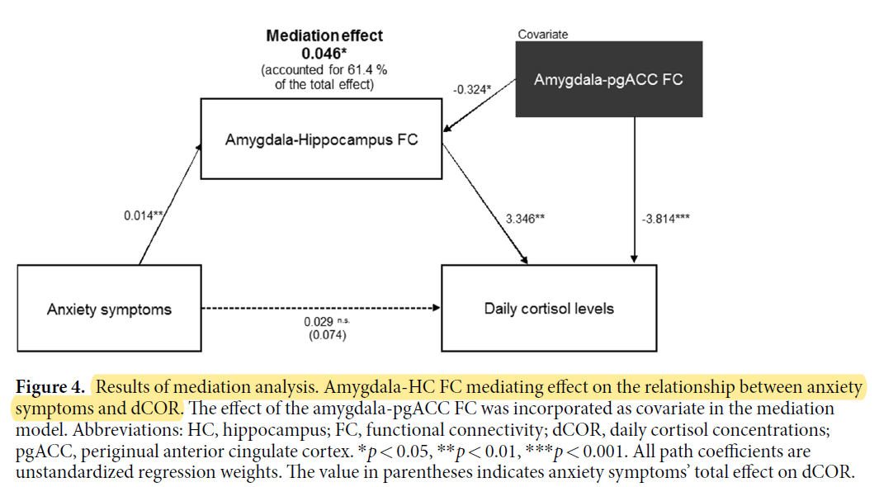

以下是要删除的结果和图，图注部分。

**Decreased functional connectivity strength between hippocampus and amygdala were shared across psychiatric disorders compared with HC, also were distinct among all patients.**

Next, we calculated the functional connectivity strength (FCS) between hippocampus (HIP) and amygdala (AMY). Similarly, the main effect of Group was significant (F(4,500)=14.964, p<0.001, η2 = 0.108, since the results of all possible connections such as left HIP-left AMY, left HIP-right AMY were similar, see SI Section? we just reported the average connection strength between hippocampus and amygdala here).

We found that HC group was associate with significantly stronger connection between hippocampus and amygdala than any kind of mental disorder (all p < 0.003). Other *post hoc* analyses showed that the SZ patients have stronger FCS than BP patients (F(1,162)=7.515, p=0.007, η2 = 0.045) and MDD patients (F(1,211)=10.361, p=0.001, η2 = 0.048; Figure 3). No significant differences were detected from other comparisons (all p > 0.070). All results still remained unchanged after FDR correction.

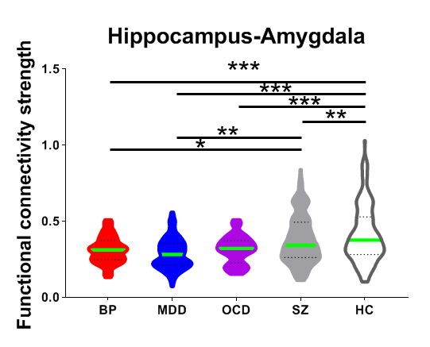

Figure 3. Results of functional connectivity strength between hippocampus and amygdala.

Differences in functional connectivity strength between hippocampus and amygdala among the five groups. SZ patients revealed significantly higher functional connectivity strength than BP, MDD patients.

Violin plots represent the distribution of functional connectivity strength, parameter in each group and solid lines indicate the medians. Error bars represent standard error. p<0.05*, p<0.01**, p<0.001***).

以上是要删除的结果和图，图注部分。