Supplementary Materials
The Correlates of Mobile Phone Addiction and Depression in Vocational School Students from the Perspective of Positive Youth Development

Supplementary Methods
To evaluate the robustness of the latent profile solution, one- through six-class models were estimated using optimism, perseverance, leadership, compassion, self-confidence, autonomy, prudence, love of learning, creativity, and curiosity as continuous indicators. Class-specific indicator means were freely estimated, indicator variances were constrained to be equal across classes, and within-class covariances were fixed to zero. Because a one-class model does not involve classification uncertainty, posterior classification probabilities and response patterns are presented for the two- through six-class solutions.
Model selection considered the log-likelihood (LL), Akaike information criterion (AIC), Bayesian information criterion (BIC), sample-size-adjusted BIC (aBIC), entropy, the bootstrap likelihood ratio test (BLRT), the Vuong-Lo-Mendell-Rubin likelihood ratio test (VLMR-LRT), class size, average posterior probabilities (AvePP), and the substantive interpretability of the class response patterns (Rovis et al., 2025). Higher LL values and lower AIC, BIC, and aBIC values indicate improved relative fit. A significant BLRT or VLMR-LRT indicates that a k-class model improves upon the corresponding k - 1 class model. Entropy and diagonal AvePP values closer to 1 indicate clearer classification, whereas classes representing fewer than 5% of the sample were flagged as potentially unstable. The final solution was selected by balancing statistical fit, classification accuracy, parsimony, class size, theoretical interpretability, and practical utility.

Supplementary Results
As shown in Supplementary Table S1 and Supplementary Figure S1, three considerations supported retention of the five-class solution. First, the diagonal AvePP values were 0.96-0.98 for the two-class model, 0.95-0.98 for the three-class model, 0.91-0.96 for the four-class model, 0.90-0.95 for the five-class model, and 0.83-0.94 for the six-class model. Thus, all candidate models showed generally clear classification, although classification accuracy declined in the six-class solution. The five-class solution retained satisfactory class separation, with all diagonal AvePP values above 0.90.
Second, the two- and three-class solutions primarily differentiated students by the overall level of their positive traits and were too coarse to represent distinctive configurations. The four-class solution recovered low, moderate, and comparatively high positive-trait profiles but combined students with generally high positive traits and students with marked relative deficits in perseverance and prudence. Consequently, it obscured the educationally meaningful distinction between the High Positive Traits Group and the Low Self-Control Group. The five-class solution separated these configurations while retaining the Low Positive Traits Group, Benevolence-Prominent Group, and Moderate Positive Traits Group. This distinction also increased practical utility: the Low Positive Traits Group may require broad strengths-based support, whereas the Low Self-Control Group highlights more specific needs related to perseverance, prudence, and behavioral self-regulation. These profile labels describe relative configurations of positive traits and should not be interpreted as clinical diagnoses.
Third, although AIC, BIC, and aBIC continued to decrease for the six-class solution, the five-class model significantly improved upon the four-class model (BLRT p = 0.03; VLMR-LRT p = 0.03), whereas the six-class model did not significantly improve upon the five-class model (BLRT p = 0.51; VLMR-LRT p = 0.51). Entropy also decreased from 0.89 to 0.86. The six-class solution subdivided the Benevolence-Prominent Group into two narrower, partially overlapping profiles without providing a statistically supported or clearly more useful classification. In contrast, all five profiles in the retained solution contained more than 5% of the sample (6.60%-46.79%). Taken together, the likelihood-ratio tests, classification quality, class size, theoretical interpretability, and practical utility supported the five-class solution. Because the profiles were derived from a single sample, independent replication remains necessary.

Supplementary Table 1
Average posterior probabilities for the two- through six-class latent profile solutions
Panel A. 2-class solution
Most likely class | Class size, n (%) | Estimated C1 | Estimated C2
Class 1 | 687 (63.91%) | 0.98 | 0.03
Class 2 | 388 (36.09%) | 0.04 | 0.96
Panel B. 3-class solution
Most likely class | Class size, n (%) | Estimated C1 | Estimated C2 | Estimated C3
Class 1 | 94 (8.74%) | 0.96 | 0.04 | 0.00
Class 2 | 660 (61.40%) | 0.01 | 0.98 | 0.02
Class 3 | 321 (29.86%) | 0.00 | 0.05 | 0.95
Panel C. 4-class solution
Most likely class | Class size, n (%) | Estimated C1 | Estimated C2 | Estimated C3 | Estimated C4
Class 1 | 88 (8.19%) | 0.95 | 0.05 | 0.00 | 0.00
Class 2 | 537 (49.95%) | 0.01 | 0.96 | 0.04 | 0.00
Class 3 | 312 (29.02%) | 0.00 | 0.07 | 0.91 | 0.02
Class 4 | 138 (12.84%) | 0.00 | 0.00 | 0.05 | 0.95

Panel D. 5-class solution
Most likely class | Class size, n (%) | Estimated C1 | Estimated C2 | Estimated C3 | Estimated C4 | Estimated C5
C1 Low Positive Traits Group | 86 (8.00%) | 0.93 | 0.00 | 0.07 | 0.00 | 0.00
C2 Benevolence-Prominent Group | 313 (29.12%) | 0.00 | 0.90 | 0.07 | 0.01 | 0.02
C3 Moderate Positive Traits Group | 503 (46.79%) | 0.01 | 0.05 | 0.95 | 0.00 | 0.00
C4 Low Self-Control Group | 71 (6.60%) | 0.00 | 0.03 | 0.00 | 0.93 | 0.05
C5 High Positive Traits Group | 102 (9.49%) | 0.00 | 0.05 | 0.00 | 0.03 | 0.92
Panel E. 6-class solution
Most likely class | Class size, n (%) | Estimated C1 | Estimated C2 | Estimated C3 | Estimated C4 | Estimated C5 | Estimated C6
Class 1 | 74 (6.88%) | 0.94 | 0.06 | 0.00 | 0.00 | 0.00 | 0.00
Class 2 | 466 (43.35%) | 0.01 | 0.93 | 0.03 | 0.00 | 0.04 | 0.00
Class 3 | 156 (14.51%) | 0.00 | 0.04 | 0.86 | 0.01 | 0.07 | 0.02
Class 4 | 60 (5.58%) | 0.00 | 0.00 | 0.03 | 0.93 | 0.00 | 0.05
Class 5 | 194 (18.05%) | 0.00 | 0.08 | 0.07 | 0.00 | 0.83 | 0.02
Class 6 | 125 (11.63%) | 0.00 | 0.00 | 0.03 | 0.02 | 0.04 | 0.91
Note. Rows indicate most likely class membership, and columns indicate model-estimated posterior class probabilities. Shaded diagonal values are the average probabilities that participants assigned to a class belonged to that class. Percentages are based on most likely class membership and may not sum to 100.00% because of rounding. AvePP = average posterior probability; C = class.

Supplementary Figure 1
Response patterns for the two- through six-class latent profile solutions
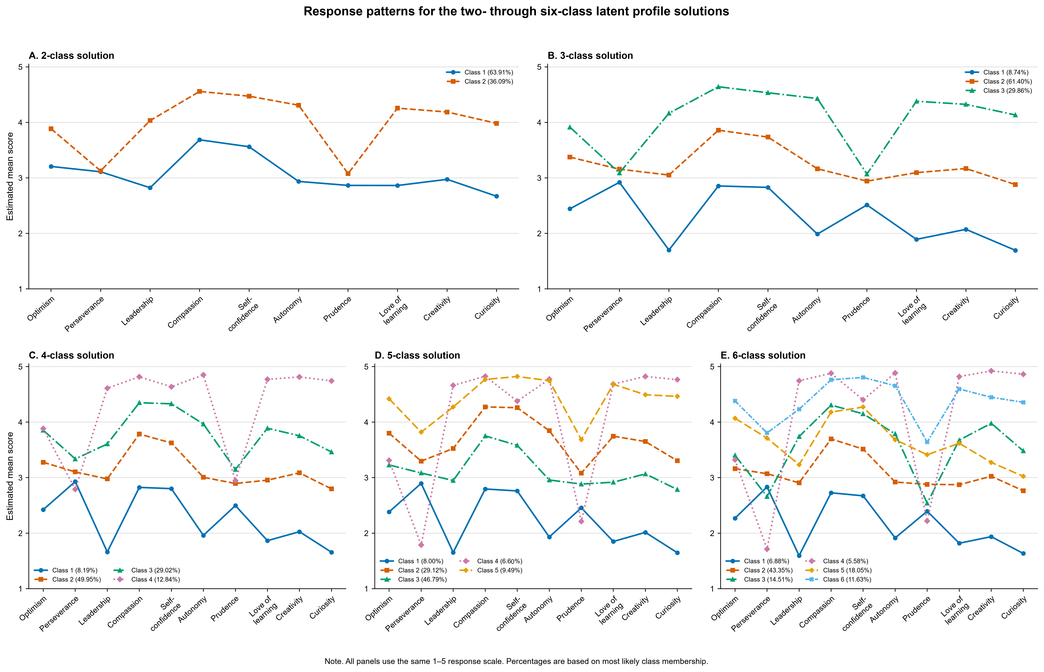
Note. Profiles are based on estimated class-specific means of optimism, perseverance, leadership, compassion, self-confidence, autonomy, prudence, love of learning, creativity, and curiosity. All panels use the same 1-5 response scale. Percentages are based on most likely class membership.

Reference
Rovis, D., Novak, M., Gacal, H., Maglica, T., Mihic, J., Sutic Barbaric, L., & Vrdoljak, G. (2025). Latent profiles in the 5 C positive youth development framework: Insights into well-being, mental health, and behavioral outcomes. BMC Psychology, 13, 1238. https://doi.org/10.1186/s40359-025-03546-7

