G52GRP Individual Report
Mobile Auction system
Yao ZHANG (yxz02u)
2013/03/18

Group ID: gp12-mvr2
Supervisor: Dr Milena Radenkovic
Other Group Members:
Thomas James Hadkiss
Jake Howland
Marike Helen Littlefair
Ryan Lobo

Contents

1. Project Brief Description……….……….……….……….……….……….……….……….……….……….……….……2
2. Personal Contribution to the project……….……….……….……….……….……….……….……….……….……2
2.1 Research and Design…….……….……….……….……….……….……….……….……….……….……….……….2
2.2 Algorithm Implementation….……….……….……….……….……….……….……….……….……….…………2
2.3 JSP and Java Implementation of the website……….……….……….……….……….……….……….……3
2.4 Component Integration……….……….……….……….……….……….……….……….……….……….…………3
2.5 Group Report……….……….……….……….……….……….……….……….……….……….……….……………….3
3. Reflection on the project….……….……….……….……….……….……….……….……….……….……….…………3
3.1 Achievements…….……….……….……….……….……….……….……….……….……….……….…………………3
3.2 Things I Would like To Do In the Future………………….……….……….……….……….……….………...4
3.3 Problems Encountered and Their Solutions……………………………………………………………………..4
3.4 Critical Discussion on Running of the Project…….……….……….……….……….……….……….………4
3.5 Skill and Knowledge Gained….……….……….……….……….……….……….……….……….……….………..5
3.6 If to Start Over Again….……….……….……….……….……….……….………………….……….……….………..6
4. Conclusion ….……….……….……….……….……….……….……….……….……….……….……….…….……………….6
6. Appendix….……….……….……….……….……….……….……….……….……….……….……….…….………………….7
6.1 G52GRP Peer Assessment for Thomas James Hadkiss ……….……….……….…….…………………..7
6.2 G52GRP Peer Assessment for Jake Howland …….……….……….……….……….…….…………………..8
6.3 G52GRP Peer Assessment for Marike Helen Littlefair ……….……….……….…….…………………….9
6.4 G52GRP Peer Assessment for Ryan Lobo….……….……….……….……….……….…….………………….10

1. Project Brief Description

In September 2012 our group gp12-mvr2 started the project “Mobile Auction System”.

The purpose of the system was to provide users with a website, accessible via web browsers on mobile devices, which aimed to improve the process of online auctioning. The project includes some fundamental functions such as setting an auction, biding an auction, sending messages to others, following an auction, reporting others and admin and some advanced functions such as proxy bidding, reputation management and auction recommendation and so on.

The development is run under the supervision of Dr Milena Radenkovic.

2. Personal Contribution to the Project

2.1 Research and Design

In the autumn semester, our group mainly concentrated on requirement specification, documents editing, technical research and implementation decisions. At the first stage, in order to make the project fully-functional, I read many articles about auction software design and wrote many software descriptions, user and software requirements in the requirement specification. In order to get the software design off the ground, I made the first version of GUI draft design, which is quite useful for later GUI design. I also draw a use case diagram, and some sequence diagrams to make the software implementation more easily and clearly. In our group, no one has experience in how to build a website, so there are lots of things to research and study. Thus, as a technical lead and main programmer, I did lots of researches into how to start the implementation such as what run environment, software and programming language should be used. After the research I nearly made all the implementation decisions. In order to make implementation more easy and clear, I researched and designed all algorithms which would be used in the project, such as p2p reputation management, proxy binding, seller and buyer ranking and so on. I designed the source code hierarchy (shown in Appendix Figure 1 )which should be considered carefully to make the project easier to maintain and refactor. In order to speed up the development process and prevent subtle issues that can cause major problems, I use Model Version Controller (MVC) (shown in Appendix Figure 2), Data Access Object (DAO) (shown in Appendix Figure 3) and Abstract Factory design patterns to build the project.

2.2 Algorithm implementation

In terms of the algorithms, after researched in peer to peer reputation management, seller and buyer ranking and ebay’s proxy bidding, I designed and then implemented these algorithms. The Figure 2.1 below is the equation of reputation evaluation. The queried trust rating is the average of the evaluated trust ratings, weighted by the credibility of their senders. I completed the Java implementation of these algorithms and did thoroughly test on it.

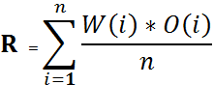

Figure 2.1 – Calculation of reputation

2.3 JSP and Java Implementation of the website

For the code of our software, I programmed all server part with the GUI implemented by Tom. The server part I programmed includes JSP, java classes, java servlets, javascript files, and MySQL queries, which are nearly all programming things apart from HTML. Because I have no experience on website programing, I studied all these languages and website build structure by myself. And every week, I spent at least 10 hours on programming study and implementation. After the implementation was completed, I used JUnit to test and debug the source codes to make the program more robust and safe. The Implementation steps and JUnit test results are in the appendix Figure 4 and Figure 5. In addition, I attended all implementation meetings.

2.4 Component Integration

Although the parts of server part and database integrated smoothly, integrating these two parts with GUI was relatively difficult and a huge work. I participated in this integration. Also, since I was familiar with the whole structure of code, I endeavoured to fix bugs from each component.

2.5 Group Report

I took the responsibility for writing the technical research and implement decisions parts for the Interim Report. I also draw UML sequence diagrams which are shown in Appendix. Source code hierarchy, the most of implementation part and JUnit test done by me have contributed significantly in the Final Group Report. In particular, the implementation steps are shown in a figure which clearly represents each step for implementation. The figure is also attached in appendix.

3. Reflection on the Project

3.1 Achievements

We have created a brilliant software as discussed with Dr Milena Radenkovic. Regarding the software, besides having satisfied all the criteria it is also optimized for usability.

- Graphical User interface
Besides the usual webpage layout, JQuery library was used to make the interface looks nice and user-friendly. The interface was tested by many users, and the result is very satisfying.

- Functionality
All functions excepted were completed by our group. The finial software can allow users to register, login, logout, set an auction, bid an auction, searches an auction based on different catalogs or filters, follow an auction, pay an auction, give a feedback, view own and others profile, build a reputation, report other users, do admin functions, do proxy bidding, change own profile and so on and so forth.

- Code robustness
The source codes were built on a good hierarchy and design pattern, and tested by JUnit, hence the codes are relatively robust and easy to maintain and refactor.

3.2 Problems Encountered and Their Solution

In order to recommend users some auctions for bidding, we created a UserSearch entity to store user’s recent searches keywords. For every reload the home page, the recommended product would change. However, if user doesn’t have search history, the recommended item will be none, and there would be a Null Pointer exception. Then we check the searches history first, if there is none, randomly select an auction from the auction database which has not been expired.

For reputation management, we implemented by adding all feedback score and the divided the feedback numbers. But if a user who wants to frame up another user, and just creates a new account, bid something and then give a very low feedback score. To solve this problem, we changed the implementation, and give a weight to every feedback score, the weight depends on the feedback sender’s reputation score. This change made the peer to peer reputation management more reasonable.

3.3 Things I would like to do in the future

The overwhelming majority of functional designs were completed. On the whole, the project is accomplished successfully by our group. However, there are still some advance function was not been done due to the time left is insufficient. If we research the project later or do the project in the Year 3, I would like to research and implement something more in the future. For instance, the website cannot sent user reminder message when he or she loses his bid, which need server listener and need more time to research. The website cannot build the profile based on his or her location. In addition, I am not extremely satisfied with the efficiency of the code. There are still some algorithms could be optimized. For instance, the peer to peer reputation management system is not extremely robust, and there are still some unfair circumstances on reputation evaluation. Additionally the code could be optimized with database connection pool to link to database so that more time could be saved.

3.4 Critical Discussion on the Running of the Project

As a group we have managed to work really well. We have managed deadlines well by making use of an online project management system. We listed milestones and tasks which needed to be completed and who was responsible for each task. Task assignment was based on personal strength of each member. We frequently communicated via Facebook. When we each encountered problems we would address them as a team in meetings, discussing and working together to tackle the problem.

Superior teamwork also was accompanied with small problems. Some group member could not complete tasks on time and with not very high quality. Uneven workload issue, which is fairly typical for team working, existed in our group. It seems that the majority of work, particularly programming the software, was done by Tomas and me. Tomas, the leader of our group, organized the group quite well and Jack worked on report integration and database. Marike and Ryan did little contribution to the whole project.

Overall, with easy going and competent teammates, careful plan and serious implementation, the project has run successfully.

3.5 Skills and Knowledge Gained

During the project, I play a role as a technical lead and main programmer throughout the whole working process. The project brought valuable experience, so that I learnt lots of things which have a profound influence to me, both on study, communication and teamwork skills.

- Software engineering

Via the process of the project work, I’ve had a good command of many kinds of software methodologies and agile approaches. For instance, I’ve learnt how to use pair programming to produce more efficient code and thought out better methods and how to use Test Driven Development (TDD) to reduce the bugs and make the program more robust by using Unit Testing before programming. Additionally I learned how to have scrum meetings and use PERT chart to estimate working time.

- Programming skills

By the implementation of server side code programming, a big progress was made in my programming skills, and I learnt lots of skills about using JSP, java servlet, java, javascript and MySQL to build a website. I also learnt a lot about testing and debugging skills, which would have a profound influence to my further study and future project programming.

- Using software skills

I also learnt to use some useful software for my computer science study. For example, I’ve learnt how to use SVN to manage the project repository and implement subversion control, use Visual Paradigm to do all the UML design, use Netbeans and GlassFish server to build a website with JSP and use JUnit to test the source files.

- Communication and teamwork skill

Furthermore, my English spoken skill has a huge improvement. The project work deepened my understanding on the importance of the team working and made me understand how to get on well with group partners.

- Writing and planning skills

Additionally, my writing skill is also enhanced by writing the reports and accepting the instructions of our supervisor. It also improves my skills of planning and scheduling for a project which would make me have a better sense of time on doing a software project.

- Good habit developed

Keeping meeting minutes is remarkably useful to group work and makes us avoid to forgetting or missing any significant information or precautions. Some professional things or good ideas can be token down and remind us when we want to use them later. Via doing the project work, I developed the good habit of taking minutes, and it should be advantageous for my future group work hopefully.

3.6 If to Start Over Again

If I was to do the project again, some parts I would do differently next time. As I am an international student, my oral English is not very good, so that I express my opinions relatively rarely. In order to avoid misunderstanding to the greatest extent, I would communicate more with other group members to make them learn about my idea more clearly and try to be active in formal meeting rather than being shy for my poor English. Moreover, I would back up the project code and use SVN to commit it more frequently in case my laptop destructed or stolen again.

4. Conclusion

Working on this project has been immensely enjoyable and memorable. This is owing to the interesting and ambitious topic our supervisor gave us and the effective teamwork. Experiencing from the beginning of the project when I had no idea of how to start it to now when we have completed the project successfully, I felt the sense of accomplishment. It has prompted me to do research and to learn new knowledge in technical field. It also has enhanced my existing programming skills a lot.

6. Appendix

6.1 G52GRP Peer Assessment for Thomas James Hadkiss

Complete one copy of this form for each member of your G52GRP group except yourself. Enclose all completed form as an appendix with your Individual Report. Rate the group member in question by ticking or marking with an “x” exactly one box for each evaluation aspect in the table below. Give a brief written justification for each assigned rating in the space provided below the table. For further information, see the Peer Assessment section of the G52GRP Student Handbook.

Name of assessed group member: ___ Thomas James Hadkiss __________

 | None | Lacking | Adequate | Good | Excellent
Research & information gathering |  | x
Creative input |  |  |  | x
Co-operation within group |  |  |  | x
Communication within group |  |  |  |  | x
Concrete contribution |  |  | x
Attendance at meetings |  |  |  | x

Justification of assigned marks:

Tom is a good group leader, and he communicated with us patiently and responsibly, often send message to organize meetings, so his communication within group is excellent and the Co-operation within group is good. And he gave some good ideas on the functionality of the website, hence his creative input is also good. He attends the most of meetings, thus his attendance at meetings is good.

However, he only did the GUI (HTML), which is not difficult, and not much information is gathered by him, so his concrete contribution is adequate, and his research & information gathering is lacking.
6.2 G52GRP Peer Assessment for Jake Howland

Complete one copy of this form for each member of your G52GRP group except yourself. Enclose all completed form as an appendix with your Individual Report. Rate the group member in question by ticking or marking with an “x” exactly one box for each evaluation aspect in the table below. Give a brief written justification for each assigned rating in the space provided below the table. For further information, see the Peer Assessment section of the G52GRP Student Handbook.

Name of assessed group member: ___ Jake Howland __________

 | None | Lacking | Adequate | Good | Excellent
Research & information gathering |  | x
Creative input |  |  | x
Co-operation within group |  |  | x
Communication within group |  | x
Concrete contribution |  |  | x
Attendance at meetings |  |  |  | x

Justification of assigned marks:

Jack is the editor and database designer of our group. For the interim and final report, every member did his or her own part, and then Jack edited them together. He also designed the database with us together and then implemented the database code, but the code often has some syntax errors without checking and cannot run correctly. Thus I reckon that his concrete contribution is adequate, and creative input is adequate, Co-operation within group is adequate. He communicated within group less, so it is lacking. He did not research many things or gather information, so his research & information gathering is lacking. He attended most meetings, so his attendance at meetings is good.
6.3 G52GRP Peer Assessment for Marike Helen Littlefair

Complete one copy of this form for each member of your G52GRP group except yourself. Enclose all completed form as an appendix with your Individual Report. Rate the group member in question by ticking or marking with an “x” exactly one box for each evaluation aspect in the table below. Give a brief written justification for each assigned rating in the space provided below the table. For further information, see the Peer Assessment section of the G52GRP Student Handbook.

Name of assessed group member: ___ Marike Helen Littlefair__________

 | None | Lacking | Adequate | Good | Excellent
Research & information gathering |  | x
Creative input |  | x
Co-operation within group |  | x
Communication within group |  | x
Concrete contribution |  | x
Attendance at meetings |  |  | x

Justification of assigned marks:

Marike is GUI designer. She only designed the GUI, but not including GUI implementation. And she also does only some market researches. She does nothing on building the software and little on writing report, and he sometimes delayed his work or reporting part several days. But her attendance at meetings is adequate.
6.4 G52GRP Peer Assessment for Ryan Lobo

Complete one copy of this form for each member of your G52GRP group except yourself. Enclose all completed form as an appendix with your Individual Report. Rate the group member in question by ticking or marking with an “x” exactly one box for each evaluation aspect in the table below. Give a brief written justification for each assigned rating in the space provided below the table. For further information, see the Peer Assessment section of the G52GRP Student Handbook.

Name of assessed group member: ___ Ryan Lobo__________

 | None | Lacking | Adequate | Good | Excellent
Research & information gathering |  | x
Creative input | x
Co-operation within group |  | x
Communication within group |  | x
Concrete contribution |  | x
Attendance at meetings |  |  | x

Justification of assigned marks:

Ryan’s role is the programmer with me on server part, but he did nothing on programming. Then we told him to do the testing part, and he delayed his work many working days. Then I had to substitute him to do the JUnit tests so that we can complete work before due time. He often delayed his work. Apart from his part of the reports and asking a JSP server for TSG, he did little for the project. But the attendance is adequate. Retrospectively, he gave none creative input.
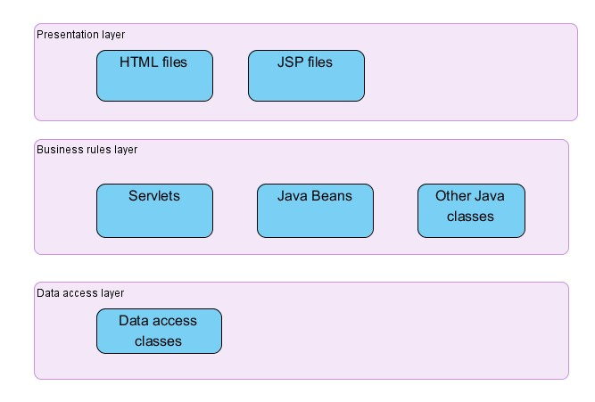

Figure 7. 1 - Souce could hierarchy design

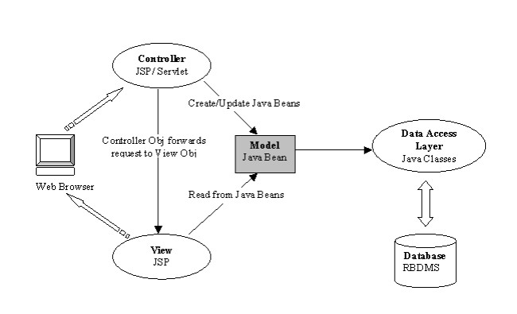
Figure 7.2 – Model View Controller Design Pattern

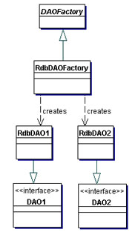
Figure 7.3 – DAO Design Pattern

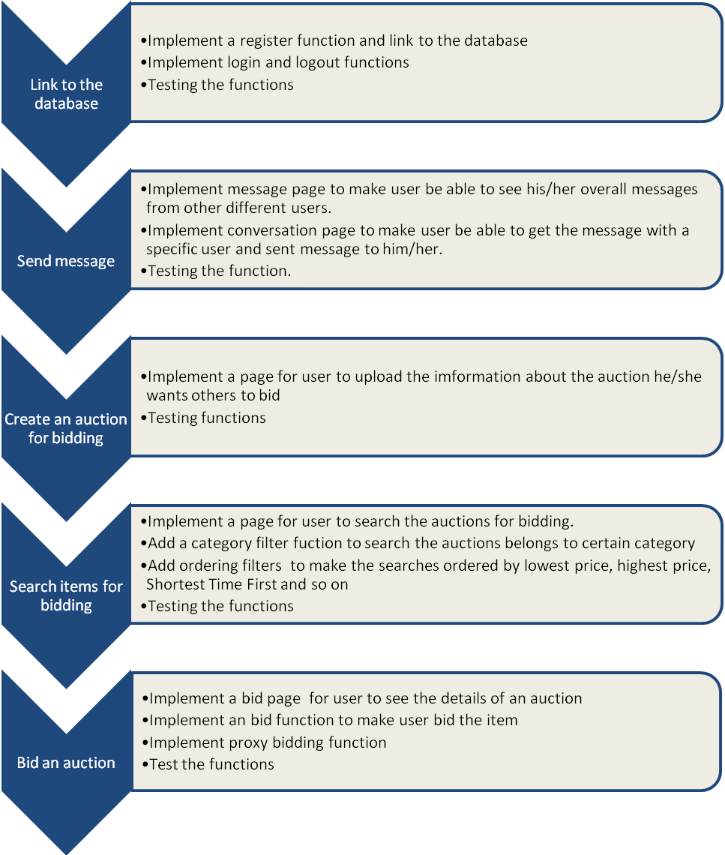

Figure 7.4 - Implementation Steps

(Continued on following page)

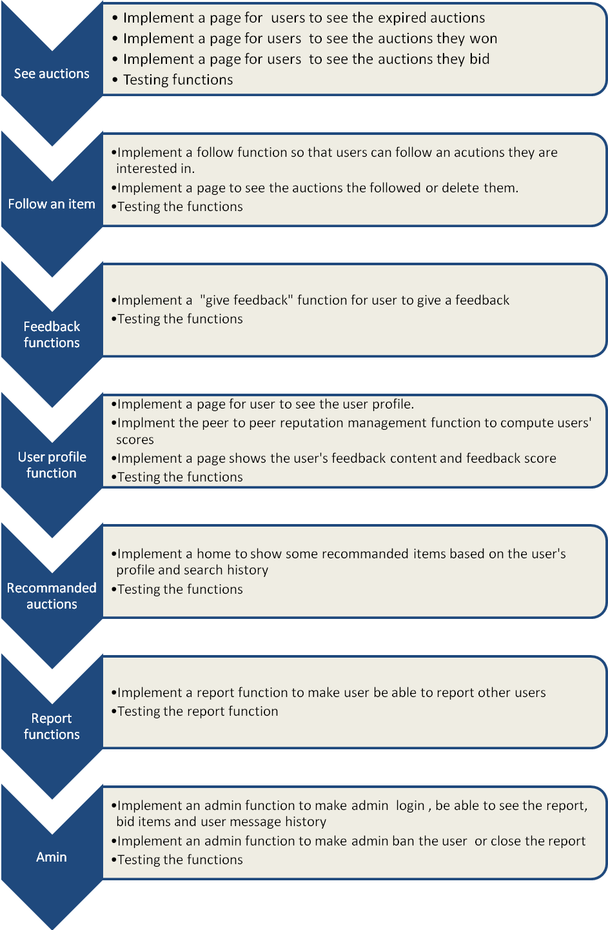
Test class | Test Date | Test successfully? | Successful debugging?
Bids.java | 2012-02-03 | ✓
Feedback.java | 2012-02-03 | ✓
FollowItem.java | 2012-02-03 | ✓
ItemImage.java | 2012-02-03 | ✓
Listing.java | 2012-02-03 | ✓
Message.java | 2012-02-03 | ✓
Report.java | 2012-02-03 | ✓
Type.java | 2012-02-03 | ✓
UserSearches.java | 2012-02-03 | ✓
Userinfo.java | 2012-02-03 | ✓
BidsBean.java | 2012-02-12 |  | ✓
FeedbackBean.java | 2012-02-12 | ✓
FollowItemBean.java | 2012-02-12 |  | ✓
IOWorkBean.java | 2012-02-12
ItemImageBean.java | 2012-02-12 | ✓
ListingBean.java | 2012-02-12 | ✓
LoginBean.java | 2012-02-12 | ✓
MessageBean.java | 2012-03-12 | ✓
PageBean.java | 2012-03-12 | ✓
RegisterBean.java | 2012-03-12 | ✓
ReportBean.java | 2012-03-12 |  | ✓
TypeBean.java | 2012-03-13 | ✓
UserSearchesBean.java | 2012-03-13 | ✓
UserinfoBean.java | 2012-03-14 |  | ✓
BidsDAO.java | 2012-03-14 | ✓
FeedbackDAO.java | 2012-03-14 |  | ✓
FollowItemDAO.java | 2012-03-14 |  | ✓
ImageDAO.java | 2012-03-14 | ✓
Listing_DAO.java | 2012-03-17 | ✓
MessageDAO.java | 2012-02-17 |  | ✓
ReportDAO.java | 2012-03-17 | ✓
TypeDAO.java | 2012-03-17 | ✓
UserSearchesDAO.java | 2012-03-17 | ✓
UserinfoDAO.java | 2012-03-17 |  | ✓

Figure 7.5 –Results of JUnit Testing

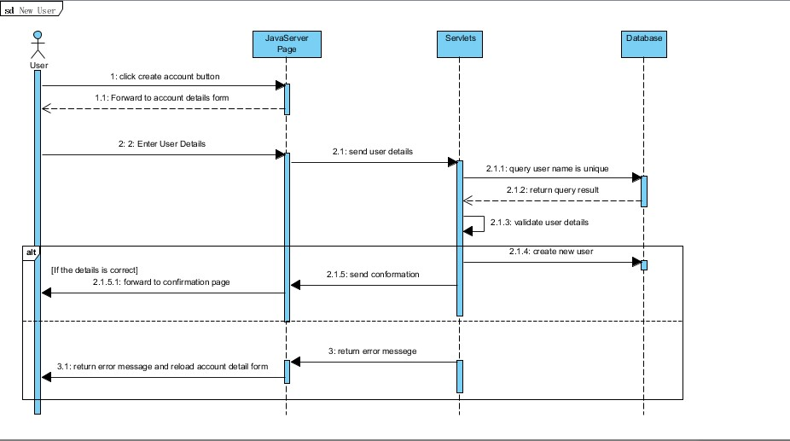

Figure 7.6 – Regester Sequence diagram

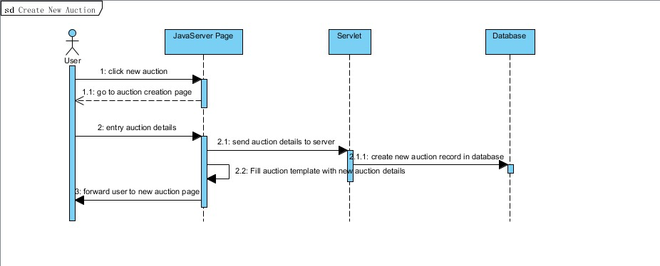

Figure 7.7 - Create a new auction sequence diagram
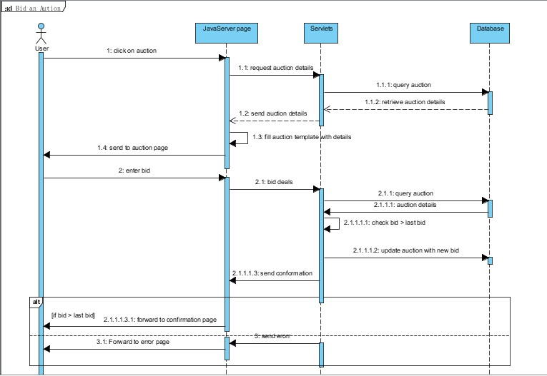

Figure 7.8 – Bid an auction

Quality and quantity of concrete contribution to group deliverables: writing, coding, testing, open day display, preparations for presentations, etc.
Quality and quantity of concrete contribution to group deliverables: writing, coding, testing, open day display, preparations for presentations, etc.
Quality and quantity of concrete contribution to group deliverables: writing, coding, testing, open day display, preparations for presentations, etc.
Quality and quantity of concrete contribution to group deliverables: writing, coding, testing, open day display, preparations for presentations, etc.

