Microscope intructions:

1. Light for transmission measurements can be turned on on the left

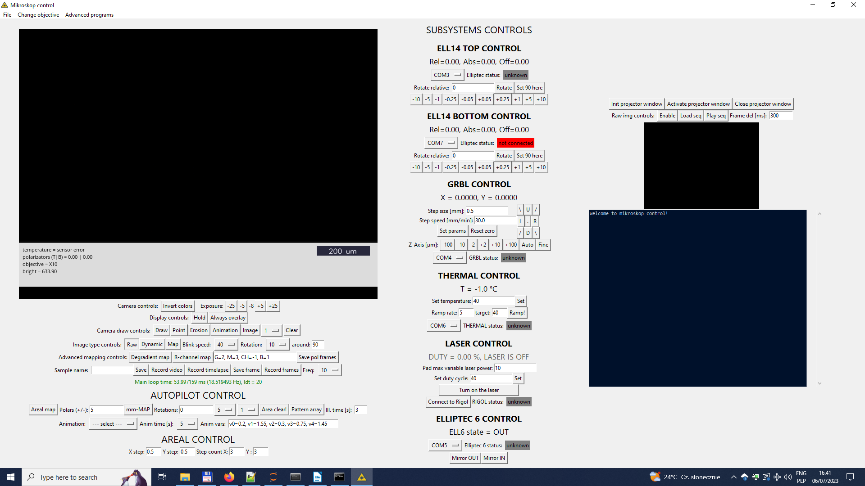

Main mikroskop folder:
c:\Users\Laser\Documents\mikroskop_control\

Configuration file location:
c:\Users\Laser\Documents\mikroskop_control\external_variables.txt

Commands:
SET_TEMP <float rate> <float rate> <float margin>

D_CHECK_CRYSTAL <string pattern.png>
creates target list for laser illumination, requires one selected DNA crystal, generates target.png with target list overview

ILLUMINATE_TARGETS <string animation_name> <int angle> <int brush_size> <float time> <int repeats_per_target> <float cooldown_time>
ILLUMINATE_TARGETS simple-circle 0 10 1.5 1 1.25
starts animation in every target from target list

