Project Two README
Phetmanee Thongkham
CS-340
Jeffrey Scranton
October 25, 2026

Grazioso Salvare Dashboard README
Phetmanee Thongkham | CS 340 Project Two
For this project, I worked on a dashboard for Grazioso Salvare to help find dogs that could be trained for search and rescue. The dashboard uses animal records from the Austin Animal Center database. Users can choose a rescue type, view the matching animals, and see information in a table, pie chart, and map.

Functionality
The dashboard starts by showing all animals in the database. Users can choose Water Rescue, Mountain or Wilderness Rescue, or Disaster or Individual Tracking. Each option searches the database for dogs that meet the breed, sex, and age requirements. Reset brings back all animals and clears the table filters and sorting.
The table shows ten animals per page. Users can sort columns, filter the records, and select an animal. The pie chart shows the breeds in the filtered results. The map shows the location of the selected animal. Animals without names are shown as Unnamed animal, and a message appears if an animal does not have a valid location.

Rescue profiles
Profile | Preferred breeds | Sex and age in weeks
Water Rescue | Labrador Retriever Mix; Chesapeake Bay Retriever; Newfoundland | Intact Female; 26–156
Mountain or Wilderness Rescue | German Shepherd; Alaskan Malamute; Old English Sheepdog; Siberian Husky; Rottweiler | Intact Male; 26–156
Disaster or Individual Tracking | Doberman Pinscher; German Shepherd; Golden Retriever; Bloodhound; Rottweiler | Intact Male; 20–300
I used the age_upon_outcome_in_weeks field to filter by age. The searches include both ends of each age range. They also check that the animal is a dog and match the required sex and breed. The breed searches include mixes and records with more than one breed listed. The age limits follow the table in the dashboard specifications.
The dashboard includes the Grazioso Salvare logo and my name. Clicking the logo opens https://www.snhu.edu.

Files and installation
- ProjectTwoDashboard.ipynb contains the dashboard code.
- The dashboard runs from the original Jupyter notebook.
- CRUD_Python_Module.py contains my Project One CRUD class. The code in this module was not changed.
- Grazioso_Salvare_Logo.png is the logo used on the dashboard.
- The dashboard uses the CRUD module to read records from MongoDB.
- requirements.txt lists the needed Python packages. The screenshots folder can be used to keep the dashboard screenshots.
Extract the ZIP in Codio. Keep the notebook, CRUD module, and logo in the same folder. Use the existing course environment. If packages are missing, run this command in the terminal:
python -m pip install -r requirements.txt
Use the Austin Animal Center dataset from the course. If the database is already set up, skip the import. Otherwise, import the CSV from the terminal using the command below. Replace the example file path with the actual CSV path. Importing the same data again can create duplicate records.
mongoimport --type csv --headerline --db aac --collection animals --file /path/to/aac_shelter_outcomes.csv
MongoDB should be running on localhost at port 27017. The database is aac and the collection is animals. The notebook uses the aacuser account. Check that the password in the notebook matches the password set for that account.

Launch in Codio
Open ProjectTwoDashboard.ipynb and run the code cell. The app.run_server() line starts the dashboard on port 8050. Open https://YOUR-CODIO-HOST/proxy/8050/, using your own Codio hostname. Keep the notebook running while using the dashboard.
If port 8050 is already in use, stop the earlier dashboard or change the last line to app.run_server(port=8051). Then open the same Codio address with /proxy/8051/ at the end.
Restart the notebook kernel and run the cell again after making code changes.
If the table is unexpectedly empty, check the notebook output for errors. Make sure MongoDB is running, the data is loaded, and the username and password are correct. The CRUD read method returns an empty list when a database error occurs, so an empty table does not always mean there are no matching animals.

Tools and architecture
I used MongoDB to store the animal records. It works well with Python because PyMongo lets the program use dictionaries to search and read the data. MongoDB can also check several requirements in one query, such as breed, sex, and age. My AnimalShelter class handles these database calls and serves as the model part of the project.
I used Dash for the dashboard layout and controls. The table and charts make up the view, while the callbacks act as the controller by updating the results when a user chooses a filter. Pandas organizes the data, Plotly Express creates the pie chart, and Dash Leaflet displays the map. JupyterDash lets the application run from the course notebook.

Implementation steps
- I reviewed the project instructions and dashboard specifications.
- I connected the notebook to my existing AnimalShelter class using the database username and password.
- I loaded all animal records into the table and removed the MongoDB _id field from the displayed data.
- I added the three rescue searches and the Reset option.
- I connected the pie chart and map to the table so they respond to the displayed results.
- I added the logo, the link to SNHU, and my name.
- I prepared the project files and README. The required screenshots go in the next section.

Technical challenges addressed
One issue was that MongoDB adds an _id field that the dashboard cannot display directly. I handled this by removing that field from the table data. The map also needed to use location_lat and location_long instead of fixed column numbers. This keeps it from reading the wrong fields if the column order changes.
I also added checks for empty results, missing names, and missing coordinates so those records do not cause errors in the map. The dashboard passes the username and password to AnimalShelter because the original class requires both. I kept the original notebook structure and JupyterDash setup.

Resources
MongoDB documentation: https://www.mongodb.com/docs/
PyMongo documentation: https://pymongo.readthedocs.io/
Dash documentation: https://dash.plotly.com/
Dash DataTable: https://dash.plotly.com/datatable
Plotly Python: https://plotly.com/python/
Dash Leaflet: https://www.dash-leaflet.com/
Pandas documentation: https://pandas.pydata.org/docs/
Jupyter documentation: https://docs.jupyter.org/
Course resources: CS 340 Dashboard Specifications Document, supplied starter notebook, Project One CRUD module, and Grazioso Salvare logo.

Execution evidence
The following sections are for the five required screenshots.

Figure 1 Initial unfiltered dashboard
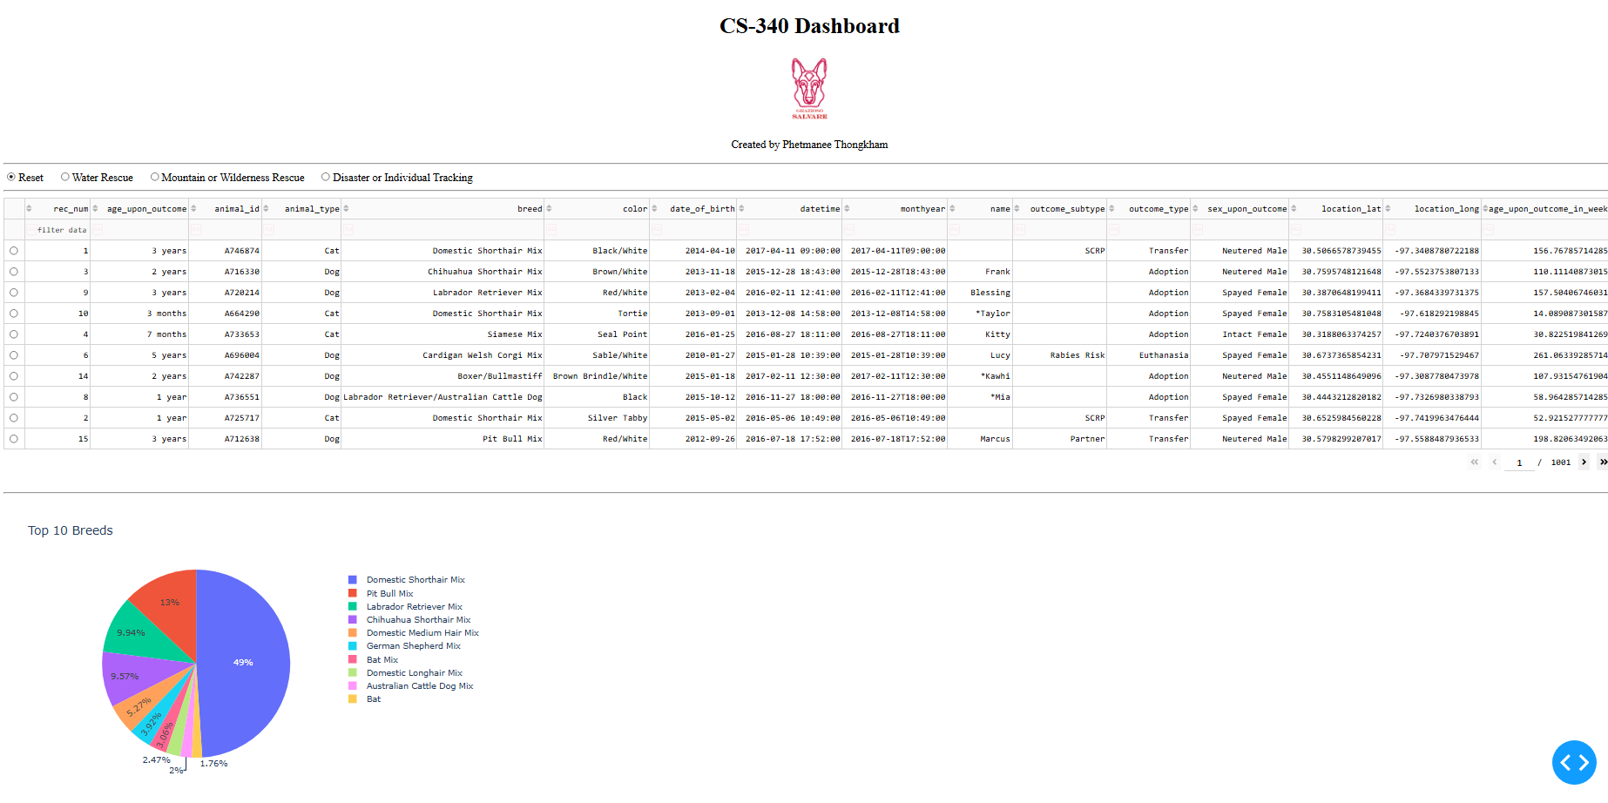
The starting view should show all animals and both charts.

Figure 2 Water Rescue
This view should show dogs that match the water rescue breeds, Intact Female, and ages 26 to 156 weeks.
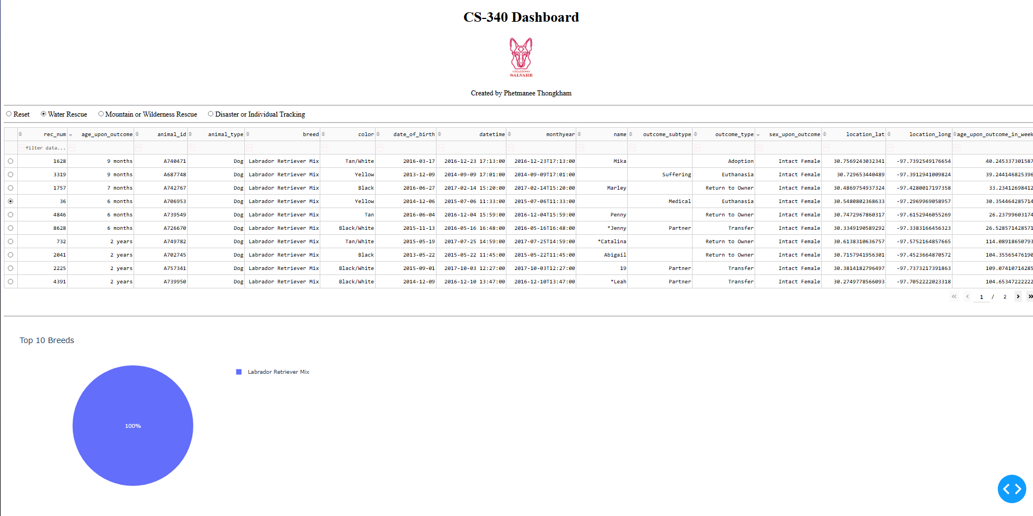

Figure 3 Mountain or Wilderness Rescue
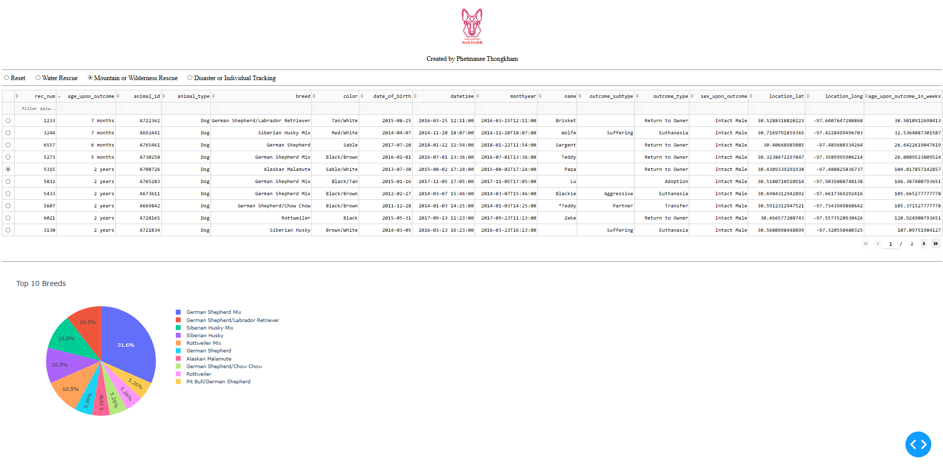
This view should show dogs that match the mountain rescue breeds, Intact Male, and ages 26 to 156 weeks.

Figure 4 Disaster or Individual Tracking
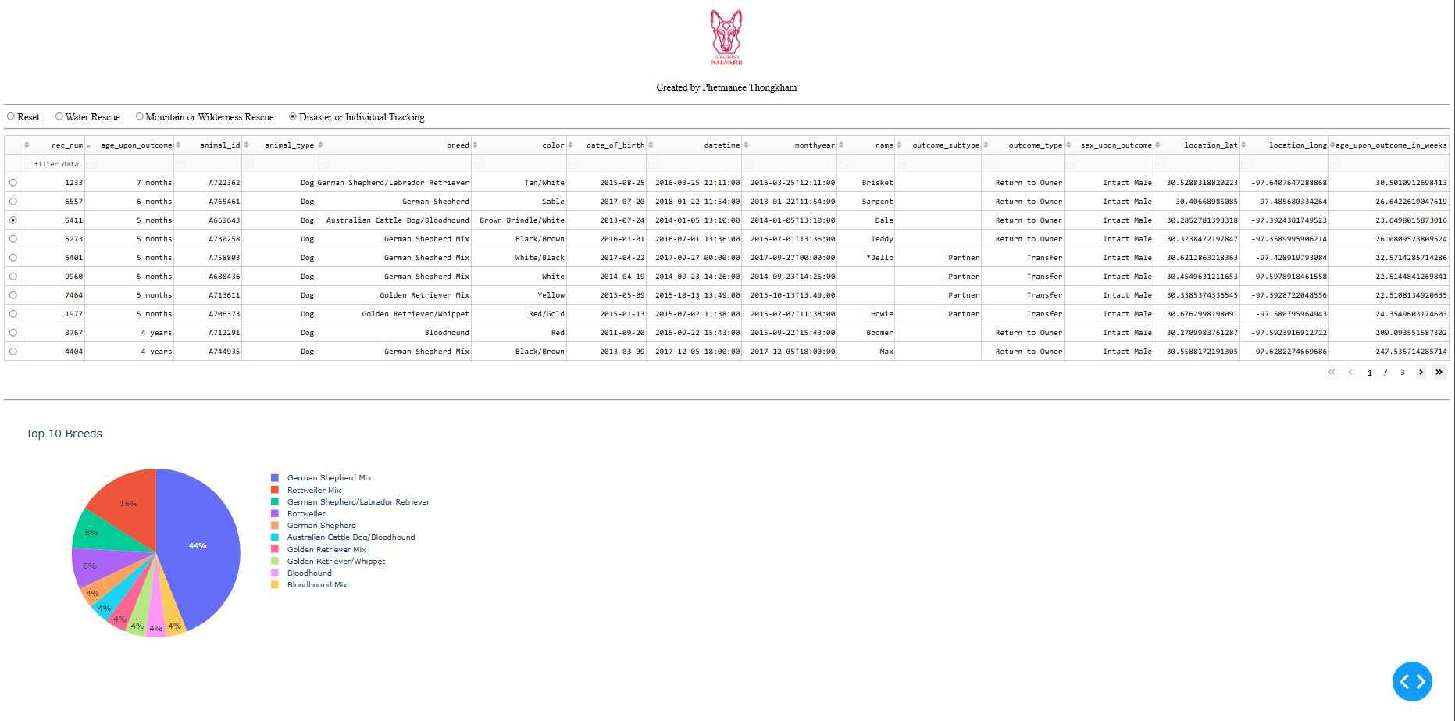
This view should show dogs that match the tracking breeds, Intact Male, and ages 20 to 300 weeks.

Figure 5 Reset
After choosing a rescue filter, select Reset. The table should show all animals again, and the charts should update.
