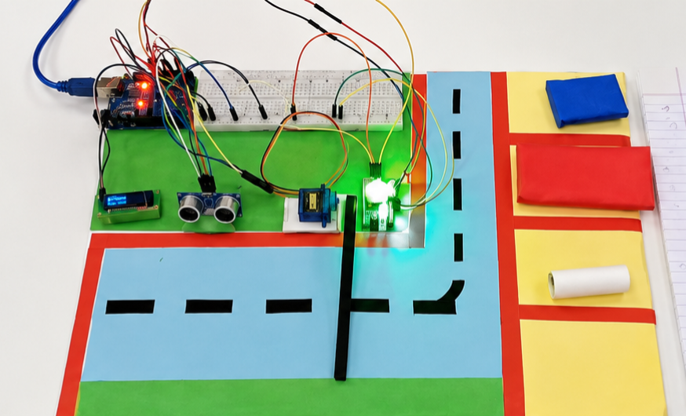

A Project Report

on

Smart Automatic Parking System

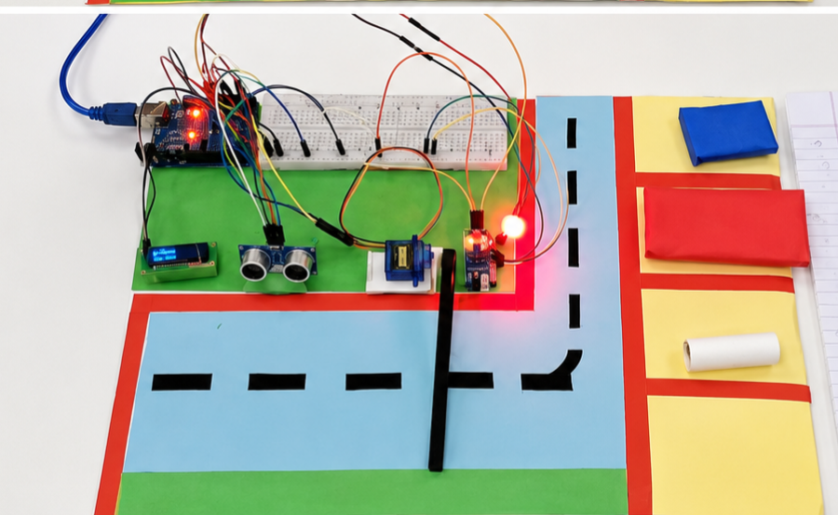

Acknowledgment

I express my sincere gratitude to my faculty for their valuable guidance and support throughout this project. I also thank the Department of Information Technology, Manipal University Jaipur, for providing the necessary resources to complete this project successfully.

Abstract

This project presents the design and implementation of a Smart Automatic Parking System using Arduino and IoT concepts. The system detects vehicle entry and exit using sensors, controls a gate using a servo motor, and displays real-time parking availability on an OLED display. Additionally, LED indicators are used to show parking status (available/full). The system aims to automate parking management, reduce manual effort, and improve efficiency.

Table of Contents

S. No. | Content | Page No
1 | Introduction | 4
2 | Objectives | 4
3 | Components Used | 4
4 | Working Principle | 5-6
5 | Block Diagram | 6
6 | Circuit Connections | 7-8
7 | Algorithm | 7
8 | Code (Summary) | 8
9 | Result | 9
10 | Advantages | 9
11 | Applications | 9
12 | Conclusion | 10
13 | Future Scope | 10

1. Introduction

Parking management is a major challenge in urban areas. This project provides an automated solution using sensors and microcontrollers. The system detects vehicles, controls entry/exit gates, and displays available parking slots in real-time.

2. Objectives

• Automate parking entry and exit
• Display real-time slot availability
• Reduce human effort
• Improve parking efficiency
• Provide visual indicators using LEDs

3. Components Used

• Arduino Uno
• Ultrasonic Sensor (HC-SR04)
• IR Sensor
• Servo Motor
• OLED Display (SSD1306)
• LEDs (Red & Green)
• Breadboard & Jumper Wires

4. Working Principle

• Ultrasonic sensor detects vehicle at entry
• If slot is available → gate opens
• Slot count decreases
• IR sensor detects vehicle exit
• Slot count increases
• OLED displays available slots
• LEDs indicate:
- Green → Available
- Red → Full

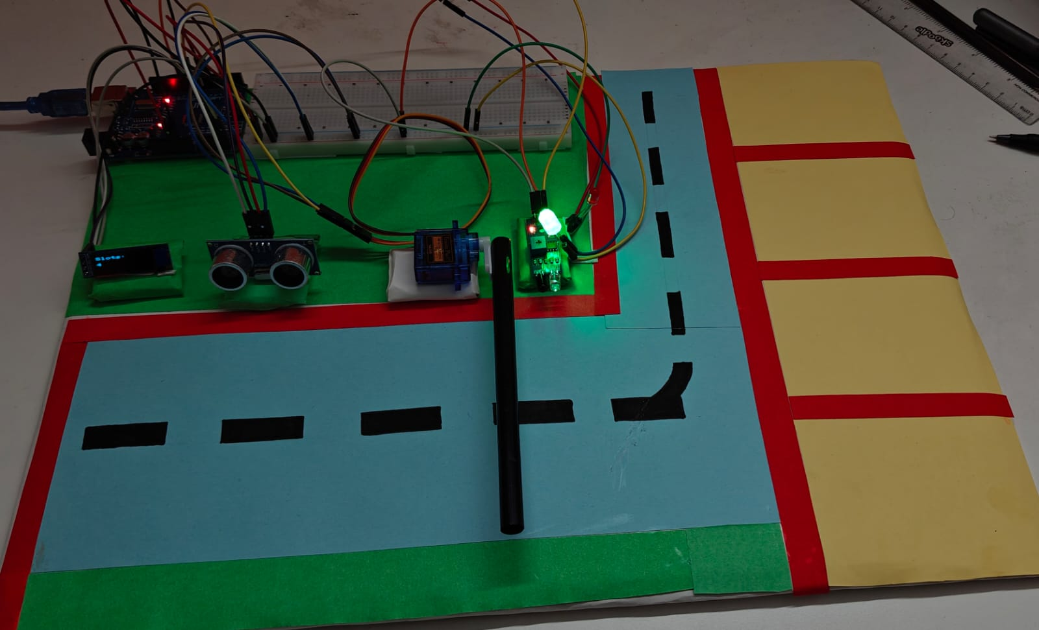

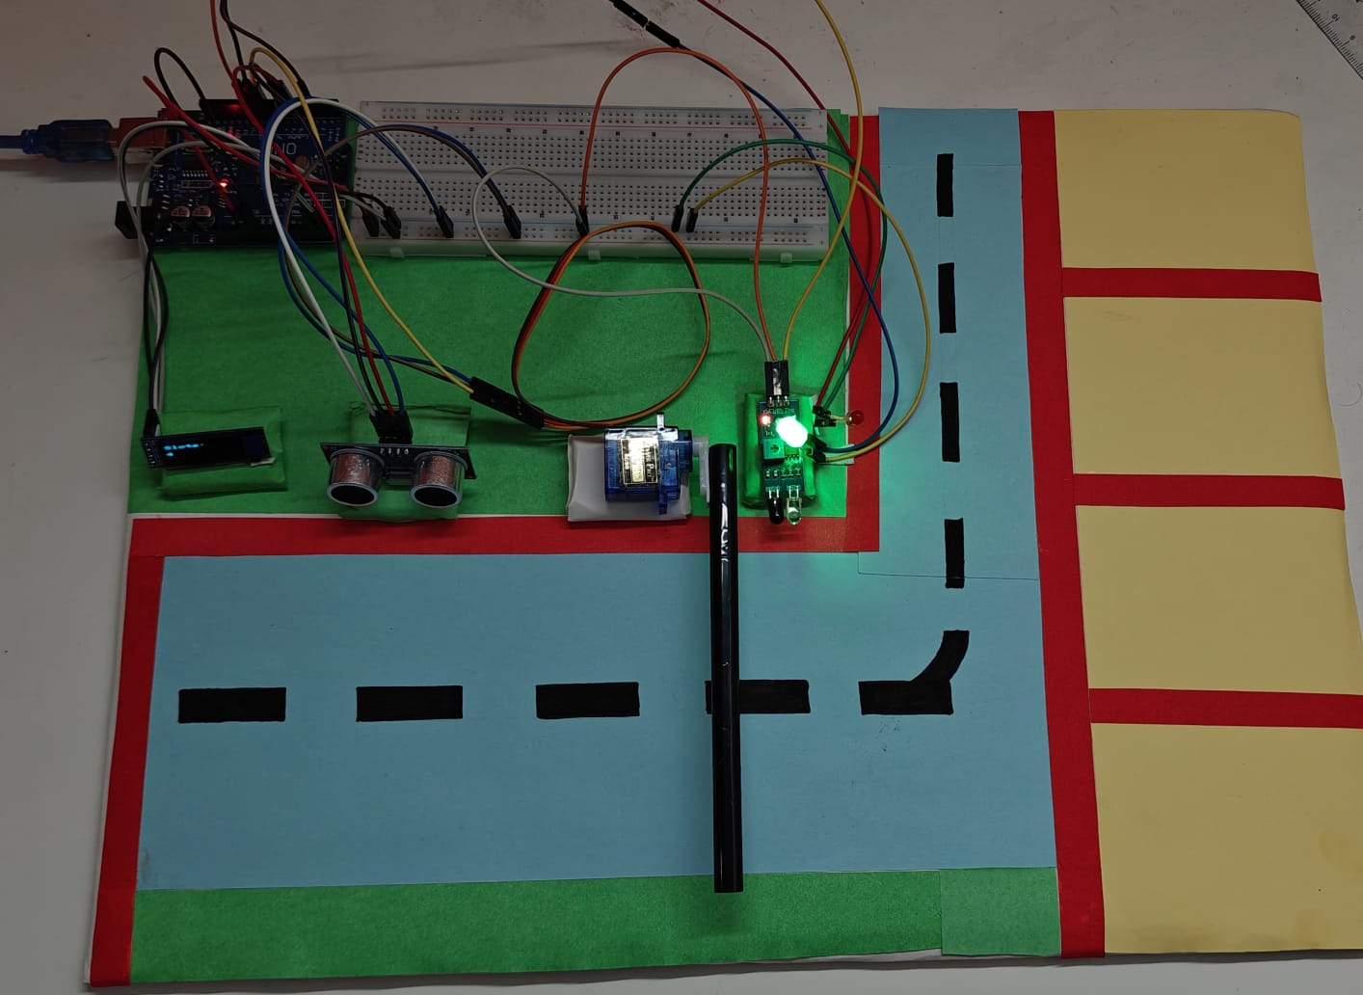

5. Block Diagram

Sensors → Arduino → Outputs
Inputs:
- Ultrasonic Sensor
- IR Sensor
Outputs:
- Servo Motor
- OLED Display
- LEDs

6. Circuit Connections

• Ultrasonic → Pins 6 (Trig), 7 (Echo)
• IR Sensor → Pin 3
• Servo Motor → Pin 9
• OLED Display → SDA (A4), SCL (A5)
• Green LED → Pin 10
• Red LED → Pin 11

7. Algorithm

- Start system
- Initialize sensors and display
- Check entry sensor
- If vehicle detected and slot available:
  - Open gate
  - Decrease slot
- Check exit sensor
- If vehicle exits:
  - Increase slot
- Update display
- Repeat

8. Code (Summary)

The system is implemented using Arduino C++ with libraries:
- Servo.h
- Wire.h
- Adafruit_SSD1306
Functions include:
- Distance measurement
- Slot management
- Display update
- Gate control

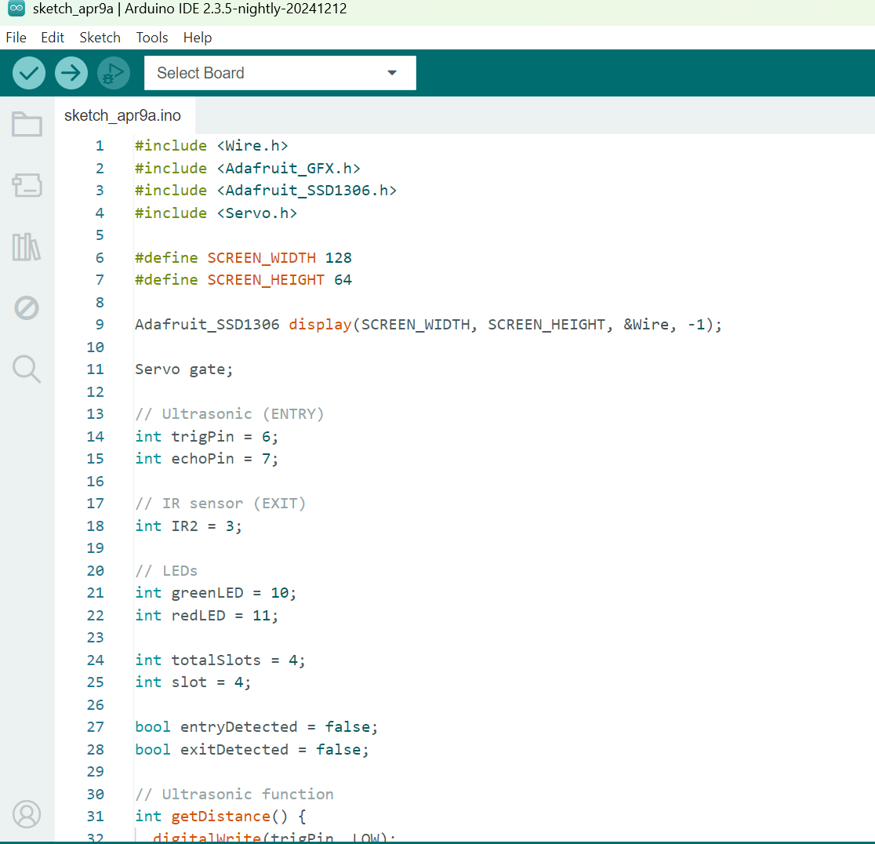
9. Result

The system successfully:
• Detects vehicle entry and exit
• Automatically controls gate
• Displays slot availability
• Uses LEDs for indication

10. Advantages

• Low cost
• Easy to implement
• Real-time monitoring
• Reduces manual work

11. Applications

• Shopping malls
• Airports
• Smart cities
• Office parking systems

12. Conclusion

The Smart Parking System effectively automates parking management using simple sensors and microcontrollers. It improves efficiency, reduces human effort, and can be extended for real-world smart city applications.

13. Future Scope

• Mobile app integration
• IoT cloud monitoring
• Online slot booking
• Number plate recognition

