Autonomous Heart Monitoring System

Version 3.4

Prepared by:
On-campus Group-1

Submitted to:
Dr Syed Mohammed Shamsul Islam

Student No. | Student Name
10544647 | Mathew Buttner
10534354 | Peter (Huy Hoang) Nguyen

All members contributed equally.
Date of submission:
31/03/2022

Distribution List
Who | What | Version | When
Canvas | Soft Copy | 2.0 | 22/03/22
Peter | Soft Copy | 3.0 | 26/03/22
Mathew | Soft Copy | 3.0 | 26/03/22
Canvas | Soft Copy | 3.4 | 26/03/22

Modification History
Who | What | Version | When
Mathew | Created file and set up layout | 1.0 | 15/03/22
Peter, Mathew | Added requirements and assumptions | 1.1 | 16/03/22
Peter | Added draft state machine diagram | 1.2 | 17/03/22
Mathew | Added use-case diagram | 1.3 | 17/03/22
Peter | Added class diagram | 1.4 | 18/03/22
Mathew | Changes to class diagram | 1.5 | 18/03/22
Peter | Added use-case elaborations – Access, store, and analyse data | 1.6 | 19/03/22
Mathew | Changes to use-case elaborations | 1.7 | 19/03/22
Peter | Added use-case elaborations – Obtain sensor reading continuously and send alert | 1.8 | 20/03/22
Mathew | Changes to use-case elaborations | 1.9 | 20/03/22
Peter | Added use-case realisations | 2.0 | 21/03/22
Mathew | Added/ made changes to use-case realisations | 2.1 | 21/03/22
Peter | Added extra sections | 2.2 | 22/03/22
Peter | Added activity diagram for use-cases | 2.4 | 23/03/22
Mathew | Changes to activity diagrams | 2.5 | 23/03/22
Peter | Added associated class diagrams for each use-case | 2.6 | 24/03/22
Mathew | Added/Updated associated class diagrams | 2.7 | 24/03/22
Peter | Added sequence diagrams for each use-case | 2.8 | 25/03/22
Mathew | Changes to sequence diagrams | 2.9 | 25/03/22
Peter | Added introduction & project scope | 3.0 | 26/03/22
Mathew | Rewrote introduction & project scope | 3.1 | 26/03/22
Mathew | Updated assumptions | 3.2 | 26/03/22
Mathew | Added Authenticate User use case, elaboration, activity, sequence and class diagram | 3.3 | 26/03/22
Mathew | Updated glossary | 3.4 | 26/03/22

Table of Contents

Autonomous Heart Monitoring System 1
Table of Contents 4
1. Introduction 5
2. Glossary of Terms 5
3. Project Scope 5
3.1 Functional Requirements 5
3.2 Non-Functional Requirements 6
4. Assumptions 6
5. Use Case Diagram 7
6. Domain Model Class Diagram 8
7. State Machine Diagrams 9
8. Use Case Realisation 10
8.1 Authenticate User Realisation 10
8.1.1 Elaboration of Authenticate User 10
8.1.2 Authenticate User Activity Diagram 11
8.1.3 Authenticate User Sequence Diagram 12
8.1.4 Associated Class diagram for Authenticate User 13
8.2 View Data User Realisation 14
8.2.1 Elaboration of View Data 14
8.2.2 View Data Activity Diagram 15
8.2.3 View Data Sequence Diagram 16
8.2.4 Associated Class Diagram for View Data 17
8.3 Store Data Realisation 18
8.3.1 Elaboration of Store Data 18
8.3.2 Store Data Activity Diagram 19
8.3.3 Store Data Sequence Diagram 20
8.3.4 Associated Class Diagram for Store Data 21
8.4 Analyse Data Realisation 22
8.4.1 Elaboration of Analyse Data 22
8.4.2 Analyse Data Activity Diagram 24
8.4.3 Analyse Data Sequence Diagram 25
8.4.4 Associated Class Diagram for Analyse Data 26
8.5 Obtain sensor reading continuously Realisation 27
8.5.1 Elaboration of Obtain sensor reading continuously 27
8.5.2 Obtain sensor reading continuously Activity Diagram 28
8.5.3 Obtain sensor reading continuously Sequence Diagram 29
8.4.4 Associated Class Diagram for Obtain sensor reading continuously 29
8.6 Send alert Realisation 30
8.6.1 Elaboration of Send alert 30
8.6.2 Send alert Activity Diagram 31
8.6.3 Send alert Sequence Diagram 32
8.5.4 Associated Class Diagram for Send Alert 33

1. Introduction
Bio-sensors are constantly being designed, developed and integrated into daily items such as personal devices and garments. These sensors are capable of collecting and transmitting large amounts of data through various networking mediums. Some of the most common types of bio-signals include heart rate, body temperature, Electrocardiogram (ECG) and electroencephalogram (EEG). The continuous monitoring of patients is a challenging task for health care providers to perform, especially for patients with chronic diseases such as cardiac problems, high or low blood pressure and lung issues. Rather than staying in a hospital these patients usually live at home, which puts them further away from medical assistance when an emergency occurs. This also makes it more difficult for physicians to obtain real time data on the patient’s vitals/status.

2. Glossary of Terms
Term | Definition
Perfect Technology Assumption | The term Perfect Technology Assumption (PTA) is the assumption that a system will run perfectly when operating.
Heart rate | The number of heartbeats expressed in a unit of time, generally as beats per minute (bmp).
Bio-Sensor | A device that incorporates biological sensing and measuring signals to analyse biological material etc.

3. Project Scope
This project aims to develop a system that can be for hospital or in-home patients which face mobility problems and require consistent heart rate monitoring in real time. To ensure this health monitoring system operates efficiently and effectively the system will be fully autonomous, which means little to no human intervention is required. This system would obtain readings from heart and body temperature sensors and use this data to alert staff when an emergency is occurring. The system would analyse this data using machine learning techniques which would allow for the detection of potential emergencies to be detected early and be reported. The system is also required to store all patient data for later view and to ensure ICU staff are provided with the most accurate information for each patient, the system should give better results in less time. The system should also use low cost IoT based architectures with affordable and connected bio-sensor devices.

3.1 Functional Requirements
3.1.1 System should be able to record heartbeat rate from bio-sensor device.
3.1.2 System should be able to record body temperature from bio-sensor device.
3.1.3 System should be able to predict abnormalities before they occur.
3.1.4 System should be able to alert doctor/ICU staff to potential abnormalities.
3.1.5 System should be able to send record to doctors during abnormality.
3.1.6 System should be able to store patient’s data.
3.1.7 Patients and Doctors should be able to view patient’s data.

3.2 Non-Functional Requirements
3.2.1 System should continuously send data in real time.
3.2.2 System should use low cost IoT based architectures.
3.2.3 System should use affordable and connected bio-sensors.
3.2.4 System should provide better results in less time.
3.2.5 System should encrypt data before transmission.
3.2.6 System should require authentication to access stored data.
3.2.7 System should have a user-friendly interface.
3.2.8 The system should be able to support at least 500 people.

4. Assumptions
4.1 Bio-sensor device(s) have preprogramed parameters for each patient to detect/predict abnormalities.
4.2 System will alert emergency services if warnings are not acknowledged/in event of negligence.
4.3 Patients can only view their data and doctors can view all their patient’s data
4.4 System and bio-sensors will always have internet access (PTA).
4.5 System is always online (PTA).
4.6 Data displayed be the system is always accurate (PTA).
4.7 System will never fail (PTA).
4.8 Patients are already registered to the system.
4.9 The doctor does not have to be logged into the system to receive alerts.

5. Use Case Diagram
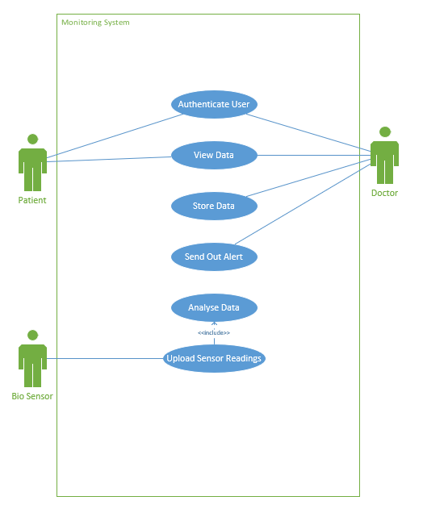

6. Domain Model Class Diagram
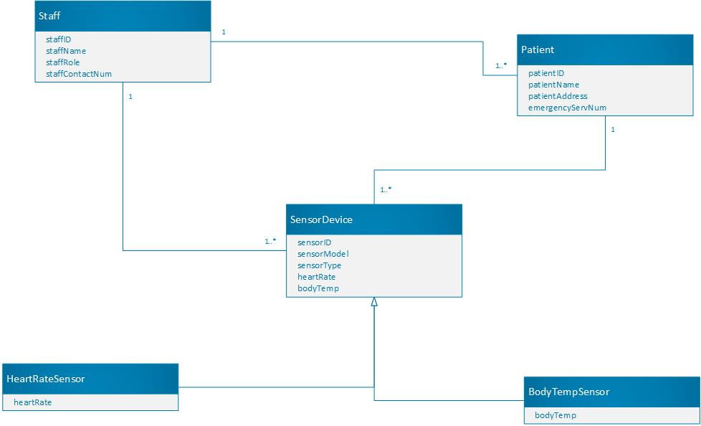

7. Analysis Class Diagram
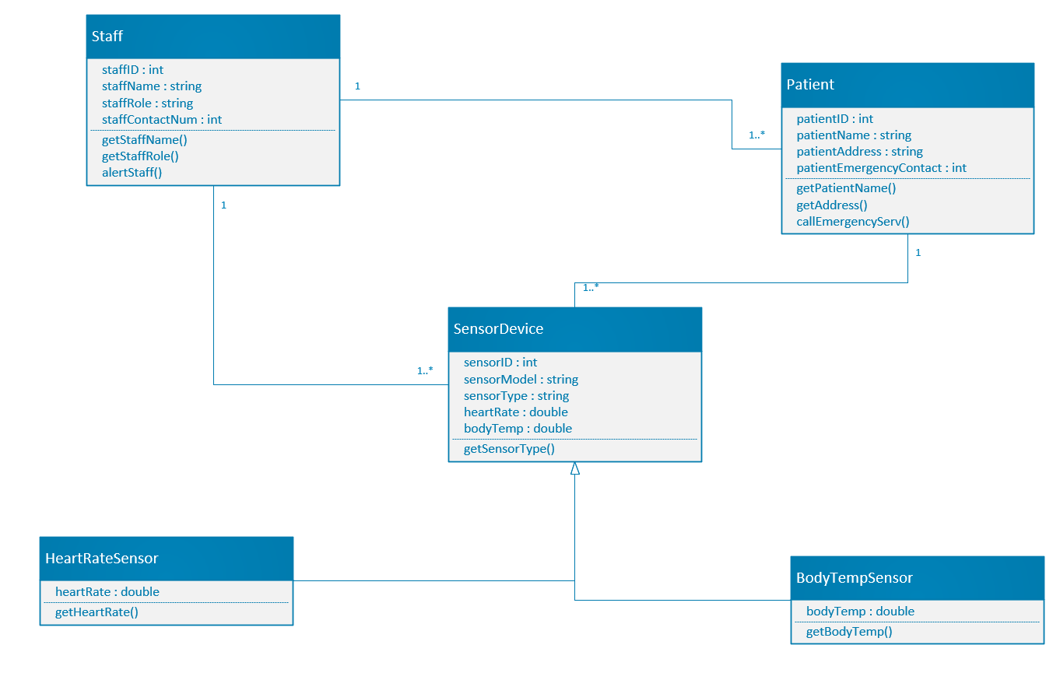

8. State Machine Diagrams
8.1 State machine diagram for SensorDevice.

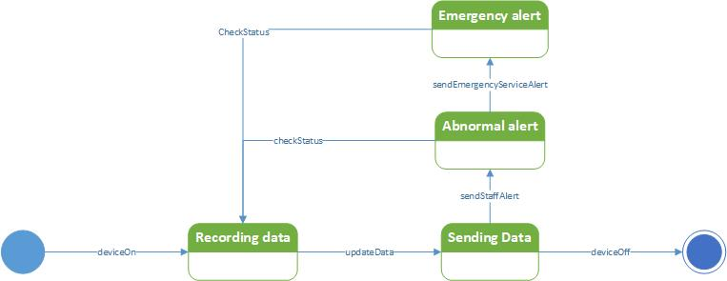

8. Use Case Realisation

8.1 Authenticate User Realisation
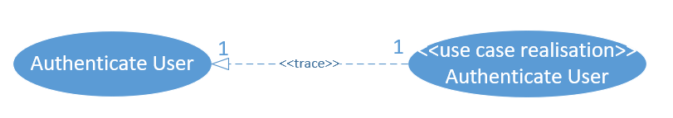

8.1.1 Elaboration of Authenticate User
Use case name: | Authenticate User
Trigger Event: | The patient or doctor want to log in to the system.
Brief description: | The patient and doctor need to login to access the system.
Actors: | Patient and Doctor.
Related use cases: | None
Pre-conditions: | The patient and doctor have a login id.
Post-conditions: | The user will be authorised to access the system.
Flow of activities: | Actor | System
 | 1. Patient/Doctor indicates desire to login to the system.  2. Patient/Doctor enters login details for system. | 1.1 System prompts for login details.  2.1 System retrieves user login details.  2.2 System authenticates user details  2.3 System grants user access to the system.
Exception conditions: | 1. Patient or doctor do not have a login to the system.

8.1.2 Authenticate User Activity Diagram
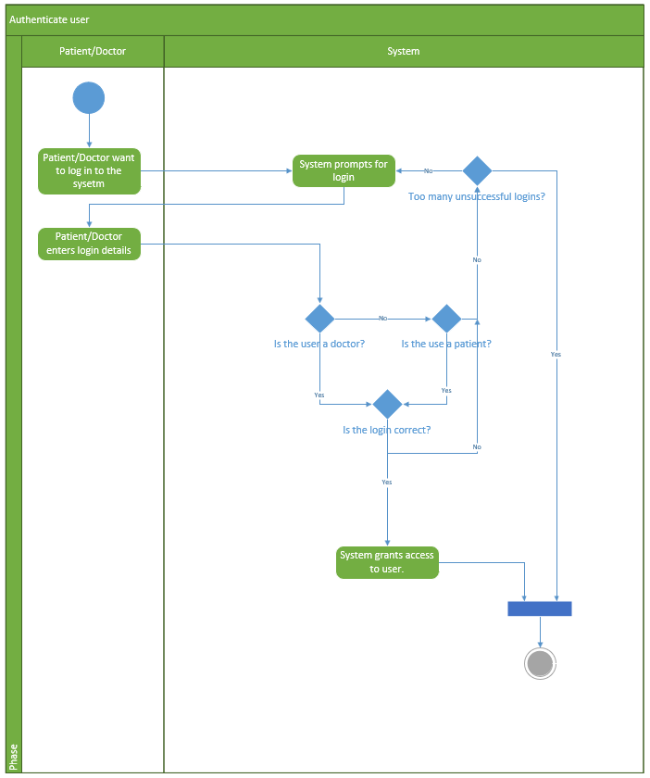

8.1.3 Authenticate User Sequence Diagram
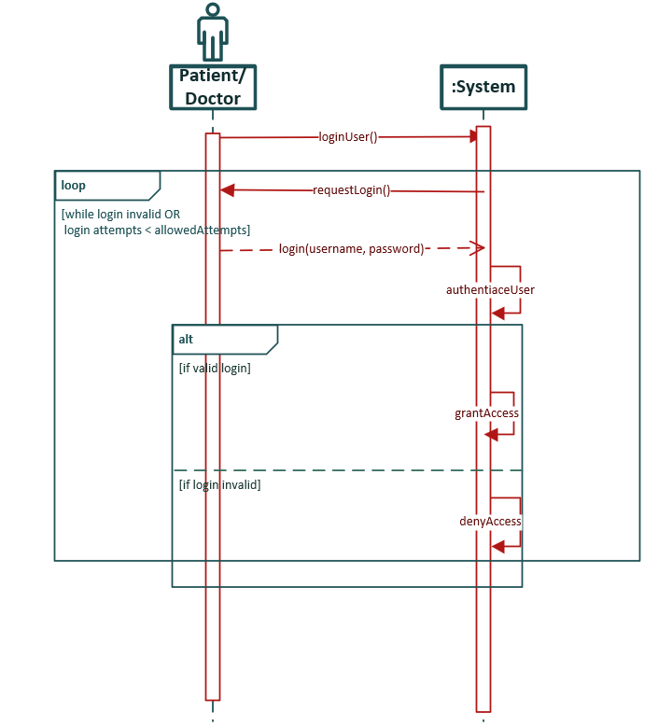

8.1.4 Associated Class diagram for Authenticate User
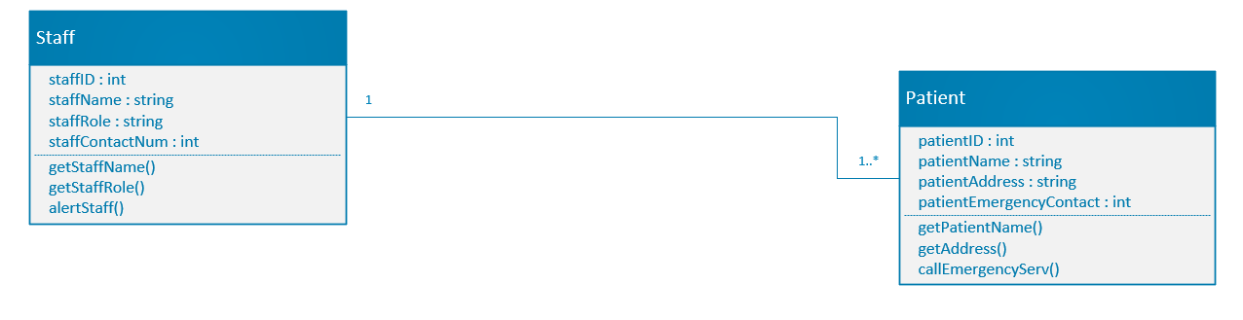

8.2 View Data User Realisation
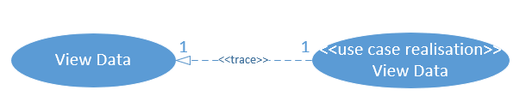

8.2.1 Elaboration of View Data

Use case name: | View Data
Trigger Event: | The patient or doctor wants to view data for a certain patient.
Brief description: | Patient data is stored within system for access by patients or doctors with authentication.
Actors: | Patient and Doctor.
Related use cases: | None
Pre-conditions: | The patient/doctor has logged in. The system is set up with patient data already stored.
Post-conditions: | All patient information can be looked up either in real-time or past data.
Flow of activities: | Actor | System
 | 1. Patient/Doctor indicates desire to access past data.  2. Patient/Doctor enters login details for system.  3. Patient/Doctor selects desired patient. | 1.1 System prompts for login details.  2.1 System invokes Validate User use case  2.2 System retrieves patients available and prompts for selection.  3.1 System retrieves data for patient.  3.2 System returns data information.
Exception conditions: | 1. Patient unavailable.  2. Patient available but no patient data recorded yet.

8.2.2 View Data Activity Diagram
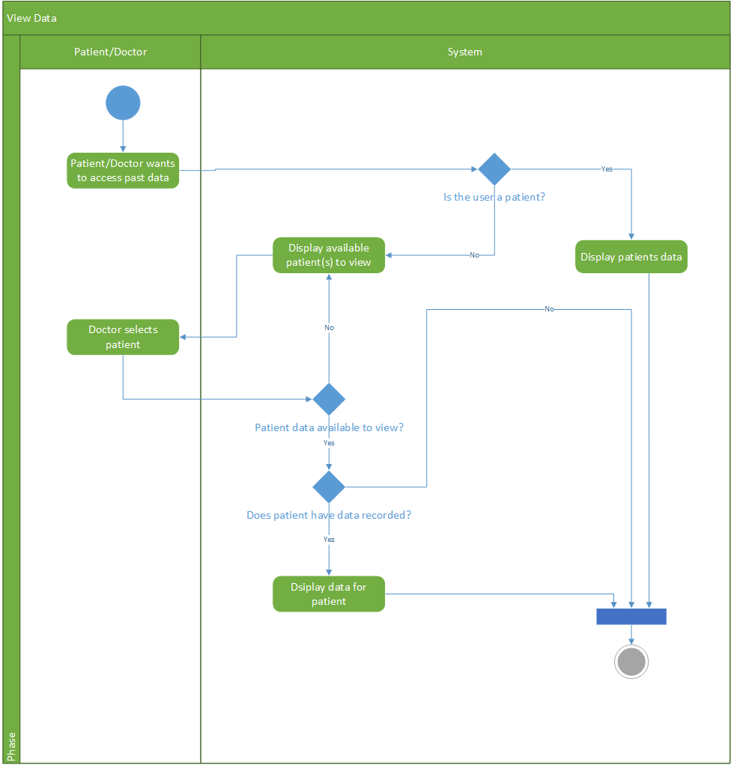

8.2.3 View Data Sequence Diagram
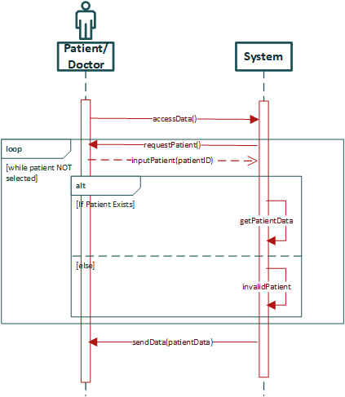

8.2.4 Associated Class Diagram for View Data
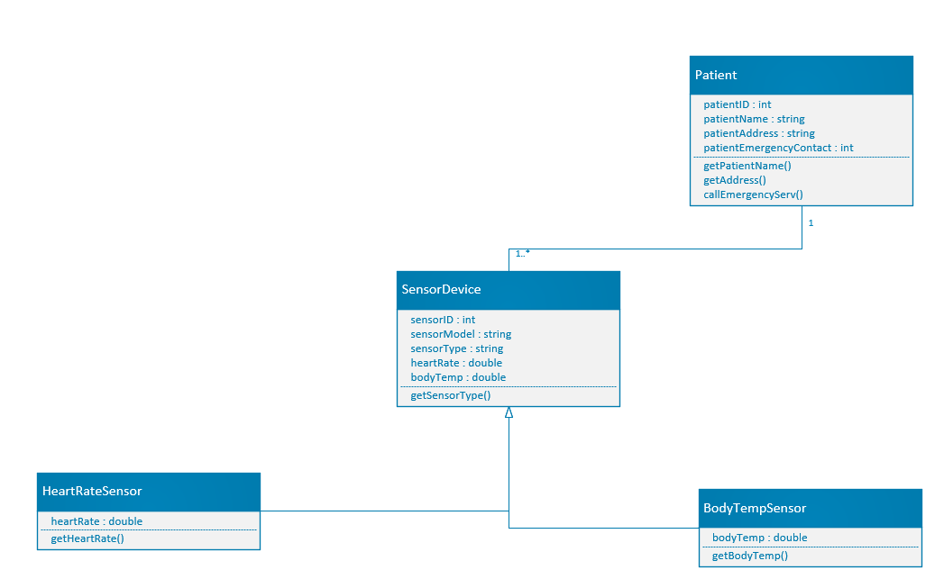

8.3 Store Data Realisation



8.3.1 Elaboration of Store Data

Use case name: | Store Data
Trigger Event: | Doctor wants to turn on automatic data recording for a select patient.
Brief description: | Automatic data recording continuously records the patient’s heartbeat and body temperature.
Actors: | Doctor
Related use cases: | None
Pre-conditions: | Patient has data stored in the system.  Doctor has logged in to the system.
Post-conditions: | Selected patient has their heartbeat and body temperature recorded into the system continuously.
Flow of activities: | Actor | System
 | 1. Doctor indicates desire to store data.  2. Doctor selects desired patient for data storage. | 1.1 System retrieves patients available and prompts for selection.  2.1 System enables storing of data continuously for selected patient.
Exception conditions: | 1. Patient not in the system

8.3.2 Store Data Activity Diagram

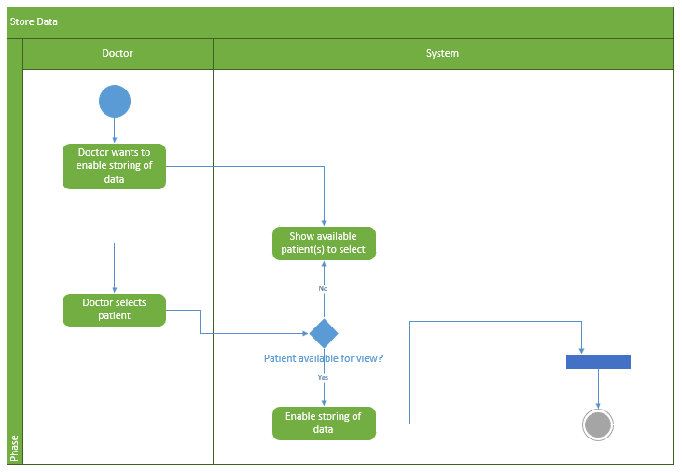

8.3.3 Store Data Sequence Diagram

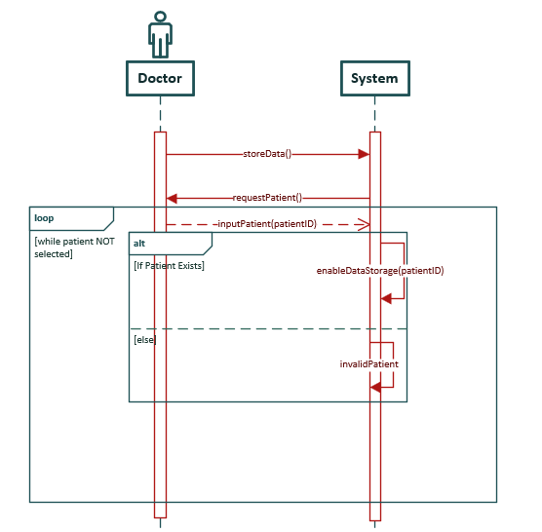

8.3.4 Associated Class Diagram for Store Data
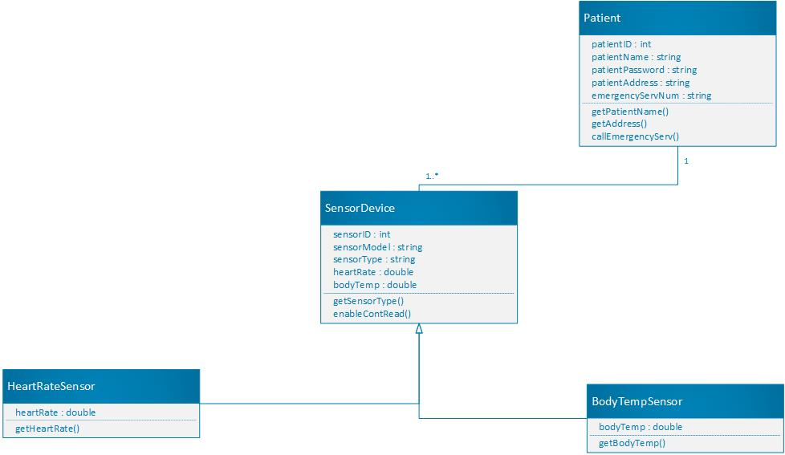

8.4 Analyse Data Realisation



8.4.1 Elaboration of Analyse Data

Use case name: | Analyse Data
Trigger Event: | Doctor wants to modify parameters for analysis process
Brief description: | A range of data is graphed and output to show the Doctor a patients’ overall health. Doctor enters parameters to define ‘normal’ health and abnormalities.
Actors: | Doctor.
Related use cases: | Upload Sensor Readings, Send Out Alert
Pre-conditions: | Patient exists within the system.  Doctor has logged into the system.
Post-conditions: | Selected patient has their data shown and graphed for analysis.  Data is continuously analysed for abnormalities.  May invoke Send Out Alert use case.
Flow of activities: | Actor | System
 | 1. Doctor indicates desire to analyse past data.  2. Doctor selects desired patient for data.  3. Doctor indicates desire to update parameters. | 1.1 System retrieves patients available and prompts for selection.  2.1 System retrieves and displays real time data for patient.  3.1 System prompts for new parameters  3.1 System records new parameters.  3.2 System returns patient data.  3.3 System continues to analyse data.
Exception conditions: | 1. Patient unavailable.

8.4.2 Analyse Data Activity Diagram

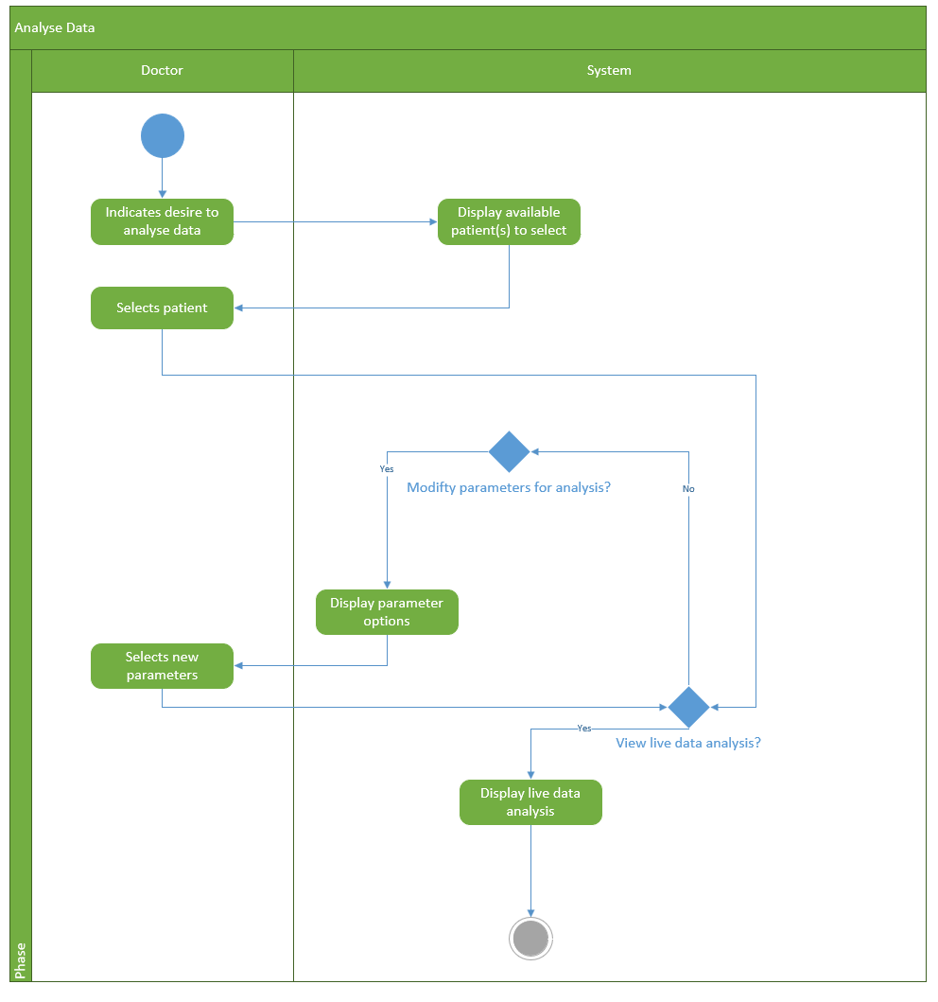

8.4.3 Analyse Data Sequence Diagram

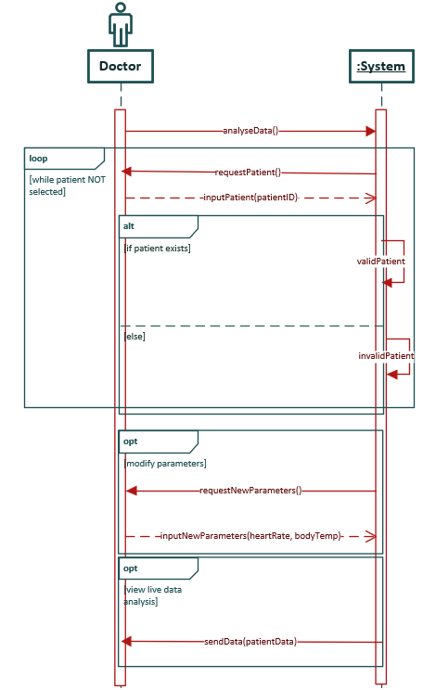

8.4.4 Associated Class Diagram for Analyse Data

8.5 Obtain sensor reading continuously Realisation

8.5.1 Elaboration of Obtain sensor reading continuously

Use case name: | Obtain sensor reading continuously
Trigger Event: | Patient attaches and turns on sensors.
Brief description: | The heartbeat and body temperature data are sent to the system from the sensors continuously.
Actors: | Bio Sensor
Related use cases: | Analyse Data.
Pre-conditions: | Sensor device is turned on.
Post-conditions: | Data from the sensor is sent to the system.  Always invokes Analyse Data use case.
Flow of activities: | Actor | System
 | 1. Bio-sensor inputs sensor information continuously. | 1.1 System records input.  1.2 System sends confirmation of received data.
Exception conditions: | 1. System does not recognise bio-sensor.

8.5.2 Obtain sensor reading continuously Activity Diagram

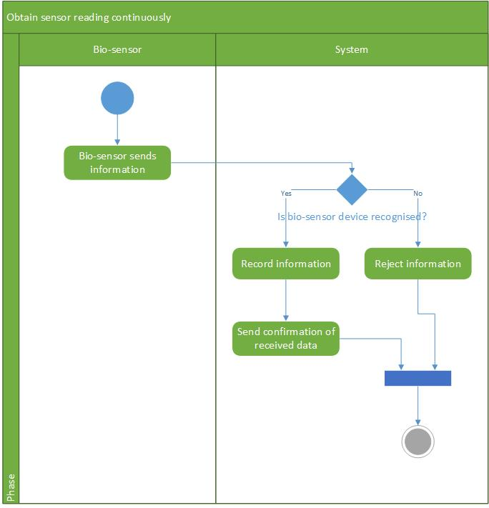

8.5.3 Obtain sensor reading continuously Sequence Diagram

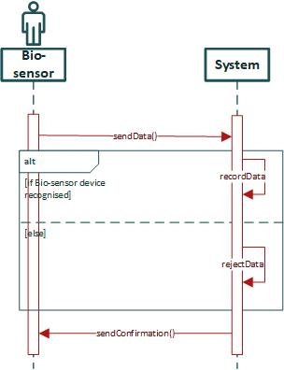

8.4.4 Associated Class Diagram for Obtain sensor reading continuously

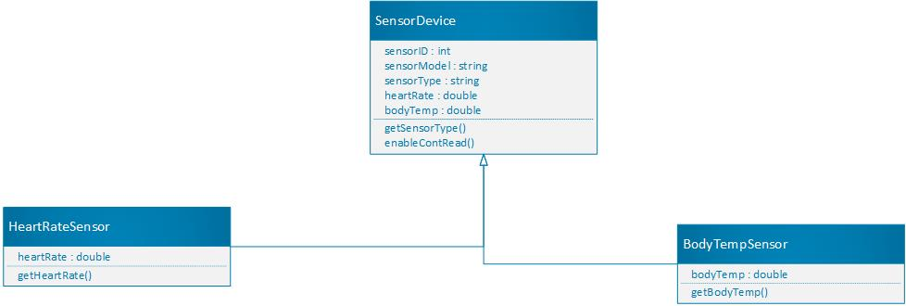

8.6 Send alert Realisation



8.6.1 Elaboration of Send alert

Use case name: | Send alert
Trigger Event: | An abnormality is detected in the patient.
Brief description: | System sends out an alert to staff/doctor or emergency services.
Actors: | Doctor
Related use cases: | Analyse Data
Pre-conditions: | There is internet connection.  May be invoked by Analyse Data use case.
Post-conditions: | Notification sent to doctor/emergency services.
Flow of activities: | Actor | System
 | 1.1 Doctor prompts for alert.  2.1 Doctor prompts for alert. | 1. System indicates desire to alert doctor  1.1 System retrieves contact details for doctor.  2. System indicates desire to send out alert  3 System sends alert.
Exception conditions: | 1. No network connection.

8.6.2 Send alert Activity Diagram
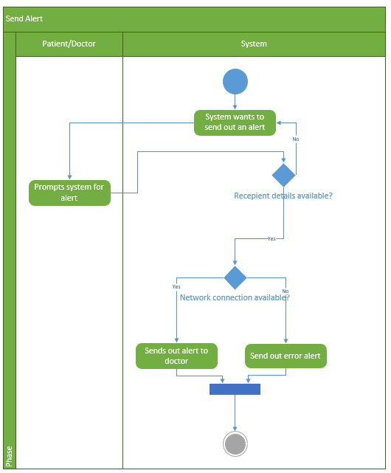

8.6.3 Send alert Sequence Diagram
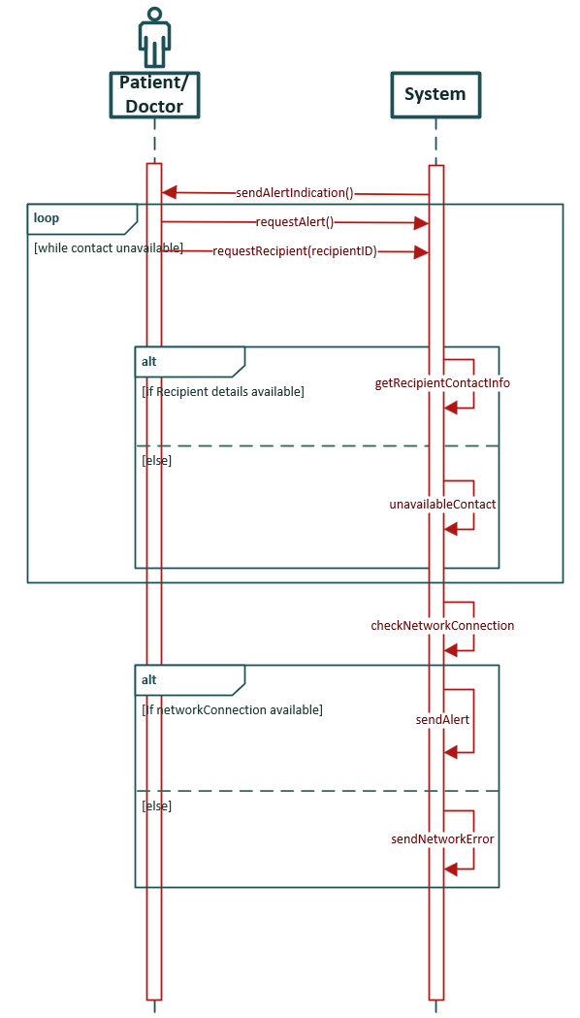

8.5.4 Associated Class Diagram for Send Alert

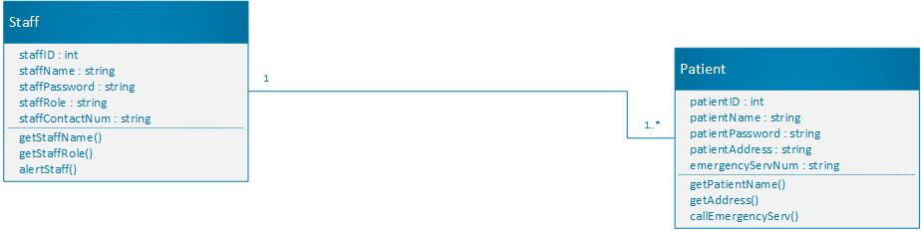

- Design class diagrams
- State Machine Diagrams
- Component Diagram
- Any other items deemed necessary to ensure the model is complete and thorough.

